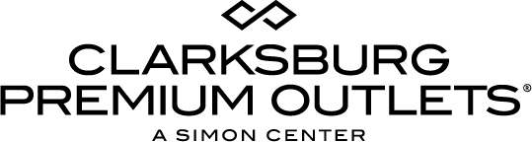
For more information:
Becca Meyer
BRAVE Public Relations
404-233-3993
bmeyer@bravepublicrelations.com

FOR IMMEDIATE RELASE

Coming soon to Clarksburg Premium Outlets: American Eagle Outfitters
Men and women’s fashion brand joining Washington D.C.-area’s premier outlet shopping destination this June

CLARKSBURG, Md. (May 31, 2018) – Simon, a global leader in premier shopping, dining and entertainment destinations, announced today that Clarksburg Premium Outlets will welcome American Eagle Outfitters in June. In addition, the center recently welcomed denim concept G-Star RAW to its list of sought-after brands.

“American Eagle Outfitters complements our ever-evolving list of brands offering the latest seasonal trends,” said Michael Mitchroney, general manager of Clarksburg Premium Outlets. “As we gear up for summer, we invite the community to shop seasonal trends at the center for enormous savings of up to 65 percent every day.”

Opening in a 6,280 square-foot space this June, American Eagle Outfitters will offer a high quality, on-trend assortment of men’s and women’s clothing, accessories and personal care products at affordable prices. The shopper-favorite brand will be located on Low Street next to Auntie Anne’s Pretzels and Journeys – just in time for summer fashion!

Clarksburg Premium Outlets shoppers can also expect to find other top brands, including the recently opened G-Star RAW as well as A|X Armani Exchange, kate spade new york, Theory and Salvatore Ferragamo.

To learn more about stores at Clarksburg Premium Outlets and upcoming events, please visit premiumoutlets.com/clarksburg.

About Clarksburg Premium Outlets
Clarksburg Premium Outlets is the Washington, D.C. area’s newest outlet center featuring an impressive collection of world-recognized and retailers with savings of 25 to 65 percent every day. Located in Montgomery County, the center serves as Simon’s first two-level, LEED-certified center, incorporating numerous energy-saving measures, such as LED-lighting, bike racks and storm water management systems, and amenities such as a sophisticated community space with covered walkways, spacious courtyards, landscaping, fountains, waterfalls, custom art, a fireplace and a children’s play area. The 392,000 square foot center offers Washington, D.C.-area shoppers a vast variety of apparel, footwear, accessories and home décor from popular brands including A|X Armani Exchange, Armani Outlet, kate spade new york, Theory and Saks Fifth Avenue OFF 5TH. For a map and store listings, as well as directions, event and tourism resources, visit premiumoutlets.com/clarksburg or find the center at facebook.com/clarksburgpremiumoutlets, twitter.com/ClarksburgPO and instagram.com/ClarksburgPremiumOutlets.
###

