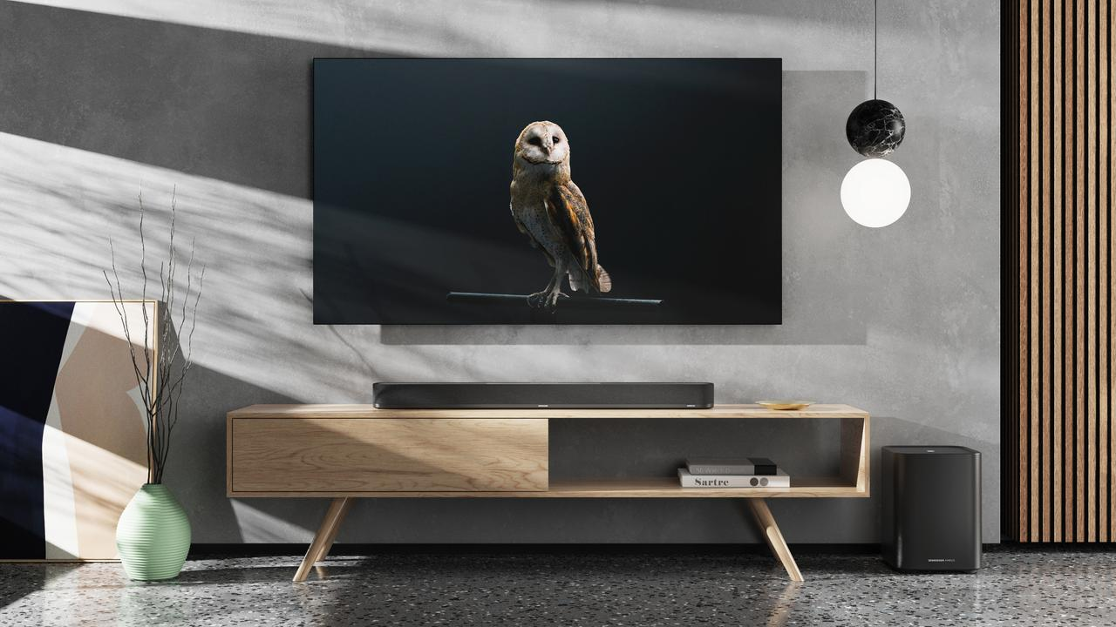THE WORLD’S MOST IMMERSIVE SOUND
Announcing the AMBEO Soundbar Plus and AMBEO Sub – the Sennheiser portfolio experiences another thrilling expansion.
Old Lyme, CT, September 1, 2022 – The expansion of the Sennheiser AMBEO Soundbar line-up, with the new AMBEO Soundbar Plus and the AMBEO Sub offers additional choices for consumers seeking to bring best-in-class immersive sound into their homes. The world's first 7.1.4. standalone soundbar, AMBEO Soundbar Plus places the user in the center of the action – but now in a more compact housing than its larger, award-winning sister – the AMBEO Soundbar Max, previously known as the AMBEO Soundbar. The AMBEO Sub guarantees a breathtaking cinematic experience and is, as one would expect from the Sennheiser brand, also outstanding for listening to your favorite music.

"The AMBEO Soundbar Plus and AMBEO Sub build on the success of the award-winning AMBEO Soundbar Max, ranked by reviewers as the best soundbar in the world," said Maximillian Voigt, Sennheiser Product Manager AMBEO Soundbars. "Thanks to the deep, immersive sound and more compact housing, our new AMBEO Soundbar Plus offers even more choices for those who want a home theatre experience with audiophile-quality sound."
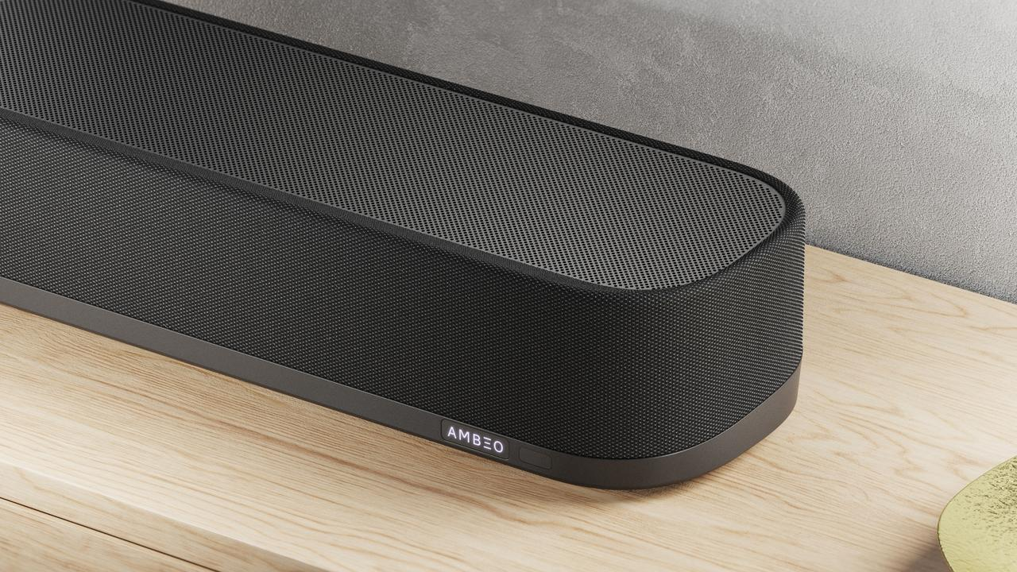

AMBEO Soundbar Plus
The AMBEO Soundbar Plus offers a new, more compact soundbar within the Sennheiser product portfolio. It is driven by the same groundbreaking 3D sound — developed in collaboration with the world leader in audio research and development, the Fraunhofer-Institute for Integrated Circuits IIS — as the AMBEO Soundbar Max. *

AMBEO Self-Calibration reads a room’s acoustic properties and then positions seven virtual speakers around the listener, plus four more overhead. This lets the AMBEO Soundbar Plus project sound from any corner of the room. Users get to experience the depth, impact, and spaciousness of a movie theatre at home — without the fuss of extra cables or satellite speakers.

The AMBEO Soundbar Plus is great for listening to audiophile-grade music and automatically adapts its sound to the content that’s being played. Customizable presets are also available, along with an equalizer and more in the Smart Control App. Breathtaking immersive 3D sound is provided with Dolby ATMOS, DTS:X, 360 Reality Audio and MPEG-H Audio. Users can even upmix stereo and 5.1 content to create thrilling 3D sound experiences that make it sound like the artist is in the room.

The Sennheiser AMBEO Soundbar Plus uses the AMBEO|OS platform. This enables multiple music streaming services, such as Apple AirPlay 2, Spotify Connect, TIDAL Connect, and works with a Google Assistant-enabled device with Chromecast built-in. ** Furthermore, it provides seamless integration with Alexa Built-in *** and Apple Siri.

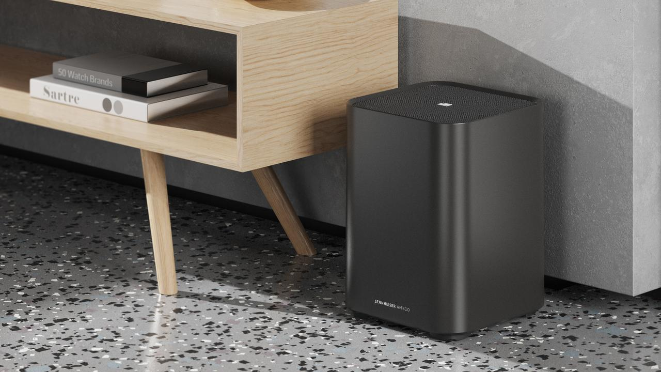

AMBEO Sub
The new Sub delivers a unique immersive sound designed to give you goosebumps. The extremely deep bass is powered by the AMBEO virtualization technology, that provides unmatched natural and immersive sound, while an 8” high-end proprietary woofer, paired with a 350W Class-D amplifier, guarantees unmatched thundering bass.

With a design that matches its incredible sound quality, a closed enclosure ensures audiophile-grade bass down to 27Hz. The multi-sub array technology allows users to connect up to four subwoofers to scale bass performance and calibrate them individually for optimal sound, while a wireless connection provides for a neat and clean room without the need for any cables.

The AMBEO Sub’s advanced self-calibration and its built-in far-field microphone allow the device to precisely learn the acoustics of your room and adjust to every environment for a unique sound experience, while its intuitive Smart Control App guarantees a smooth user experience that makes the most out of your AMBEO Sub. Just plug it in, set it up and enjoy.

Pricing and availability
The Sennheiser AMBEO Soundbar Plus and AMBEO Sub, can be pre-ordered from September 1 and will be available from September 22, 2022. The AMBEO Soundbar Plus has an MSRP of $1,499.95 USD // 1,999.95 CAD and AMBEO Sub has an MSRP of $699.95USD// $999.95 CAD.

* upHear technology licensed by Fraunhofer IIS. www.iis.fraunhofer.de/audio
** Google, Google Home and Chromecast built-in are trademarks of Google LLC. Google Assistant is not available in certain languages and countries.
*** Subject to regional availability and language. Amazon, Alexa and all related marks are trademarks of Amazon.com, Inc. or its affiliates.
About the Sennheiser brand
We live and breathe audio. We are driven by the passion to create audio solutions that make a difference. Building the future of audio and bringing remarkable sound experiences to our customers – this is what the Sennheiser brand has represented for more than 75 years. While professional audio solutions such as microphones, meeting solutions, streaming technologies and monitoring systems are part of the business of Sennheiser electronic GmbH & Co. KG, the business with consumer devices such as headphones, soundbars and speech-enhanced hearables is operated by Sonova Holding AG under the license of Sennheiser.

www.sennheiser.com
www.sennheiser-hearing.com

Press contact
Sonova Consumer Hearing GmbH
Paul Hughes
Head of PR and Influencers
Sennheiser Headphones & Soundbars
T +49 (0) 162 2921 861
paul.hughes@sonova.com

