Neumann’s MCM Conquers the Big Stage
Berlin, Germany, March 2023 – Neumann.Berlin, the legendary studio specialist, is quickly gaining traction in the live market, too. Since the release of the Miniature Clip Microphone System (MCM), more and more FOH engineers are discovering its superior sound quality and handling advantages over existing solutions.

Dave Bracey (FOH Adele Recidency show, Las Vegas)
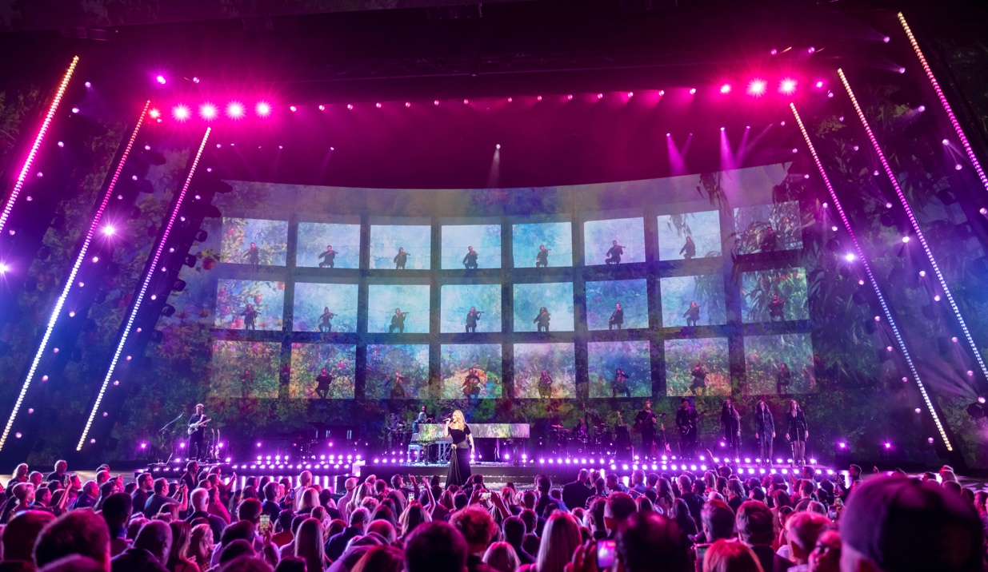
Stage design of "Weekends with Adele" with string section in the background, Photo: STUFISH

Weekends with Adele is the British singer’s first concert residency. Held at Caesars Palace Colosseum in Las Vegas, and running from 18th November 2022 to 25th March 2023, it is certainly a classy show, both visually and sonically. Unanimously praised by critics, the show is mixed in immersive audio.

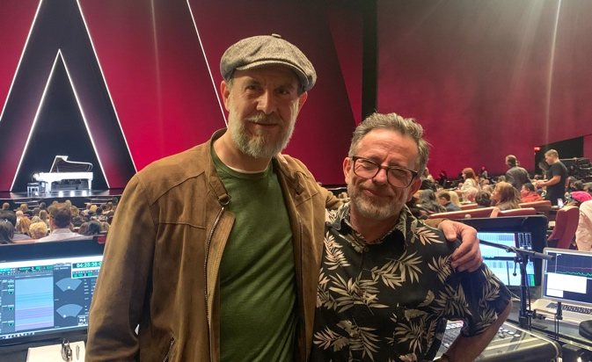
“Audio wise, many things have changed in our quest to set a high standard in Vegas, but the most impressive leap forward is the sound of the string section,” says Front of House engineer, Dave Bracey. “We have 24 strings that are hidden for the first few songs that they feature in, but their reveal is one of the first big audience gasp moments. Luckily for us the new Neumann MCM acoustic instrument mics were in production just in time for our rehearsals. The improvement in audio quality over our previous mic selection could not have been more noticeable,” Bracey describes his experience to Neumann’s CEO Ralf Oehl, who attended Adele’s show in January.
Neumann’s CEO Ralf Oehl and FOH Dave Bracey, just before the show

“The warmth and detail these mics delivered produced a very accurate and natural sound with very little effort from me! The mounting system for them is excellent, as testified by the positive attitude of the players attaching them to their instruments. This is usually a tricky subject, but with the MCM clamps we keep hearing… ‘oooh I like these’.”

Colin Pink (FOH Hans Zimmer Live-Tour)
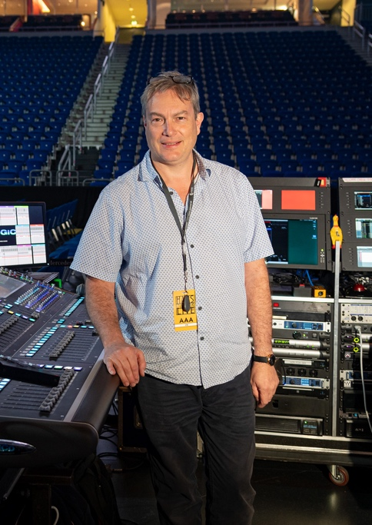
As early as April 2022, Colin Pink was among the first big name FOH engineers to try out Neumann’s Miniature Clip Microphone System, when he used it on Hans Zimmer Live at Mercedes Benz Arena, Berlin, in front of 15,000. The MCM’s full and smooth sound was a perfect fit for the orchestra’s string section, and the players also loved the easy handling.

“The first thing you notice is the simplicity of fitting. It can be done easily with one hand and allows for great placement, and it always feels secure”, states Colin Pink. “The sound is very open and smooth – like a condenser from 30 cm. There is no harshness, and you get a great extended low frequency response. You still retain all the detail and presence, but with a more natural presentation. I was worried that this would increase the chances of ‘feedback’, but I had no experience of this. It truly is a remarkable microphone for strings.”
FOH engineer Colin Pink at his workplace
Molly Rogers, who plays violin and viola at Hans Zimmer Live, is enthusiastic as well: “The Neumann clip system is by far the easiest I’ve ever used. I switch back and forth from violin to viola quite often on this and other tours. In the past, I’d either need multiple mic packs to take on and off or I would feel the pressure of trying to move the mic to the other instrument in time – but with the new clips, I felt so much less stress during song changes with how simple the process was!”
Molly Rogers on stage in Berlin

Based on those thoroughly positive experiences, the MCM System will now be used on the entire 2023 Hans Zimmer Live Tour.

Marco Dellatorre / Clair Brothers (FOH Andrea Bocelli Concert, Abu Dhabi)
MCMs on the timpani waiting for the concert to start at Etihad Park, Abu Dhabi
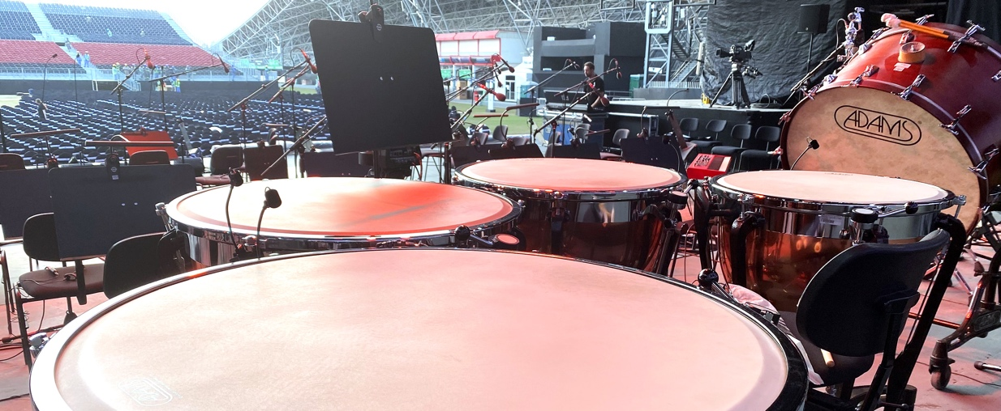
More than 30 MCM systems were used on strings, solo cello, brass, woodwinds, and timpani at an open air concert with Andrea Bocelli at Etihad Park, Abu Dhabi. During the orchestra rehearsal, sound engineer Marco Dellatorre noticed a big difference in the quality that the MCM were delivering in the mid and low frequency range, and a decision was made to replace the previous setup with Neumann MCMs.

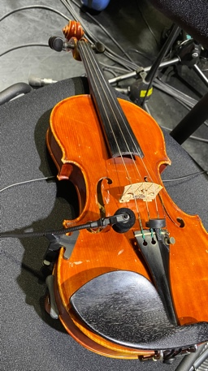
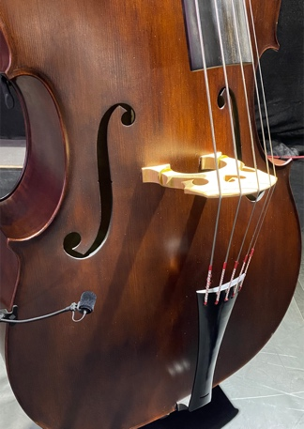
“We had the chance to A/B the mics, and the difference was crystal clear: we dramatically gained on details and natural sound. Right after we noticed that, we decided to increase the amount of MCMs. We discovered a game changer: this is the way we approach our passion in music, this is the only way we think is possible to grow as professionals!” As a consequence, the onsite production company Clair Innovations (part of Clair Brothers) confirmed their decision to purchase a large number of MCM Systems for their equipment pool.
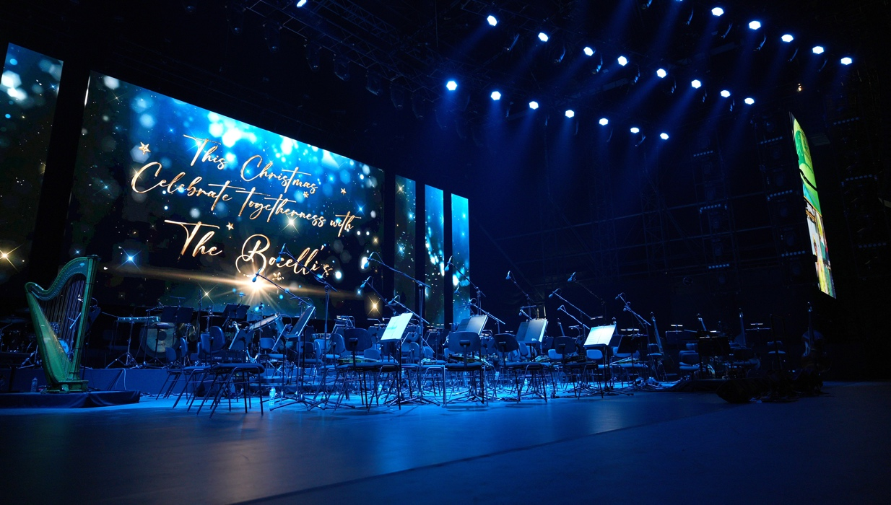
“We’re excited to bring Neumann sound to the stage!” rejoices Portfolio Manager Stephan Mauer. “Within the past decade, live sound has undergone an enormous transformation. Audiences have come to expect more than just a concert: an experience that unites them with their favorite artist. For this to happen, live sound must be as perfect as in the studio – even though conditions are far from ideal! That’s where the MCM shines: It offers true Neumann sound in a visually unobtrusive format that does not distract from the performance.”

About Neumann
Georg Neumann GmbH, known as “Neumann.Berlin”, is one of the world’s leading manufacturers of studio-grade audio equipment and the creator of recording microphone legends such as the U 47, M 49, U 67 and U 87. Founded in 1928, the company has been recognized with numerous international awards for its technological innovations. Since 2010, Neumann.Berlin has expanded its expertise in electro-acoustic transducer design to also include the studio monitor market, mainly targeting TV and radio broadcasting, recording, and audio production. The first Neumann studio headphones were introduced in 2019, and since 2022, the company has put an increased focus on reference solutions for live audio. Georg Neumann GmbH has been part of the Sennheiser Group since 1991, and is represented worldwide by the Sennheiser network of subsidiaries and long-standing trading partners.

Press Contact Neumann:
Andreas Sablotny
andreas.sablotny@neumann.com
T +49 (030) 417724-19

