MEDIA ALERT: Synthax U.S. Showcases Flexible, Reliable Sound Cards and Audio Networking Solutions for IT Pros During SC19

Offerings from RME, Digigram and Ferrofish will all be on display
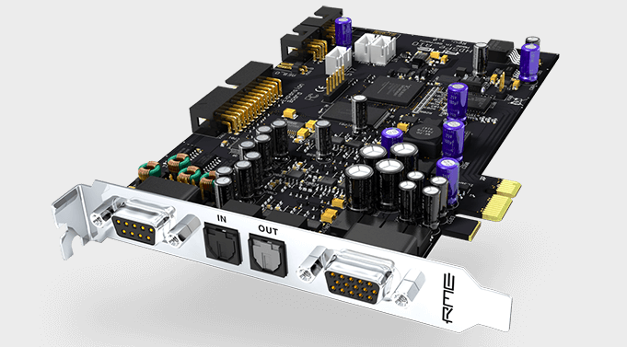
Denver, Colorado, November 11, 2019 – Synthax, distributor of German interface manufacturer RME, converter manufacturer Ferrofish and broadcast audio systems manufacturer Digigram, will highlight several audio networking solutions and sound cards designed to streamline IT professionals and integrators’ workflows during SC19 at booth 395 from November 18–21, 2019.
Attendees of the international conference for computing professionals will get the chance to experience the flexible and reliable sound cards and networking solutions that RME, Digigram and Ferrofish have to offer.
“With a variety of formats available, including Dante, MADI, ADAT and AVB, along with customized solutions, Synthax U.S.’s brands are your one-stop source for flexible, high-performance computing solutions,” said Derek Badala, Synthax’s Director of Sales, Americas. “The reliability and precision of our networking gear and sound cards is what makes our solutions the ‘go-to’ for IT and computing professionals around the world.”
RME
RME’s catalog of sound cards and audio networking equipment has been an industry-standard for reliable audio transfers without compromising in quality. Top highlighted products during SC19 will include the company’s HDSPe AIO — a 38-channel PCI Express Card with multi-format I/O.

Digigram
A leader in IP technologies for flexible and secure workflows for more than 30 years, Digigram’s wide array of sound cards, audio processing software and IP audio codecs offer users reliable, best-in-class performance, including the LX-Dante Multichannel Dante PCIe Sound Card.

Ferrofish
Leader in affordable converting solutions, Ferrofish’s catalog offers flexible solutions for a variety of audio formats, including MADI and ADAT. During SC19, Ferrofish will display its Verto series of compact digital format converters which allow for simple integration of ADAT and MADI devices into an existing Dante network.

For more on RME, Digigram and Ferrofish’s offerings, visit Synthax US’s SC19 booth 395.

For more information on Synthax, visit: https://www.synthax.com/

About Synthax, Incorporated
Synthax Inc. is the exclusive USA distributor for RME digital audio solutions, Digigram broadcast audio systems, Appsys digital audio tools, Ferrofish advanced audio applications, myMix personal monitoring systems and ALVA cableware. We supply a nationwide network of dealers with these products for professional audio, broadcast, music industry, commercial audio, theater, military and government applications. For additional information, visit the company online at http://www.synthax.com.

Media Contacts:
Katie Kailus
Public Relations
Hummingbird Media
+1 (630) 319-5226
katie@hummingbirdmedia.com

Jeff Touzeau
Public Relations
Hummingbird Media
+1 (914) 602 2913
jeff@hummingbirdmedia.com

