Press Release

EVOC TRAVEL: THE MISSION PRO & MISSION BACKPACKS
MULTI-FUNCTIONAL: DIGITAL NOMADS CAN WORK AND TRAVEL COMFORTABLY AND WITHOUT LIMITS WITH THE MISSION PRO 28L

ULTIMATE FREEDOM HAS NEVER BEEN SO CONVENIENT AND COMFORTABLE: EVOC HAS LAUNCHED THE MISSION PRO 28L BACKPACK IN FOUR COLOURWAYS TO CATER TO DIGITAL NOMADS AND FANS OF A “LEAN” WORK HABIT. SPECIALLY DESIGNED TO MEET THE NEEDS OF MODERN GLOBETROTTERS, THE MULTI-FUNCTIONAL ORGANISATIONAL WIZARD OF EVOC’S TRAVEL COLLECTION IS AN INDISPENSABLE TRAVEL COMPANION.
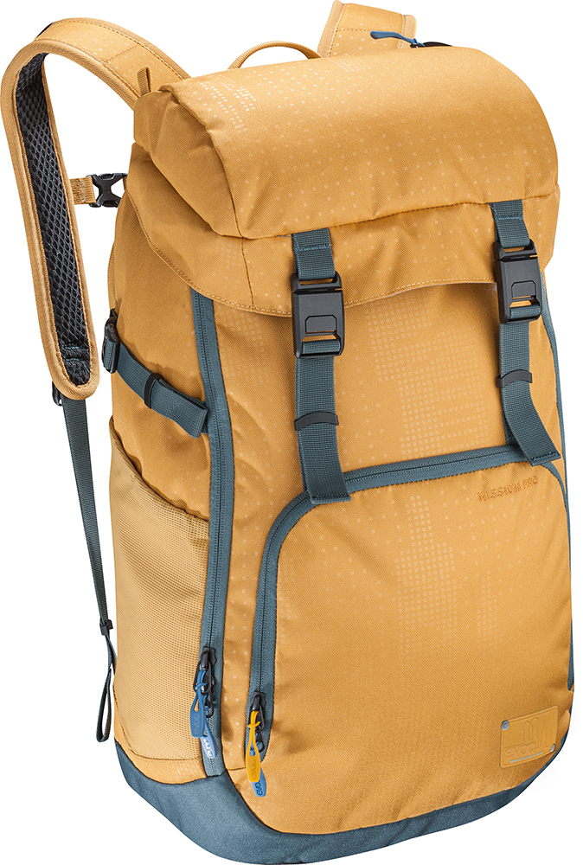
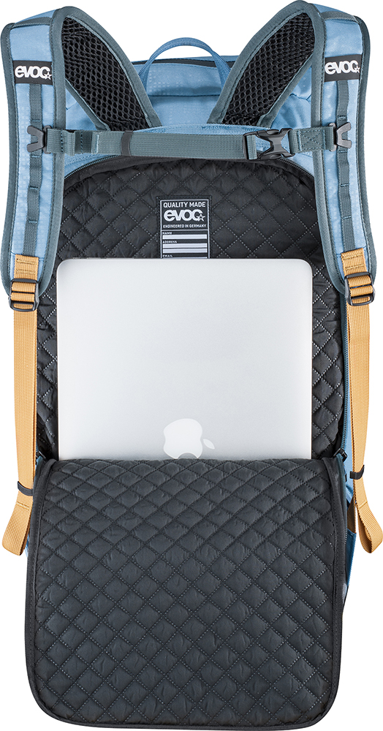
No matter how remote your travel destination may be: If there is WLAN you can combine your job with the ultimate adventure. In future, you’ll be able to take your office with you in the MISSION PRO. The quick-access back compartment is padded with high-quality, embossed, soft-touch material and offers enough space for a 15-inch laptop and your tablet. In this way, the most essential work equipment is safely stored, while the main compartment features several dividers for magazines or documents.
Your passport, mobile phone and the like will definitely never get lost when stowed in the additional top compartment with key holder and water-repellent zip. Pens, memory cards and necessities go in the backpack’s front compartment – in the “to go” desk drawer, so to speak. Store your charger cable and headphones in a separate external compartment on one side and your obligatory drinking bottle in a flexible mesh pocket on the other to have it right at hand at any time.

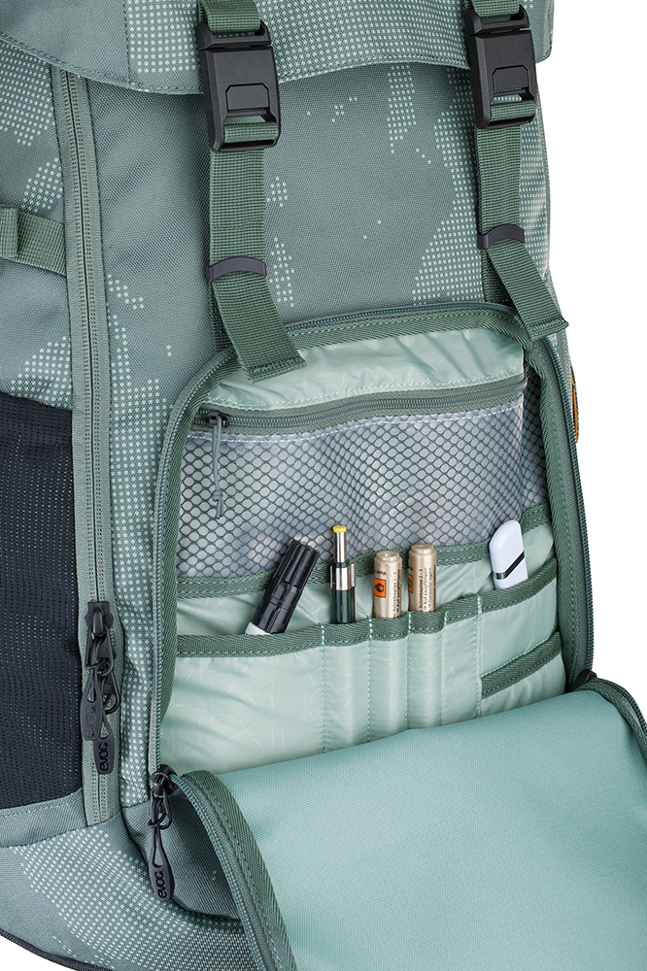
COMFORTABLE “TO GO” OFFICE
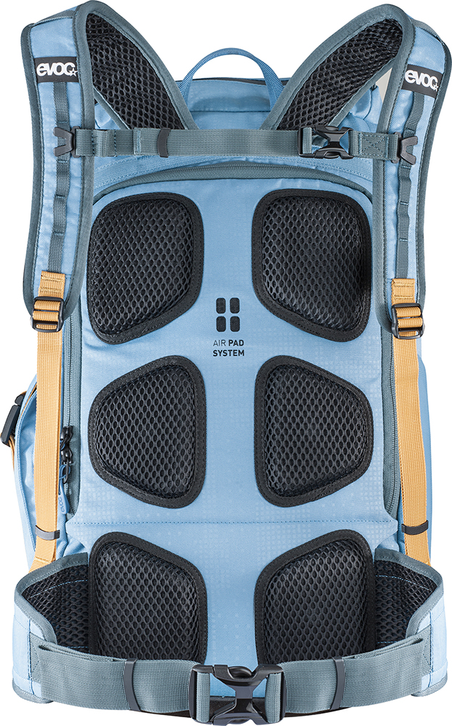
EVOC is known for the highest standards when it comes to their backpacks’ ergonomics. The top-quality carrying system of the MISSION PRO is enhanced by a completely stowable hip belt with breathable mesh insert, which provides for optimum load weight distribution onto the hips when the backpack is fully loaded. The chest belt is height-adjustable or entirely detachable for even more carrying comfort. And to make sure you pass through check-in at the airport quickly, the MISSION PRO now features magnetic QUICK SNAP FASTENERS that are even easier to open and close. Bumpy routes to your designated hut or beach office are taken care of by compression straps, which keep the pack’s content securely fixed and stable. Thanks to perfect ventilation as a result of the integrated AIR PAD SYSTEM, your back is guaranteed to stay dry even during high-strain activities or on hot days.
The MISSION PRO also lives up to its name when it comes to looks: An intricate skyline design represents the founding history of the EVOC brand, which took place between Munich and Hong Kong, and is eternalised by means of a repeat print with an iridescent effect on robust nylon fabric.

FOR A DIGITAL HOLIDAY OR UNIVERSITY USE: THE MISSION 22L
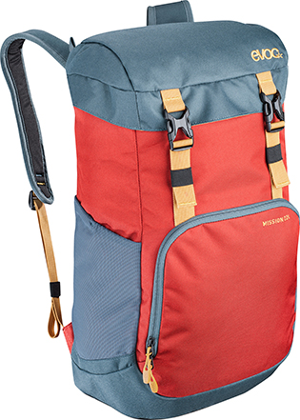
Schoolboys and schoolgirls, university students or anyone who likes having their laptop with them at all times will love the multi-functional organisational wizard, the MISSION 22L, which comes in four stylish colourways. This top-loader backpack with drawcord features a laptop pocket that’s integrated in the main compartment, and is a touch smaller than its bigger brother, the MISSION PRO. The pack has a slightly simplified interior, comes without detachable belts and is equipped with conventional buckles for closing. When it comes to ergonomics, AIR PAD SYSTEM and ventilation, however, the MISSION 22L as the second new member of the EVOC TRAVEL family makes no compromises either.

SPECIFICATIONS
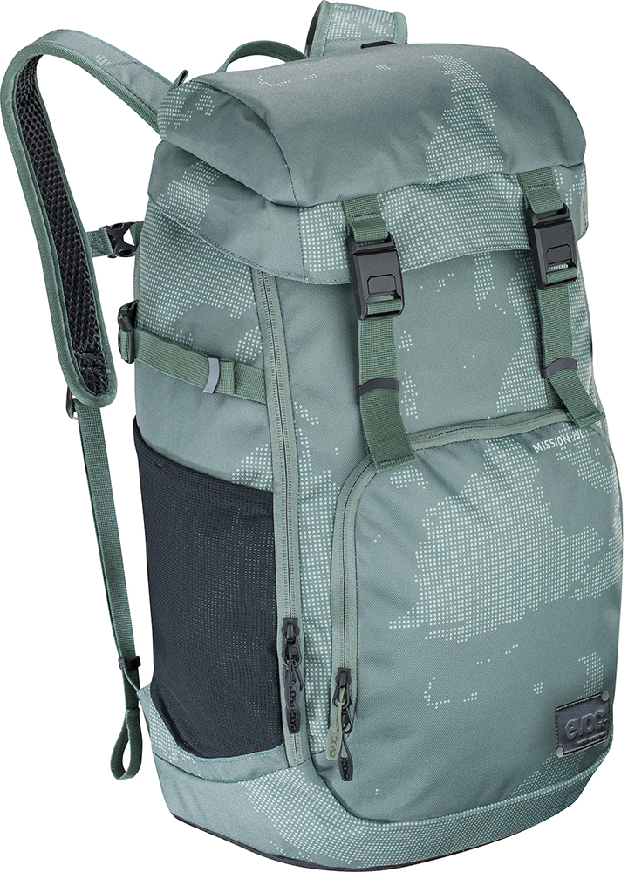 |  | 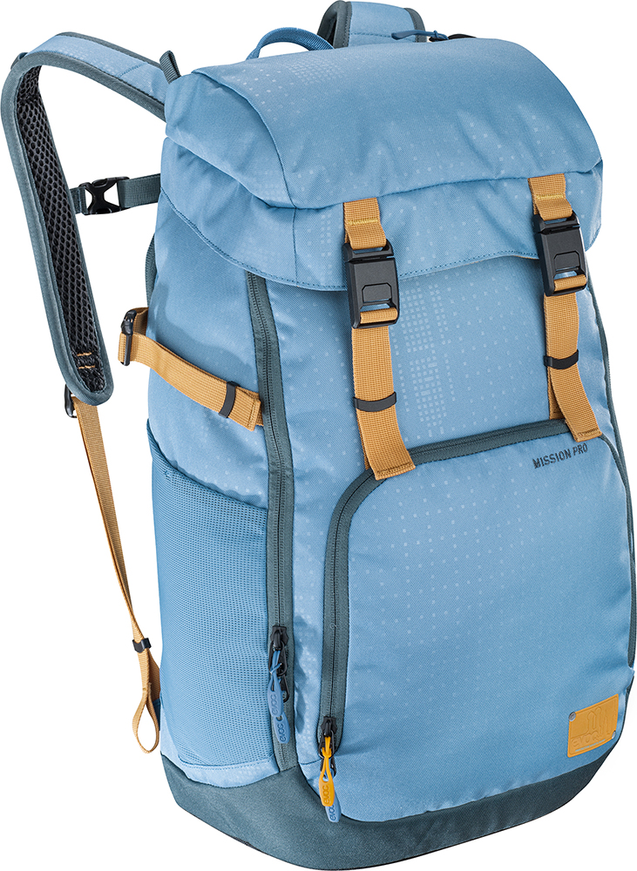 | 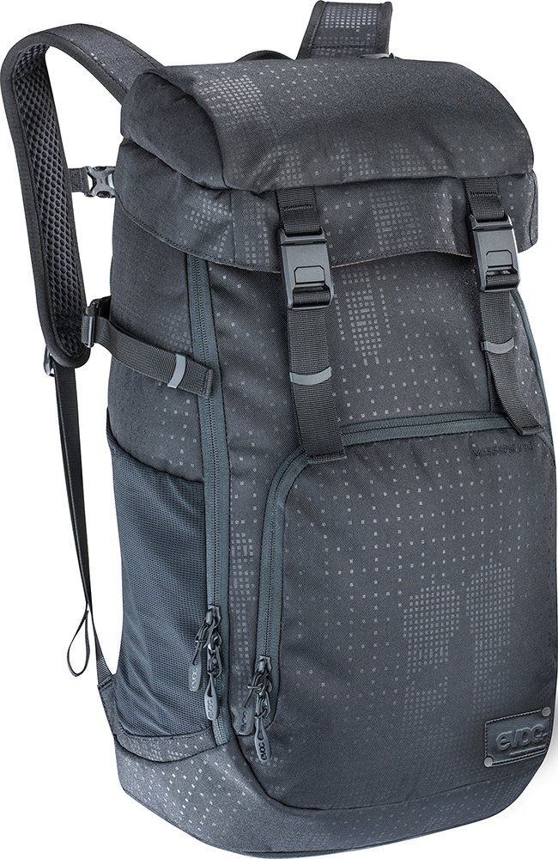
 | 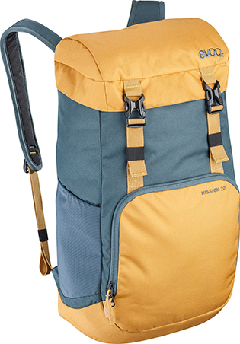 | 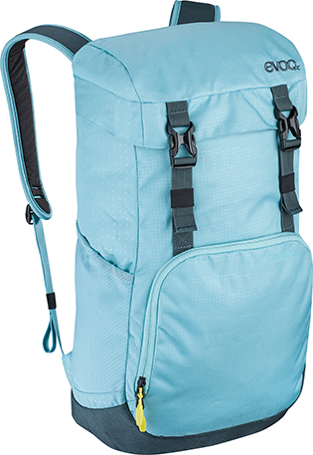 | 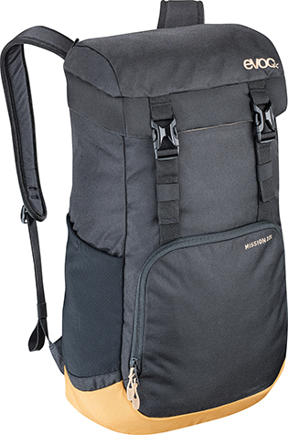

MISSION PRO

Capacity: 28 l
Size: 47 x 28.5 x 16 cm
Weight: 930 g
Colour: olive, loam, copen blue, black
Price: € 145.00 / 150 USD / 200 CAD

MISSION

Capacity: 22 l
Size: 42 x 25 x 15 cm
Weight: 610 g
Colour: red chili/slate, slate/loam, aqua blue, black
Price: € 95.00 / 100 USD / 135 CAD

Date: April 2019
Subject to change

