Synthax Named U.S. Distributor for Appsys Pro Audio,
Expands Audio Networking Options

Synthax’s latest addition offers a variety of high-quality networking solutions

Orlando, FL, May 29, 2019 – Synthax [InfoComm 2019 booth 5150], distributor of premium German interface manufacturer RME, German converter manufacturer Ferrofish and personal monitor mixer myMix, has announced at that it now distributing Switzerland-based Appsys Pro Audio to the U.S., Canada and Latin America, effective immediately. Synthax will highlight Appsys products at its booth 5150 during InfoComm 2019 from June 12–14, 2019, at the Orange County Convention Center in Orlando, Florida.
Designed in Switzerland and manufactured in Germany, Appsys is known for creating and developing professional audio equipment in close collaboration with its customers to meet their specific needs. The company manufacturers a range of ADAT products, including extenders, splitters and repeaters as well as digital format converters including its popular Multiverter MVR-64.
“Appsys will play a key role in the Synthax portfolio of brands,” said Mathias von Heydekampf, Managing Director of Synthax. “With its innovative audio networking solutions and its high build quality, Appsys products will continue Synthax’s mission as masters of networking. We are proud and excited bring Appsys products to a wide network of users in the U.S. and Canada.”

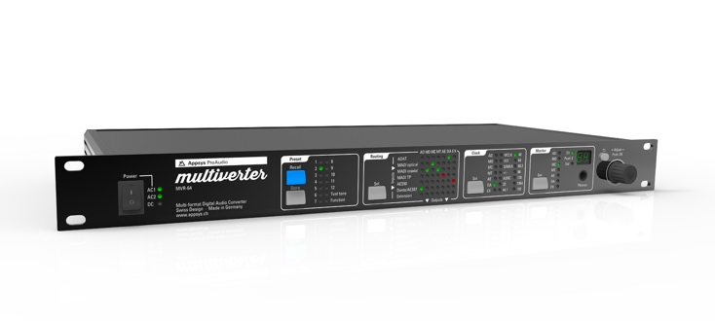
Swiss Army Knife: The Multiverter MVR-64
At this month’s InfoComm, Synthax will highlight one of Appsys most popular products, its Multiverter MVR-64 digital format converter. Dubbed the any-to-any converter, the Multiverter lets users interface their gear to any signal source with the ability to convert between a wide selection of digital interfaces all at once. The Multiverter supports a stunning 64 channels of conversion for ADAT, MADI optical, MADI coaxial, MADI-TP, AES50, Dante/AES67, and is extensible to future interfaces via break-out boxes.
Users also have remote control over MIDI, MIDI over MADI, USB, RS485, AES50 Aux Data channel and network socket. The MVR-64 boasts 12 store and recall presets, a headphone amp which allows users to monitor any incoming signal as well as a test tone generator which simplifies troubleshooting when it comes to complex setups.
Appsys also offers a Sample Rate Converter Hardware Module to accompany the MVR-64, allowing users to add even more power to their Multiverter. The module features 64x64 channel asynchronous, bi-directional conversion between two arbitrary sample rates and interfaces.
A Variety of Applications
The Multiverter is a perfect solution for a wide variety of applications. Touring bands can use the Multiverter in their rack with their standard I/O knowing that when playing live, they’ll be able to connect to any front of house or monitor console. Broadcast trucks can use the Multiverter to receive a MADI feed from the live event and convert it to Dante while recording via a Dante virtual sound card. In post-production or recording studio applications, the Multiverter can be used to bring all digital audio together by integrating a client’s gear with a studio’s existing setup.
For peace of mind, the Multiverter MVR-64 comes complete with a triple-redundant power supply and can be powered with industry-standard 4-pin XLR plug battery packs.
The Multiverter MVR-64 is available now and priced at $2,999 MAP.
Check out Appsys Multiveter MVR-64 along with the latest RME, Ferrofish and myMix products at Synthax booth 5150 during InfoComm Orlando, June 12–14.
For more information on Appsys, visit: https://appsys.ch/en/
For more information on RME, visit: http://www.rme-audio.de/en/

About Synthax, Incorporated
Synthax Inc. is the exclusive USA distributor for RME digital audio solutions, Ferrofish advanced audio applications, myMix audio products, and ALVA cableware. We supply a nationwide network of dealers with these products for professional audio, broadcast, music industry, commercial audio, theater, military and government applications. For additional information, visit the company online at http://www.synthax.com.

Media Contacts:
Katie Kailus
Public Relations
Hummingbird Media
+1 (630) 319-5226
katie@hummingbirdmedia.com

Jeff Touzeau
Public Relations
Hummingbird Media
+1 (914) 602 2913
jeff@hummingbirdmedia.com

