For more information, please contact Marta de Paco
On +34 670 780 664 or email press@comunicahair.com

Important:
These images are only available for editorial content.
Credits must be included.
Notification of their publication is expected.

ZIORTZA ZARAUZA
GEODE Collection

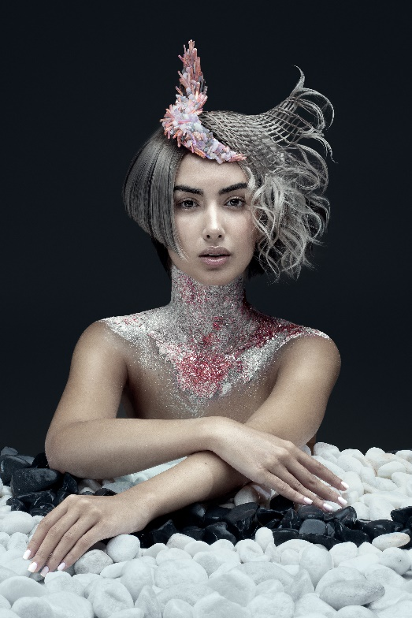
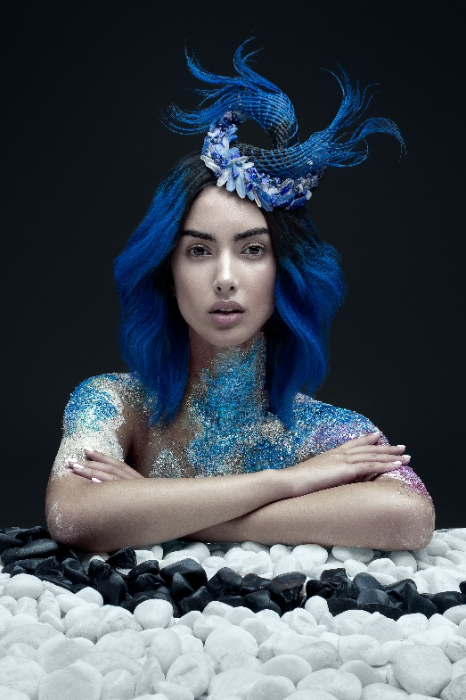
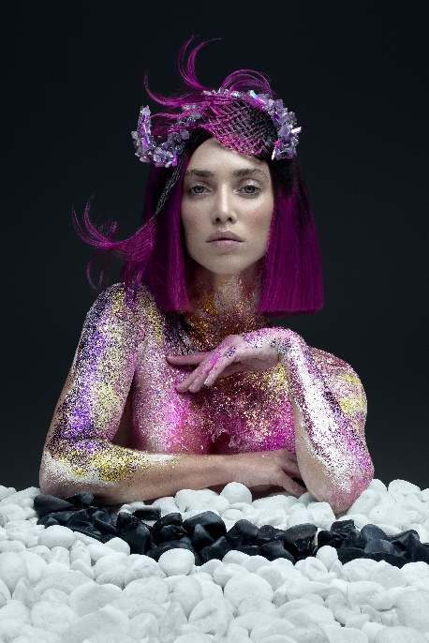

Hair: Ziortza Zarauza @Centro Beta
Hair Instagram @ziortzazarauza
Photography: David Arnal
Photography Instagram @davidarnalteam
MUA: De María
MUA Instagram @de_maria
Retouching: Javier Villalabeitia
Retouching Instagram @javiervillalabeitia
Products: Montibello
Products Instagram @montibello_peluqueria

ZIORTZA ZARAUZA
GEODE Collection

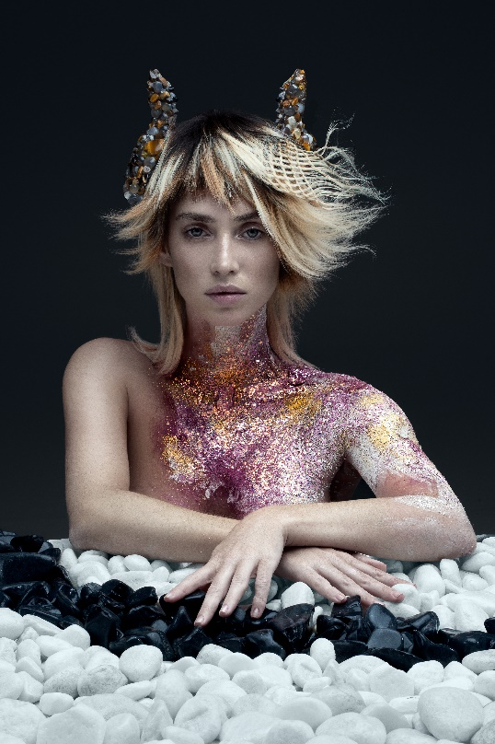

With the appearance of rough rocks, the geodes hide within them precious crystalline formations. They can go unnoticed at first glance and to find their true beauty you have to discover their interior. For this reason, these images reflect the surprising combination of the evolution from stone to gemstone, with details that make hair a luxurious, extraordinary object, which emerges before our eyes to marvel us with its vivid tones and its capricious forms as in nature.

