Sennheiser Evolution Wireless Digital recognized for outstanding technical achievement at 37th annual TEC awards; Neumann M 50 inducted into TEC Hall of Fame

Anaheim, June, 2022 – Audio specialist Sennheiser was recognized by the NAMM Foundation with an Outstanding Technical Achievement award in the category of ‘Wireless Technology’ for its Evolution Wireless Digital (EW-D) system at the 37th Annual TEC Awards. Also, the legendary Neumann M 50 condenser microphone was inducted into the TEC Hall of Fame. Thom Salisbury, Business Development Manager, accepted both honours on behalf of the group.

“We are grateful to the NAMM Foundation and our customers around the world for recognizing Evolution Wireless Digital," commented Oliver Schmitz, Manager, Music Industry Portfolio at Sennheiser. “Evolution Wireless Digital is able to deliver impressive versatility and app-based ease of use at a very attractive price point – this is appealing to a number of audio applications in the pro audio and system integration markets.”

Thom Salisbury, Business Development Manager, accepted both honours on behalf of the Sennheiser Group

Thom Salisbury also accepted a TEC Hall of Fame Award on behalf of Neumann.Berlin for its legendary M 50 tube microphone, which was presented on behalf of the NAMM organization by industry media veteran George Petersen. “Neumann is pleased to once again be included in the TEC Hall of Fame,” commented Neumann CEO Ralf Oehl. “Since its introduction in 1950, the M 50 has played a pivotal role in capturing orchestras around the world with sonic integrity and unsurpassed musical character.”

Raising the ceiling on wireless value for performance
Sennheiser's Evolution Wireless Digital microphone systems work on UHF frequencies, featuring the company's latest technology in digital wireless transmission along with the ability to set up multiple wireless channels within a snap. Users can enable automatic frequency setup via the Smart Assist App for even greater accessibility and convenience. As intermodulation is negligible, the system is able to simply stack frequencies in an equidistant grid – making EW-D an efficient wireless tool in today’s busy spectrum.

Evolution Wireless Digital offers unprecedented ease of use through its innovative Smart Assist App  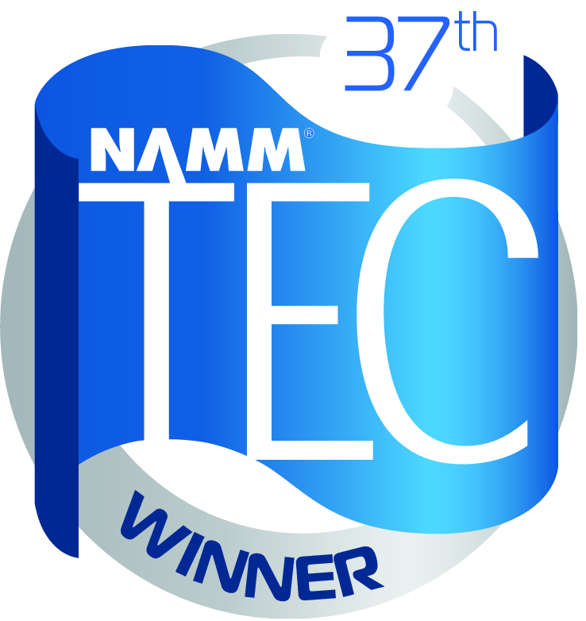 | 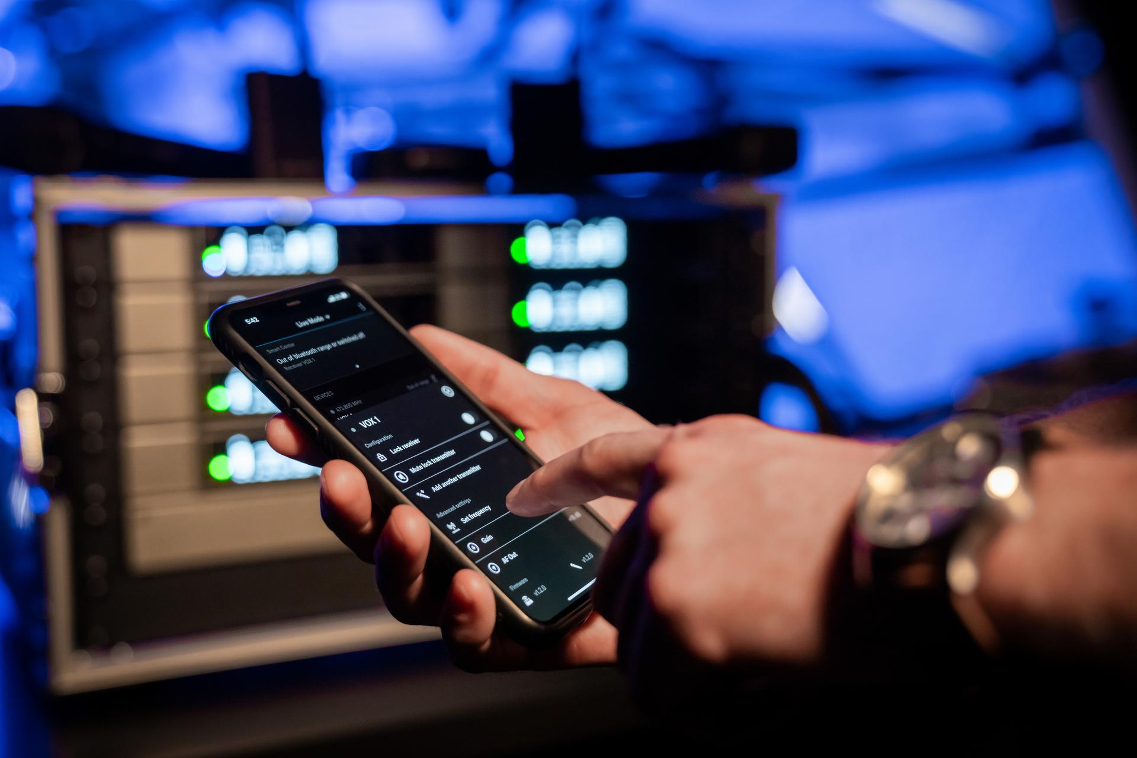

Neumann M 50: Recording the classics
The Neumann M 50, which was introduced in 1950, was instrumental in the development of the Decca tree recording technique. Its open-mesh head basket houses a small-diaphragm capsule flush-mounted in a small sphere, and its unique acoustic properties are ideally suited to orchestral recordings.

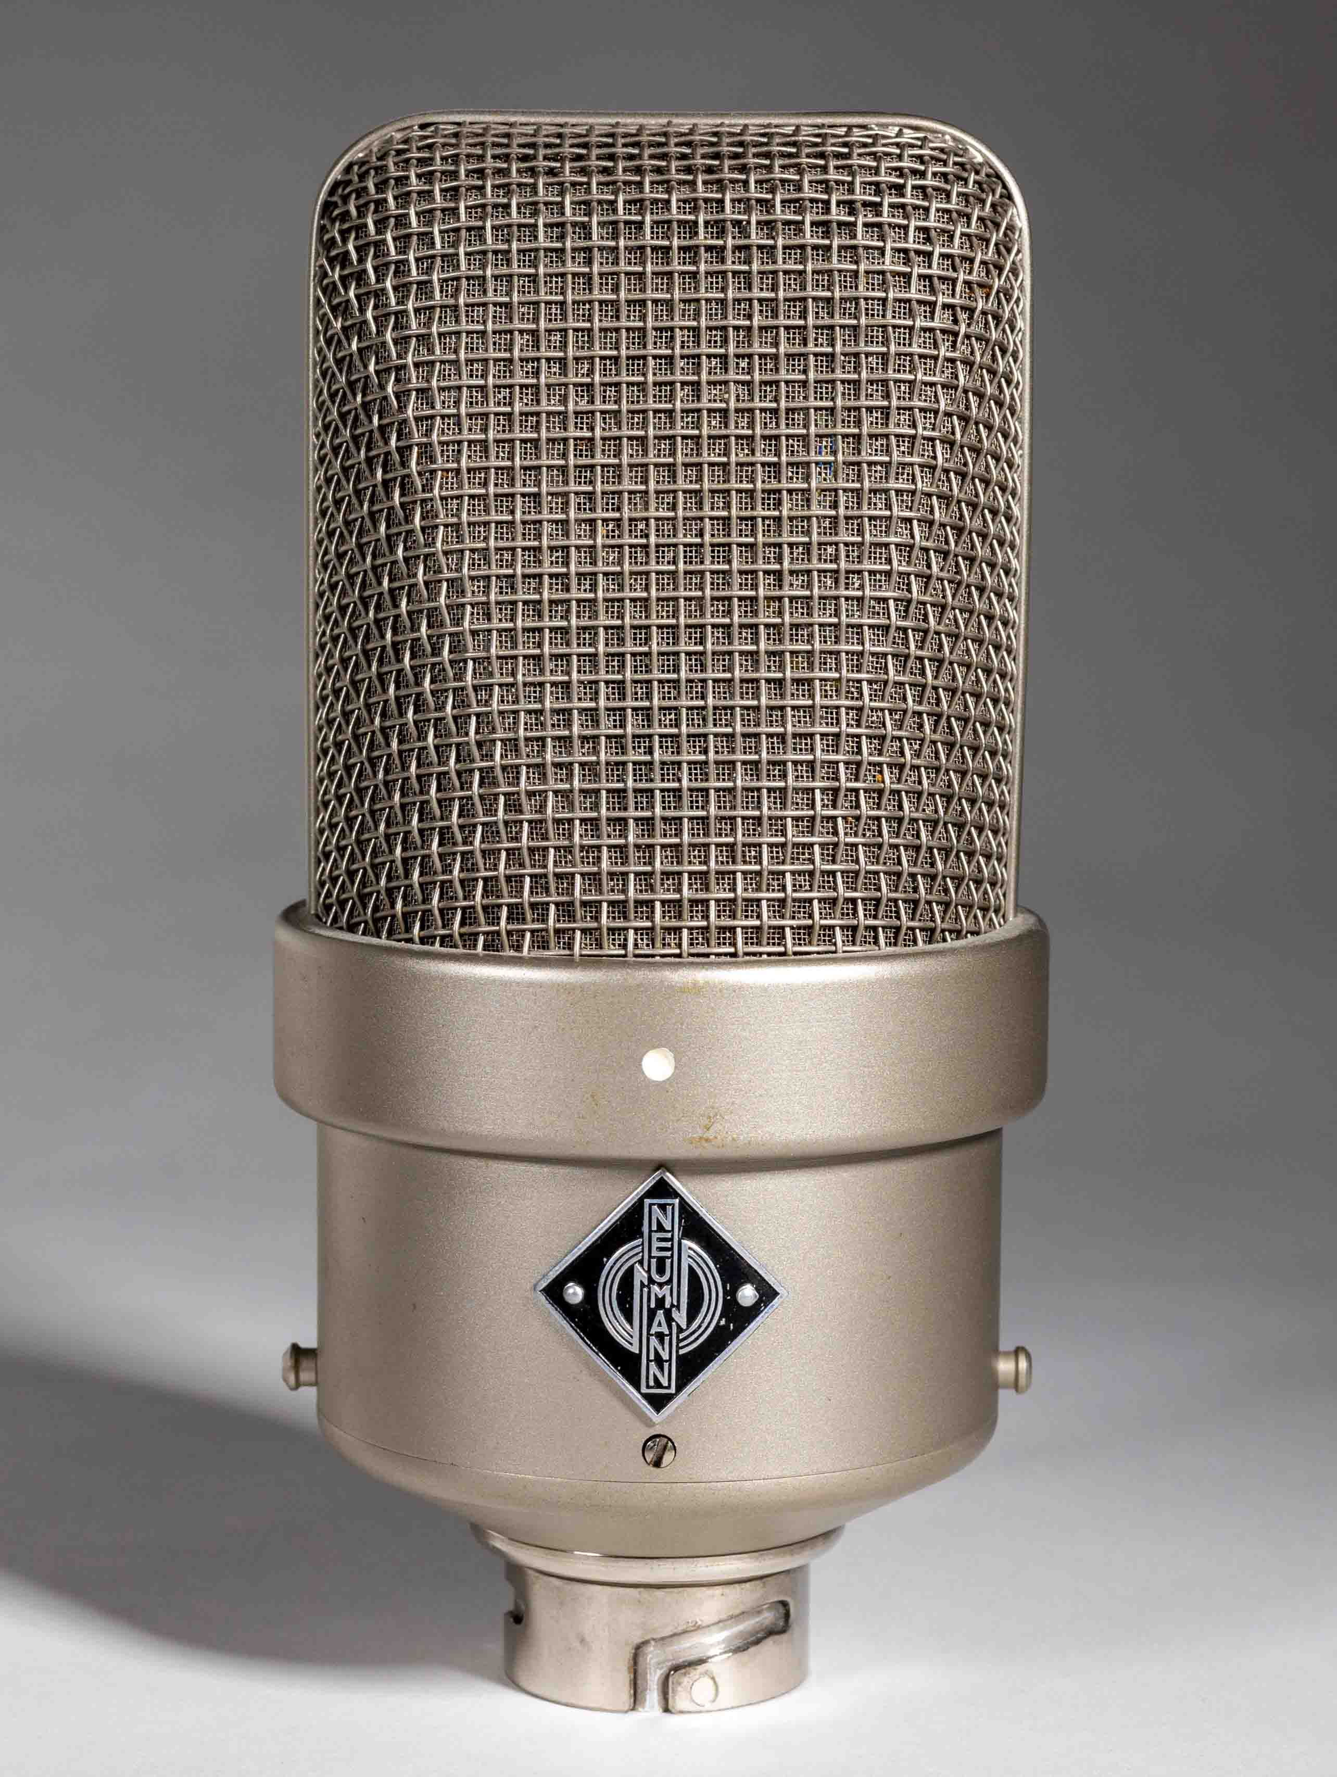 | The Neumann M 50 was instrumental in the development of the Decca tree and has played a pivotal role in capturing orchestras with sonic integrity and unsurpassed musical character

(Ends)

The high-resolution images accompanying this media release can be downloaded here.

About the Sennheiser brand
We live and breathe audio. We are driven by the passion to create audio solutions that make a difference. Building the future of audio and bringing remarkable sound experiences to our customers – this is what the Sennheiser brand has represented for more than 75 years. While professional audio solutions such as microphones, meeting solutions, streaming technologies and monitoring systems are part of the business of Sennheiser electronic GmbH & Co. KG, the business with consumer devices such as headphones, soundbars and speech-enhanced hearables is operated by Sonova Holding AG under the license of Sennheiser.

www.sennheiser.com
www.sennheiser-hearing.com

About Neumann
Georg Neumann GmbH, known as “Neumann.Berlin”, is one of the world’s leading manufacturers of studio-grade audio equipment and the creator of recording microphone legends such as the U 47, M 49, U 67 and U 87. Founded in 1928, the company has been recognized with numerous international awards for its technological innovations. Since 2010, Neumann.Berlin has expanded its expertise in electro-acoustic transducer design to also include the studio monitor market, mainly targeting TV and radio broadcasting, recording, and audio production. The first Neumann studio headphones were introduced in 2019, and since 2022, the company has put an increased focus on reference solutions for live audio. Georg Neumann GmbH has been part of the Sennheiser Group since 1991, and is represented worldwide by the Sennheiser network of subsidiaries and long-standing trading partners.

www.neumann.com

Global Press Contacts
Andreas Sablotny Stephanie Schmidt
andreas.sablotny@neumann.com stephanie.schmidt@sennheiser.com
+49 (30) 4177 2419 +49 (5130) 600 1275

