Powersoft releases comprehensive training video series for armoníaplus

youtube channel includes detailed overviews of all new features, updates

Florence, Italy
7 May 2019
Powersoft, the Italian manufacturer of professional power amplifiers, has just released a series of training videos on Youtube for their best-in-class audio design environment software ArmoníaPlus. The hour-long set of tutorials comprehensively covers the new features that Powersoft introduced with ArmoníaPlus when it was released last October. Aside from educating new users on the software, the goal of these tutorials is also to bring existing users who were familiar with its previous iteration, Armonía, up to speed.

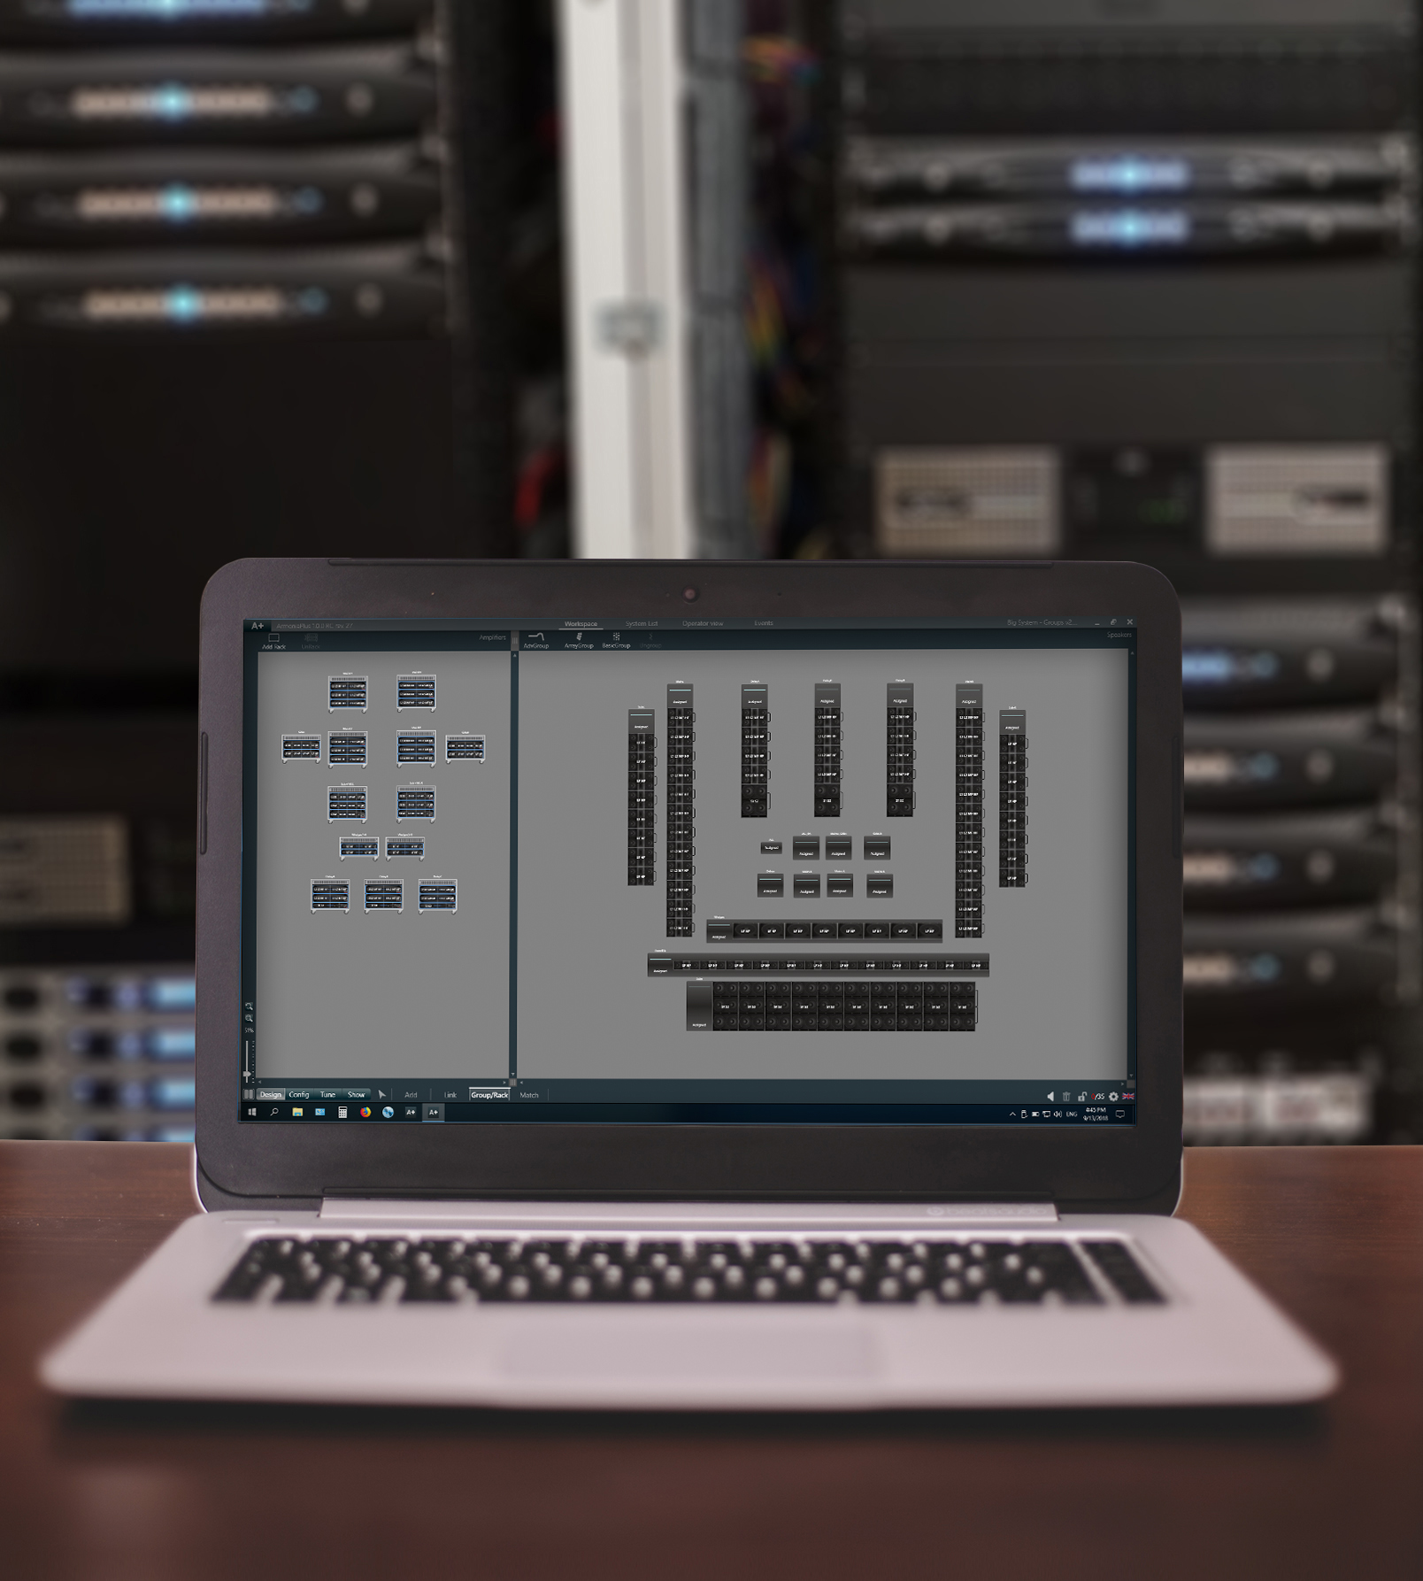
ArmoníaPlus’s redesign includes a single window interface with four main views and takes further advantage of intuitive hotkeys and simplistic icons to allow users to move between functions efficiently. Users can move through four main steps: Design, Config, Tune, and Show, each offering a variety of functions and flexibility for different scenarios, as well as allowing users to audition different speaker presets easily. The Youtube tutorials cover all of these functions, as well as new features such as Shading, which allows the interface to reduce the gain of loudspeaker limiter thresholds coherently, keeping the balance between elements even if the system is limiting.

“When we were designing ArmoníaPlus, we wanted to make the system easier to use and employ,” said Powersoft U.S. Application Engineer Rick Woida. “We also wanted to make certain that we were still supporting our users who work with Armonía and allowing them to learn the new features over time.”

For more information on ArmoníaPlus, please visit: https://armonia.powersoft.it/

To access the ArmoníaPlus video tutorials, please visit: https://www.youtube.com/watch?v=44_Co8DwN7w&list=PLknHTxg4-tXlCqoCtkyAtwVTPqv6zGiSG

For further information

Francesco Fanicchi  POWERSOFT FIRENZE  francesco.fanicchi@powersoft.com  +39 346 9719798 | Jeff Touzeau  Hummingbird Media  jeff@hummingbirdmedia.com  +1 (914) 602-2913

ABOUT POWERSOFT:
Powersoft is the world leader in lightweight, high power, single rack space, energy efficient amplifiers for the professional audio market. Founded in Italy in 1995, headquartered in Florence, Italy, with offices in Camarillo, CA, Powersoft couples the experience and precision of its production department with exceptional components to deliver products with perfect audio response and high-performance reliability. Its state-of-the-art amplifiers can be found in an array of markets, ranging from stadiums, sporting arenas, theme parks, performance venues and airports to convention centers, churches, and clubs, and are used by the world's leading tour sound companies. For more information, visit the Powersoft website: www.powersoft.com

