For immediate distribution

BAE Audio PDIS Direct Injection Stereo Box is Now Available Through Select Dealers

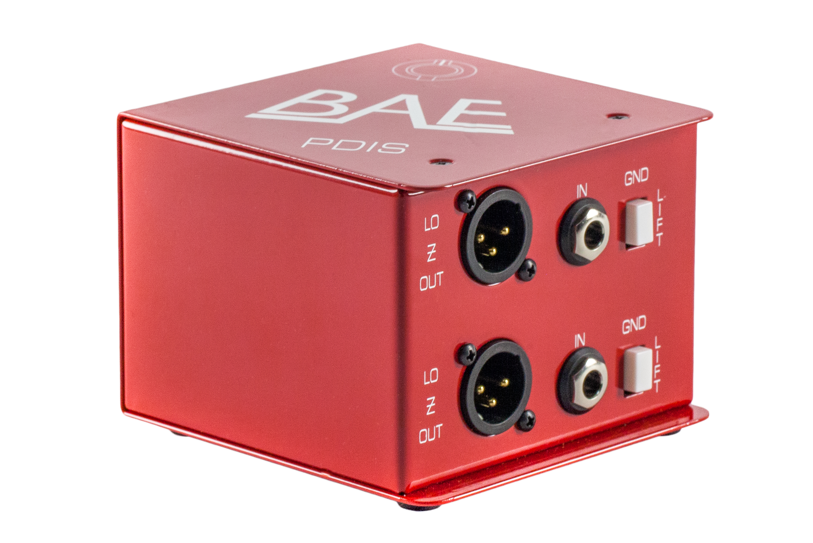
North Hollywood, CA – December 19, 2018 – BAE Audio, a manufacturer of premium analogue gear, has announced that its new passive direct injection stereo box (PDIS) is now available. The PDIS is based upon the single channel PDI. Like the mono PDI, the PDIS uses an OEP/Carnhill transformer to imbue any signal passed through it with a satisfying warmth and analog richness.
“The PDI has been a huge success for us, bringing the magic of a high-quality transformer to direct signals both in the studio or on stage," says BAE Audio President Mark Loughman. "Now, the PDIS meets the needs of users who require two channels of smooth direct analog injection in a single box. It's an ideal solution for direct recording of stereo sources.”
Sturdy enclosure, stellar sound
The PDIS features Neutrik connectors, including quarter-inch inputs and low-impedance XLR outputs for each channel on one side. It also includes a pair of through outputs for each channel on the reverse side. This feature allows for unique routing configurations, such as sending a keyboard signal both via the Lo-Z outputs to your console as well as via the quad Hi-Z through outputs to two separate amplifiers or effects chains. Dual ground lift switches help navigate any noise issues caused by grounding.
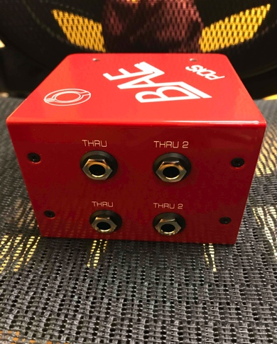
The PDIS features OEP/Carnhill transformers — a main ingredient for its overall muscality. Known for their warmth and clarity in the high end and natural-sounding harmonics in the low end, OEP/Carnhill transformers are a key sonic element of BAE Audio’s hardwire devices. The instantly recognizable analog character of the PDIS separates it from other competing direct injection boxes on the market.
The PDIS is an ideal DI solution for keyboards, stereo guitar rigs, drum machines and just about any other conceivable stereo application. Additionally, the unit can function as two independent separate instrument DI channels and handle two mono instruments if needed, such as a guitar and a bass, simultaneously. Tracks recorded with the PDIS easily integrate with mic’d sound sources in the mix as is, or are well prepared for reamping if desired.
Like all BAE Audio products, the PDIS is hand-wired in California. It features 100% through-hole components for maximum signal integrity, and recessed switches and connectors combine with a rugged steel chassis help it stand up against the wear and tear of daily studio or stage use. For even further assurance, BAE Audio backs the PDIS with a 5-year warranty and its industry-wide reputation for excellence.
The PDIS is now shipping soon and retails for $200. For more information, please visit baeaudio.com
About BAE Audio
BAE Audio is a U.S.-based manufacturer of high-end microphone preamp and equalizers, all of which are faithful to vintage designs of the seventies and before. The company is committed to the vintage philosophy of hand wiring and hand soldering all of its components to achieve a high quality and authentically vintage sound. For more information on BAE Audio, please visit our website at www.baeaudio.com.

Media contact
Jeff Touzeau
Public Relations
Hummingbird Media
+1 (914) 602 2913
jeff@hummingbirdmedia.com

