Duplitech Turns to Xytech’s MediaPulse to Streamline Asset Management as Film Restoration Business Grows

The company selected the facilities management software for its robust enterprise-level feature set for remastering classic films

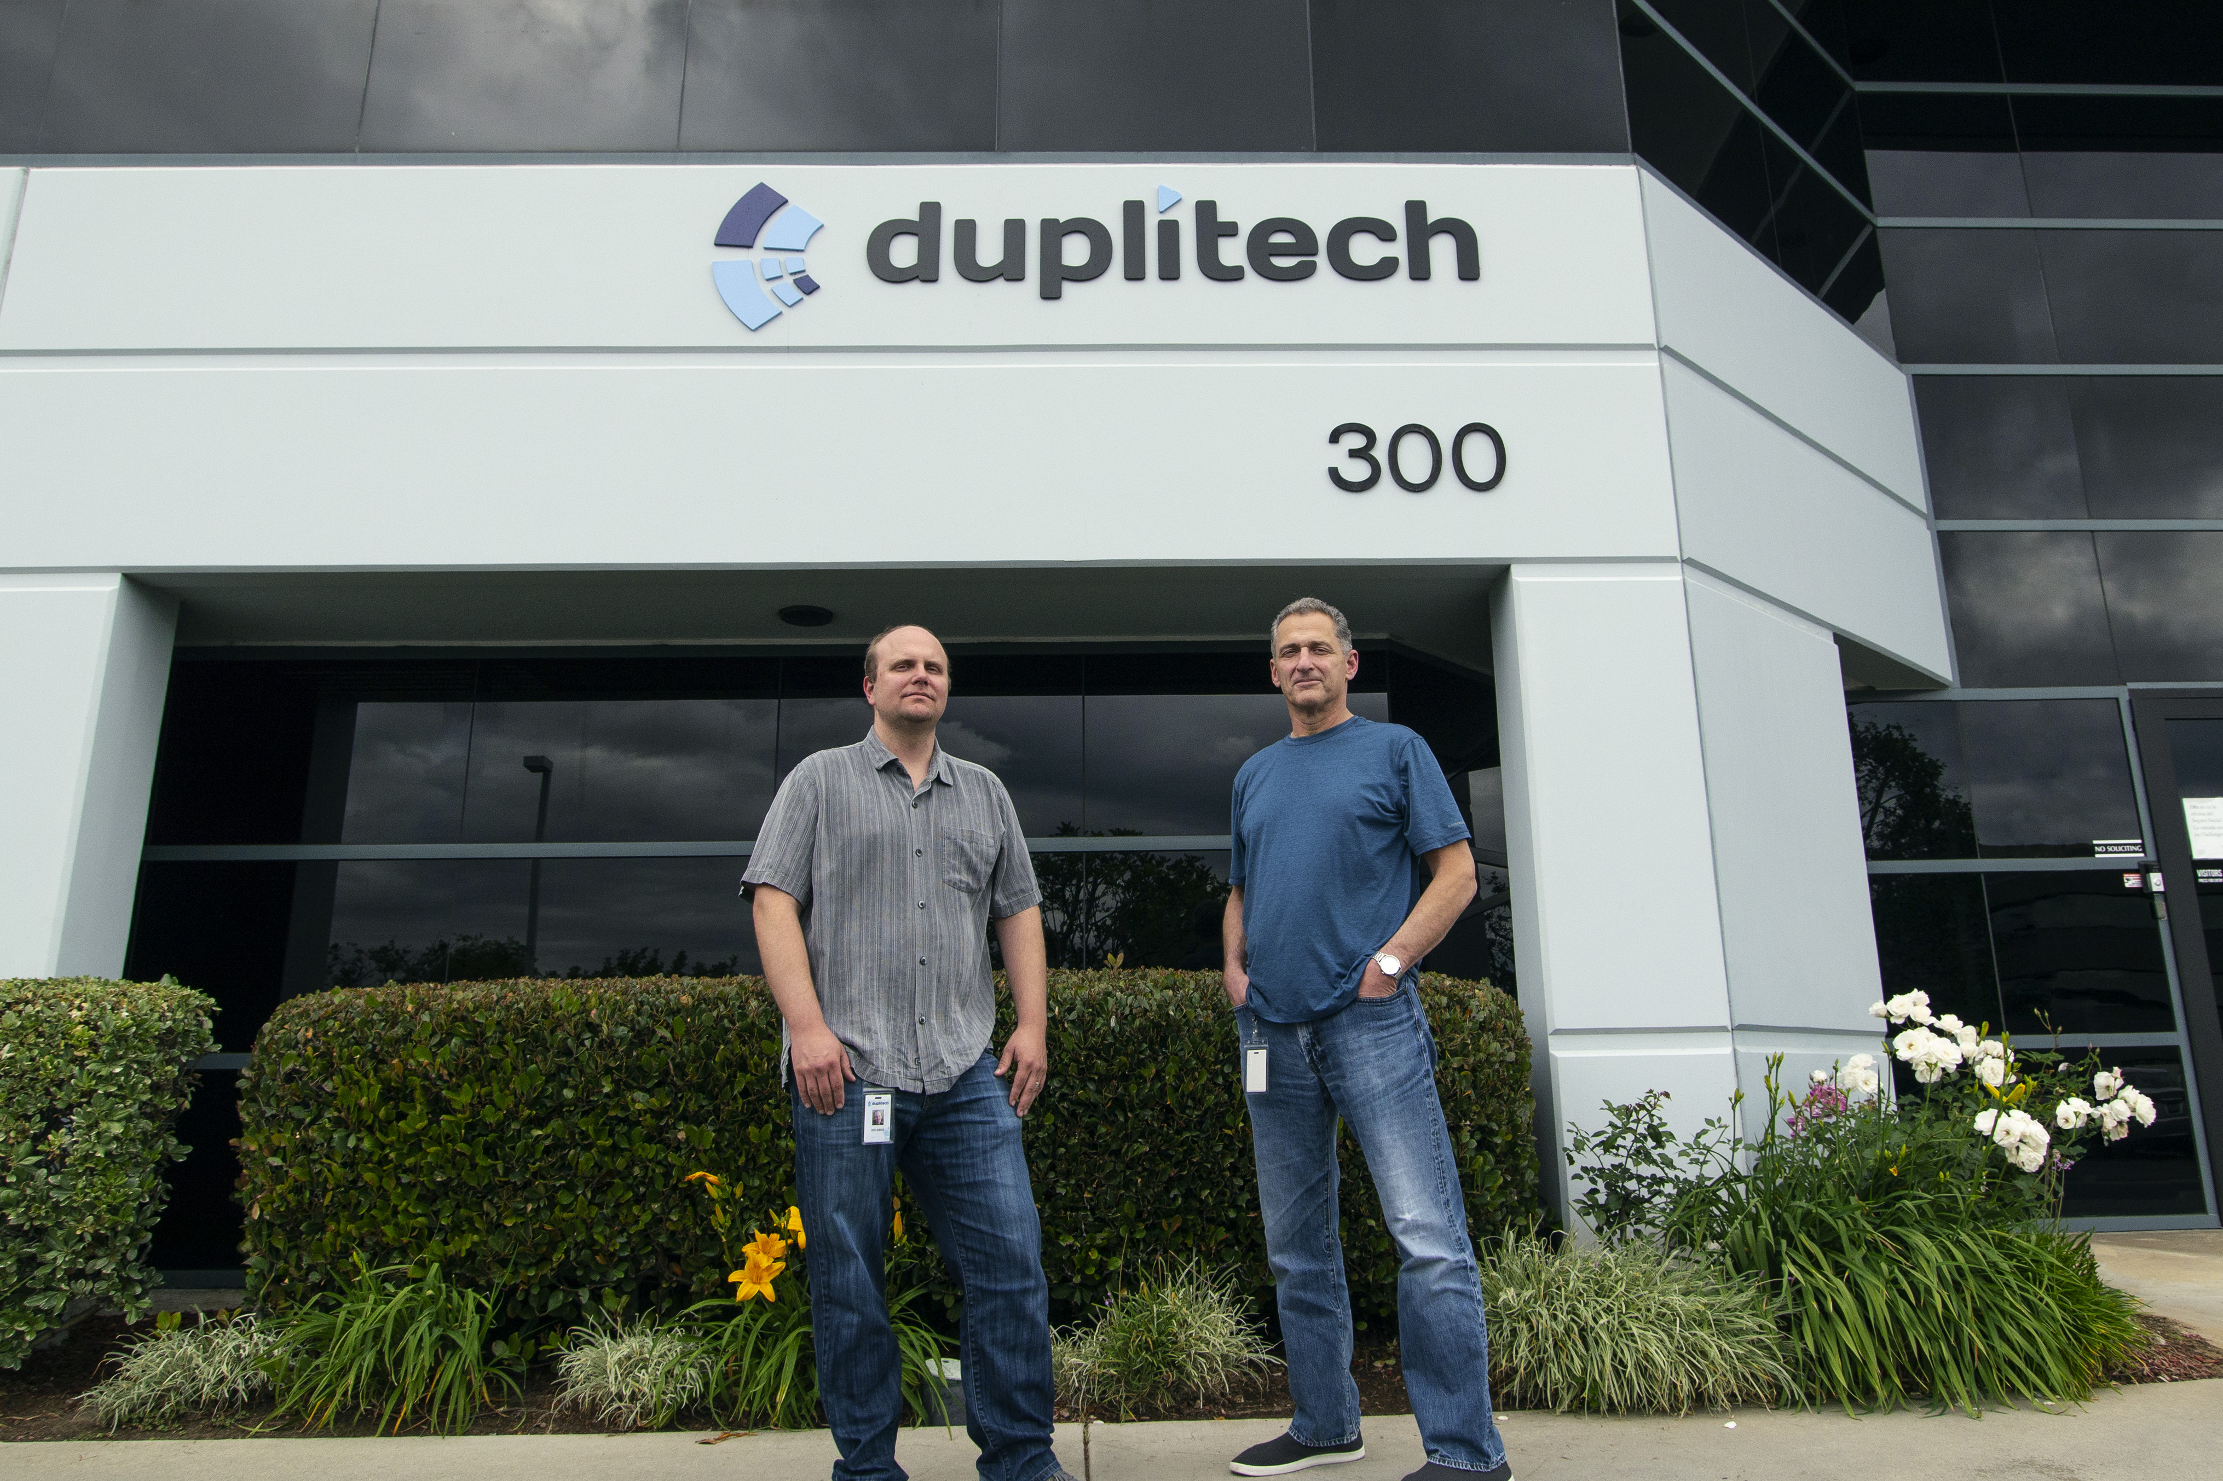
Torrance, California, May 21, 2019 — Three years ago, media service company Duplitech launched its 4K Film Services Department. The new department’s focus centers primarily on remastering classic movies recorded on film from the 1940s to the 2000s for home entertainment. Today, film restoration is the fasting growing segment of Duplitech’s business. Because the remastering requires the handling of delicate original negatives and other irreplaceable elements, Duplitech needed to expertly manage these sensitive assets and turned to Xytech's MediaPulse, the leading resource, work order and asset management software solution engineered for modern media organizations.

"We deal with some very sensitive and often one-of-a-kind assets, so our chain of custody process has to be on top of everything, and location management is critical,” said Steven Johnson, COO of Duplitech. “We needed a robust software solution boasting enterprise-level features for asset management, so we chose Xytech’s MediaPulse.”

A Robust Feature Set
While Duplitech’s core business focuses on preparing catalogue titles for release in the home entertainment market, its film restoration arm has continued to grow with the company restoring such classics as Teen Wolf, The Thing and Return of the Pink Panther. As a result, a robust feature set was an important requirement when selecting to work with MediaPulse.

“We might receive a film from as far back as the 1940s and part of our process is to get every single asset from this film. These film deliveries are sometimes delivered on as many as three pallets and must be managed in a database,” Johnson explained. “Someone has to be able to quickly look at the data and say, ‘OK these are the assets we want to use, these assets can be destroyed, and these assets might need some additional preservation.’ MediaPulse allows us to easily track what is going on with each of these assets and categorize them as usable or non-usable. It’s important for us to be able to retain a standardized set of metadata for each type of asset. The MetaVault library software of MediaPulse ensures our data is consistent.”

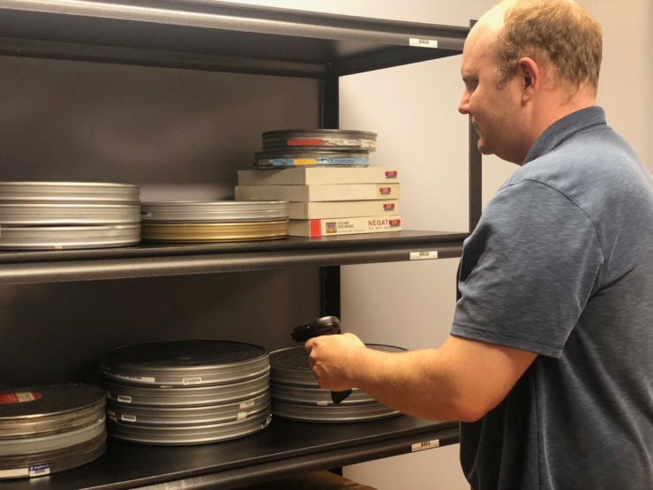
Check Disk Management
Another important function MediaPulse serves is check disk management, ensuring there is no content leakage. Duplitech prints a barcode on each check disk every time one is generated. The barcode is recorded into MediaPulse and then is assigned to an employee physically looking at the disk.

“Each employee has to check each disk back into the system when they are finished with it,” Johnson said. “It keeps track of where the asset is at any time.”

MediaPulse also streamlines Duplitech’s auditing process while performing media asset inventories each month.

“We are able to conduct audits where we scan every asset and MediaPulse then informs us of any discrepancies,” Johnson explained. “It’s a critical feature for us.”

About Xytech
For more than 30 years, the world’s premiere media companies have depended on Xytech to run their businesses. MediaPulse is the only end-to-end solution for the complete content lifecycle. MediaPulse provides scheduling, automation, asset management, billing and cost recovery for broadcasters, media services companies and transmission facilities in a scalable platform-independent solution. For more information, visit xytechsystems.com.

About Duplitech
Founded in 1996, Duplitech is an independent media services company located in the greater Los Angeles area. We provide the industry's most cost-effective solutions to preparing catalogue titles for release in the home entertainment market. Our services include 2K/4K Motion Picture Film Scanning, HDR-10+/Dolby Vision Color Grading and Restoration, UHD Blu-ray, Blu-ray and DVD Authoring, Digital Cinema Package (DCP) creation, Subtitling/Captioning and VOD Mezzanine Package creation/QC.

Media Contacts:

Katie Kailus
Public Relations
Hummingbird Media
+1 (630) 319-5226
katie@hummingbirdmedia.com

Jeff Touzeau
Public Relations
Hummingbird Media
+1 (914) 602 2913
jeff@hummingbirdmedia.com

