For immediate distribution

Powersoft Launches Snapshot Selector App for Mobile Devices, Making it Easy to Recall Settings on its X Series Amplifier Platoform without a Computer

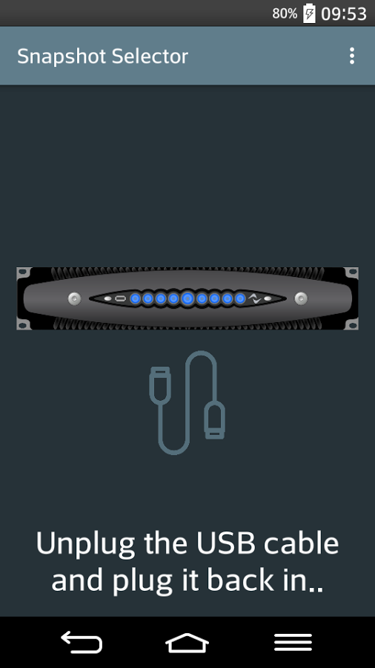
Florence, Italy – December 11, 2017 – Powersoft has announced a brand new app for mobile devices, called Snapshot Selector. The free and easy-to-use app, now compatible with Android devices, allows users of Powersoft’s X Series amplifier platforms to instantaneously recall a full slate of saved settings by simply connecting their phone to their amplifier with a USB cable. The app makes the X Series amplifier platforms an even more appealing solution for audio professionals, including in rental environments.

“We are always looking for ways to expand the functionality of our products to better meet the needs of our users,” says Francesco Fanicchi, Head of Brand and Communications of Powersoft. “The X Series amplifier platforms are already among the most powerful and versatile amplification solutions on the market, and the Snapshot Selector app provides our users with yet another impactful tool that makes setup of Powersoft-driven sound systems easier and faster than ever before.”

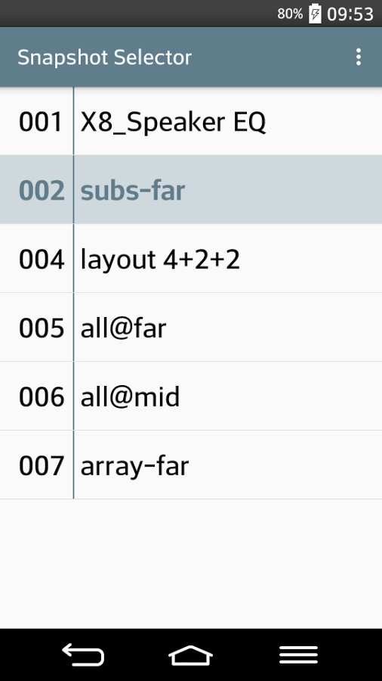
Settings in a Snap
When users connect a mobile device to their X Series amplifier platform via USB, a link to Snapshot Selector in the Google Play Store will automatically pop up. There, users may download the app for free. Henceforth, upon connecting a phone to the amplifier, the app will launch automatically. A simple user interface allows the user to save and recall an exact snapshot of all settings on the amplifier, including routing, equalization, and limiting, at any time. The app also allows the users to select the source priority that will be applied after the snapshot has been recalled.

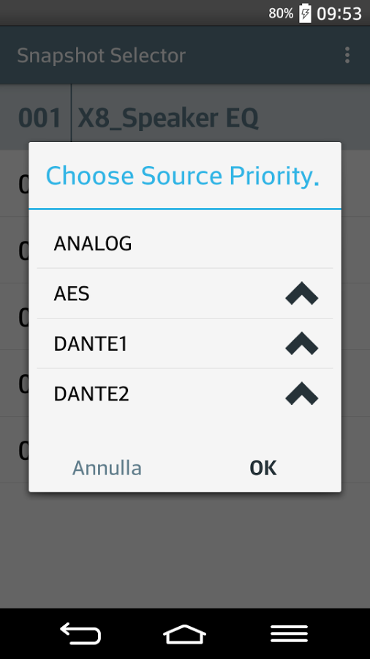
Snapshot Selector allows configuration of complete racks and system without connecting a computer, as long as the snapshots for the loudspeakers are already stored in the amplifiers. This provides valuable functionality for rental amplifier providers or users, enabling rental providers to apply application-relevant settings quickly to an amp before it leaves the warehouse.

###

For further information, contact:

Jeff Touzeau (media contact)  Hummingbird Media  Tel : +1 (914) 602 2913  Email: jeff@hummingbirdmedia.com | Francesco Fanicchi  Powersoft (Florence, Italy)  Tel: +39 346 9719798  Email: francesco.fanicchi@powersoft.it

Or visit www.powersoft-audio.com
About Powersoft:
Powersoft is the world leader in lightweight, high power, single rack space, energy efficient amplifiers for the professional audio market. Founded in Italy in 1995, headquartered in Florence, Italy, with offices in Camarillo, CA, Powersoft couples the experience and precision of its production department with exceptional components to deliver products with perfect audio response and high-performance reliability. Its state-of-the-art amplifiers can be found in an array of markets, ranging from stadiums, sporting arenas, theme parks, performance venues and airports to convention centers, churches, and clubs, and are used by the world's leading tour sound companies. For more information, visit the Powersoft website @ www.powersoft-audio.com

