Earbuds that put sound first
Sennheiser introduces MOMENTUM True Wireless 2

London, March 13, 2020 – There’s listening to true wireless headphones, and then there’s experiencing the exceptional sound of MOMENTUM True Wireless 2 from Sennheiser. Finely crafted for discerning audio lovers, Sennheiser has announced the second generation of its acclaimed MOMENTUM True Wireless. The audio specialist has taken its premium true wireless earphones to even greater heights: the earbuds ensure the best possible listening experience at any time with enhancements such as Active Noise Cancellation, refined ergonomics and an outstanding 7-hour battery life that can be extended to up to 28 hours by charging on the go using the supplied case.

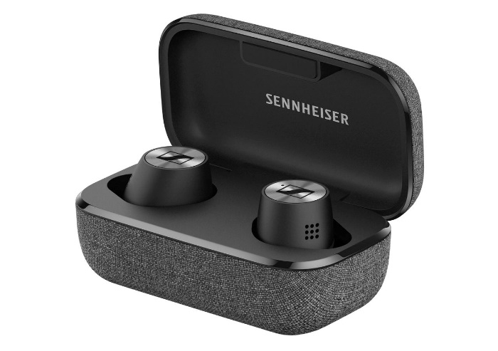
“For 75 years, we at Sennheiser have been obsessed with shaping the future of audio and creating unique sound experiences for our customers. With the MOMENTUM True Wireless 2, we now set out to redefine the standard for true wireless listening,” said Stephane Hareau, Global Head of Products Consumer at Sennheiser. “The new generation builds on its popular predecessor and delivers exceptional Sennheiser sound, while taking the MOMENTUM True Wireless experience to the next level with the addition of Active Noise Cancellation, optimised ergonomics and an outstanding battery life,” added Frank Foppe, Product Manager at Sennheiser.

MOMENTUM True Wireless 2 has been designed to provide the best possible listening experience at any time.

The best possible listening experience – anytime, anywhere
The ideal choice for the discerning listener, the new MOMENTUM True Wireless 2 delivers exceptional sound quality that can be enjoyed in any situation. The difference is their superior audio technology: Sennheiser’s 7mm dynamic drivers, designed and manufactured at the company’s headquarters in Germany, create outstanding stereo sound with deep bass, natural mids and clear, detailed treble. This audio experience can be effortlessly tailored to one’s taste via the built-in equaliser and Sennheiser’s Smart Control App.

It’s now possible to enjoy incredible high-fidelity sound even in noisy environments thanks to the new Active Noise Cancellation feature. This works in tandem with the earbuds’ excellent passive noise isolation to minimise distractions without compromising the quality of sound. When greater situational awareness is needed, the Transparent Hearing feature lets the wearer blend in outside ambient sound at a touch. This also makes it possible to have natural conversations in comfort without even needing to remove the earbuds.

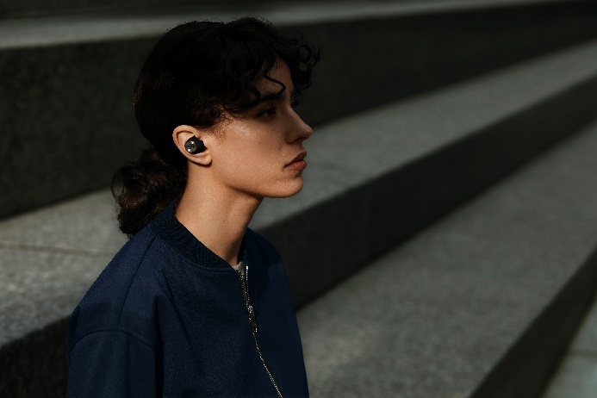

The MOMENTUM True Wireless 2’s ANC works in tandem with their excellent passive noise isolation to minimise distractions without compromising the quality of sound.

It is also incredibly natural to make phone calls and interact with smart devices using voice commands. The earbuds’ advanced beamforming technology employs two microphones to reduce noise and ensure crystal clear voice pick-up.

Flawless wireless transmission is assured by Bluetooth 5.1 and the latest high-quality audio codec support, including AAC and Qualcomm® aptXTM for rock solid connectivity. The MOMENTUM True Wireless 2’s Bluetooth device management makes it easy to manage Bluetooth connections.

A smarter user experience to make life simpler
The MOMENTUM True Wireless 2 has been created to anticipate every need and simplify every interaction: Operation is brilliantly intuitive thanks to effortlessly easy touch controls. These can even be customised to let users define their preferred way of controlling audio, calls or activating voice assistants such as Google Assistant or Apple Siri. Just as intuitive is the convenient Smart Pause feature, which automatically pauses audio playback when the earbuds are removed and seamlessly resumes when they are replaced in the ear.

Ease of use is also enhanced by Sennheiser’s Smart Control App which, as well as enabling EQ adjustments and firmware updates, lets the user customise settings for the touch interface and Transparent Hearing.

Designed for a full day of comfortable listening pleasure
The new MOMENTUM True Wireless 2 has been refined for optimal user convenience and all-day wearing comfort. The exquisitely crafted earbuds are 2mm smaller than the previous model to improve ergonomics for the best possible fit and to minimise fatigue. For all-day listening, they offer nearly twice the battery life of the previous model, with 7 hours of playback time that can be extended to up to 28 hours by charging on the go using the supplied case.

As with every MOMENTUM product from Sennheiser, the second generation of the MOMENTUM True Wireless has an elegantly timeless design. They have been finely crafted from carefully selected premium materials to ensure great looks, durability and IPX4-rated weather resistance. The earbuds reward every glance and touch with premium materials such as the iconic Sennheiser spin design rendered in a high-quality metallic finish and gold-plated charging pins. In addition to the classic black edition, the MOMENTUM True Wireless 2 will be available in a stylish white colour scheme, with coordinating fabric finishes on the slim charging case.

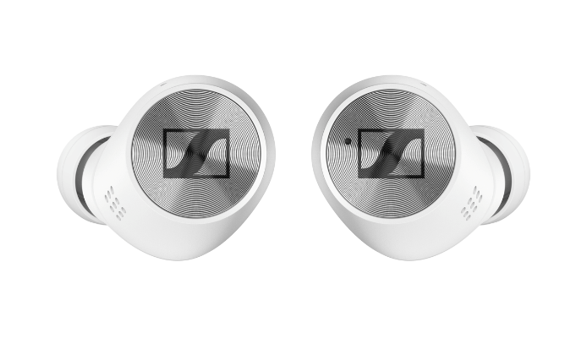

In addition to the classic black edition, the MOMENTUM True Wireless 2 will be available in a white colour scheme.

Priced at 279 GBP (MSRP), MOMENTUM True Wireless 2 will be available in black from April, while the white colour variant will be available at a later point.

About Sennheiser
Founded in 1945, Sennheiser is celebrating its 75th anniversary this year. Shaping the future of audio and creating unique sound experiences for customers – this aim unites Sennheiser employees and partners worldwide. The independent family company, which is managed in the third generation by Dr. Andreas Sennheiser and Daniel Sennheiser, is today one of the world’s leading manufacturers of headphones, loudspeakers, microphones and wireless transmission systems. In 2018, the Sennheiser Group generated turnover totaling €710.7 million. www.sennheiser.com

North and East Europe Press Contact
Sennheiser electronic GmbH & Co. KG
Maik Robbe
Communications Manager UK & Nordics
maik.robbe@sennheiser.com

