Toyota Motor Corporation

Toyota GAZOO Racing Outlines 2016 Motorsports Activities

Toyota City, Japan, February 4, 2016―Toyota GAZOO Racing, the in-house brand responsible for motorsports activities administered by Toyota Motor Corporation, today announced its schedule for 2016.

Motorsports events offer a crucial means of conveying the excitement of driving, and are at the heart of Toyota’s efforts to foster a greater following of car fans and enthusiasts. By conducting these activities under the umbrella of Toyota GAZOO Racing, Toyota can focus on developing its people and improving its products, thereby contributing to the creation of ever-better cars.

In 2017, Toyota will return to the FIA World Rally Championship (WRC). Preparations are ongoing, with a rally vehicle based on the Yaris compact hatchback currently being developed to meet FIA 2017 regulations.

Under the Toyota GAZOO Racing team name, Toyota will also participate in the FIA World Endurance Championship (WEC), the Nürburgring 24 Hours endurance race, and the Japanese Rally Championship. In WEC, 2016 will see the debut of the new Toyota TS050 Hybrid race vehicle, with which the team will aim to recapture the series championship and achieve its first win in the 24 Hours of Le Mans this June. The TS050 Hybrid was developed at Toyota’s Higashi-Fuji Technical Center, and utilizes a new hybrid system. In the 2016 Nürburgring 24 Hours endurance race, Toyota will celebrate its tenth year of participation by entering three cars: the Toyota C-HR Racing, and the Lexus RC F and RC.

In the U.S., Toyota will continue to compete in NASCAR events. In South America, Toyota will support Toyota Auto Body Co., Ltd., who will participate in the Dakar Rally in early 2017.

Meanwhile, in Japan, Toyota will participate in the Super GT and Super Formula series, both of which are in the top tier of motorsports events within Japan, and will also compete in the Super Taikyu series with the 86 coupe.

As part of its initiatives to cultivate young drivers who hope to compete in high-level international racing events, Toyota will continue to run the Toyota GAZOO Racing Rally Challenge Program for rallies, and the Toyota Young Drivers Program (TDP) for races.

Toyota will also actively try to raise awareness of automotive culture, creating a new generation of car enthusiasts in the process. Key to these efforts will be a wide range of participative, informal motorsports events targeting participation by ordinary customers, such as the Toyota GAZOO Racing 86/BRZ Race, Toyota GAZOO Racing Netz Cup Vitz Race, and Toyota GAZOO Racing Rally Challenge. Additionally, Toyota will collaborate with dealers nationwide to hold a variety of interactive events at circuits and similar venues.

Furthermore, by utilizing digital platforms and social networking sites, Toyota will continue to share information about upcoming races, rallies, and events. Additionally, Toyota will share information on its lineups of tuned and performance models, such as the GRMN and G’s series, which have been adapted based on racing and rally experiences.

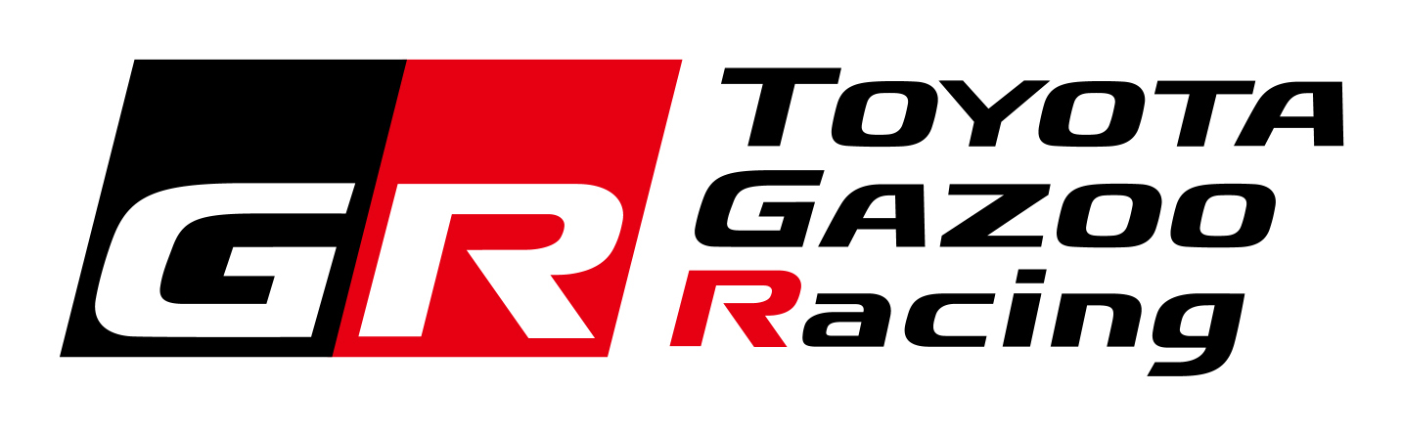
A new logo for Toyota GAZOO Racing activities was also announced today, along with a unified color scheme that will be implemented for all vehicles that race in WRC, WEC, the Nürburgring 24 Hours endurance race, and the Japanese Rally Championship.

Going forward, Toyota will continue to work together with its affiliates to create fun and exhilarating experiences that publicly raise the profile of motorsports.

Outline of Toyota’s 2016 Motorsports Activities

1) FIA World Rally Championship（WRC）
- Early last year, Toyota announced its decision to return to WRC, seeing the series as an important platform to help promote its ever-better-cars initiatives.
- Under the leadership of Team Principal Tommi Mäkinen, Toyota is developing a rally vehicle in Finland for participation from 2017 onwards, with Toyota Motorsport GmbH (TMG) developing the engine.
- The vehicle is based on the Yaris hatchback, and is work is currently underway to ensure compliance with 2017 FIA regulations. Testing of the actual vehicle is scheduled to start in March.

Team name | Toyota GAZOO Racing
Team representative | Akio Toyoda
Team principal | Tommi Mӓkinen (Finland)
Vehicle | Yaris WRC (length: 3,910 mm; width: 1,820 mm)
Engine | Toyota engine (under development at TMG)  1.6-liter direct-injection turbo (in line with global race engine specifications)
Tires | Michelin

2) FIA World Endurance Championship（WEC）
- The FIA World Endurance Championship has taken place every year since 2012. In 2016, Toyota will compete in all nine championship fixtures, including a new race in Mexico.
- This year’s highlights will include the championship’s third and seventh races: the 24 Hours of Le Mans (June 18–19), and the 6 Hours of Fuji (October 16).
- TMG and Toyota GAZOO Racing have applied to enter two of the newly-developed TS050 Hybrid vehicles into all nine races.
- The THS-R powertrain, developed at Toyota's Higashi-Fuji Technical Center in Japan, features not only a new engine, but also front and rear motors/generators with increased capacity to better power all wheels. Toyota plans to utilize these advanced hybrid technologies in its mass-production hybrid vehicles.
- All vehicles will be equipped with Michelin tires.
- Anthony Davidson, Sébastien Buemi, Kazuki Nakajima, Stéphane Sarrazin, and Mike Conway will be joined by newcomer Kamui Kobayashi.

Team | Vehicle | Car no. | Driver
Toyota GAZOO Racing | TS050 Hybrid | TBD | Anthony Davidson (U.K.)
Toyota GAZOO Racing | TS050 Hybrid | TBD | Sébastien Buemi (Switzerland)
Toyota GAZOO Racing | TS050 Hybrid | TBD | Kazuki Nakajima (Japan)
Toyota GAZOO Racing | TS050 Hybrid | TBD | Stéphane Sarrazin (France)
Toyota GAZOO Racing | TS050 Hybrid | TBD | Mike Conway (U.K.)
Toyota GAZOO Racing | TS050 Hybrid | TBD | Kamui Kobayashi (Japan)

3) Nürburgring 24 Hours endurance race
- Toyota GAZOO Racing will enter three vehicles―a Toyota C-HR Racing, a Lexus RC, and a Lexus RC F―into the 44th 24 Hours of Nürburgring endurance race. The event will be held in Germany from May 26 to 29. This year, Toyota will be celebrating its tenth year of participation in the race under the GAZOO name.
- The tough driving conditions faced by the drivers and crews will further enhance Toyota’s abilities to train personnel who can develop ever-better cars.
- The C-HR Racing model is the result of efforts to apply new production methods to the creation of a crossover vehicle.
- The RC incorporates improvements made to reliability and quality, as well as features based on new technologies.
- Having participated in the development of the RC F, Tom’s will also supervise the race, further contributing to Toyota’s efforts to train employees and develop ever-better cars.
- All vehicles will be equipped with Bridgestone tires.

Team | Vehicle | Car no. | Driver
Toyota GAZOO Racing | Toyota C-HR Racing | TBD | Masahiko Kageyama (Japan)
Toyota GAZOO Racing | Toyota C-HR Racing | TBD | Kumi Sato (Japan)
Toyota GAZOO Racing | Toyota C-HR Racing | TBD | Hiroki Yoshida (Japan)
Toyota GAZOO Racing | Lexus RC | TBD | Takayuki Kinoshita (Japan)
Toyota GAZOO Racing | Lexus RC | TBD | Takamitsu Matsui (Japan)
Toyota GAZOO Racing | Lexus RC | TBD | Naoya Gamo (Japan)
Toyota GAZOO Racing  with Tom’s | Lexus RC F | TBD | Takeshi Tsuchiya (Japan)
Toyota GAZOO Racing  with Tom’s | Lexus RC F | TBD | Tatsuya Kataoka (Japan)
Toyota GAZOO Racing  with Tom’s | Lexus RC F | TBD | Kazuya Oshima (Japan)
Toyota GAZOO Racing  with Tom’s | Lexus RC F | TBD | Takuto Iguchi (Japan)

4) NASCAR
- Toyota will once again compete in the NASCAR series through Toyota Motor Sales, U.S.A., Inc. and Toyota Racing Development, U.S.A.
- Toyota will compete in both the Sprint Cup Series and the Xfinity Series with the Toyota Camry. The Toyota Tundra will compete in the Camping World Truck Series.
- All vehicles will be fitted with Goodyear tires.

NASCAR Sprint Cup Series Racing Teams
Team | No. | Driver (all from U.S.)
Joe Gibbs Racing | 11 | Denny Hamlin
Joe Gibbs Racing | 18 | Kyle Busch
Joe Gibbs Racing | 19 | Carl Edwards
Joe Gibbs Racing | 20 | Matt Kenseth
Furniture Row Racing | 78 | Martin Truex Jr.

5) Dakar Rally
- Toyota regularly supports Team Land Cruiser Toyota Auto Body, which competes in the Dakar Rally with Toyota Land Cruiser 200 vehicles.
- At the 2016 Dakar Rally held in January this year, one of the team’s vehicles finished in first place in the Cross-Country Series Production Vehicles class for the third consecutive year, while the other finished the race in fifth place in the same class.

Vehicle | Driver/Navigator |  | Position in Cross-Country Series Production Vehicles class¹ | Position in Diesel Cross-Country Series Production Vehicles class | Overall position
#343  (Land Cruiser 200) | Driver | Nicolas Gibon (France) | 1 | 1 | 32
#343  (Land Cruiser 200) | Co-driver | Jean Pierre Garcin (France) | 1 | 1 | 32
#342  (Land Cruiser 200) | Driver | Akira Miura² (Japan) | 5 | 5 | 48
#342  (Land Cruiser 200) | Co-driver | Laurent Lichtleuchter (France) | 5 | 5 | 48
^{*1} Includes gasoline and diesel classes
^{*2} Toyota Auto Body employee

6) Super GT

(1) GT500 Class
The Lexus RC F will be competing in this top-tier Japanese race series. All vehicles are equipped with two-liter, four-cylinder, RI4AG direct-injection gasoline turbo engines. Lexus GAZOO Racing will be supporting the following teams with involvement from Toyota Racing Development.

Class | Team | Vehicle | No. | Driver | Tires
GT500 | Lexus Team LeMans Wako's | Wako's 4CR RC F | 6 | Kazuya Oshima (Japan) | BS
 |  |  |  | Andrea Caldarelli (Italy) | BS
GT500 | Lexus Team  WedsSport Bandoh | WedsSport ADVAN  RC F | 19 | Yuhi Sekiguchi (Japan) | YH
 |  |  |  | Yuji Kunimoto (Japan) | YH
GT500 | Lexus Team Tom's | TBD | 36 | Daisuke Ito (Japan) | BS
 |  |  |  | Nick Cassidy (New Zealand) | BS
GT500 | Lexus Team Tom's | KeePer Tom's RC F | 37 | James Rossiter (UK) | BS
 |  |  |  | Ryo Hirakawa (Japan) | BS
GT500 | Lexus Team Zent Cerumo | Zent Cerumo RC F | 38 | Yuji Tachikawa (Japan) | BS
 |  |  |  | Hiroaki Ishiura (Japan) | BS
GT500 | Lexus Team Sard | Denso Kobelco  Sard RC F | 39 | Kohei Hirate (Japan) | BS
 |  |  |  | Heikki Kovalainen (Finland) | BS
Tire legend: BS: Bridgestone; YH: Yokohama

(2) GT300 Class
Toyota will enter a new Toyota Prius and a Lexus RC F GT3 in the GT GT300 class series.

Class | Team | Vehicle | No. | Driver (all from Japan) | Tires
GT300 | apr | Toyota Prius apr GT | 30 | Hiroaki Nagai | YH
 |  |  |  | Kota Sasaki | YH
GT300 | apr | Toyota Prius apr GT | 31 | Koki Sagai | BS
 |  |  |  | Yuichi Nakayama | BS
GT300 | LM corsa | Syntium LM corsa RC F | 60 | Akira Iida | YH
 |  |  |  | Hiroki Yoshimoto | YH
Tire legend: BS: Bridgestone; YH: Yokohama

7) Japanese Super Formula Championship
- For the top category of Japanese formula car races, Toyota has developed a two-liter, four-cylinder, RI4A direct-injection gasoline turbo engine. Toyota will be supplying 11 vehicles to six teams.
- Beginning with the 2016 series, all vehicles will be equipped with tires made by Yokohama Rubber Co.,Ltd.

Team | No. | Driver
P.MU/CERUMO・INGING | 1 | Hiroaki Ishiura (Japan)
P.MU/CERUMO・INGING | 2 | Yuji Kunimoto (Japan)
Kondo Racing | 3 | TBD
Kondo Racing | 4 | TBD
Sunoco Team LeMans | 7 | Kamui Kobayashi (Japan)
Sunoco Team LeMans | 8 | Narain Karthikeyan (India)
KCMG | 18 | Yuichi Nakayama (Japan)
Team Impul | 19 | Joao Paulo de Oliveira (Brazil)
Team Impul | 20 | TBD
Team Tom's | 36 | Andre Lotterer (Germany)
Team Tom's | 37 | Kazuki Nakajima (Japan)

8) Japanese Rally Championship
- As it did last year, Toyota GAZOO Racing will compete in the pinnacle of Japanese rallying, entering a model based on the Vitz hatchback (sold as the Yaris outside of Japan).
- Toyota’s participation will be wide-ranging, with staff acting as mechanics and the company’s involvement covering areas from vehicle development to racing. The purpose of participation is to train employees and cultivate expertise required for vehicle development.

Team | Vehicle | Drivers (co-drivers) | Engineers and technicians
Toyota GAZOO Racing | TGR Vitz GRMN Turbo | TBD | Toyota personnel

9) Super Taikyu series
Since 2012, Toyota GAZOO Racing has sponsored Tom's Spirit, a team competing in the Super Taikyu series with the Toyota 86 sports coupe. This year the team will enter the series with the Toyota Team Tom’s Spirit 86, aiming to convey the fun-to-drive nature of sports cars such as the 86.

Team | Vehicle | Drivers
Toyota Team Tom's Spirit | Toyota Team Tom’s Spirit 86 | Takuto Iguchi  Takamitsu Matsui  Naoya Gamo

10) Japan-based participatory motorsports events
In the hope of extending the enjoyment of driving to all, Toyota GAZOO Racing will provide a full range of driving activities throughout the year at venues around Japan, with increased support for people who would like to compete in participatory motorsports events such as one-make races. From this year onward, the TRD Rally Challenge will be integrated with Toyota GAZOO Racing’s activities, and will be known as Toyota GAZOO Racing Rally Challenge.

- Toyota GAZOO Racing 86/BRZ Race (Organized by the Toyota Cars Race Association)
Toyota GAZOO Racing will continue to hold this series of races for street-legal cars, adjusting some of the standards to encourage more car fans to participate.

Date | Location |  | Date | Location
April 2-3 | Twin Ring Motegi |  | September 2-3 | Fuji Speedway
April 23-24 | Okayama International Circuit |  | October 2 | Tokachi International Speedway
May 14-15 | Sportsland SUGO |  | October 29-30 | Suzuka Circuit
June 4-5 | Fuji Speedway |  | TBD (coinciding with TGRF) | Fuji Speedway
July 3 | Autopolis
Note: All rounds will be held in two formats: the Professional Series and the Clubman Series.

(2) Toyota GAZOO Racing Netz Cup Vitz Race
(Organized by the Toyota Cars Race Association)

Toyota GAZOO Racing will continue to hold this series of races for street-legal cars.
Date | Location |  | Date | Location
April 10 | Twin Ring Motegi |  | August 6-7 | Fuji Speedway
April 23-24 | Okayama International Circuit |  | September 3 | Fuji Speedway
May 21-22 | Autopolis |  | September 11 | Sportsland SUGO
May 28-29 | Okayama International Circuit |  | September 25 | Suzuka Circuit
June 4-5 | Fuji Speedway |  | October 2 | Tokachi International Speedway
June 26 | Tokachi International Speedway |  | October 16 | Autopolis
July 3 | Autopolis |  | October 29-30 | Suzuka Circuit
July 10 | Sportsland SUGO |  | November 5-6 | Fuji Speedway
July 31 | Tokachi International Speedway |  | TBD (coinciding with TGRF) | Fuji Speedway

(3) Toyota GAZOO Racing Rally Challenge
To date, the TRD Rally Challenge program has been organized as a Toyota Racing Development event by Toyota Technocraft Co., Ltd. From 2016, it will be consolidated under Toyota GAZOO Racing’s activities, and will be held as the Toyota GAZOO Racing Rally Challenge. In order to encourage even more people to attend and participate, the program will take the format of a series of 16 one-day rally events, which will be held on Sundays between February and November at venues across Japan.

Date | Location |  | Date | Location
February 21 | Chitose (Hokkaido Prefecture) |  | July 17 | Hirosaki (Aomori Prefecture)
April 3 | Nantan (Kyoto Prefecture) |  | July 31 | Shibukawa (Gunma Prefecture)
April 24 | Kiso (Nagano Prefecture) |  | August 21 | Fukushima (Fukushima Prefecture)
May 29 | Tokushima (Tokushima Prefecture) |  | August 28 | Tango Peninsula (Kyoto Prefecture)
June 12 | Rikubetsu (Hokkaido Prefecture) |  | September 4 | Toyoura (Hokkaido Prefecture)
June 19 | Takaoka (Toyama Prefecture) |  | September 11 | Asamushi (Aomori Prefecture)
June 26 | Akitakata (Hiroshima Prefecture) |  | October 16 | Kyoryu Katsuyama (Fukui Prefecture)
July 10 | Yoshinogari (Saga Prefecture) |  | November 6 | Shinshiro (Aichi Prefecture)

11) Driver development initiatives in Japan
(1) Toyota GAZOO Racing Rally Challenge Program
This program started in 2015 with the aim of cultivating young drivers to compete on the world stage. Takamoto Katsuta and Hiroki Arai, both of whom were selected last year, will continue with the program this year and will train to participate in rallies in Europe under Tommi Mӓkinen’s guidance. In 2016, they are scheduled to compete in the Finnish Rally Championship series.
Driver | Co-driver
Takamoto Katsuta | Daniel Barritt (U.K.)
Hiroki Arai | Phil Hall (U.K.)
(2) Toyota Young Drivers Program (TDP)
- This program supports young drivers who hope to compete in top racing events around the world.
- The program is dedicated to identifying new talent, and provides a framework to hone the abilities of participants, depending on their particular strengths.
- In 2016, Ryo Hirakawa, a Toyota Young Drivers Program participant, will compete in the European Le Mans Series for the first time.
- Sho Tsuboi, who won the inaugural FIA F4 Japanese Championship in 2015, will compete in the Japanese Formula Three Championship this year.

List of Toyota Young Drivers Program participants for 2016
Driver  (all Japanese) | Race category | Team | Remarks/2015 results
Ryo Hirakawa | Super GT | Lexus Team Tom's | ・Super Formula  (8th overall in series)  ・Super GT GT500  (5th overall in series)
Ryo Hirakawa | European Le Mans Series | TBD
Yuichi Nakayama | Japanese Super Formula Championship | KCMG | ・Competed in Super Formula  ・Super GT GT300  (3rd overall in series)
Yuichi Nakayama | Super GT (GT300) | apr
Kenta Yamashita | Japanese Formula Three Championship | Team Tom’s | ・Japanese Formula Three Championship (Five wins, 2nd overall in series)
Sho Tsuboi | Japanese Formula Three Championship | Team Tom’s | ・Won FIA F4 Japanese Championship

2016 race schedules for Toyota Young Drivers Program graduates
Driver  (all Japanese) | Race category | Team
Kazuki Nakajima | FIA World Endurance Championship | Toyota GAZOO Racing
Kazuki Nakajima | Japanese Super Formula Championship | Team Tom’s
Kamui Kobayashi | FIA World Endurance Championship | Toyota GAZOO Racing
Kamui Kobayashi | Japanese Super Formula Championship | Sunoco Team LeMans
Hiroaki Ishiura | Super GT | Lexus Team Zent Cerumo
Hiroaki Ishiura | Japanese Super Formula Championship | P.MU/CERUMO・INGING
Kohei Hirate | Super GT | Lexus Team Sard
Kazuya Oshima | Super GT | Lexus Team LeMans Wako's
Yuji Kunimoto | Super GT | Lexus Team WedsSport Bandoh
Yuji Kunimoto | Japanese Super Formula Championship | P.MU/CERUMO・INGING

(3) Formula Toyota Racing School (FTRS)
Formula Toyota Racing School provides a way for Toyota to conduct driving education and also expand its motorsports foundation through the discovery and cultivation of Japanese racing drivers who will one day be able to compete in top racing categories around the world. From 2016 on, support for race participation will be provided to the participants deemed to have the greatest driving potential.

Note: The 2016 FTRS schedule has not yet been determined.

(4) FIA F4 Japanese Championship
Toyota GAZOO Racing will support young drivers competing in the FIA F4 Japanese Championship, which is the entry class formula category. Seven events and 14 races have been scheduled

12) Five Continents Drive Project
The Five Continents Drive Project, which Toyota began in Australia in 2014, finished its North American leg, the Ever-Better Expedition, in 2016. The project is scheduled to continue in South America later this year.

Under this project, which is endorsed by Toyota GAZOO Racing, employees will test their vehicles by driving in harsh conditions around the world, gaining experience and knowledge of road conditions that cannot be predicted or replicated during testing. The understanding obtained in this exercise will support Toyota’s goal of developing ever-better cars and cultivating expertise in employees. Toyota aims to use the Tokyo Olympic Games in 2020 as a milestone for the completion of this project.

Year | Continent | Distance driven | Number of days driven
2014 | Australia | Approx. 20,000 km | 72 days
2015 | North America | Approx. 28,000 km | 110 days
2016 | South America | Approx. 20,000 km (planned) | 100 days (planned)

13) Toyota GAZOO Racing Waku Doki circuit events and sports driving lessons
In addition to providing members of the public with a deeper understanding of basic vehicle operations, Toyota GAZOO Racing is delivering programs designed to allow beginners to easily and safely enjoy cars and get a taste of circuit racing. In total, 14 Regular Circuit Racing Programs will be held across Japan in 2016. In addition, Toyota GAZOO Racing will conduct activities that offer participants the chance to experience full braking and slalom driving techniques. Toyota GAZOO Racing will also offer sports driving lessons in nine different sessions at various circuits across Japan. These events are aimed at drivers wanting to improve their sports driving proficiency or to take the next step and compete in events such as the 86/BRZ Race.

a. Waku Doki circuit event (full braking and slalom experience)
These circuit events will provide a deeper understanding of vehicle behavior during basic driving operations.

b. Waku Doki regular circuit racing program
This program recreates the experience of circuit driving.

c. Sports driving lessons
Lessons will be provided to help drivers advance their skills and prepare for competition in events such as the 86/BRZ Race series.

Date | Location | Type |  | Date | Location | Type
March 31 | Twin Ring Motegi | c |  | August 30 | Fuji Speedway (Second session) | c
April 5 | Okayama International Circuit | c |  | August 31 | Fuji Speedway (“mobilitas”) | b
April 26 | Sportsland SUGO | c |  | September 6 | Tsukuba Circuit | b
June 2 | Fuji Speedway (First session) | c |  | September 11 | Tokachi International Speedway | b
June 18 | Autopolis (First session) | b |  | September 17 | TS Takata Circuit | b
June 19 | Autopolis (First session) | c |  | September 21 | Fuji Speedway (short) | b
July 2 | Ebisu circuit | b |  | October 22 | Autopolis (Second session) | b
July 6 | Twin Ring Motegi | b |  | October 23 | Autopolis (Second session) | c
July 17 | Asan Circuit | b |  | October 26 | Suzuka Circuit | c
July 19 | Tsukuba Circuit | c |  | November 5 | Sportsland SUGO | b
July 31 | Nihonkai Maze Circuit | b |  | November 9 | Suzuka Circuit | b
August 3 | Okayama International Circuit | b
Note: Toyota holds regular Waku Doki circuit events (full braking and slalom experience) at Mega Web, its vehicle experience facility in Tokyo.

14) Providing venues for car fans
Toyota will seek to provide venues and opportunities for enthusiasts to gather and exchange opinions and ideas about cars.

- Toyota GAZOO Racing Festival
This annual festival attracts a large number of car fans with a wide range of interests. As usual, Toyota plans to hold the festival at Fuji Speedway in November.

(2) Toyota GAZOO Racing Park
With the goal of encouraging more people to become interested in cars, Toyota will hold a variety of events aimed at people of all ages.

(3) Toyota GAZOO Racing exhibitions at custom car shows in Japan
Toyota GAZOO Racing organizes displays at custom car shows in Japan, such as the annual Tokyo Auto Salon. Through these events, visitors can get a good look at such vehicles as at the latest cars in the GRMN and G's lineups, as well as concept cars and racing vehicles. This kind of interaction enables Toyota to incorporate feedback into product planning.

15) New Toyota GAZOO Racing logo and unified color scheme

- New Toyota GAZOO Racing logo

- Unified color scheme

FIA World Rally Championship FIA World Endurance Championship
(Toyota TS040 Hybrid pictured)
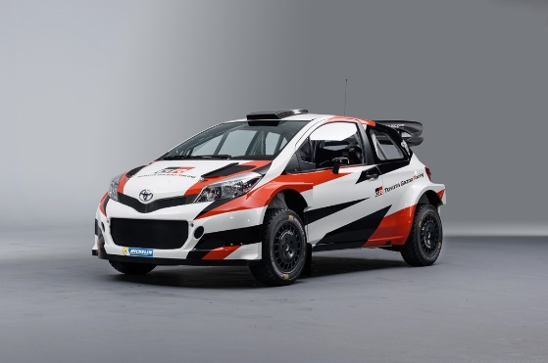
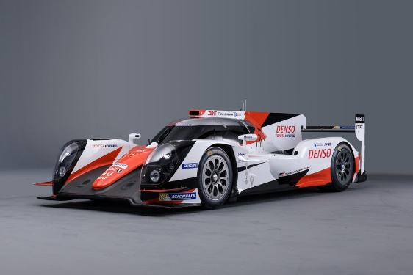

Nürburgring 24 Hours endurance race Japanese Rally Championship
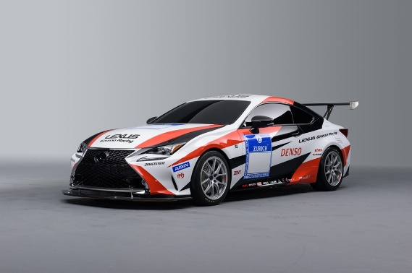
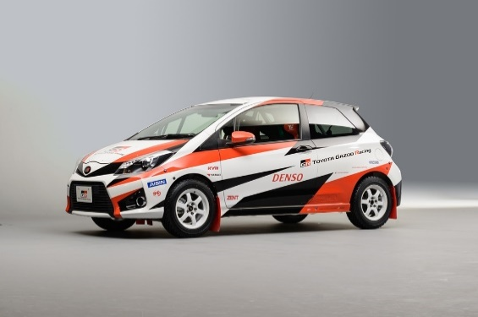

Note: The materials and images featured in this press release can be downloaded from the following websites:
Photos from Toyota GAZOO Racing's 2016 press conference, along with presentation materials used at the event:
http://www.toyota.co.jp/ms/press/ (Photos from the event will be uploaded by the end of February 4.)
PDF version of this press release: http://newsroom.toyota.co.jp/en/detail/11057630/
Video of the motorsports activity presentation:
https://www.youtube.com/user/ToyotaGlobalNews

