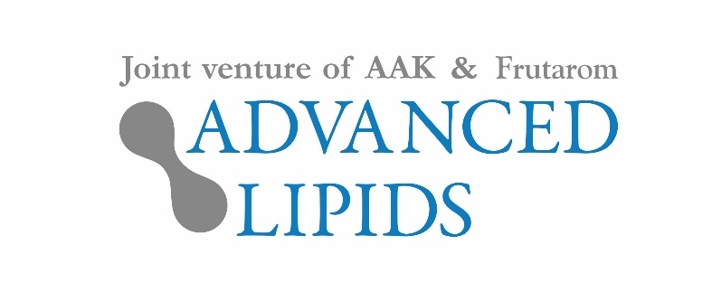

4 December 2018

PRESS RELEASE

Quality is king in China’s infant
formula market, research shows

Chinese parents care much more about the quality and nutritional value of infant formula than its price, new research by Advanced Lipids has shown.

China accounts for almost half of all infant formula sales globally. To gain new market insights, Advanced Lipids, manufacturer of the fat ingredient INFAT®, surveyed 211 urban Chinese parents.

All fed their children with infant formula, either exclusively or in combination with breastfeeding. Nearly three in five (59%) named nutritional value as one of the two factors most important to them when choosing formula, while 45% chose quality and 39% chose safety. Only six per cent said price was an important factor.

The survey shows that many Chinese parents are prepared to shop around to find high-quality products. Eight in ten (80%) of the respondents (all of whom lived in major cities and had a joint income above the national average) said they had tried at least two different formulas, with 38% trying at least three.

The most common reasons for switching products were that another formula offered higher quality (75%) and concerns about safety (74%). By far the most common source of information was the internet: 71% of parents searched online before deciding on a product, compared to 49% who consulted friends and 27% who sought the advice of a doctor.

Dr. Sigalit Zchut, Clinical Marketing Manager for Advanced Lipids, said: “Our research shows clearly that Chinese formula consumers are highly quality-focused. They want the very best for their children and are prepared to shop around to find products that offer safety and the best possible nutritional value. Furthermore, they’re prepared to pay for the best, with very few buying decisions influenced by price.”

The parents were much more likely to prefer to buy formula products manufactured overseas than in China (82% v 18%). However, country of origin was not a significant driver of product choice, with only 2% of respondents considering it one of the most important factors when choosing a formula.

Ronald van der Knaap, CEO of Advanced Lipids, added: “After well publicized concerns about the safety of some Chinese formula brands, many consumers turned to formula manufactured overseas. However, it’s interesting to note that country of origin is itself not a big driver of product choice. It’s not enough for Chinese consumers that a product comes from overseas – it has to offer high quality.”

Advanced Lipids is the manufacturer of INFAT®, a high-quality fat ingredient for formula. INFAT® contains high levels of the structured triglyceride SN-2 palmitate (also known as OPO) and mimics the structure of human milk fat, providing a range of health benefits for infants.

For more information about this press release, contact:
Richard Clarke, Ingredient Communications
Email: richard@ingredientcommunications.com | Tel: +44 1293 886291

About Advanced Lipids
Advanced Lipids is a joint venture between Frutarom, a global leader in the fields of taste and health, and AAK, a global provider of value-adding vegetable oils and fats to the infant formula industry and many other industries. Combining Frutarom’s clinical and chemical expertise in lipid technologies with AAK’s international strength in food safety, production and logistics, Advanced Lipids offers a unique package of clinical research, development, flexible blending, quality and logistics.

Find out more at www.advancedlipids.com

