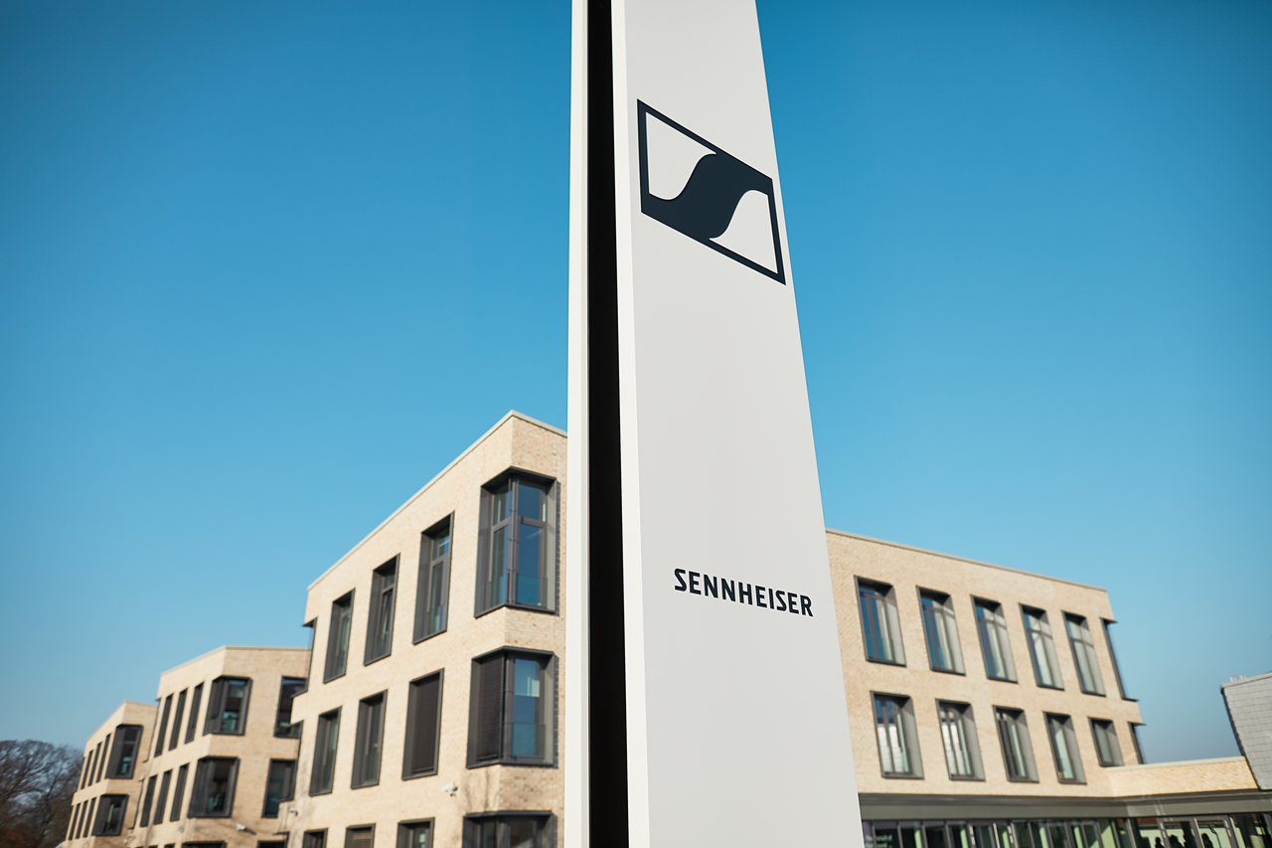

SENNHEISER CLOSES THE CHALLENGING PANDEMIC YEAR 2020 BETTER THAN EXPECTED
The family business achieved total revenue of 573.5 million EUR

Wedemark, June 30, 2021 – Sennheiser closes the pandemic year 2020 better than initially forecast: The family-owned company achieved revenues of 573.5 million euros and earnings before interest and taxes (EBIT) of 3.6 million euros. After a very challenging phase, particularly in the first months of the global COVID-19 pandemic, the company managed to effectively counteract the effects of the pandemic and achieve a significant stabilization of sales in both the Professional and Consumer segments by the end of 2020. This positive development has continued in 2021.
As expected, the Corona pandemic and its massive impact on the global audio market are reflected in the Sennheiser Group's sales and earnings development for fiscal year 2020. The Professional area, with its Pro Audio, Business Communication and Neumann business units, generated revenues of 307.9 million euros, some 15 percent below the previous year. The Pro Audio business unit in particular was affected by the pandemic: With the cancellation of live events around the world, the entire event and music industry came to a standstill for a long period of time.

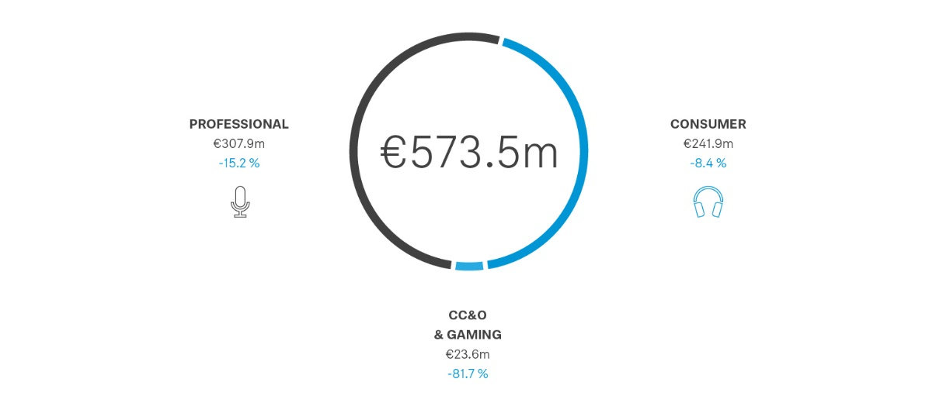

The Consumer Electronics segment generated operating revenues of 241.9 million euros*, down around 8 percent* compared to the previous year. The Consumer segment recorded significant declines in sales, particularly at the beginning of the pandemic, as sales in stationary retail were limited or even non-existent in some phases. The global headphone market declined by around 30 to 40 percent during this period. Sales of Sennheiser headphones also fell temporarily to the same extent. By the end of the year, however, a significant stabilization of sales in both the Professional and Consumer was achieved.

Together through the pandemic year
Thanks to the great commitment of the entire Sennheiser team, it was possible to counteract the negative effects of the pandemic and navigate the company well through the year despite the difficult conditions. As a result, the audio specialist was able to close fiscal 2020 better in all areas than had been expected in the middle of the year, achieving a positive break-even result despite the decline in sales. “The Sennheiser team has shown great commitment to helping each other and incredible team spirit over the past year. With a lot of dedication, flexibility and also creativity, everyone carried the company through the crisis together,” explains Daniel Sennheiser, Co-CEO of Sennheiser.

One of the key factors in this success was agile business management: “We responded to the various dynamics and developments that arose in the individual markets as a result of the pandemic effects by always being as flexible as possible to provide specific responses to specific challenges,” says Dr. Andreas Sennheiser, co-CEO of Sennheiser. Added to this was consistent cost management to realize short- and medium-term savings amounting to 50 million euros. These included both personnel costs and material costs. The reduction in personnel costs was achieved through a six-month phase of short-time working in Germany, and a reduction in working hours in other countries. In addition, senior executives voluntarily waived part of their salaries.

Despite savings, Sennheiser continued to invest in the development of new products and technologies. Investments in Development amounted to 41.3 million euros in fiscal year 2020, which corresponds to 5.5 percent of total revenue. Sennheiser's 3D audio technology program AMBEO remains an important strategic component of all four business units.

Turnover by regions
In a global view of the markets, EMEA remained the region with the largest revenue in 2020 with 278.6 million euros. In its home market of Germany, Sennheiser generated revenues of 90.7 million euros. In the APAC region, revenues totaled 144.6 million euros and in the Americas region, revenues totaled 150.3 million euros.

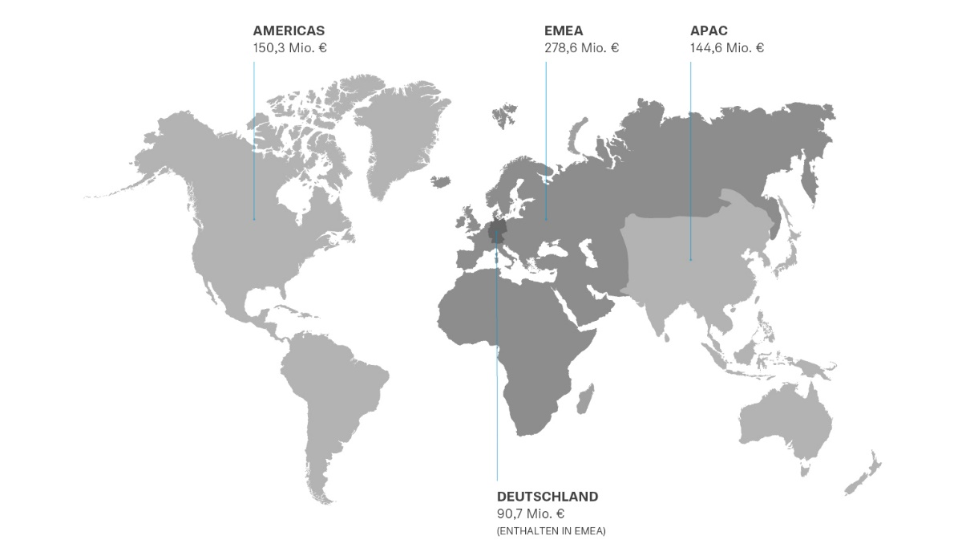

Important factors driving the positive development of revenue in the regions at the end of the year were the adaptability of the entire company to the novel situation and, in particular, the close customer relationships in the markets. “At our locations around the world, we responded very early and very quickly to the pandemic,” explains Dr. Andreas Sennheiser. “Wherever possible, we have relied on home offices and developed hygiene concepts – often before these measures were applied widely in the business world. Our employees have maintained close contact with customers over the past year and demonstrated with creative concepts such as #thisisyourcrew, #dontstopthemusic or #dontstoptheeducation that we are passionate about standing by our customers' side even in these difficult times.”

Strategic direction with focus on the Professional business
In 2020, Sennheiser also made fundamental strategic decisions for the future direction of the company: In order to be best able to exploit the respective growth opportunities of all four business units – Pro Audio, Business Communication, Neumann and Consumer Electronics – Sennheiser decided to give the individual business units more autonomy and responsibility. At the beginning of 2021, the audio specialist announced that in the future it will concentrate its own strengths and resources on the Professional area, and thus on the three business units Pro Audio, Business Communication and Neumann.

“In the Pro Audio business, we want to reinforce our strong position in the global market with a focus on digital services,” explains Dr. Andreas Sennheiser. “A good example of this is our new microphone system Evolution Wireless Digital: here we combine outstanding product quality with digital workflows. By linking our devices with the “Smart Assist” app, the best audio experiences are created with absolutely intuitive operation at the same time. A real relief for many musicians.” Daniel Sennheiser adds, “In the area of business communications, we will greatly expand our product portfolio in the coming years. Our goal is to be present with our products in the majority of meeting rooms and lecture halls around the world. And Neumann, with its legendary products, is already one of the world's best-known brands for studio-quality audio solutions. Here, too, we will focus on digital workflows in the future and further expand the business.”

Sennheiser has found a strong partner for its Consumer Electronics business in the Swiss company Sonova. Sonova Holding AG, a leading provider of hearing solutions, will take over the consumer business completely and continue to operate it under the Sennheiser brand.

About Sennheiser
Shaping the future of audio and creating unique sound experiences for customers – this aim unites Sennheiser employees and partners worldwide. Founded in 1945, Sennheiser is one of the world’s leading manufacturers of headphones, loudspeakers, microphones and wireless transmission systems. Since 2013, Sennheiser has been managed by Daniel Sennheiser and Dr. Andreas Sennheiser, the third generation of the family to run the company. In 2020, the Sennheiser Group generated turnover totaling €573.5 million. www.sennheiser.com
Press Contact
Sennheiser electronic GmbH & Co. KG
Mareike Oer
Head of Corporate Communications
T +49 (0)5130 600-1719
mareike.oer@sennheiser.com

