Marshall Day Acoustics and Sennheiser announce collaboration
Integration of AMBEO VR Mic with IRIS room acoustics measurement system

Aachen, 9 September 2019 – At the 2019 International Congress on Acoustics, Marshall Day Acoustics (MDA) and Sennheiser have announced a collaboration to ensure that the IRIS room acoustics measurement system from MDA will now fully support Sennheiser’s AMBEO VR Mic.

“We are really thrilled to have Marshall Day Acoustics join our ‘AMBEO for VR’ partnership program,” said Véronique Larcher, Director AMBEO Immersive Audio at Sennheiser. “Moreover, it’s great to be entering the field of room measurement with the AMBEO VR Mic, an Ambisonics microphone.”

“IRIS is among the premier room acoustics measurement systems in the world and one of the few that enables full spatial analysis, which is such a critical part of room evaluation,” commented Daniel Protheroe of Marshall Day Acoustics. “We are very happy to now be able to offer our customers direct support for the Sennheiser AMBEO VR Mic through the inclusion of the AMBEO A-format to B-format converter.”

The AMBEO VR Mic, an Ambisonics microphone, is now fully supported by the IRIS room acoustics measurement system | 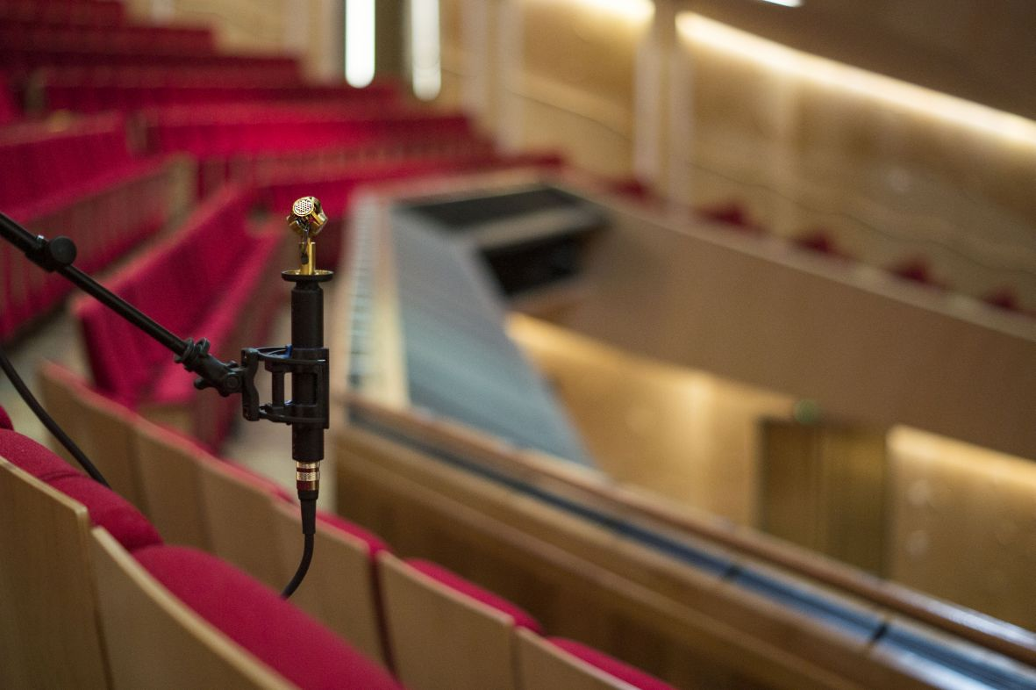

Measuring a room’s impulse response
The IRIS measurement system utilises an Ambisonics microphone such as the AMBEO VR Mic, which is placed at a listening position. A loudspeaker at a source position creates a single-sweep sine stimulus to excite the room, allowing the IRIS software to record the room’s impulse response in 3D and immediately process the results. IRIS intuitively visualises how the room’s surfaces reflect sound to the listening position in three dimensions, all via an easy-to-use interface. The 3D image plot created by IRIS can be used to relate sound rays to physical features of the room, observe the directional distribution of early and late sound energy, as well as identify surfaces causing problematic reflections.

The easy-to-use IRIS software provides intuitive visualisations of room acoustics measured via an AMBEO VR Mic | 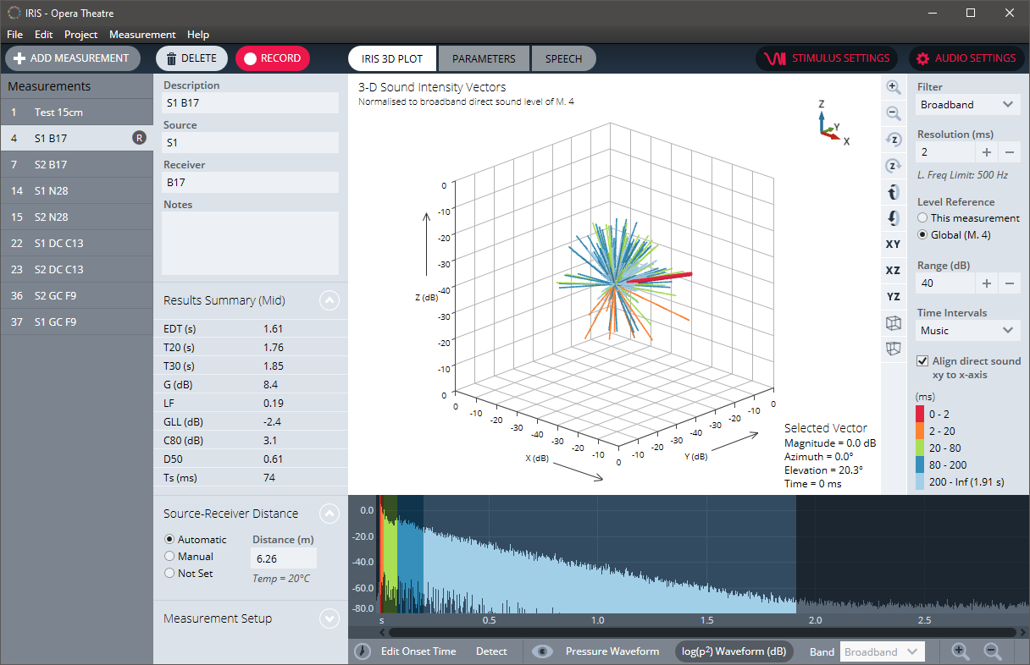

In addition to the core measurement and visualisation functionality, IRIS allows users to export 3D impulse responses, which can in turn be used for rendering recorded spaces into virtual and augmented reality environments.

Visit Marshall Day Acoustics at the International Congress on Acoustics, Booth 33, Sound Of Numbers SL.

The images of this press release can be accessed here: http://sennheiser-brandzone.com/pincollection.jspx?collectionName={23daec8e-2ec0-4520-88ee-372bfdb57ae8}

About Marshall Day Acoustics
A united team of engineers, architects, musicians, designers and scientists, all with one common goal: to deliver exceptional acoustic design. Founded in 1981 by Sir Harold Marshall and Christopher Day, Marshall Day Acoustics is one the world’s premier acoustic consultancies, and internationally renowned for their work in concert hall design, such as the Philharmonie de Paris and Guangzhou Opera House. Marshall Day Acoustics’ world-class consulting work is complemented by their research and development efforts, which have produced a number of leading software products for the acoustics industry. www.marshallday.com | www.iris.co.nz

About Sennheiser
Shaping the future of audio and creating unique sound experiences for customers – this aim unites Sennheiser employees and partners worldwide. Founded in 1945, Sennheiser is one of the world’s leading manufacturers of headphones, loudspeakers, microphones and wireless transmission systems. Since 2013, Sennheiser has been managed by Daniel Sennheiser and Dr. Andreas Sennheiser, the third generation of the family to run the company. In 2018, the Sennheiser Group generated turnover totaling €710.7 million. www.sennheiser.com

Marshall Day Acoustics PR Contact Sennheiser PR Contact

Daniel Protheroe Stephanie Schmidt
daniel.protheroe@marshallday.co.nz stephanie.schmidt@sennheiser.com
+64 (9) 379 – 7822 +49 (5130) 600 – 1275

