“Many adolescents suffer in silence”
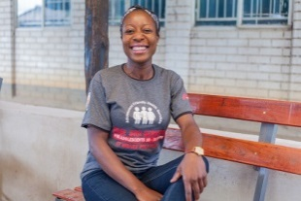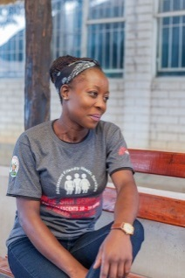 MSF226327, MSF226326

Tapiwa, aged 25 is a peer educator in the ‘adolescent corner’ run by MSF at the Edith Opperman clinic in Mbare, Harare. She talks to the teenagers who come to the clinic about the changes happening in their bodies and how to avoid the pitfalls and problems that adolescents typically face.
“I educate my peers in MSF’s adolescent corner, a clinic where adolescents can seek various services offered for free. The clinic provides treatment for any general diseases and it also provides HIV testing and counselling services.
Some of the adolescents have started to be sexually active but they are not using any protection to prevent themselves from infections and unwanted pregnancies, thereby putting themselves at risk.
Some were infected with HIV by their mothers at birth but have never had the chance, until now, to get tested.
There is a lot of stigma in the community that can hinder adolescents from accessing sexual and reproductive health services. Some health workers actually scold adolescents who visit clinics, accusing them of being wayward, so some adolescents end up not seeking services for fear of stigma.
As a young person, if I approach my peer, it is easier for him or her to listen to and accept what I explain, because we the same age and have a common understanding compared to an elderly person. They will take it that I am not trying to humiliate or stigmatise them, but am trying to genuinely assist so that they can access services.
It’s difficult for parents to tell their children about accessing family planning services, but it is easy for me as a peer educator to give that advice, especially if he or she is already sexually active.
Many adolescents suffer in silence because they cannot open up to discuss issues about their sexual and reproductive health rights, while some simply do not have the information. We sometimes meet adolescents who are pregnant but who don’t even know how they got pregnant.
I have realised that most adolescents do not get information from their parents, but they can get information from peers, and they will open up to peers to discuss issues that affect them.
I feel that I have a lot of information which is worth sharing, and this motivated me to become a peer educator.
In general, adolescents do not go to a clinic unless they are seriously ill. That is why we sometimes go into the community to talk to adolescents and sometimes we approach parents to explain about the services we offer. While some parents are dismissive, others are forthcoming. Some actually make an appointment and ask us to come and take their adolescents to the clinic after school.
Sometimes, too, we go to places like Mukuvisi where we find adolescent sex workers and we distribute condoms. From there, someone might come and disclose that they always feel itchy and they want to find out if we treat STIs.
We are socialised into believing that issues of sexual and reproductive health rights are for adults and we tend to ignore the fact that adolescents also engage in sexual activities. Because of this notion, adolescents are reluctant to access services because they think the services are for adults.
I would like to encourage adolescents to improve their health seeking behavior. They should come to seek services because they are being offered for free.”
MSF, alongside the City of Harare Health Department, has run an adolescent-friendly corner at the Edith Opperman clinic in Mbare, Harare, since November 2015. MSF provides adolescent- friendly services that include general health check-ups, HIV testing and counselling, screening for sexually transmitted infections (STIs), and family planning, all free of charge.

