The Crypt Sessions Presents
Matt Haimovitz In Concert on September 23

Haimovitz brings Bach’s moving, solitary cello works to the Crypt, accompanied by newly commissioned works by Philip Glass, Luna Pearl Woolf, Vijay Iyer and more.

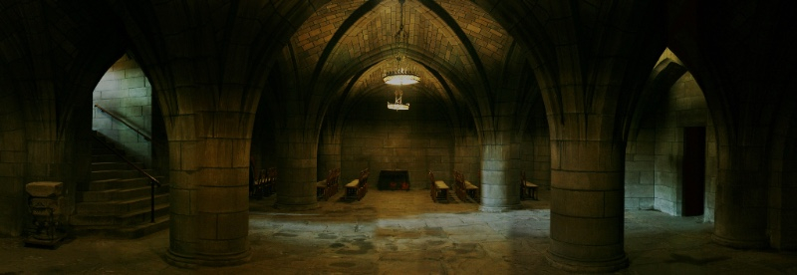

On September 23rd, Cellist Matt Haimovitz will give an intimate performance of selections from Bach’s cello suites in the extraordinary underground crypt beneath The Church of the Intercession, Harlem. The concert will also feature newly commissioned works by Philip Glass, Du Yun, Vijay Iyer, Roberto Sierra, and Luna Pearl Woolf all of which act as overtures to Bach’s cello oeuvre. There will be a wine and cheese reception at 7PM before the concert at 8PM.

The unique programming of the evening is reflected in his recently released album entitled Overtures to Bach, which includes six new commissions that anticipate and relate to each of the accompanying cello suites. The album was released this month on PENTATONE Oxingale Series and includes Haimovitz's new interpretation of the Bach Suites, inspired and informed by an authoritative manuscript by Bach's second wife and performed on period instruments.

The concert is a part of Unison Media’s Crypt Sessions, a concert series in partnership with Intercession and sponsored by Yamaha, which most recently featured twin sister piano duo Christina & Michelle Naughton performing Messiaen’s Visions of the Amen.

Tickets are $35, with all proceeds going to the church.

More info is available at: www.DeathOfClassical.com.

CONCERT INFO:

Matt Haimovitz
September 23rd, 2016 | Doors 7PM | Show 8PM
Tickets: $35 (Direct Link)

CONCERT PROGRAM

Johann Sebastian Bach: Suite I in G Major - Prelude
Philip Glass: Overture to Bach
Johann Sebastian Bach: Suite II in D minor - Prelude
Du Yun: The Veronica
Johann Sebastian Bach: Suite III in C Major - Prelude
Vijay Iyer: Run
Johann Sebastian Bach: Suite IV in E-flat Major - Prelude
Roberto Sierra: La Memoria
Johann Sebastian Bach: Suite V in C minor – Prelude & Fugue
Luna Pearl Woolf: Lili’uokalani, for solo cello piccolo
Johann Sebastian Bach: Suite VI in D Major - Prelude

ABOUT MATT HAIMOVITZ:
Renowned as a musical pioneer, cellist Matt Haimovitz is praised by The New York Times as a “ferociously talented cellist who brings his megawatt sound and uncommon expressive gifts to a vast variety of styles” and by The New Yorker as “remarkable virtuoso” who “never turns in a predictable performance.” He has inspired classical music lovers and countless new listeners by bringing his artistry to concert halls and clubs, outdoor festivals and intimate coffee houses – any place where passionate music can be heard. He brings a fresh ear to familiar repertoire, champions new music, and initiates groundbreaking collaborations, as well as creating innovative recording projects. Besides his relentless touring schedule, he mentors an award-winning studio of young cellists at McGill University’s Schulich School of Music in Montreal.

ABOUT UNISON MEDIA:
Unison Media is a classical music company committed to exploring new ways to present and promote music and those who create and perform it. Unison believes in a holistic approach – publicity, social media or marketing on their own no longer have an impact, and it’s only when they are combined in a cohesive, coordinated fashion that you start to get real results. Unison launched the Crypt Sessions in 2015 with the intention of reinvigorating the standard of what a classical music concert should be and to provide a niche venue in the heart of Harlem.

