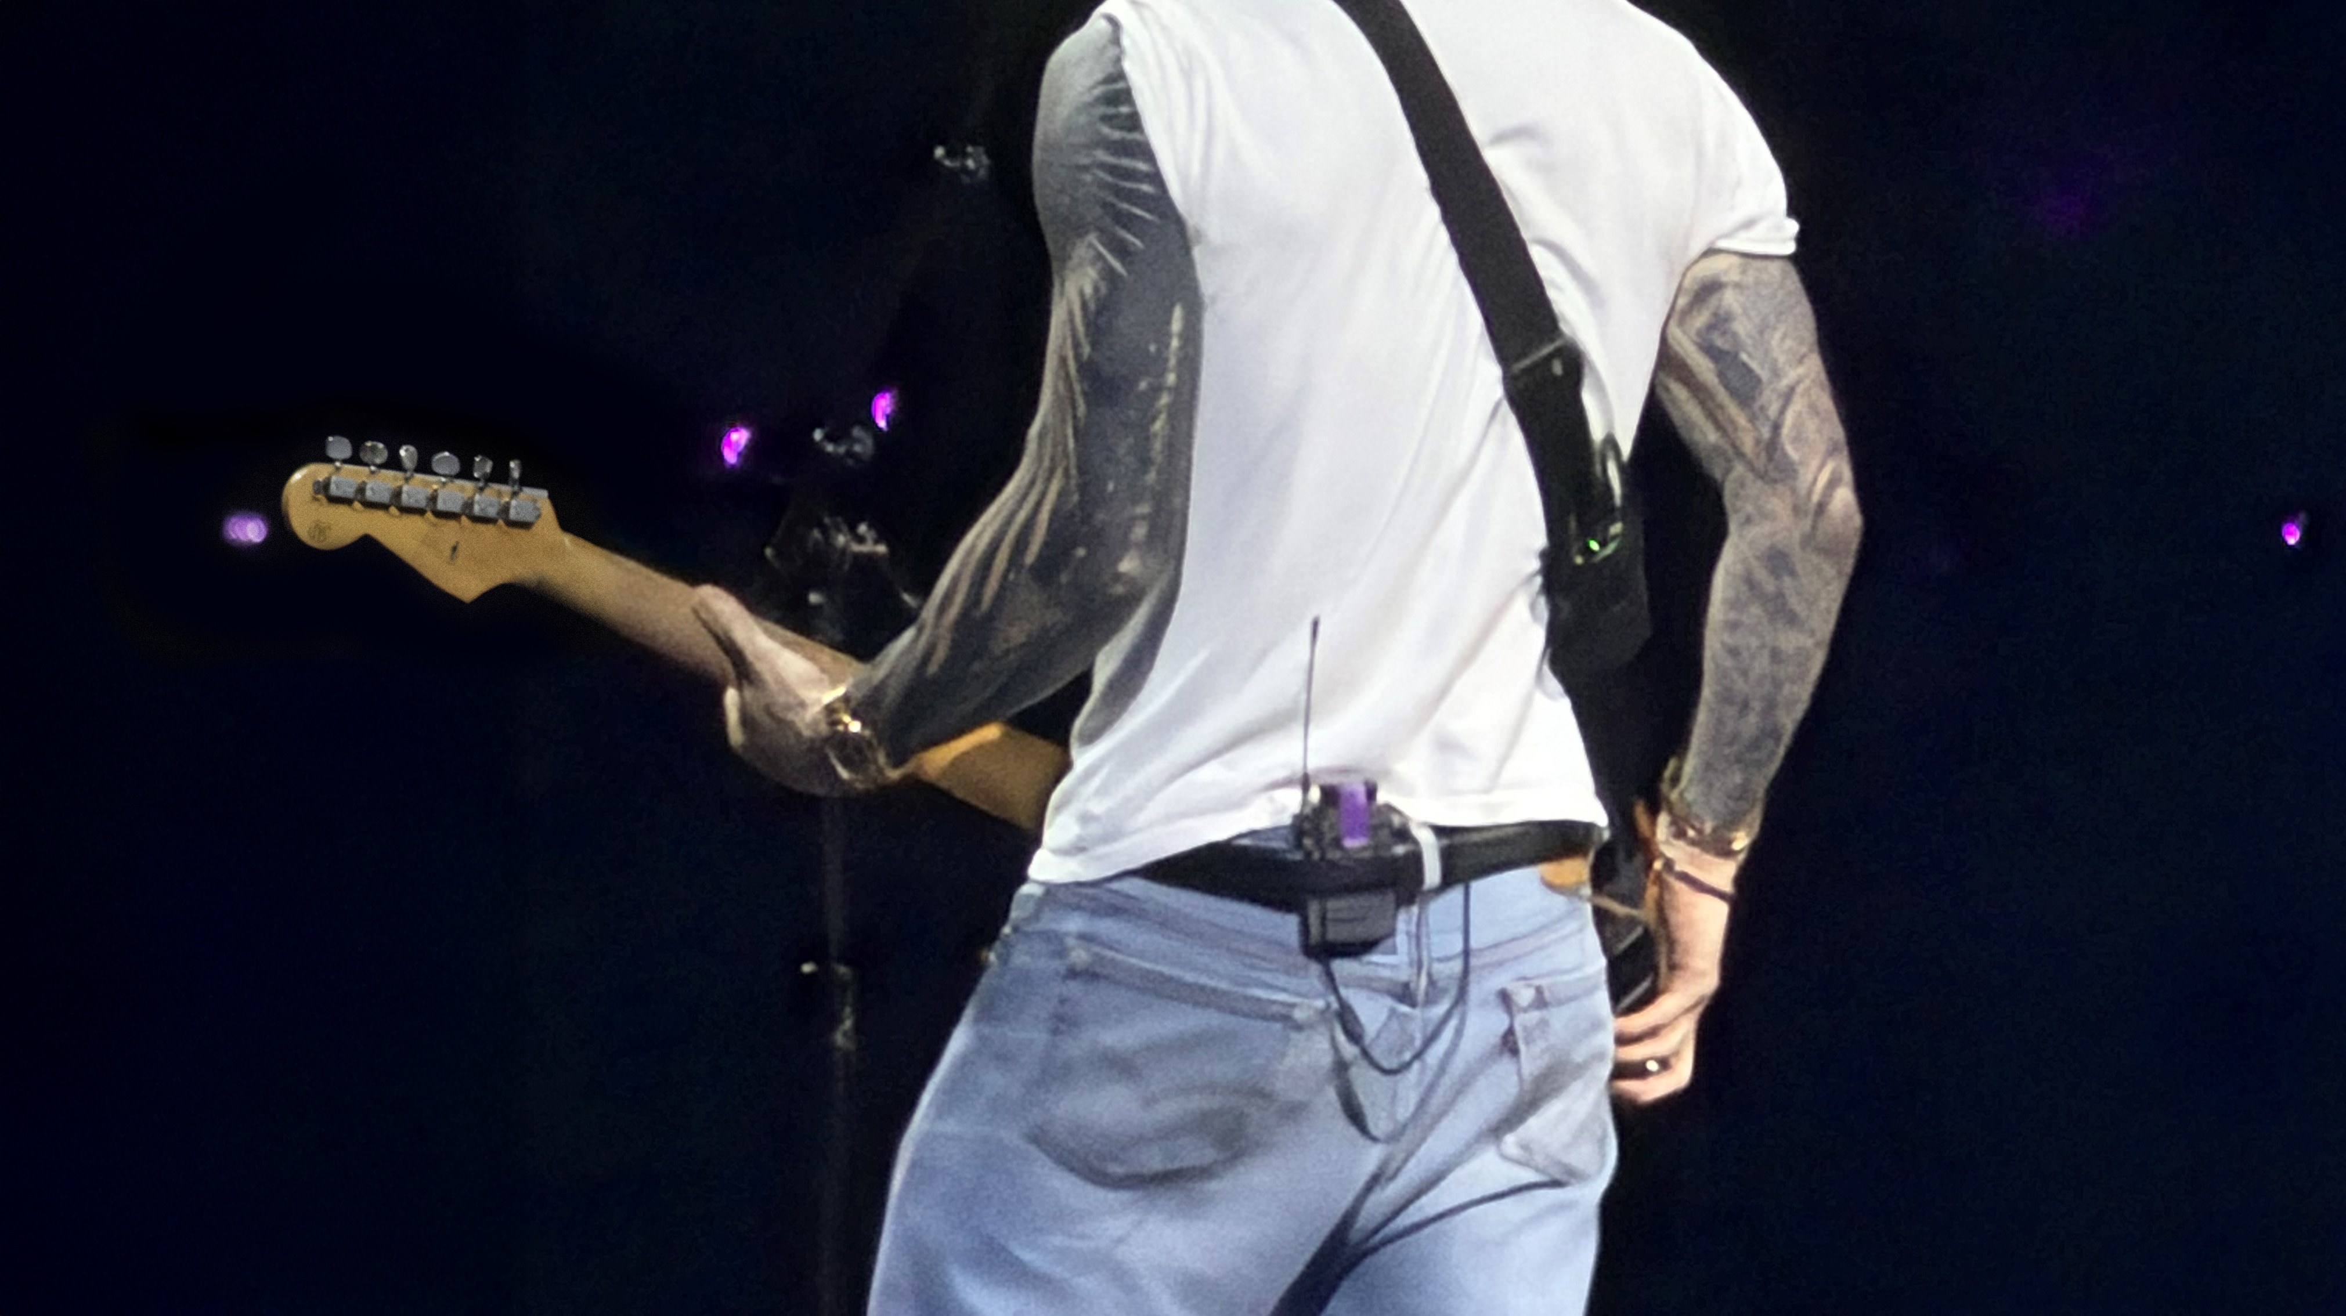

Ympyrä sulkeutuu: Maroon 5 ja analogisen aikakauden loppu
Ottamalla Sennheiser Specteran täysimittaiseen käyttöön yhtyeen kiertueella, Dave Rupsch todistaa digitaalisen laajakaistaisen langattoman teknologian olevan vaativan stadion-äänentoiston tulevaisuus.

Monitorimiksaaja Dave Rupsch on työskennellyt 25 vuoden ajan kriittisellä paikalla miksauspöydän takana maailmanluokan ikonien, kuten My Chemical Romancen, Katy Perryn, Megadethin, Red Hot Chili Peppersin ja Nick Jonasin keikoilla. Hän on seurannut alan digitaalista vallankumousta, ja vaikka line array -järjestelmät ja mikserit ovat kehittyneet huipputarkoiksi työkaluiksi, yksi olennainen lenkki laahasi itsepintaisesti menneisyydessä. Rupsch oli pitkään jahdannut ”valkoista valastaan:” täysin digitaalista ja virheetöntä IEM-signaaliketjua. Se oli viimeinen puuttuva osa-alue, jolla modernin konserttitekniikan ympyrä saataisiin suljettua, mutta sen tavoittelu tuntui aivan liian pitkään lähes mahdottomalta.

Lisää alla englanniksi.

That search came to an end during the 2025 Maroon 5 tour. While Rupsch had spent years relying on industry-standard analog wireless systems, the increasing congestion of the UHF spectrum was becoming an unavoidable disruption. During the tour opener in Phoenix, a city notorious for its fully occupied radio spectrum, “The team found that environmental factors like noise floor and limited maneuverability were becoming unnecessary stressors while doing an already psychologically demanding job,” Rupsch explained. Seeking a premium experience for the band, Rupsch decided it was time to move beyond the limitations of traditional RF, and with the assistance of Clair Global, the Sennheiser Spectera system, the world’s first wideband, bidirectional digital wireless ecosystem, was put to the test.

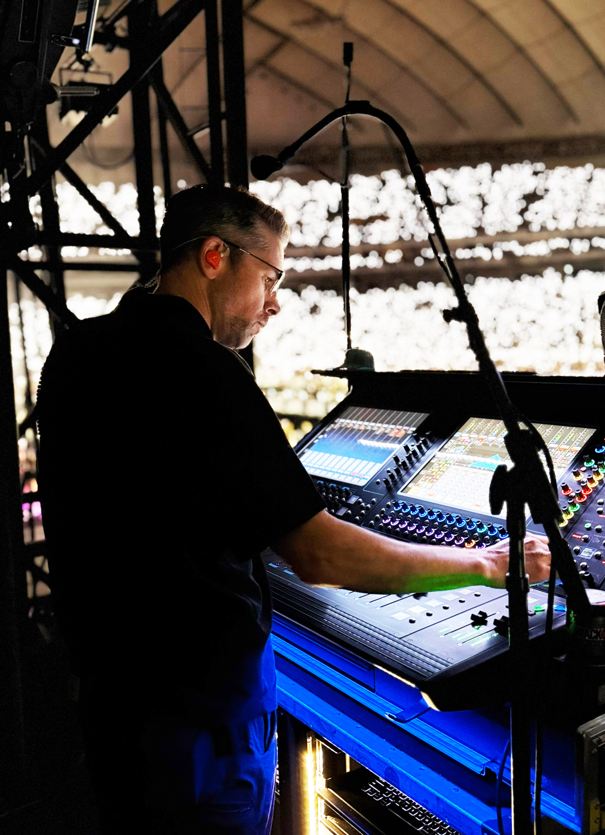 | Monitor engineer Dave Rupsch monitoring the mix behind the console during Maroon 5’s 2025 performance at the Tokyo Dome

The transition from a trial to a full-scale deployment with the entire band happened much faster than anticipated. Initially, Rupsch planned to ease into the technology, noting that “in the Wild West, the first guy through the saloon door is the one who gets taken out!” He placed only the crew and music director (MD) on Spectera packs, but the results were immediate.

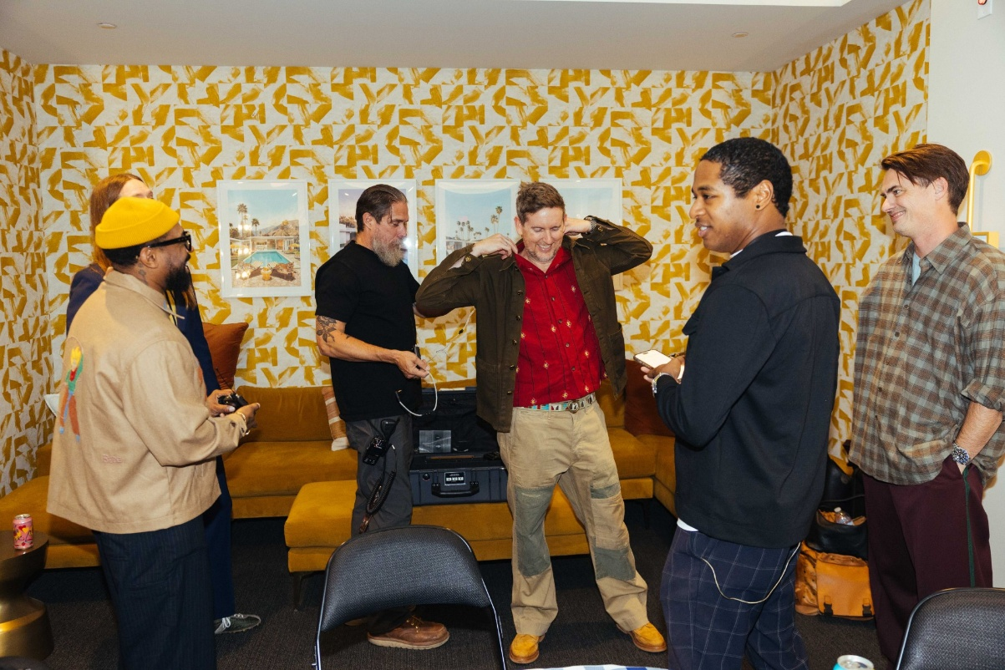 | Maroon 5 members and touring musicians (L–R) PJ Morton, James Valentine, Jesse Carmichael, Jacob Scesney, and Sam Farrar get their Spectera bodypack and IEM systems dialed in by assistant tour manager Shawn Tellez (third from left)

Within five minutes, the MD approached Rupsch to relay that the pack sounded fantastic before walking on stage to show the rest of the band, prompting them to immediately inquire as to why they weren’t yet using it. Rupsch recalled, “Our ‘trial period’ was about five minutes before Spectera ended up being used on every show of the tour.” The shift in audio quality was rooted in the absence of traditional analog artifacts.

Frontman Adam Levine onstage using his Spectera bodypack and in-ear monitors during Maroon 5’s Love Is Like tour | 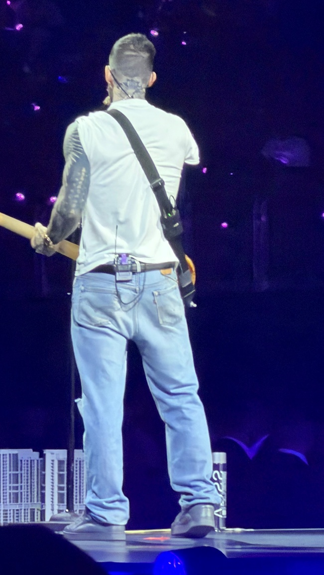

Rupsch noted that, “the absence of any analog RF artifacts like noise floor, swishes, pops, or clicks allowed the performers to lean into the minute details of the mix.” The band’s studio engineer immediately responded to the spacious stereo imaging, while several band members commented that it was the clearest they had ever heard themselves.

Beyond the leap in sonic fidelity, Spectera’s architecture has fundamentally redefined the monitor workflow for Dave Rupsch. A key efficiency is the move from traditional BNC to standard Cat 5 cabling for antenna deployment. “Cat 5 is so much more pliable and easier to coil,” Rupsch noted. “It’s now possible to add these to our cross-stage looms without the signal loss or interference typically associated with long analog runs.” Because these antennas are smaller and lighter than conventional helical models, they can be easily claw-mounted to scaffolding anywhere on site.

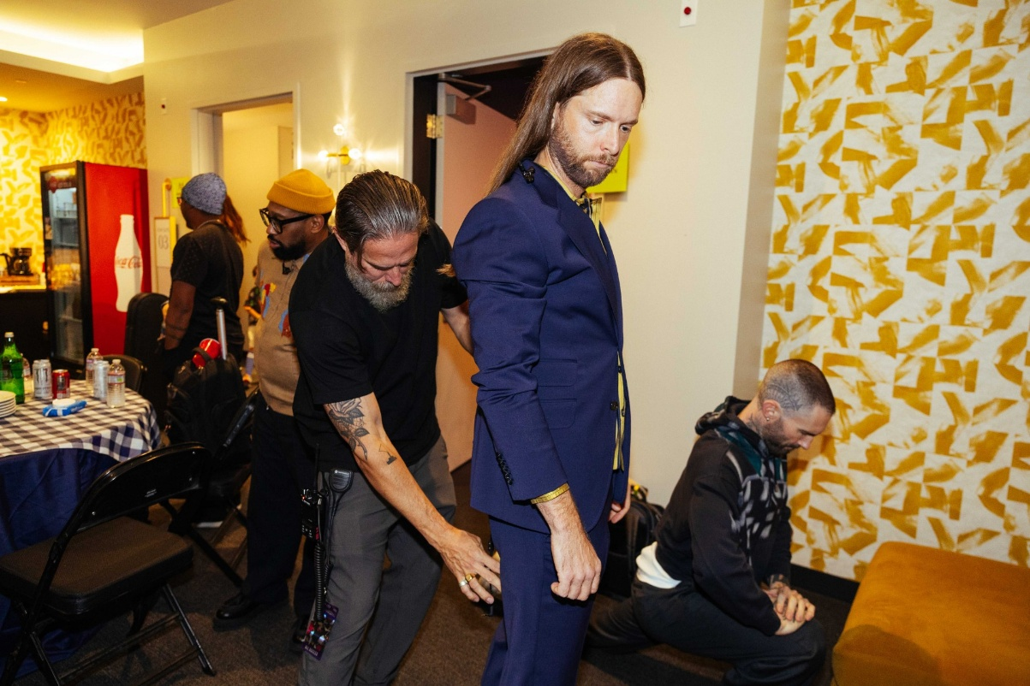
Shawn sets up guitarist James Valentine’s Spectera bodypack as his bandmates gear up for the performance

The system’s ability to “bend” around corners and walls is driven by its high-density network of multiple antennas. For the Maroon 5 arena tour, Rupsch utilized a four-antenna setup — placing units at stage right, stage left, the thrust, and backstage. This configuration ensured Adam Levine remained connected even when moving through the crowd, upstage, or into the dressing rooms.

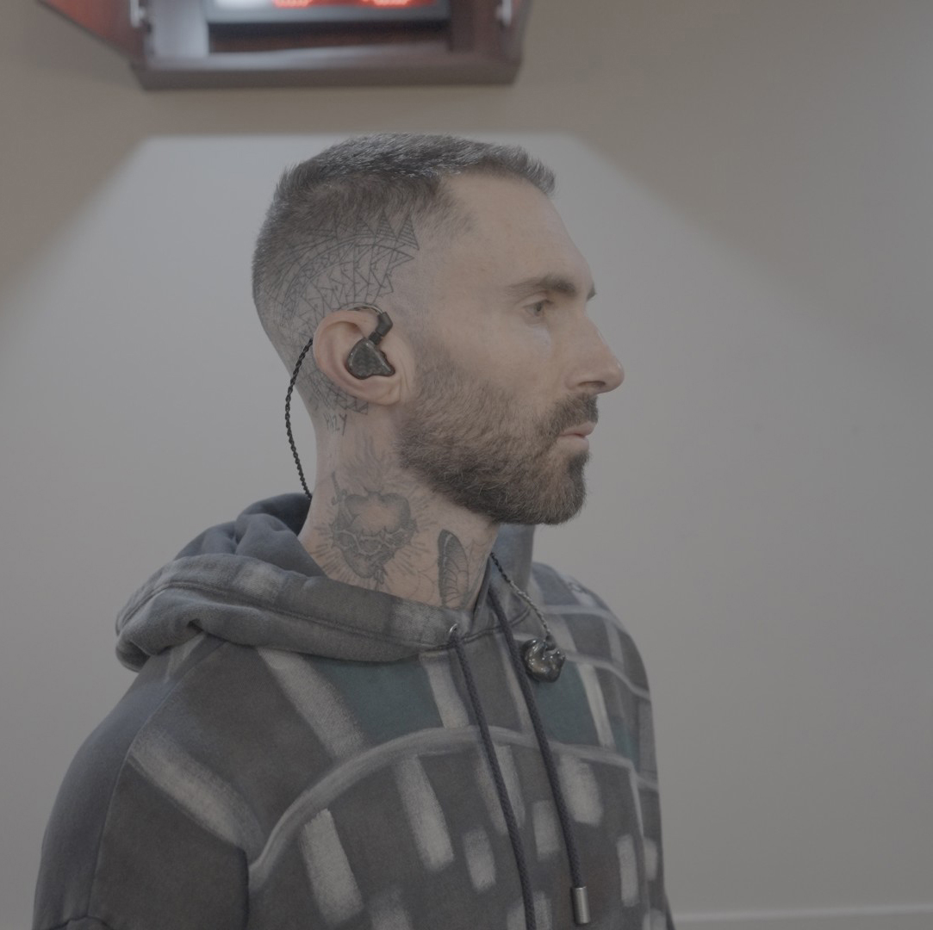 | Adam prepares to take the stage with his trusted in-ear monitors, powered by Sennheiser Spectera

Rupsch recommends a minimum of three antennas for standard arena stages to ensure a stable connection the moment an artist puts on their pack backstage. This multi-point strategy creates a powerful network that maintains signal integrity through physical barriers, providing seamless coverage across the performance area and the arena concourse.

As Rupsch looks toward a massive 2026 stadium tour with My Chemical Romance, Spectera has elevated from a curiosity to a necessity. He plans to carry two Base Stations to handle large-scale environments and performers with headset mics who can “take advantage of Spectera’s dual transmit and receive features.” For Rupsch, this marks the end of a fifteen-year wait for the industry. “We as engineers and RF coordinators have been waiting for these advancements to reveal themselves,” he reflects. By delivering a quality, clean, sonically satisfying digital IEM transmission, the “white whale” has finally been caught, providing the reliability and purity that the modern stage demands.

(Ends)

The images accompanying this media release can be downloaded here.

About the Sennheiser Brand – Over 80 Years of Building the Future of Audio
We live and breathe audio. We are driven by the passion to create audio solutions that make a difference. This passion has taken us from the world’s greatest stages to the quietest listening rooms – and made Sennheiser the name behind audio that doesn’t just sound good: It feels true. Since 1945, we stand for building the future of audio and bringing remarkable sound experiences to our customers.
While professional audio solutions such as microphones, meeting solutions, streaming technologies and monitoring systems are part of the business of Sennheiser electronic SE & Co. KG, the business with consumer devices such as headphones, soundbars and speech-enhanced hearables is operated by Sonova Holding AG under the license of Sennheiser.

www.sennheiser.com
www.sennheiser-hearing.com

Press contact
Burson Finland Oy (previously Hill and Knowlton)
sennheiser.finland@hkstrategies.com

