First Baptist Church of Everett Deploys In-Ear Monitoring System, myMix to Alleviate Acoustical Challenges
In-ear monitors and the myMix personal monitoring system provide the church with lower SPL, crystal clear audio and unlimited flexibility
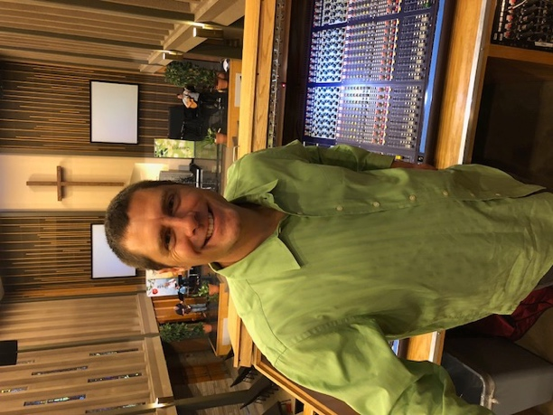
Everett, Washington, April 26, 2018 — When First Baptist Church of Everett in Everett, Washington, was built in the late 1960s, the main sanctuary was designed as a giant hall — allowing a speaker to preach from the pulpit and be heard clearly in the back of the sanctuary without any amplification. While this was a common design at the time, the removal of the pulpit and the introduction of floor monitors caused the sanctuary to become an acoustical nightmare.

“The sanctuary was basically a giant echo chamber,” said Andy Finseth, First Baptist of Everett’s lead audio engineer. “Using floor monitors in the room was a significant challenge with the additional sound and the echo bouncing off the back wall and traveling all the way through the room. This forced us to run our mains much louder, and, as a result, a lot of times we would easily get volume complaints especially from some of our senior members.”

Today, First Baptist Church holds two contemporary services each Sunday that draw some 400 parishioners each week. A switch to in-ear monitors has made all the difference during these services.

“Every week we monitor our Sound Pressure Levels (SPL),” Finseth explained. “With the floor monitors, we were regularly running around 95 decibels on average, and it was still fairly muddy sound.”

After redesigning the Church’s system himself, Finseth made the switch to in-ear monitors in 2005. The switch to IEMs helped lower the stage volume — along with the addition of properly aligned mains which narrowed the field of throw keeping the sound from bouncing off the sanctuary walls — bringing down the Church’s average SPL to around 85 decibels.

“The in-ear monitors provide a very pleasant sound no matter what kind of music the worship band is playing,” Finseth said. “If they are going from jazz to rock to a hymn — we get clear sound no matter what, and we don’t get any complaints about volume anymore.”

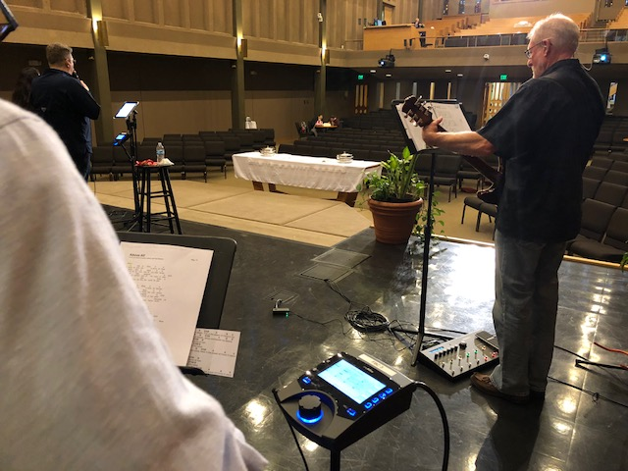
myMix: Flexibility is Key
In 2010, Finseth was searching for a new in-ear monitoring system for the worship band and tested out myMix during a summer street festival. The ability to put each member of the band onto the myMix network and allow them to individually select what mix they wanted to listen to won over Finseth and the worship band on the personal monitoring and mixing system.

“The flexibility of the inputs is really what sold us on the myMIx,” Finseth said. “If the vocalists want, they can listen to each vocalist individually, but maybe the drummer doesn’t want to listen to all the vocalists individually, he wants to listen to just the worship leader — myMix allows you to do this. It offers this unique flexibility that is second to none.”
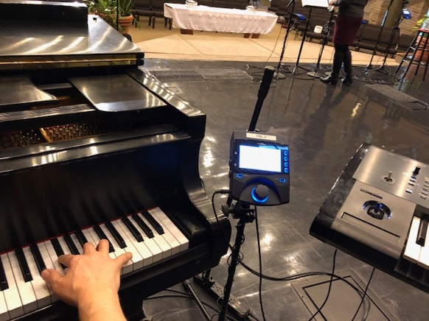
Currently First Baptist Church has 14 myMix units but employs around 10 during each service. Finseth sets up 2 myMixes for guitar, 2 for drums — one that is running the drum mix and one that the drummer uses as their monitor system, 1 at keyboard, 1 at piano, 1 at bass and a few extra for vocalists or additional guitarists.

“The myMix is a great system,” Finseth said. “While any in-ear monitor system would have helped improve the sound in our sanctuary, the myMix system is the best system I’ve tried out. It offers the most flexibility and is just an all-round solid platform.”

For more information, visit mymixaudio.com.

About myMix
Part of the Synthax family, the North American distributor for RME, myMix is a personal monitor mixing and recording system featuring local network inputs and can operate either self-contained or integrated with any analog or digital mixing consoles. Thanks to its ease of use, the myMix is ideal for on-stage performances, studio monitoring as well as installed applications such as houses of worship.

Media Contacts:
Katie Kailus
Public Relations
Hummingbird Media
+1 (630) 319-5226
katie@hummingbirdmedia.com

Jeff Touzeau
Public Relations
Hummingbird Media
+1 (914) 602 2913
jeff@hummingbirdmedia.com

