For immediate distribution

Voiceover Actor Martin Yap Takes the Fast Track with Flock Audio’s PATCH LT
With dozens of sonic options now at his fingertips, Yap says his sonic playground just got a lot bigger

Toronto, Canada – January 27, 2021 – As a sound source, perhaps no instrument throughout history is as intricate and instantly recognizable as the human voice. Award-winning voiceover actor Martin Yap takes great care in ensuring that his own unique voice talent translates in the best possible way for his clients — from the moment the words leave his mouth until they finally reach the listener’s ear. A multiple Promax Award Winner, he routinely works with A-list clients including McDonalds, Walmart, Nintendo, Discovery Channel and many others.
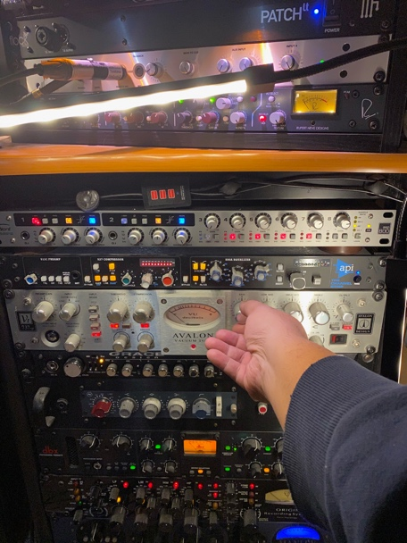
Early into his voiceover career, Yap became acutely aware of the need to hone several ‘sonic templates’ — each mapping to specific client needs. In his well-appointed home studio, this soon translated into specific signal chains for projects involving movie trailers, radio spots, corporate work and more. “After I gained a bit of experience, I would walk into a studio, put on the headphones and ask the engineer, ‘What are you putting me through?’ Eventually I started putting together a whole arsenal of gear that worked well on my voice so that I would have plenty of choices to fit the need.”
“For instance, a certain microphone and preamp works really well for a ‘corporate’ kind voice, and another chain might work well for ‘movie trailer’ kind of voice,” he continues. “I liken it to you are an actor who dons a costume or puts on prosthetics to help he or she transition into being that character they are trying to become.” For Yap, the dream has always been to match his voice to the right signal chain at the push of a button, so he could leverage any of his signal chains for a specific desired outcome.
Harnessing the signal chain with PATCH LT
Enter Flock Audio, whose PATCH System happened upon Yap approximately two years ago: “It was a Holy Grail moment,” he recalls. “I thought that if this thing actually works, it would be exactly what I wanted putting this flexible matrix of options at my fingertips. When PATCH LT finally came out a few months ago, it had features I wanted in a 16x16 I/O format. I jumped on it right away and it hasn’t disappointed.”
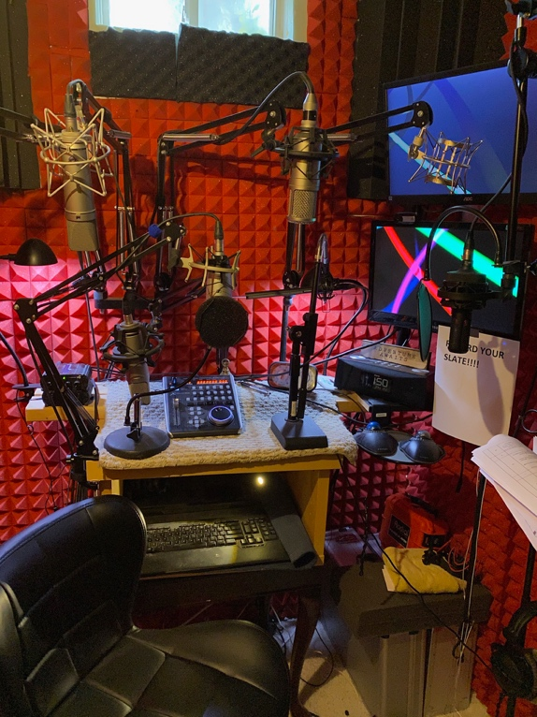
While the switch to Flock Audio’s PATCH System virtually eliminated the hassle of physical patching, it helped Yap begin to fully realize the full potential of his valuable collection of microphones, outboard preamplifiers, dynamic processors and channel strips: “It was just pure joy. What I am I going to pair my voice with today?” he says. “There are so many options and it really opens up your imagination. All of a sudden, I can do all these things and try out new combinations. I am still like a kid in a playground here, and the playground just got a lot bigger!” His growing equipment list includes microphones from Neumann, Microtech Gefell and Manley, and preamps and outboard processors from Neve, DBX, Avalon, Grace Design and others.
By implementing PATCH LT into his setup, Yap has made nearly 100 signal chain combinations instantly accessible via the PATCH APP. This makes for both a faster workflow and a bespoke signal chain that he can dial in for a given client at a moment’s notice. Yap cites a recent example in which he was able to change his entire signal chain seconds before he was to record a new VO track: “I was at a session maybe about a week ago,” he recalls. “In my mind, the client wanted a certain kind of sound. But right before we started recording, it dawned on me that they really wanted a ‘movie trailer’ kind of sound, which is a completely different signal chain for me. All I did was rearrange it in PATCH; I never had to leave the booth or tell the client, and just a few clicks later, I had the right signal chain loaded up. The session went great and the client loved what they heard.”
While Yap may be in the minority among his voiceover peers who have more modestly appointed studios, he insists that having end-to-end control over the quality of his work makes him more valuable to clients: “I care not only about the performance, but also how I present the final file to the client. Flock Audio enables more of that control to happen and helps me present my work in best way possible.”
About Flock Audio
Flock Audio Inc. is a pro audio manufacturer based in Kelowna, Canada, founded in 2017. The company is best known for its PATCH System Series, which is a Digitally controlled, 100% Analog Patch bay routing solution for professional audio environments. For more information on Flock Audio and its products, please visit the company website at http://www.flockaudio.com.

Media contact
Jeff Touzeau
Public Relations
Hummingbird Media
+1 (914) 602 2913
jeff@hummingbirdmedia.com

