March 22, 2019
Toyota Motor Corporation
GAZOO Racing Company

Tour de Corse: Preview
The Toyota Yaris WRC takes on the twisting turns of Corsica

TOYOTA GAZOO Racing World Rally Team takes the lead of the drivers’, co-drivers’ and manufacturers’ standings to the French island of Corsica for the first pure asphalt round of the season, the classic Tour de Corse. Championship leader Ott Tänak will look to continue his recent run of podium finishes on an event where he finished second last year, with team-mates Jari-Matti Latvala and Kris Meeke also out to replicate strong performances on previous visits to Corsica.

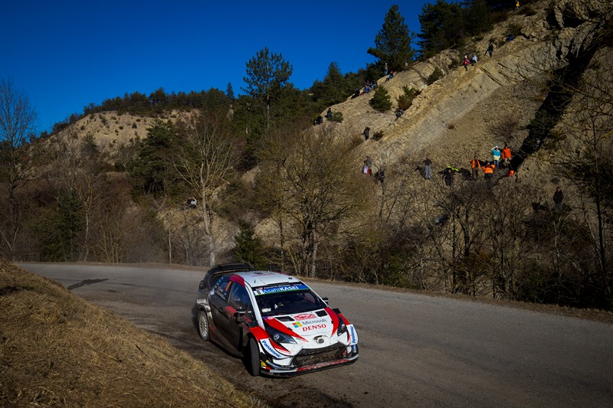

Car 8 (Ott Tänak and Martin Järveoja)

The Tour de Corse is also known by its nickname of ‘The Rally of 10,000 Corners’ thanks to its narrow and twisting stages. Stages are on average longer than on any other round, which coupled with abrasive asphalt makes tyre wear a major consideration. With the mountain roads often lined by rock faces on one side and steep drops on the other, there is little room for error.

The route has been changed significantly for 2019, with new stages making up 75 per cent of the competitive distance. There is a new start location in Porto-Vecchio in the south of the island, where two loops of three stages will be held on Friday with no service until the end of the day at Bastia airport. Saturday features three stages each run twice around the north east of the island, before heading west for the final two stages ahead of the finish in Calvi.

Quotes:
Tommi Mäkinen (Team Principal)
“We will go to Corsica feeling optimistic about our chances, particularly after our strong performance there last year when we were fastest on half of the stages. It is a very challenging rally, as I found out many times when I was driving, but our drivers have all shown they can be fast there. With so many corners and really long stages, you need to have full confidence in the car, otherwise you can lose a lot of time. That is why it is very important to get the setup right. This year, that will be especially true on Friday because there isn’t a proper service in the middle of the day to make big changes. But I know that our team has been preparing as well as possible and hopefully we can have another strong weekend.”

Ott Tänak (Driver car 8)
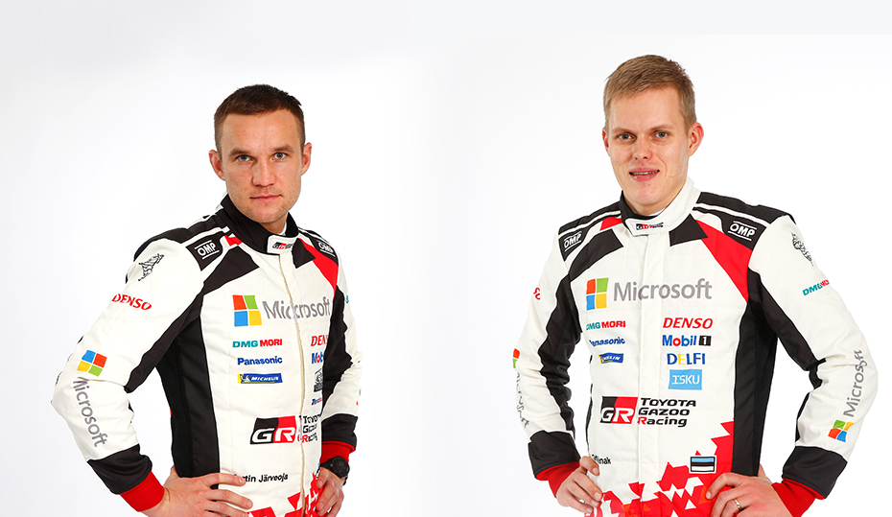
“I am looking forward to Corsica. Being first on the road there as championship leader should be a good thing, as this is the best place to be on asphalt where the road is cleanest. In the past, Corsica was probably the rally on which I struggled the most, but we had good pace last year on our first time there in the Toyota Yaris WRC. We know that we have a really strong package now on asphalt, so I believe that we can have a good performance. I’m sure that some of our rivals will be very fast too, but the aim is to continue our positive start to the season and keep scoring as many points as possible.”
Martin Järveoja and Ott Tänak

Jari-Matti Latvala (Driver car 10)
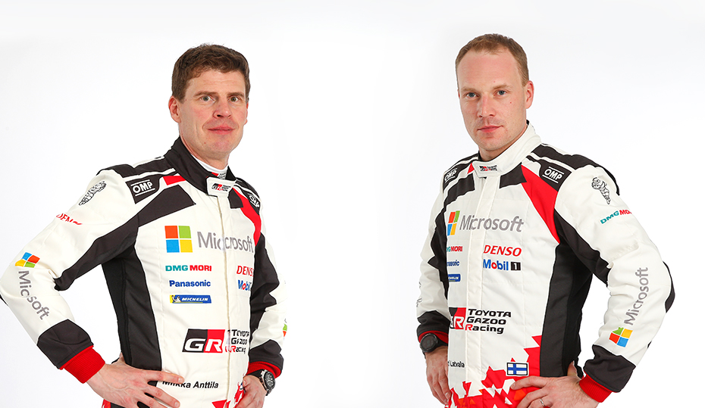
“Corsica is a rally I always look forward to. The asphalt is abrasive so provides good grip, and the road is usually pretty clean. The island itself is very beautiful too. I like the changes to the route this year. A couple of the stages were used when I won the rally in 2015, so I have good memories of those. I had a good test earlier this week: We did 200 kilometres and tried a lot of things, not only for this rally but also development for the future. On Rallye Monte Carlo I struggled with understeer, so we worked on that and improved the turning, as well as the braking, and I’m feeling more confident with the car. Now I’ve got a couple of days of relaxing at home, and feeling ready for the recce to start on Monday”.
Miikka Anttila and Jari-Matti Latvala

Kris Meeke (Driver car 5)
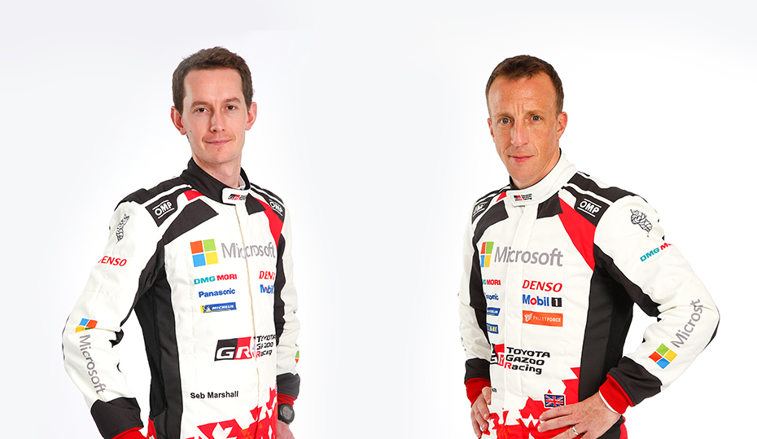
“I’ve had good times in Corsica in recent years: My speed’s always been there. It’s always a huge challenge, and especially so this year with about 75 per cent of the route being completely new. For that reason, I think making good pace-notes on the recce is going to be an equally important part of the challenge. I had a good feeling with the Yaris WRC in asphalt trim in Monte Carlo, but it was a very different rally to Corsica – except perhaps for the Power Stage where we went pretty well! I enjoyed my pre-event test last Sunday, even though it was a lot to learn in just one day on just one road. But I think we’re quite clear on our direction for the setup, and I’m looking forward to the rally.
Seb Marshall and Kris Meeke

The statistics (Tour de Corse):
Year | Ott Tänak | Jari-Matti Latvala | Kris Meeke
2018 | 2 | DNF | 9
2017 | 11 | 4 | DNF
2016 | 10 | 4 | 16
2015 | 10 | 1 | 4

What happened last year?

Ott Tänak finished in second place in his first full asphalt event in the Toyota Yaris WRC. Esapekka Lappi was poised to join him on the podium before he hit a kerb and had to stop to change a wheel, and finished sixth in the end. The pair won half of the rally’s 12 stages between them. Jari-Matti Latvala retired following a crash on the Saturday.
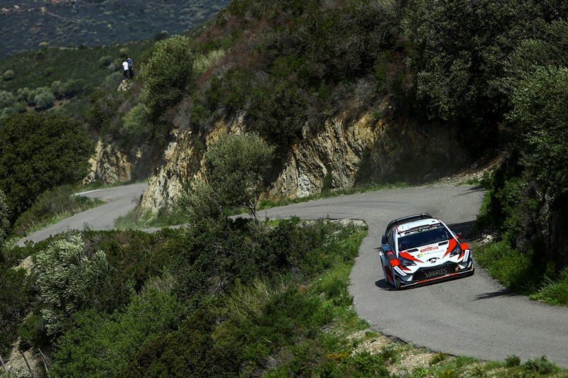
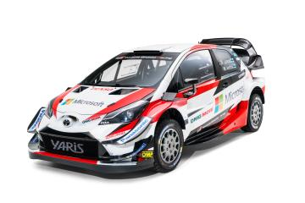

WRC Tour de Corse 2018

TOYOTA GAZOO Racing World Rally Team is inspired by the motto: “ALL FOR WIN” as it competes throughout the 2019 season. Our goal in 2019 is to fight for all three crowns. All team members are aiming for this big goal together. We look forward to your continuous support!

Press release
URL: https://toyotagazooracing.com/release/2019/#

Press Kit and Event Pictures will be uploaded here
URL: https://www.tgr-dam.com

Summary report of previous event
URL: https://toyotagazooracing.com/wrc/report/2019/03/summary.html

Follow us!
Follow TOYOTA GAZOO Racing WRT:
∇Facebook: https://www.facebook.com/TOYOTAGAZOORacingWRC
∇Twitter: https://www.twitter.com/TGR_WRC (@TGR_WRC)
∇Instagram: https://www.instagram.com/tgr_wrc/ (@TGR_WRC)
∇YouTube: https://www.youtube.com/channel/UCCtALHup92q5xIFb7n9UXVg

Contact

TOYOTA GAZOO Racing PR Office
Email: tgr_pr@tgr-dam.com

TOYOTA GAZOO Racing official website:
https://toyotagazooracing.com/

TOYOTA GAZOO Racing World Rally Team is supported by following partners:

