Lounge Studios Brings Immersive Recording Capabilities to Artists of all Levels with Brand New Neumann Monitor Setups Across Six Studios
New York City’s Lounge Studios has recorded everyone from Solange to Jay Balvin, but still honors its founder’s humble beginnings by enabling indie artists with top recording facilities, including a brand new 7.1.4 Atmos recording studio powered by Neumann KH series monitors.

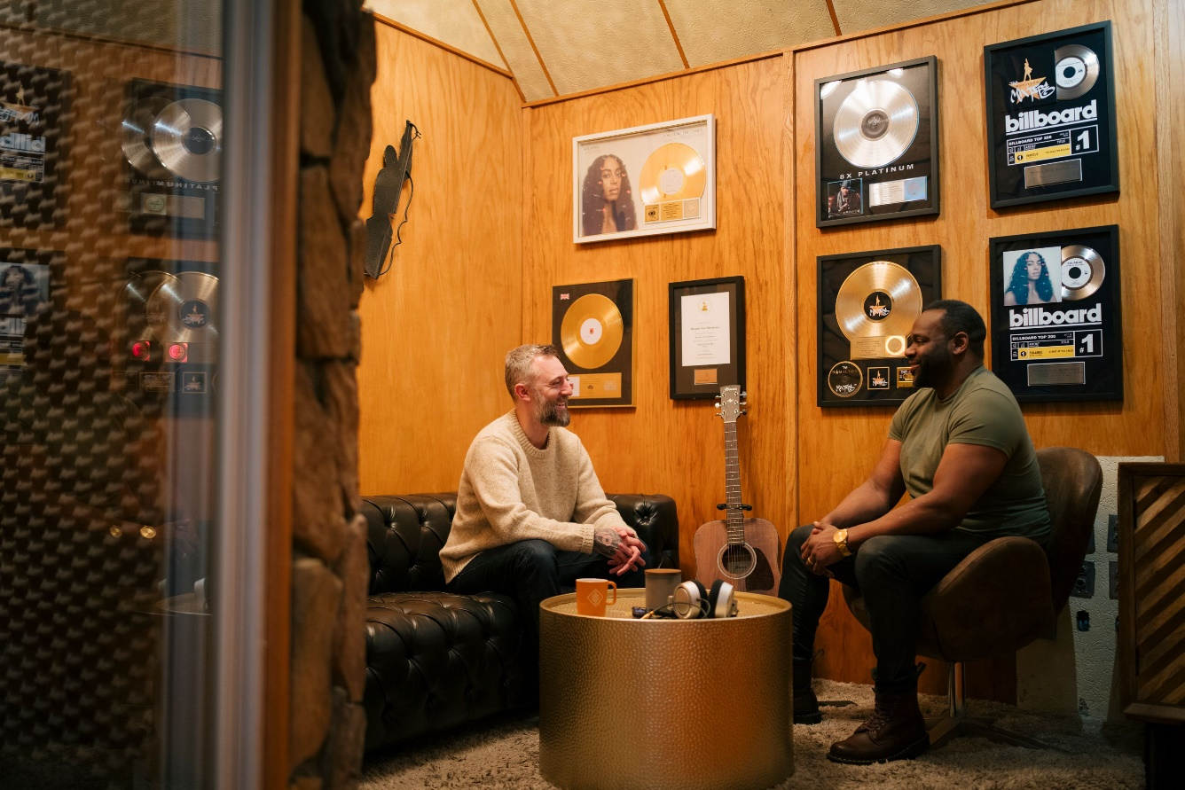

New York, April 2024 – Lounge Recording Studios is a hidden artist’s sanctuary in the heart of Times Square. Made up of 11 professional multimedia and recording studios, Lounge’s CEO and Founder Walt Randall is focused on empowering artists at all levels to create to their potential with cutting edge audio, photo and video equipment. In close collaboration with Head Engineer Mikaelin ‘Blue’ BlueSpruce, Walt has recently outfitted several of Lounge’s bespoke recording studios with over 30 Neumann KH series monitors, including a newly built 7.1.4 Dolby Atmos immersive audio recording space dubbed the Solaris Room.
Lounge Studios is known for its multi-genre approach, founded with the aim of creating a comfortable, lounge-like environment that enhances creative output. Walt Randall shared, “it was important to me to make these places comfortable. When artists come in, I want them to feel like they can feel at home with the engineer and connect with them immediately. I handpick the furniture and aesthetic to convey a relaxed atmosphere.”

Recording established and independent artists across R&B, Rock, Latin, Pop, Gospel, and Hip Hop, Lounge served as the East Coast recording studio headquarters for Atlantic Records and Warner Chappelle from 2013-2016. Today, the studio records indie musicians and their major label counterparts, with the goal of making the finest recording equipment and facilities accessible to artists at all levels.

Hand Built from Scratch
Walt founded Lounge Studios in 2003, not long after arriving in New York City with only $50 in his pocket. However, Walt’s journey really began years earlier, when his promising college football career ended after a series of devastating knee injuries, leading the athlete to embrace his creative side and reignite his long-held passion for music, “I grew up hearing my grandmother sing in our church choir, and everything changed when my mom bought me my first keyboard when I was 12. So, when football was no longer an option, I decided to try music out. I turned our dorm room into a makeshift studio where I recorded local artists and fell into a good groove.”
After returning to his hometown of Cleveland following graduation, Walt built a studio in the attic of his childhood home where he honed his skills, while meticulously planning for the next phase of his career. At 23, he moved to New York City, where he spent his first year working at the Department of Juvenile Justice helping at-risk youth, while saving every penny he made, “That first year, I didn't go partying. I didn't go to the movies. I was eating whatever the cheapest thing was. It wasn't the healthiest, but it was the sacrifice that I was making to achieve my dream. While I worked, I saved up all my money and started looking for spaces to build a studio.”
After months of searching, Walt was able to find the perfect space for Lounge Studios in the heart of Midtown Manhattan. The raw space needed to be built from scratch to accommodate the recording facility that Walt was envisioning, but it was not that simple, “I realized that I couldn't have an apartment and pay rent on a studio I would be building. For my first 12 years in New York, I was homeless. I lived in my truck while I did the initial construction on the studio space, and then I moved to a 5 feet by 8 feet closet in the studio.” Over the years, Walt hand-built all the studios, with tenacity and ingenuity, “I didn't have a lot of money to start with, so I would go to Barnes and Noble and read books on acoustics, construction, electric work. I couldn't afford to buy the books, so I would sit there and read all day, and then I would go back to the studio and start putting it together.”
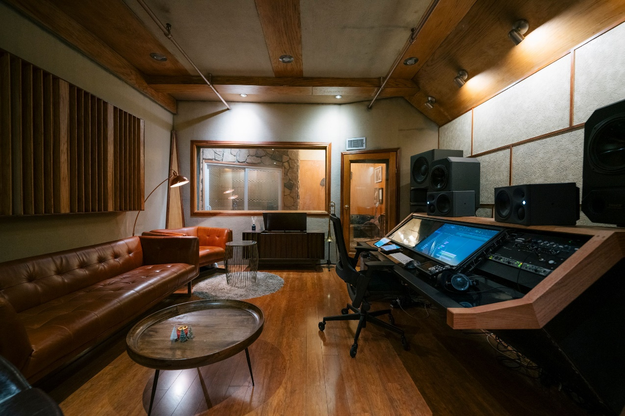
Built to evoke a lounge-like environment, Walt Randall hand built his first studio, Brown Sugar,
in the early 2000s while living in the room’s closet to make ends meet.

The hard work and sacrifice paid off. Walt opened Brown Sugar Recording Studio in May 2004, the first of many hand-built studio spaces that make up Lounge Studios. Relying on a trusty Neumann U 87, the facility opened for business. Not long after, he recruited Mikaelin ‘Blue’ BlueSpruce straight out of New York University to join him as Lounge Studios’ head engineer. Blue shared, “most engineers start their careers by sitting under a big engineer and doing all the assistant work for years and then, when it becomes their turn, they get to step into the engineer chair. My story was a little different. I was able to sit in the head engineer chair from day one, at 22 years old. As I grew, the studio grew. It became this symbiotic relationship. There was this great synergy between me and Lounge Studios, and we grew together."
Future Proofed Facilities
From day one, Walt prided himself on making the highest quality equipment available to artists who chose to work with him, “When I opened my first studio, having a Neumann U 87 was essential for credibility. We've been loyal to the U 87 for a long time, emphasizing consistency in our gear.” Since then, Lounge Studios has multiplied with new rooms being built to accommodate the growing client base while maintaining Walt’s “best in class” philosophy.
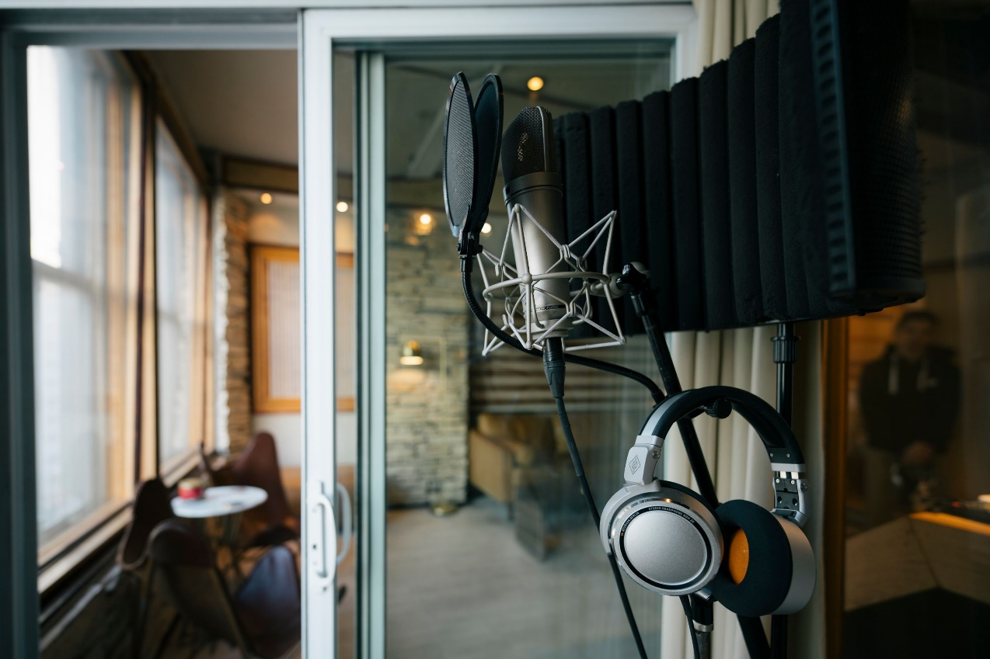
The U 87 was “essential for credibility” for Lounge Studios in the early days and remains a main character in the studios today.
Recently, Blue and Walt realized it was time to upgrade their monitor setup to ensure they are delivering top sound quality. After some research and healthy scepticism, Neumann was one of the contenders, “I had a set of monitors that I was using for a long time. They were classic studio monitors that were no longer in production, so sourcing parts was not feasible,” Blue continued, “a few years ago, I started looking for an upgrade to future proof the studio and I kept seeing posts about Neumann monitors. Initially, I was a little sceptical because I only knew the brand for their microphones, but I should have known that given the history and the craftsmanship that goes into Neumann products, they were going to be good. We decided to outfit all our rooms slowly with the Neumann monitors.”
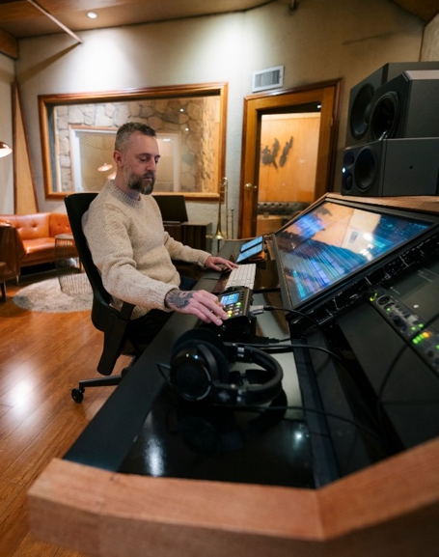
Walt added, “we met Jose Gonzalez, our Neumann sales rep, who recommended the KH series. His positive experience using them in his personal studio, and the consistent praise for Neumann monitors convinced us to try them.” Once they tested out the monitors, the choice was clear for Walt, “I had never heard this much clarity in the details. I was hearing new details in our Grammy winning mixes that I've listened to a million times. We were so blown away that we decided to switch all the rooms at Lounge Studios over to Neumann. Currently, we have 11 rooms in total, but six of them have a monitor section. Our largest studio, Ivory, has already switched from a different brand to the KH 150s, and we've had amazing success there. Our smaller room has moved to the 120s, and it's received rave reviews so far.”
Mikaelin ‘Blue’ BlueSpruce mixes on his KH 310 monitors in Brown Sugar studio, with his trusted NDH 30 headphones at his side.

Bringing Immersive to the Masses
In keeping with Lounge Studios’ ethos of accessible best-in-class audio, Walt and Blue are also making sure that their artists can take advantage of the latest and greatest audio production formats, including Dolby Atmos. Walt has recently built and opened the Solaris Room, a Dolby-certified studio outfitted with 12 Neumann KH series speakers. According to Walt, “the feedback from everyone who has listened to Atmos through Neumann has been mind-blowing.”

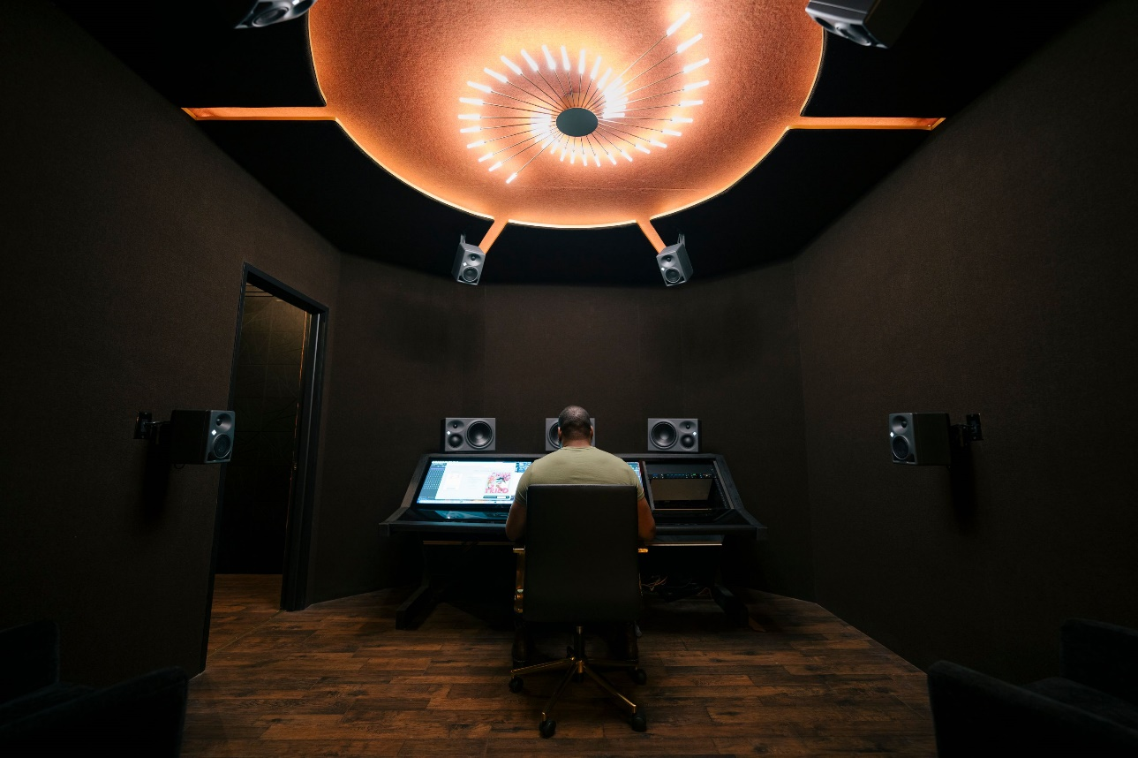
Walt mixes in the Solaris Room – the latest addition to Lounge Studios is certified for Dolby Atmos
and features 12 Neumann KH series monitors to achieve “mind-blowing” immersive audio playback.
Blue offered his own personal anecdote about the Neumann KH 310 monitors playing back immersive formats: “I remember my first experience with the 310s. I had just finished doing a mix for an amazing indie rapper called Kota the Friend. I was in my studio with my old monitors, and I was so happy with the way the mix turned out. I had already sent them to Kota when Walt called me to check out the new 310s in the Solaris Room. I decided to play my favorite song on the album, and it sounded incredible. The stereo image was wide, the detail was there, the high end was bright, and the bass sounded great. This was the best representation of my mix that I could imagine. But that wasn't the thing that convinced me to make the switch,” Blue continued, “Once I heard that song, I had to listen to the whole album on the monitors. When I got to track three, I noticed something was weird with the bass, and started to worry. As I kept going through the album, there were three songs where the sub bass wasn't right, and I had missed it on my old monitors. As mixers, you must be able to hear the real mix. You can’t have monitors that gloss over mistakes.”
As Lounge Recording Studios continues to grow with diverse studio setups including a secondary Dolby Atmos room currently in construction, Walt continues to build on his dreams and honor his humble roots by democratizing best in class audio for all artists. The secondary Dolby Atmos certified studio called the Eclipse Room will be outfitted in Neumann KH 150 and KH 80 monitors and is set to open later this year. Eclipse will further enable Lounge Studios to bring opportunities for established and indie artists looking to release immersive music. In Walt’s words, “looking at the future of Dolby Atmos, I personally want to play a role in introducing it to more indie artists. Many aren't familiar with immersive, and when they learn about it, the cost can be a deterrent. My goal is to make Atmos accessible, and we are doing that with a service called ‘Atmos My Mix’, which combines technology and processes to make Dolby Atmos affordable for indie artists.”
Link to video: Neumann on YouTube
To learn more about Lounge Studios, visit: www.loungestudiosnyc.com

About Neumann
Georg Neumann GmbH, known as “Neumann.Berlin”, is one of the world’s leading manufacturers of studio-grade audio equipment and the creator of recording microphone legends such as the U 47, M 49, U 67, and U 87. Founded in 1928, the company has been recognized with numerous international awards for its technological innovations. Since 2010, Neumann.Berlin has expanded its expertise in electro-acoustic transducer design to also include the studio monitor market, building upon the legacy of the legendary loudspeaker innovator Klein + Hummel. The first Neumann studio headphones were introduced in 2019, and since 2022, the company has increased its focus on reference solutions for live audio. With the introduction of the first audio interface MT 48, and its revolutionary converter technology, Neumann now offers all the necessary technologies needed to capture and deliver sound at the highest level. Georg Neumann GmbH has been part of the Sennheiser Group since 1991 and is represented worldwide by the Sennheiser network of subsidiaries and long-standing trading partners. www.neumann.com
Stay up to date and follow us on: FACEBOOK I INSTAGRAM I YOUTUBE

Local Press Contact:
Daniella Kohan
daniella.kohan@sennheiser.com
+1 (860) 227-2235

Press Contact Neumann:
Raphael Tschernuth
raphael.tschernuth@neumann.com
+49 (030) 417724-67

