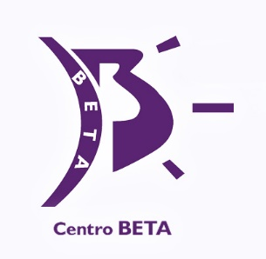
ZIORTZA ZARAUZA

Centro Beta

Ziortza Zarauza, born in 1976 in Guipúzcoa (Donostia) has been a hairdresser for more than 10 years at Centro Beta, located in San Sebastián. The daughter and granddaughter of hairdressers, she entered the profession working alongside the team at the academy of her father - Gonzalo Zarauza. Her extensive and continuous training endorses her as a professional and teacher in the sector of hairdressing and styling. Zarauza has qualified as a specialist in hairdressing and superior technique in integral aesthetics and personal image counselling. Her interest in learning has led her to attend an endless number of courses and workshops on image counselling, natural cosmetics and perfumery, extensions and postures, fashion collections and trends, volumes and textures, hair treatments, bride's updos and men’s cuts.
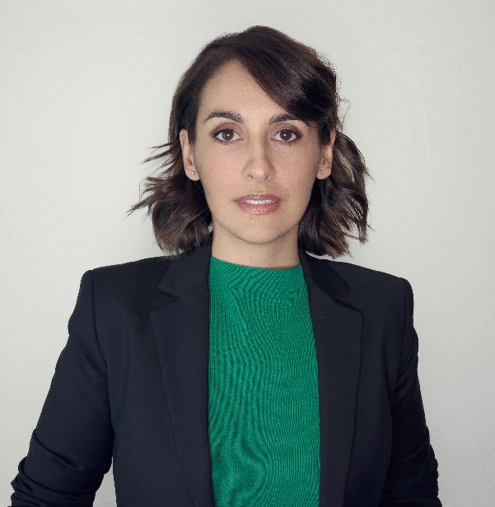
The continuous training, experience and passion in her work, has led her to discover her true vocation as a teacher. From this, she has begun to develop diverse programs with various materials for the courses, which will allow her to provide training to professionals from the sector. Nowadays, Ziortza finds herself coordinating medium-level hairdressing and aesthetic training courses.
She combines her role as a trainer, by collaborating and working with companies in the sector, among others, as the creator of the "Yes I Do" image for REVLON Professional (2015), as a guest at Effervescene (2018) and the Solidarity Show at Cosmobeauty (2019).

ZIORTZA ZARAUZA

Centro Beta

The publication of her work in specialized hair magazines has not gone unnoticed due to the visibility and creativity of her collections. She is the co-author of several textbooks for vocational training that feature editorial titles such as TECHNICAL PROTOCOLS FOR WORKING IN THE HAIRDRESSING SECTOR AND AUDIOVISUAL AND SCENIC PRODUCTION.
Amongst her many achievements, she has received the awards:
- SPANISH COUNTRY WINNER at The Style Master 2014 International Contest
- BEST TECHNIQUE AWARD at The Style Master 2014 International Contest
- Finalist in the "Avant-Garde" category at the Fígaro Awards in 2015 and 2018
- Finalist at the AIPP Awards 2017 in the Avant-garde category
- Prenominated as "Spanish Hairdresser of the Year" in 2016 and 2018 by Club Fígaro
- Winner at the ABS Global Image Awards 2018 in Chicago in the Avant-Garde category.
- Winner Tocado Awards 2020, Best Avant-Garde collection category
- Finalist Avant-Garde Category in the International Visionary Award 2020

Ziortza Zarauza is defined as a woman and a mother, passionate about hairdressing and in love with teaching. She is creative, simple, hardworking and a tireless pursuer of new learning.
.

