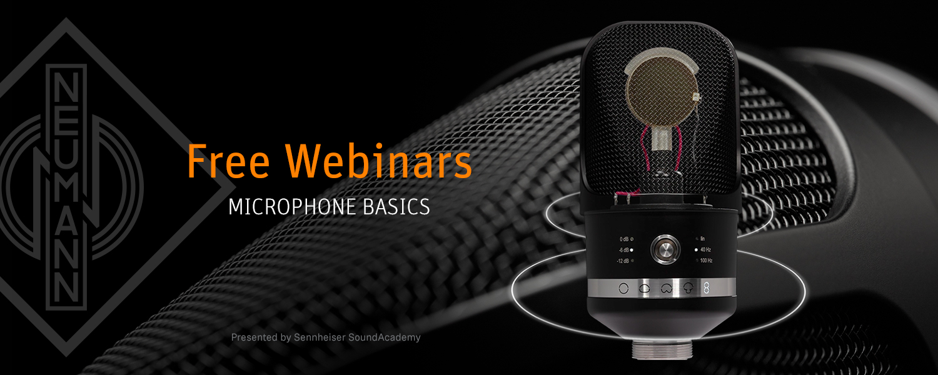

**#AtHomeWithNeumann – Free Live Webinars: Microphone Basics**

***Sydney/Berlin, 2 April 2020:***

***In cooperation with the Sennheiser SoundAcademy, Neumann will be offering detailed webinars on the basics of microphone technology over the coming weeks. In three one-hour sessions, trainer John McGregor will discuss all important aspects of Neumann studio microphones: Starting with the most important theoretical principles, through practical tips and application hints, to product care and maintenance.***

As we all take care to stay safe and stay home, this is an excellent opportunity to expand or refresh one’s skills and knowledge. The first session will be available on Friday, April 3, (5.30 p.m. and 10.30 p.m. AEDT) and Saturday, April 4 (3:00 a.m. AEDT). The other two sessions will follow on April 17 and 24. All webinars will be presented in English.

Interested parties can register at: <https://www.neumann.com/webinars>

For an overview of all the free Sennheiser SoundAcademy webinars on offer, please visit <https://www.sennheiser.com/webinars>

Neumann has also created a new hashtag **#AtHomeWithNeumann** to help guide its customers, fans and followers to informative video content that will be provided during the coronavirus crisis.

**About Neumann**

Georg Neumann GmbH, known as “Neumann.Berlin”, is the world’s leading manufacturer of studio microphones and the creator of recording legends including the U 47, M 49, U 67 and U 87. Founded in 1928, the company has been recognized with numerous international awards for its technological innovations. Since 2010, Neumann.Berlin has expanded its expertise in electro-acoustic transducer design to also include the studio monitor market, mainly targeting TV and radio broadcasting, recording, and audio productions. The first Neumann studio headphone was introduced at the beginning of 2019. Georg Neumann GmbH has been part of the Sennheiser Group since 1991, and is represented worldwide by the Sennheiser network of subsidiaries and long-standing trading partners. Website: www.neumann.com.

**Press Contact:**

Andreas Sablotny

andreas.sablotny@neumann.com

T +49 (030) 417724-19

**Local Press contact:**

Gabby Wallace

[gabby.wallace@hausmann.com.au](mailto:gabby.wallace@hausmann.com.au)

0431 045 932