Superior sound in a new color
Sennheiser launches sandy white color variant of MOMENTUM Wireless

Wedemark, April 2, 2020 – Sennheiser has introduced a new color variant of MOMENTUM Wireless, the third generation of the audio specialist’s acclaimed MOMENTUM range. In addition to the classic black variant, the headphones are now available in a sandy white color scheme, offering an on-trend lighter alternative, with subtle pale tones bringing a fresh new look to their luxurious design. Both color variants are currently available at a promotional price of 349 EUR.

Hear the difference
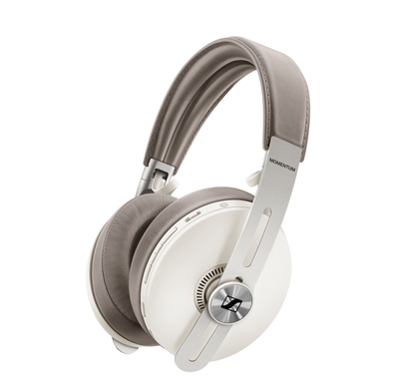
The MOMENTUM Wireless headphones offer outstanding sonic performance, reproducing the balanced depth and precision of studio-quality audio thanks to Sennheiser’s high-quality 42mm transducers. Bluetooth 5 compatibility and support for codecs including aptXTM, AAC, and SBC ensure a flawless listening experience, while aptXTM Low Latency perfectly synchronizes audio with onscreen visuals. Additionally, listeners can tailor the audio experience to their taste via the Sennheiser Smart Control app.

In addition to the classic black variant, the MOMENTUM Wireless headphones are now available in a sandy white color scheme.

Never lose your rhythm again
Auto On/Off instantly turns on or off playback as the earcups are folded open or closed, while Smart Pause uses proximity sensors to automatically pause audio when the headphones are removed and to resume playback when they are slipped back on. The MOMENTUM headphones also feature one-touch access to voice assistants such as Siri, Amazon Alexa and Google Assistant as well as an intuitive three-button interface for controlling music and calls.

Adapting to every environment with ANC and Transparent Hearing
Three Active Noise Cancellation modes block out any distraction, helping listeners create an oasis of calm – even in times like these when there’s lots of extra noise created by a home full of family members or flat mates. Additionally, the headphones offer a Transparent Hearing function that lets listeners enjoy their music while still retaining awareness of ambient sounds in their surroundings.

Three ANC modes help listeners create an oasis of calm – even in times like these when there’s lots of extra noise created by a home full of family members.

Harmony of form and function
The headphones’ pearl-blasted stainless steel sliders and the genuine sheepskin leather of the earpads not only feel luxurious, but also enhance durability and wearing comfort – even on the long listening sessions made possible by the 17-hour battery life. The folding headband design allows for easy storage and portability, while Tile technology offers extra peace of mind, as the integrated Bluetooth tracker lets users find their headphones via the Tile app.

The classic black and the new sandy white color variant of MOMENTUM Wireless are currently available at a special promotional price of 349 EUR.

About Sennheiser
Founded in 1945, Sennheiser is celebrating its 75th anniversary this year. Shaping the future of audio and creating unique sound experiences for customers – this aim unites Sennheiser employees and partners worldwide. The independent family company, which is managed in the third generation by Dr. Andreas Sennheiser and Daniel Sennheiser, is today one of the world’s leading manufacturers of headphones, loudspeakers, microphones and wireless transmission systems. In 2018, the Sennheiser Group generated turnover totaling €710.7 million. www.sennheiser.com
Global Contact

Jacqueline Gusmag
jacqueline.gusmag@sennheiser.com
T +49 (0)5130 600-1540

