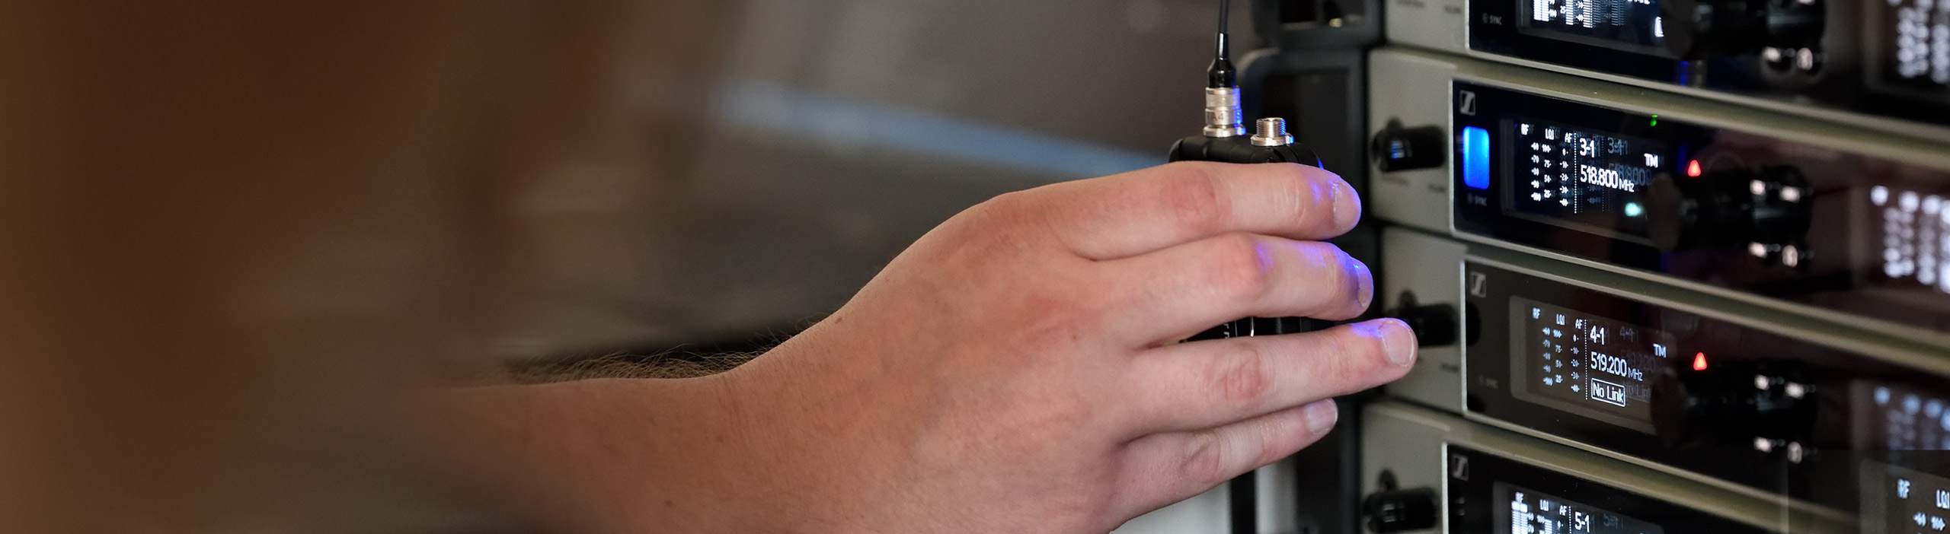

#DontStopTheEducation

Independent Artists Round Table, Immersive Audio and a chat with Blake Shelton’s Crew

Wedemark, May 20, 2020 – Sennheiser’s #DontStopTheEducation initiative continues with three more live round-table discussions with fantastic guests from the music industry. The new round tables offer top tips from independent artists, expert insights on immersive audio and a chance to hear a discussion with the talented crew members supporting country artist Blake Shelton. Other live webinars in the series will look at the planning and execution of big TV productions, antenna system design, RF wireless basics and the optimization of IEM systems. As well as offering the inside track on their art, professions and industries, all panellists and hosts are looking forward to answering your questions.

Round Table Discussion
Tuesday, May 26, 2020, 17:00 Berlin time (16:00 London, 11:00 New York, 15:00 UTC) Independent Artists – Streaming, Technical Approach, Growing an Audience
Sennheiser hosts Andy Egerton and Tim Moore will be joined by Tom Wurth, Katie Cole, Jess Guise and Frank Turner to discuss how independent artists produce and market their music. As always, the panellists will be happy to answer questions from the audience. Please register here: https://zoom.us/webinar/register/WN_P7o7pHQBTAm5LnB2ZpPRUw.

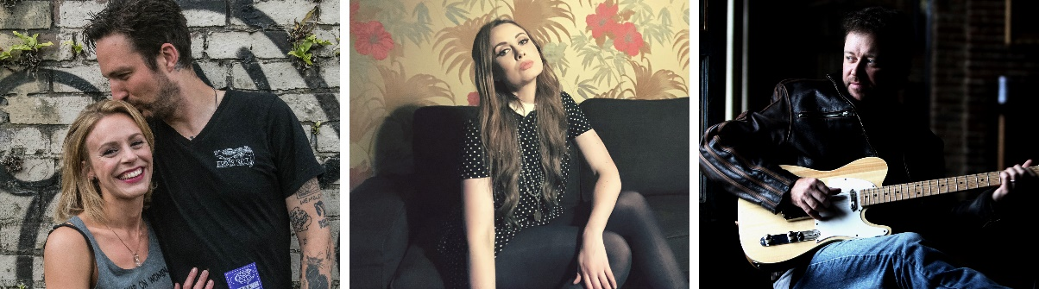
The panellists in the Independent Artists Round Table: Jess Guise, Frank Turner, Katie Cole and Tom Wurth

About the panellists
Jess Guise
UK musician Jessica Guise is very much the voice and heart of folk-pop quartet Guise. She is also the owner of Whatever Guise Productions and producer of critically acclaimed “Gin for Breakfast” in London’s Westend. Jess is a Westend actress who has appeared in The Great Gatsby and a screen actress on Eastenders, Casualty and The Musketeers.

Frank Turner
Frank Turner is a UK solo musician who is accompanied by his backing band The Sleeping Souls in the studio and during live performances. Frank’s latest album ‘No Man’s Land’ is his eighth solo record and his fourth consecutive UK Top Three album release. The concept album was accompanied by a 13-part podcast entitled ‘Tales from No Man’s Land’ which debuted at #2 on the UK charts, also making Apple Music’s ‘Best Listens of the Year’ review. Frank is also the founder of his own Lost Evenings Festival, winning the AIM award for Best Independent Festival in its inaugural year in 2017. He has carved out a career as a hard-touring, punk-folk troubadour with a diehard fanbase – who are drawn to a singer-songwriter that refuses to play the game and does things on his own terms.

Katie Cole
Nashville-resident Katie Cole was born in Australia and is a musician in The Smashing Pumpkins. She is an independent Americana artist who releases label-competitive audio, video and content. The self-proclaimed cat lady is also a Youtuber and describes herself as a “social media conqueror and tech wizard – well, maybe apprentice wizard.”

Tom Wurth
Tom is a Grammy-nominated vocalist, songwriter, touring artist and musician based in Nashville. He has worked with iconic, multi-genre performers in the studio as both an artist and producer. Tom has developed his own path for quality audio, video and marketing of his music and that of other artists.

Round Table Discussion
May 27, 2020 17:00 Berlin time (16:00 London, 11:00 New York, 15:00 UTC)

Immersive Audio Discussion with Andrés Mayo & Martín Muscatello
Brian Glasscock of the Sennheiser AMBEO Immersive Audio team will welcome Andrés Mayo and Martín Muscatello for the first in a regular series of presentations and discussions with leading immersive audio practitioners. Registrations are now open at: https://zoom.us/webinar/register/WN_G_6cEkeXRp27IV-vqbTdmA

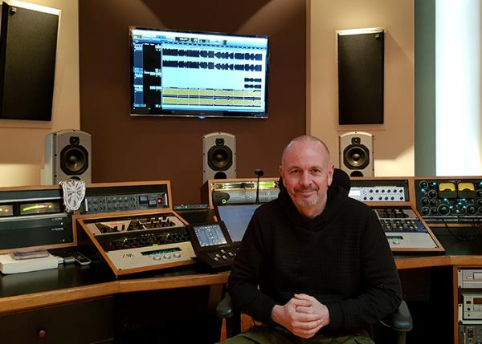 | Andrés Mayo (pictured) and Martín Muscatello will speak about their immersive Album #1

Andrés and Martín will be speaking about their “Album #1” project, which Andrés describes as being their first project exclusively tailored for immersive audio listeners: “We produced six tracks using all the available techniques, including Ambisonics, binaural and standard close-miking recordings, 360 spatialization via dedicated software, even re-amplification techniques for more complex object location. We aim to show the possibilities of 360 technology but at the same time, and more importantly, we want to develop an artistic project that preserves musicality on top of everything else.”

About the panellists
Andrés Mayo
Andrés Mayo, former President of the AES (Audio Engineering Society), is an audio engineer and music producer who has pioneered the art of mastering since 1992. He boasts credits in more than 3,000 albums released in vinyl, CD, DVD, Blu-Ray, streaming and 360-degree audio formats. He won two GRAMMY Awards and seven Gardel Awards for Technical Excellence. Member of the P&E Wing Advisory Council at NARAS, he also runs his own company – Andrés Mayo Mastering & Audio Post – and is the founder of @360MusicLab, a company devoted to the production of immersive audio.

Martín Muscatello
Martín Muscatello is a music producer based in Buenos Aires. After graduating from EMBA, he joined the staff of El Pie Recording Studios, where he earned credits in a large number of albums. Today, he runs his own production facility in “El Mejor” studio. He is part of 360MusicLab, developing and researching immersive audio and producing 360 audio content. Also, he is a professor in the Escuela de Música de Buenos Aires (Buenos Aires Music School) in the Music Production 2 and Mix 3 academic areas.

Round Table Discussion
June 2, 2020 17:00 Berlin time (16:00 London, 11:00 New York, 15:00 UTC)

Crew Call – Blake Shelton
Sennheiser hosts Tim Moore and Andy Egerton welcome members of country artist Blake Shelton’s team. The guests will include members of the band, the audio team, and other production staff who will discuss how a crew works as a unit to approach audio, wireless, planning and the execution of a major tour. Brad Baisley (Monitor Engineer), Tracy Broussard (Drummer), Jeff Parsons (FoH), Ed Hardin (Drum Tech) and Jason Herndon (Guitar Tech) will share unique insights and are happy to answer questions from the audience. Please register at https://zoom.us/webinar/register/WN_1WC_1gcuTkaP9iI49ifa6Q.

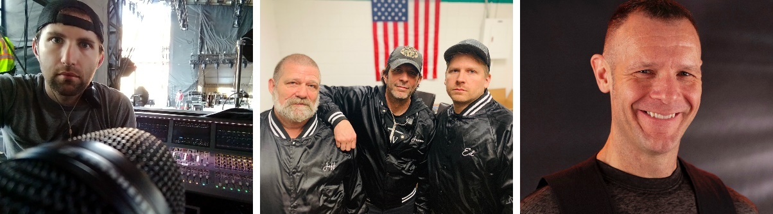
Panellists in the Crew Call: Brad Baisley, Jeff Parsons, Jason Herndon, Ed Hardin and Tracy Broussard (from left to right)

Webinar
May 28, 2020, various times

Planning and Executing a Big Live TV event
Sennheiser RF expert Volker Schmitt will describe how to plan and execute a major live TV event. Using the 2019 Eurovision Song Contest as an example, Volker will talk about the importance of planning and system redundancy as a key element and answer any audience questions.

This webinar is offered at three different times to allow as many people from around the globe to tune in as possible.
08:30 Berlin time: https://zoom.us/webinar/register/WN_cOTkalnxS8eaDNfpWEqZxw
13:30 Berlin time: https://zoom.us/webinar/register/WN__d-YDHZ7S7uXrNphKP-VeQ
18:00 Berlin time https://zoom.us/webinar/register/WN_aCWCC3w2RI-9MC97L7lpMA

RF wireless expert Volker Schmitt will talk about planning and executing major live TV events | 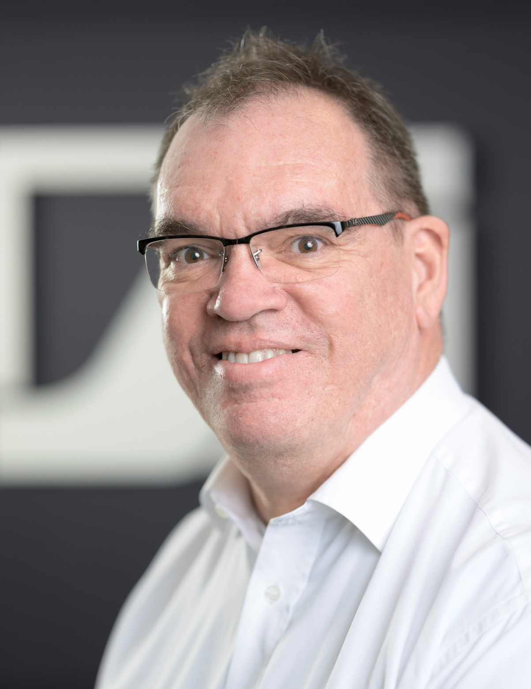

Webinar
June 3, 2020, various times

Antenna System Design (including multi-zone set-ups)
Sennheiser RF specialist Jonas Naesby will share best practice examples of designing antenna systems. He will explain how to calculate gain structures and how to extend coverage by setting up additional antenna zones.

This webinar will also be offered at three different times:
08:30 Berlin time: https://zoom.us/webinar/register/WN_oD_3pPSVQe2YCxNaP_0HEA
13:30 Berlin time: https://zoom.us/webinar/register/WN_V1kxPApQTsObck4c2QVR3Q
18:00 Berlin time: https://zoom.us/webinar/register/WN_7RFznWqGTjye9vdCSumTvQ

Jonas Naesby getting ready for a live webinar | 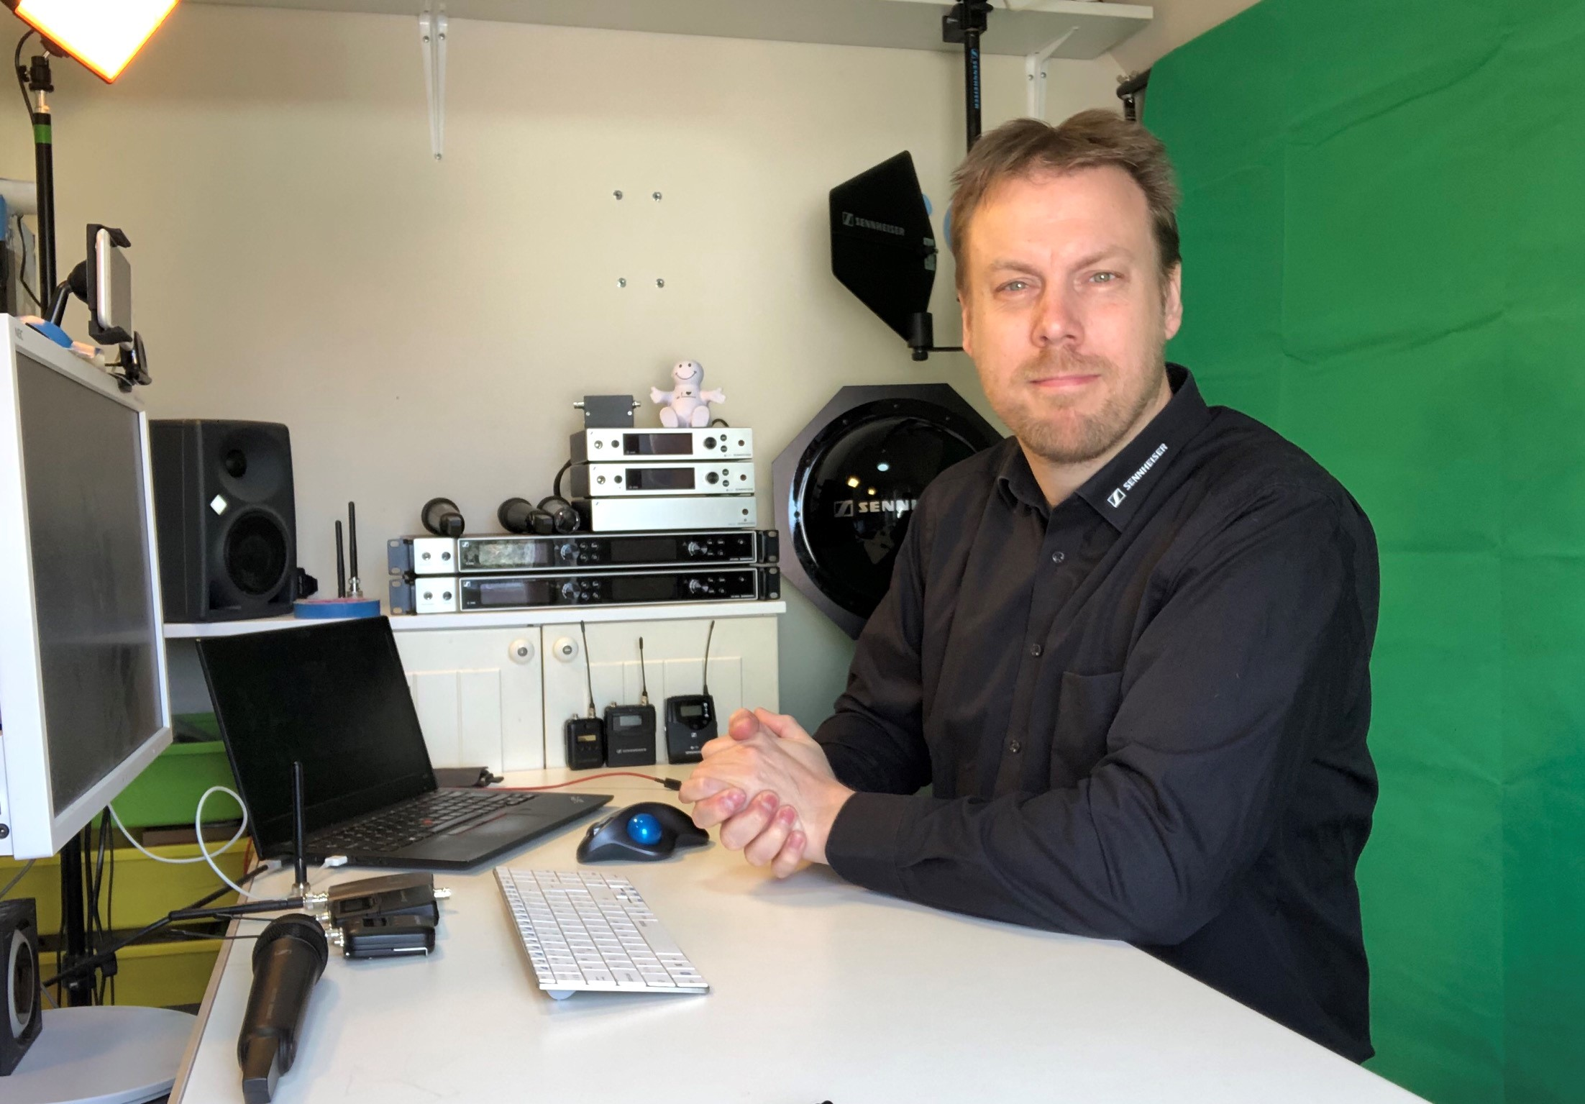

Webinar
June 4 and 5, various times

Fundamentals of Wireless Mics
In this two-hour webinar, RF expert Andrew Kornstein will provide a deep dive into wireless microphone technology. Participants will learn the theory and physics behind the electromagnetic spectrum and how it applies to day-to-day operation of wireless microphones. Andrew will also discuss many practical ways to effectively plan and deploy RF wireless systems, maximize the channel count and ensure optimum operational stability even in the most challenging RF environments.

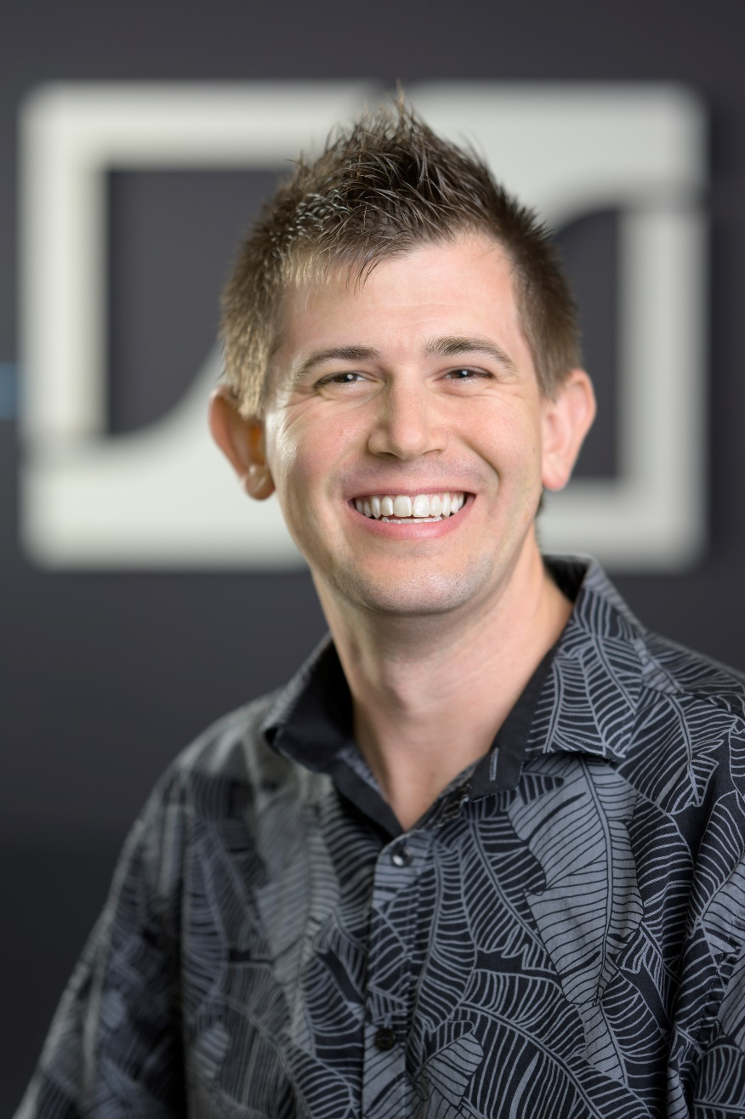 | Andrew Kornstein will provide a deep dive into wireless microphone technology

Again, this webinar will be offered at three different times:
June 4, 16:00 Berlin time: https://zoom.us/webinar/register/WN_-R_OiIcGSt6ko1SYITeUhQ
June 4, 20:00 Berlin time: https://zoom.us/webinar/register/WN_RuypjTqtQCuMyhtpGKJwNg
June 5, 01:30 Berlin time: https://zoom.us/webinar/register/WN_GTSBpDQeQ0OX2QZMbs8QCg

Webinar
June 8, various times

IEM System Optimization
RF wireless expert Jonas Naesby will show how to set up multi-channel IEM systems and do live walk tests for webinar participants to demonstrate how adjusting a few simple settings will significantly improve sound quality and coverage.

This webinar will be offered at three different times:
08:30 Berlin time: https://zoom.us/webinar/register/WN_2f1eTTGpRfGKe96AHGTckQ
13:30 Berlin time: https://zoom.us/webinar/register/WN_x4MjUtfUQeqze6SvSaMxiQ
18:00 Berlin time: https://zoom.us/webinar/register/WN_Ne_5-CTuR5u2wYXd_gW0AQ

https://www.sennheiser.com/webinars

The high-resolution images accompanying this press release can be downloaded at https://sennheiser-brandzone.com/c/181/zDWoH5v5.

About Sennheiser
Founded in 1945, Sennheiser is celebrating its 75th anniversary this year. Shaping the future of audio and creating unique sound experiences for customers – this aim unites Sennheiser employees and partners worldwide. The independent family company, which is managed in the third generation by Dr. Andreas Sennheiser and Daniel Sennheiser, is today one of the world’s leading manufacturers of headphones, loudspeakers, microphones and wireless transmission systems. In 2018, the Sennheiser Group generated turnover totalling €710.7 million. www.sennheiser.com

Global Press Contact

Stephanie Schmidt
Stephanie.schmidt@sennheiser.com
+49 (5130) 600 – 1275

