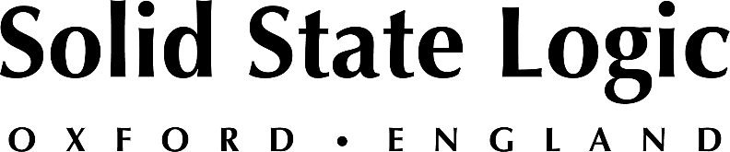

Solid State Logic to Showcase New SSL Live L650 Console and Latest Developments to System T Broadcast Production Platform at ISE 2022

SSL to present production tools and workflows to support the next-generation of events, touring and broadcast production, as well as latest in hybrid production tools for studio, post production and content creation, including UF8 and BiG SiX.

Barcelona, May 5, 2022 — Solid State Logic [Stand 7K400] will be featuring its new SSL Live L650 console and V5.0 software at ISE 2022, scheduled to occur at Fira Barcelona, Gran Via between May 10 - 13. Be among the first to experience the new SSL Live 650 — their most powerful SSL Live console to date — learn about ‘Plus Processing Packs’ new processing tools, integrated control solutions, and much more.

The new SSL Live 650 console and its smaller L450 sibling— combined with the new SSL Live V5 software — deliver all the power needed for the next generation of installed sound, event space audio and touring productions. In addition to the new consoles, 'Plus Processing Packs' are now available for the existing SSL Live console range as users look to keep their current SSL Live inventory at the cutting edge of production capabilities. Book an appointment with an SSL representative at ISE Show to discuss upgrade paths.

SSL will also be presenting its TCR solution, part of the System T broadcast production platform. TCR provides the same ahead-of-the-curve AoIP implementation, operator workflows and remote production capabilities as larger S300 and S500 surfaces, but all from within a 3U rack. Latest developments to System T include:
- New TE1 & TE2 Tempest Engines featuring scalable Pay-As-You-Go licensing capabilities designed to work in harmony with your production requirements.
- Flexible, multi-operator remote production workflows.
- NGA / Immersive production capabilities; channel and bus formats with 3D panning.
- Integrated control of Shure Axient wireless mics and Dante enabled Rednet MP8R Mic IO directly from the console.

In addition to its SSL Live and System T offerings, SSL will be presenting a range of production tools focused on content creation, music, and post-production, including its recently launched THE BUS+, BIG SiX console, UF8 and UC1 controllers, SSL 2 / 2+ interfaces and much more.

SSL is pleased to be attending ISE in Barcelona again and looks forward to meeting with attendees. To book an appointment, please visit https://www.solidstatelogic.com/events/ise-show-2022.

Solid State Logic is the world’s leading manufacturer of analogue and digital audio consoles and provider of creative tools for music, broadcast, live and post production professionals. For more information about our award-winning products, please visit: www.solidstatelogic.com.

###
For further information contact:
Jeff Touzeau
+1 (914) 602-2913
jeff@hummingbirdmedia.com

Ross Gilbert
+44 (0) 1865 842300
rossg@solidstatelogic.com

