For immediate distribution

SonoTone Introduces Fusion Series Premium Electric Guitar & Bass Strings

Launched at The 2020 NAMM Show, SonoTone Fusion series premium guitar and bass strings feature a custom alloy to produce brilliant, balanced tone and enhanced tactile feel
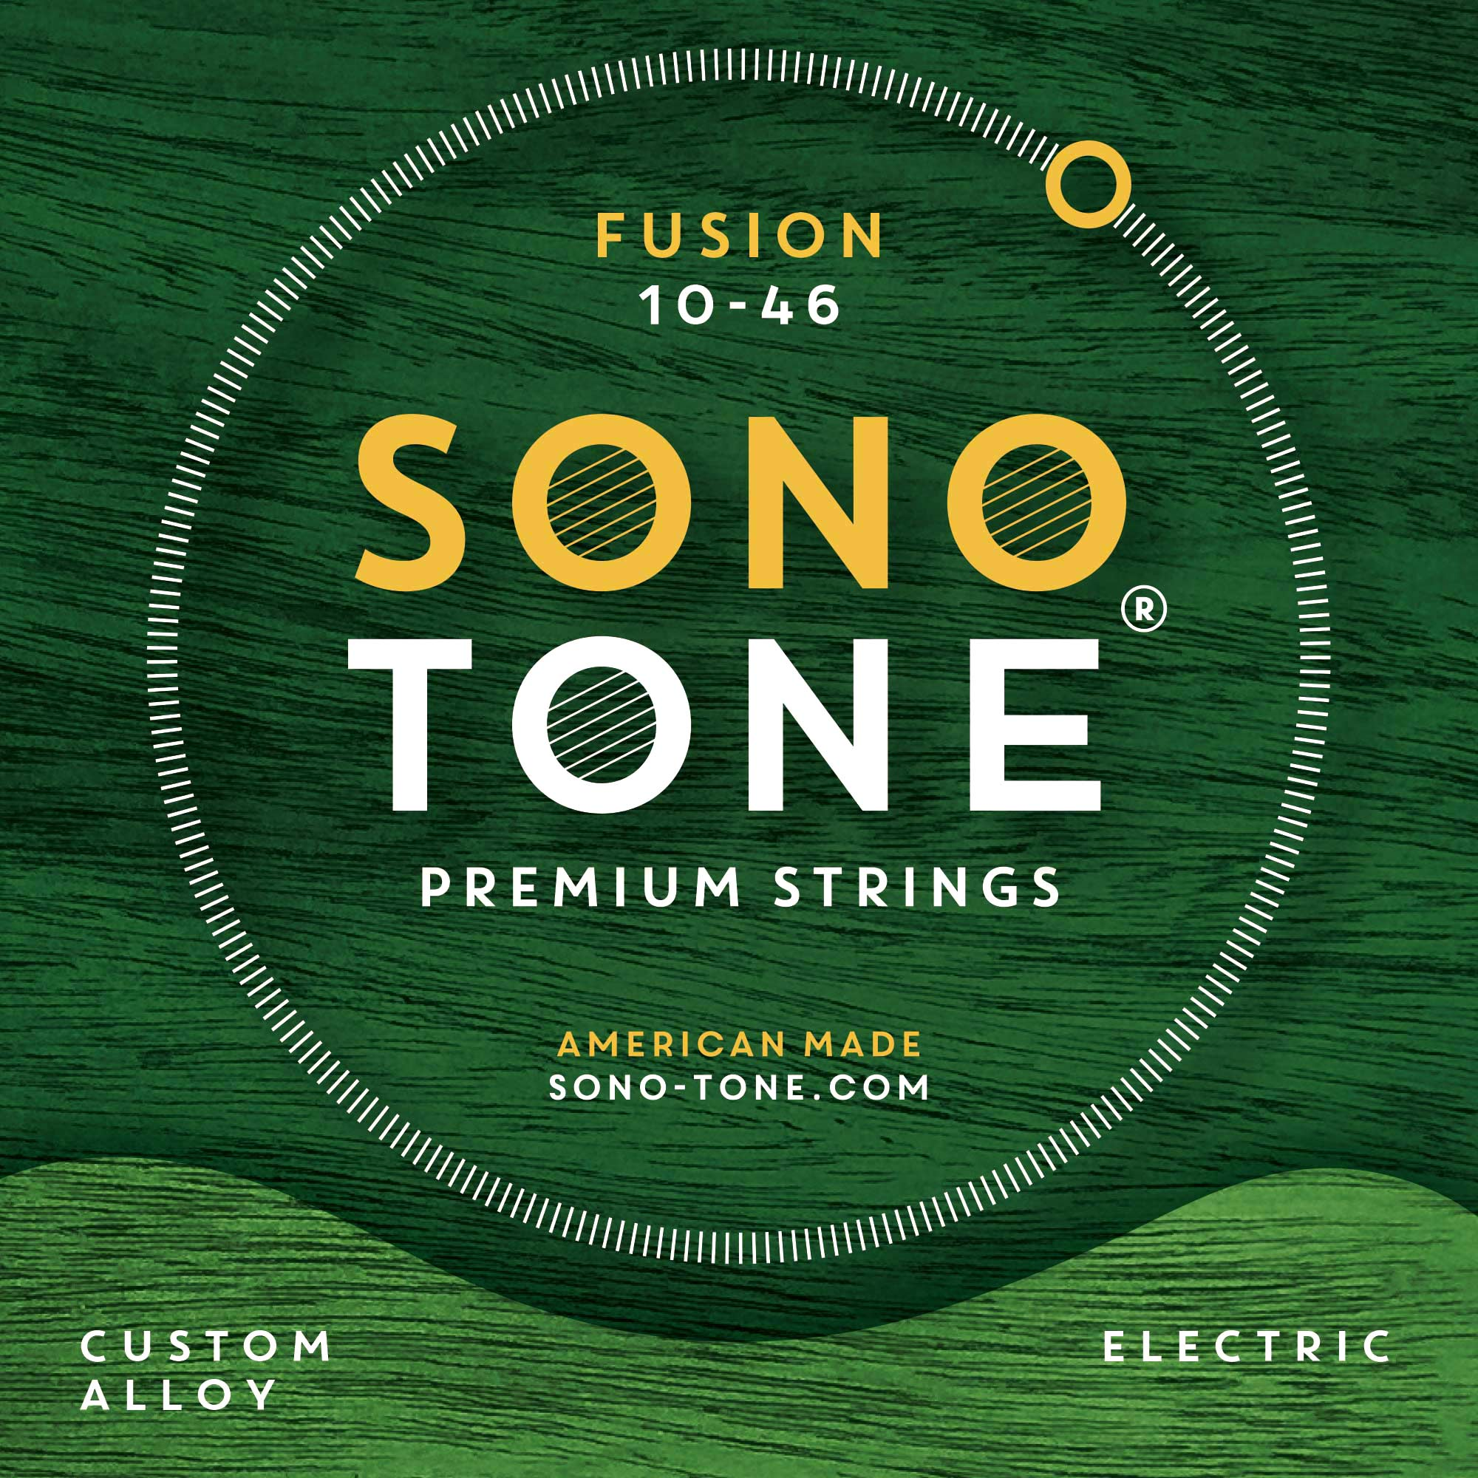
Anaheim, California, January 18, 2020 —SonoTone, the Massachusetts-based manufacturer of boutique, premium guitar strings, has debuted its Fusion series of electric guitar and bass strings, offering serious musicians, hobbyist players and vintage guitar collectors the opportunity to outfit their new, used or vintage instruments with strings formulated to stretch the tonal potential of any guitar.
Now the string of choice for professional guitar players, like Camilo Velandia, in addition to a growing legion of professional and amateur musicians, vintage instrument collectors and tone aficionados, SonoTone Fusion series strings will project a sound that is more flexible and harmonically vibrant — with a punchy, responsive attack to give players enhanced expressiveness and articulation.
In addition to improving a guitar's overall sound, players will feel the difference as soon as SonoTone Fusion series strings have settled in to the guitar. Made with the highest-quality materials available, SonoTone premium strings combine a higher percentage of iron and nickel, as well as a custom wrap, strengthening the strings’ magnetic properties while providing plenty of warmth. Whether players use SonoTone Fusion series strings for country, rock, jazz, blues, fusion or all of the above, SonoTone strings remain pliable and vibrant for the entire duration each string-set's lifespan.
Now available directly from www.sono-tone.com in the U.S. and in select European countries through Fulfillment by Amazon, as well as in Japan through the manufacturer's distribution partner, SonoTone Fusion series acoustic guitar strings are available in three gauge sets (9-42, 10-46, 10-52, 11-48) for $18.99 each; Fusion series standard 4-string bass guitar strings (45-105) are available for $69.99 each
Fusion series offers enhanced comfort and playability
The SonoTone Fusion series represents the culmination of over three years of experimentation with various materials and manufacturing techniques by SonoTone founder P.K. Pandey. Having spent more than 25 years on a quest for impeccable tone, both as a studio recording engineer and A/V systems design/build engineer, Pandey's journey eventually led him to reconsider the fundamental medium and point-of-contact between the player and the guitar, the material source of the instrument's "voice" — the taut, vibrating metal wires fastened to the bridge on one end and to the headstock on the other — i.e., the guitar strings.
Starting from this fundamental level, Pandey tested different metals, amalgams, and manufacturing processes until he eventually found the hard-won formula, known only to him, which at last recreated the vintage tone and feel of the guitars he remembered playing as a kid.
Unlike many contemporary, machine-made strings produced in bulk quantities outside the U.S. at mass-market, commodity prices, SonoTone Fusion strings use only the highest-quality materials available, with additional measures taken throughout the manufacturing process to optimize string behavior, playability, tuning stability and longevity — without using any coatings, so that only the pure elements that make up the string-wire ring out, unencumbered, through the entire body of the guitar.
To find out how SonoTone Fusion series strings will enhance the sound of your own new, used or vintage instrument, please visit www.sono-tone.com for more information.

About SonoTone
SonoTone is a small batch high-quality string manufacturer based in Massachusetts. In a world of commoditized, all-purpose guitar strings sold to the mass market, SonoTone strings are authentic, comfortable and expressive and sold directly to the customer. For more about SonoTone, please visit our website at www.sono-tone.com

Media contacts:
Jeff Touzeau
Public Relations
Hummingbird Media
+1 (914) 602 2913
jeff@hummingbirdmedia.com

David Ball
Public Relations
Hummingbird Media
+1 (630) 885-1795
david@hummingbirdmedia.com

