**NAB 2021: Xytech Launches MediaPulse 10, Takes Personalized Functionality to New Heights**

*The Version 10 update of MediaPulse features upgrades across the entire platform with a continued focus on the user experience*

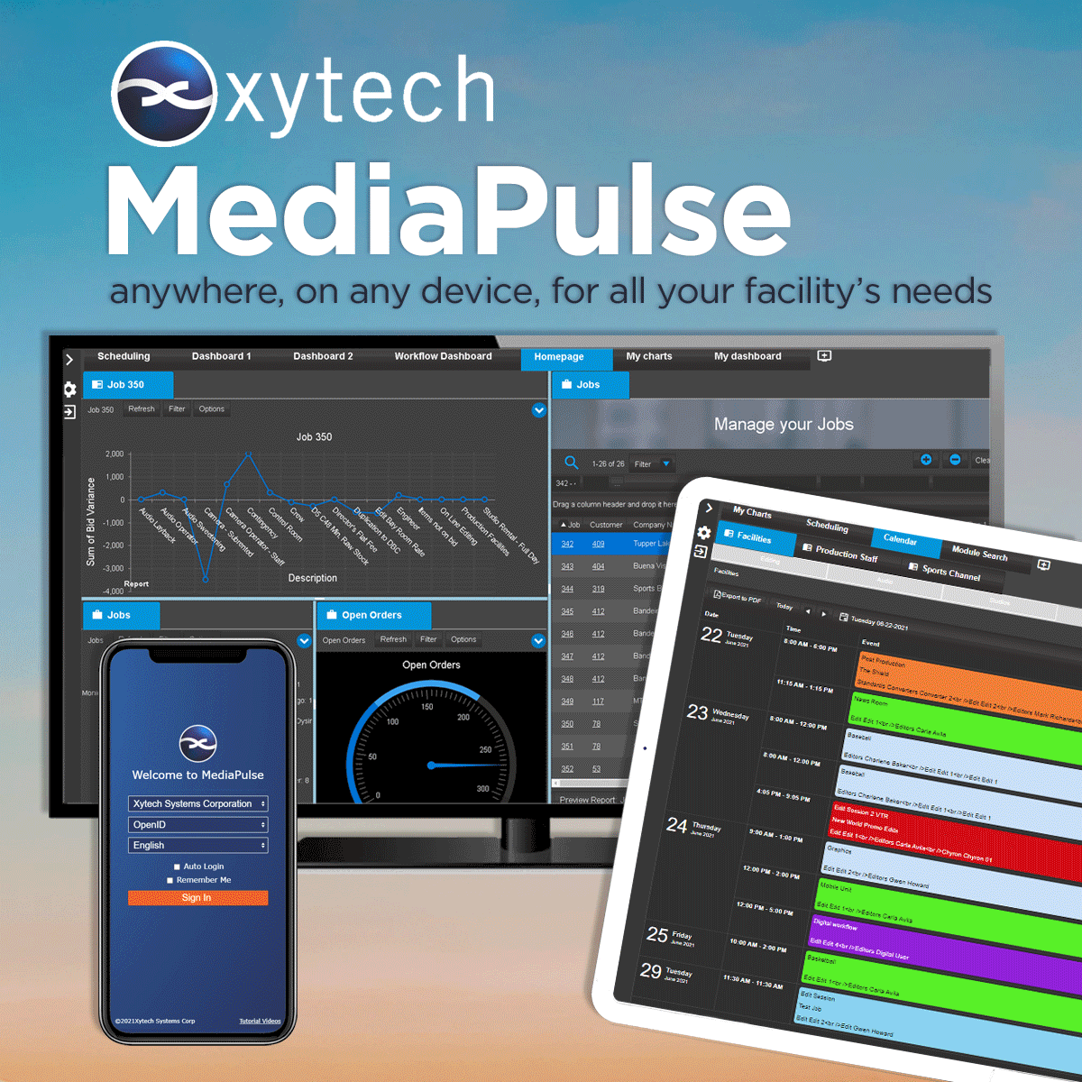**Las Vegas, September 9, 2021 —** [Xytech](http://www.xytechsystems.com), the leader in resource management software for the broadcast, studio, media services and video transmission industries, has announced it will launch MediaPulse 10, at its North Hall booth 5706 during the 2021 NAB Show in Las Vegas.

The 2021 NAB Show marks the start of the post-Covid client outreach program and is Xytech Systems’ first trade show since its acquisition of ScheduALL in April 2021. Over the course of the past year, significant upgrades have been made to the platform to upgrade performance, security, transmission, project budgeting, asset management as well as major updates to the scheduling system and application UI.

“This is the most exciting NAB of my career,” said Greg Dolan, Xytech CCO. “After such a long time, being able to reconnect with customers, colleagues and friends is a thrill. It’s been an exciting time at Xytech; we acquired ScheduALL, moved aggressively to the MediaPulse Managed Cloud, have introduced huge updates and new modules to MediaPulse, and have a great upgrade program for our ScheduALL customers.”

**MediaPulse 10 – Faster, Easier & More Robust**

The three areas of concentration for the update are mobility, the cloud and features to support the changing nature of the business. The MediaPulse Managed Cloud is faster and more secure, and the new mobile features support a customer base with new remote needs in a very different and evolving environment. The new budgeting module addresses the need to control costs on projects of all sizes including large annual facility projections. Xytech is also tapping into the ScheduALL client base and has developed new features across the transmission and scheduling modules to make MediaPulse more impactful for users.

“One of our goals for MediaPulse 10 is to provide every user exactly the functionality they need, when they need it, on the device of their choosing,” Dolan says. “As more and more businesses emerge from the COVID-19 pandemic, the need for reliable solutions able to operate anywhere continues to be vital. This version of MediaPulse 10 provides just this.”

NAB is the first opportunity for Xytech to address their ScheduALL customers. MediaPulse is now the upgrade path for these customers and the platform has added conversion routines and feature updates to provide not only a seamless migration but a rich feature footprint on a state-of-the-art platform. These clients for the first time have a cloud option for their systems with Xytech managing the platform, updates, backups and configuration. The MediaPulse Managed Cloud is highly available with redundancy for all servers with load balancing for to increase performance.

Xytech will be exhibiting at the upcoming 2021 NAB Show from October 10–13, 2021. Located in the North Hall booth 5706, Xytech will demonstrate the new features of its leading facilities management software MediaPulse 10, along with its latest subscription-based software Dash. Those interested in scheduling an appointment may contact Alexandra Kuipers at [akuipers@xytechsystems.com](mailto:akuipers@xytechsystems.com), + 1 (818) 698-4958.

**About Xytech**

For over 30 years, the world’s premiere media companies have depended on Xytech to run their businesses. MediaPulse is the only end-to-end solution for the complete content lifecycle. MediaPulse provides scheduling, automation, asset management, billing and cost recovery for broadcasters, media services companies and transmission facilities in a scalable platform-independent solution. In April 2021, Xytech acquired the ScheduALL brand of enterprise resource management software for broadcasters and media companies, providing end-users with an even more robust product roadmap and greater global service offerings. For more information, visit [xytechsystems.com](http://xytechsystems.com/).

**Media Contacts:**

Katie Kailus

Public Relations

Hummingbird Media

+1 (630) 319-5226

[katie@hummingbirdmedia.com](mailto:lipoff.alexis@gmail.com)

Jeff Touzeau

Public Relations

Hummingbird Media

+1 (914) 602 2913

[jeff@hummingbirdmedia.com](mailto:lipoff.alexis@gmail.com)