

Biuro prasowe better. gaming agency
bettergamingagency.prowly.com

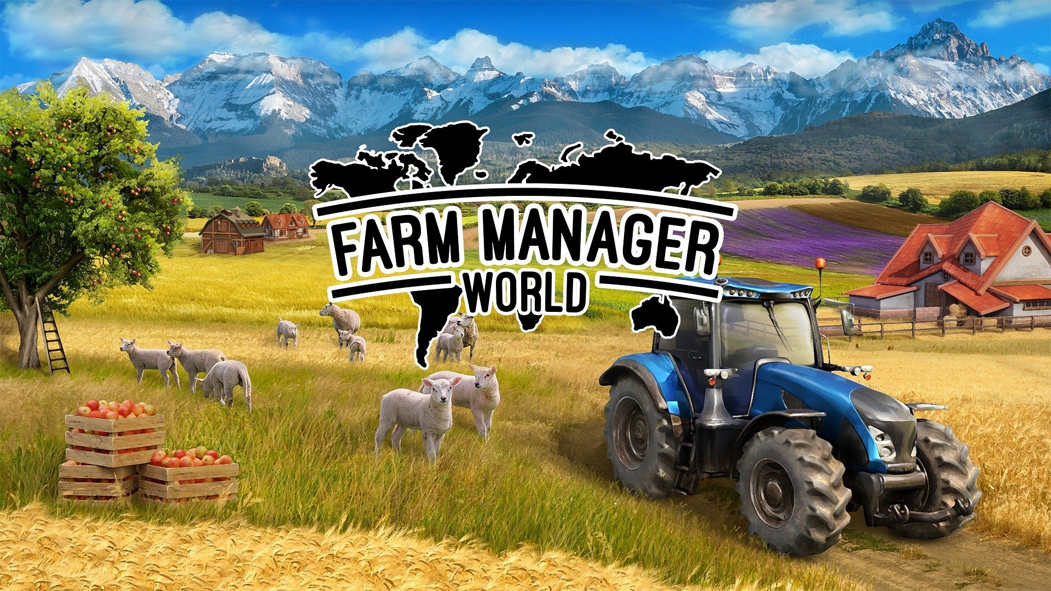

Virtual farmers of the world, unite and get your tools ready! Farm Manager World will soon sprout in Early Access.

The Farm Manager series has shown more than once that players love to build and manage their agricultural kingdoms. The latest installment,Farm Manager World, will allow players to take on this challenge on an even larger scale. The world will be wide open, giving a completely new opportunity to cultivate crops and raise animals in Asia and Central America. Farm Manager World is set to launch in Early Access on Steam soon, offering players the opportunity to embark on this challenge.

WithFarm Manager World you will get the chance to grow a variety of crops from different parts of the world. Start your farm in Europe or Central America, and then expand your agricultural business into Asia in the near future. Although it will not be an easy task though, you will get all the necessary tools to succeed.

Watch the Farm Manager World trailer:

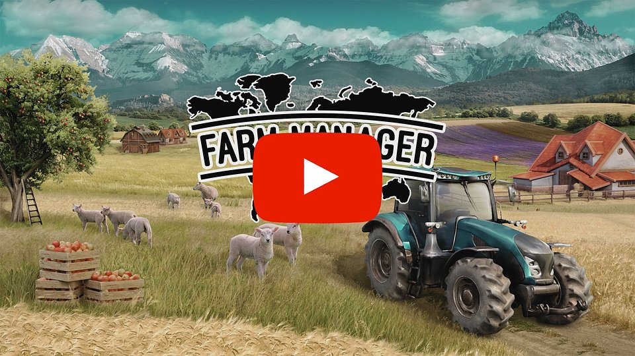
https://www.youtube.com/watch?v=yNnJE51qTY4&ab_channel=SimFarmS.A

Step by step create a well-planned farm full of buildings, specialized equipment, animals, and crops. Conduct research to understand the specific needs of each plant and use the right fertilizers to improve soil quality, pH, and nitrogen levels. By practicing crop rotation, you can increase your harvests. Take care of young animals, buy, feed, and treat them, while also gaining products and selling them when the time is right. Analyze the market, impact global prices, and make smart trades, especially with other players and friends!

Hire skilled workers and assign them to suitable tasks while also acquiring the necessary machines. Monitor the equipment condition and fuel supply to ensure smooth work during harvest. In order to process the collected products, construct factories offering a range of food preparation methods such as baking, fermenting, freezing, pickling, and more. While cultivating organic produce poses challenges with diseases and pests, it is worth the effort.

Key features of Farm Manager World:

⚬ Embrace the challenges of running an agricultural kingdom– it's not all sunshine and rainbows, but the satisfaction of building your farm empire makes it worthy!⚬ How do they plant around the world?– from exotic spices to traditional staples, your fields will be bursting with flavors and colors.⚬ Take care of furry and feathery friends- engage in feeding, breeding, and treating as you carefully raise and trade these lovely farm’s residents.⚬ Get a nice shirt and go to the market– keep an eye on prices, make smart moves, and see your profits soar. Trade and bargain with other players and friends to get the best deals.⚬ Become a master of multitasking– working on the farm means way more than hoeing. Manage a team of workers, a fleet of machinery, and the ever-evolving demands of farm life. Every decision and action impacts the success of your agricultural kingdom.⚬ Work together to build more – Farm Manager World will get mod support, as the developers will provide convenient tools for players to create modifications that will further expand the game's content.

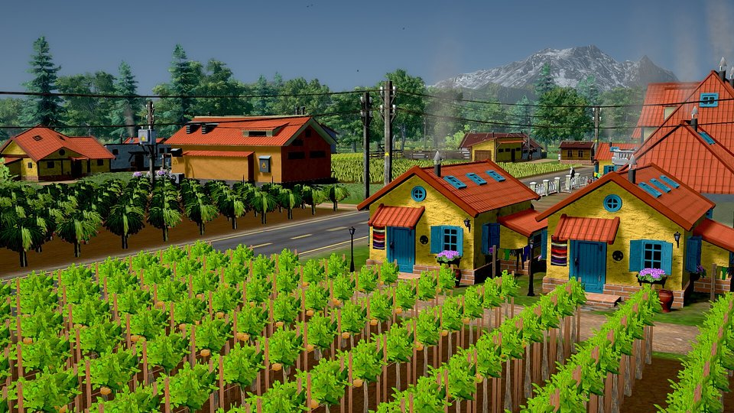

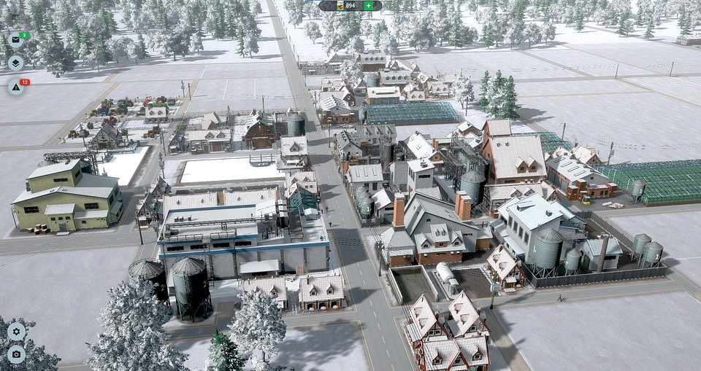

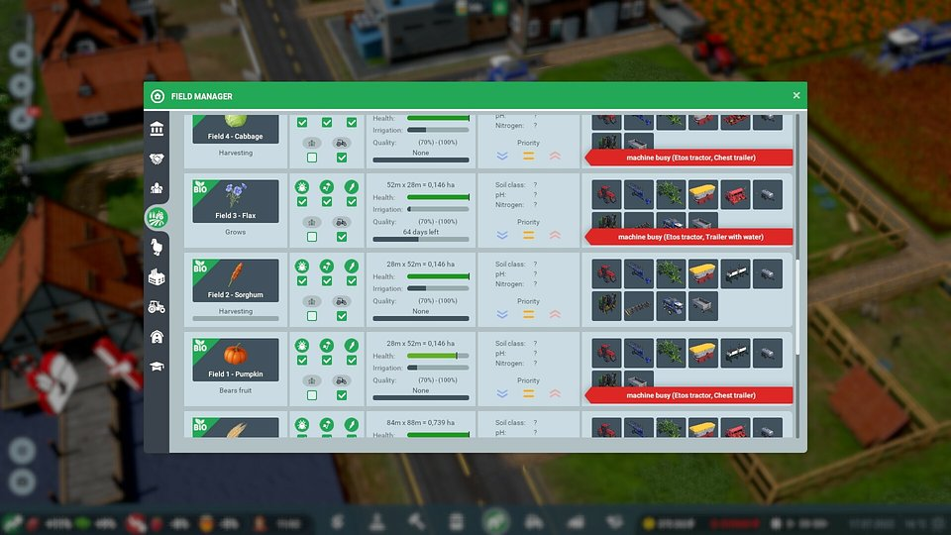

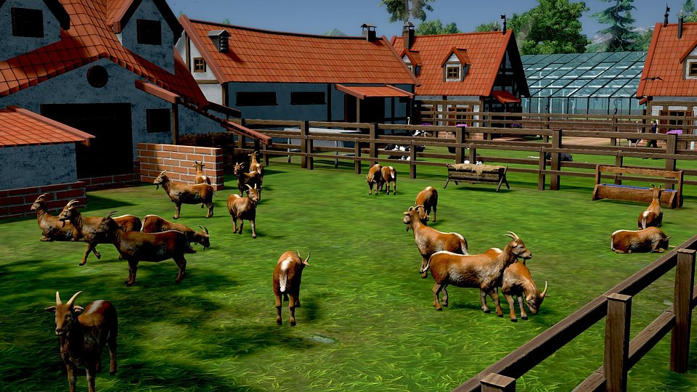

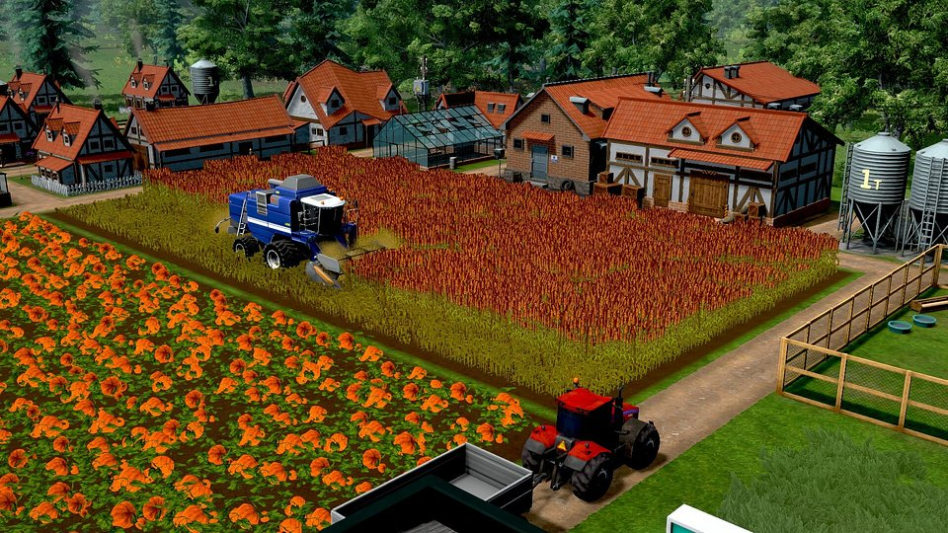

Farm Manager World is coming soon to Early Access on Steam. Add the game to your wishlist now, and do not miss the opportunity to become a world-class farmer!

Press kit is available here.

About Cleversan Games:Cleversan Games is a Polish game development studio established in 2014. In its early years, the team focused on creating utility applications and smaller mobile games. Their first major project was Farm Manager 2018. The game was warmly received, which encouraged the team to produce more games in the series. Farm Manager World is the latest installment and another significant step in the company's development.

About PlayWay:PlayWay was created in 2011 to build games for PC, Xbox, PlayStation, Nintendo Switch, Android, and iOS. Since then it has produced and released over 100 games that are sold or downloaded worldwide. PlayWay is a direct shareholder in more than 100 game development companies, with more than 200 games still to come. The company was founded by Krzysztof Kostowski, who has been working in the gaming industry since 1991.



Zuzanna Liske
PR Manager at better. gaming agency
zuza.liske@bettergaming.pro
Facebook

