**You have new connections.**

**The latest Sennheiser Smart Control App update paves the way for a powerful wireless future**

***Wedemark, Germany, September 4th, 2024* – The companion app for connected Sennheiser consumer audio devices gets a feature release in the latest version, setting the stage for customers to get even more out of new MOMENTUM and ACCENTUM true wireless earbuds.**

**Auracast assistant**

Headlining the Smart Control App update is the Auracast™ assistant; a friction-free way to instantly tap into the technology’s “one-to-many” broadcasts. From sharing music with a friend to exploring museum exhibits in a native language, MOMENTUM True Wireless 4 and ACCENTUM True Wireless, both released in 2024, are Auracast ready and are receiving a firmware update to enable the Bluetooth® LE Audio-based technology.

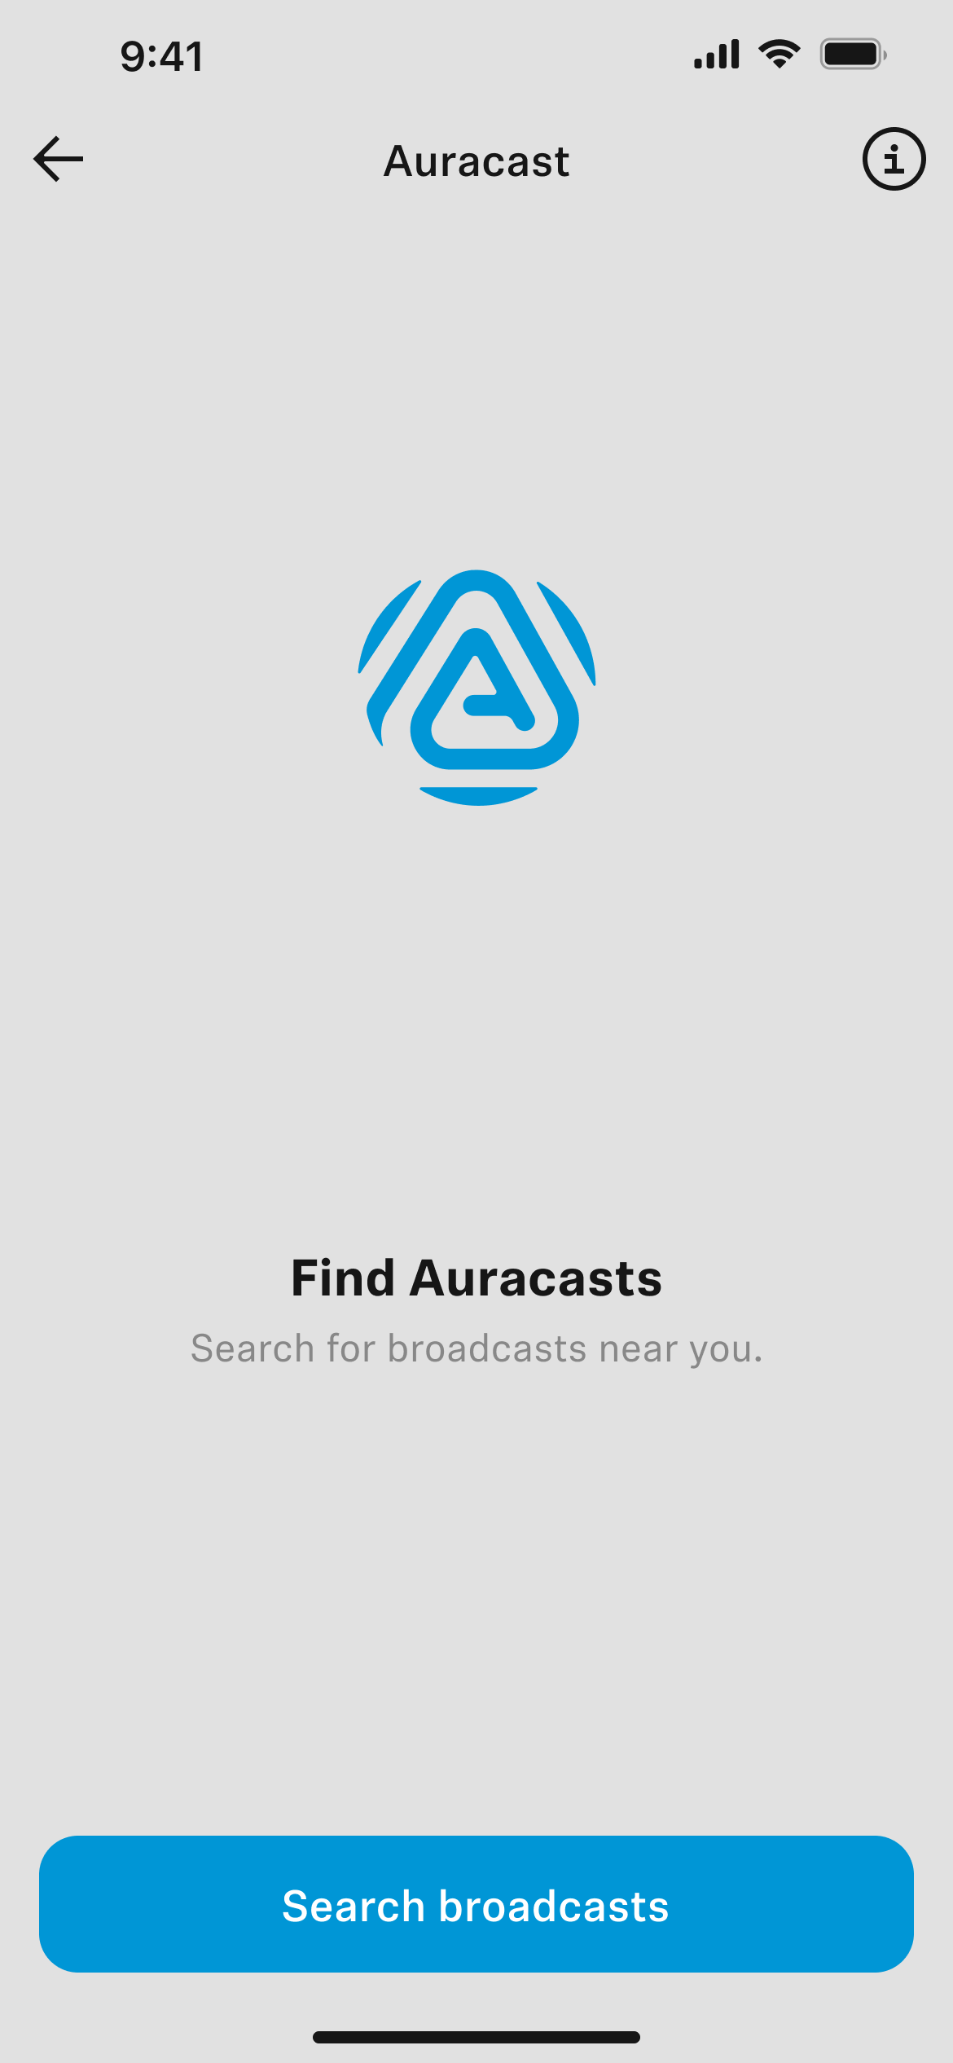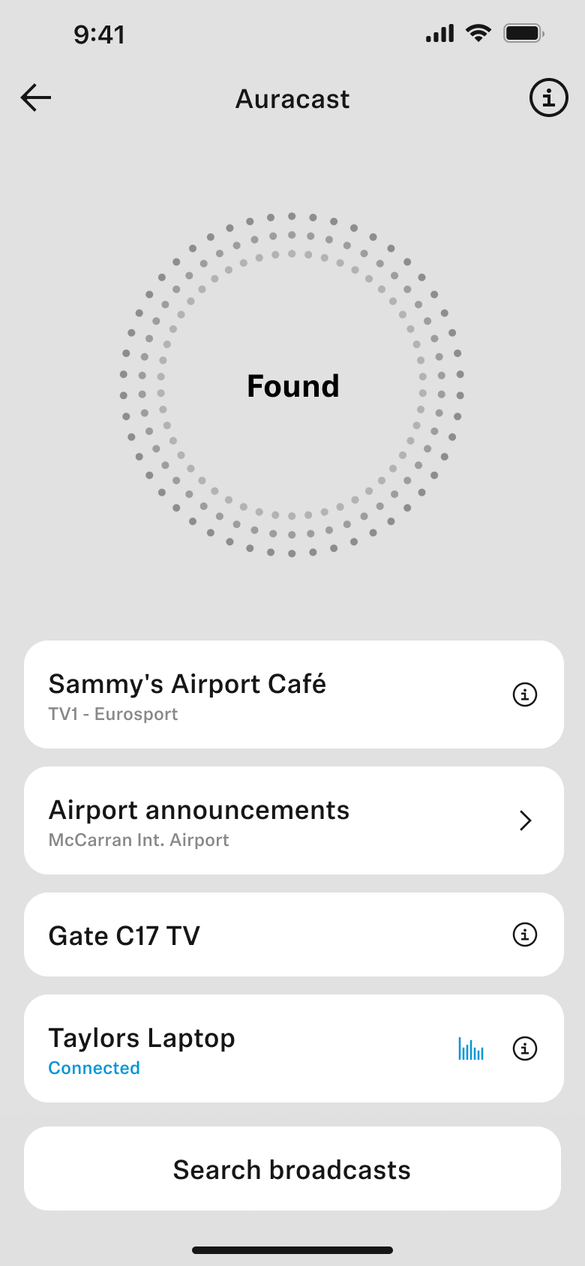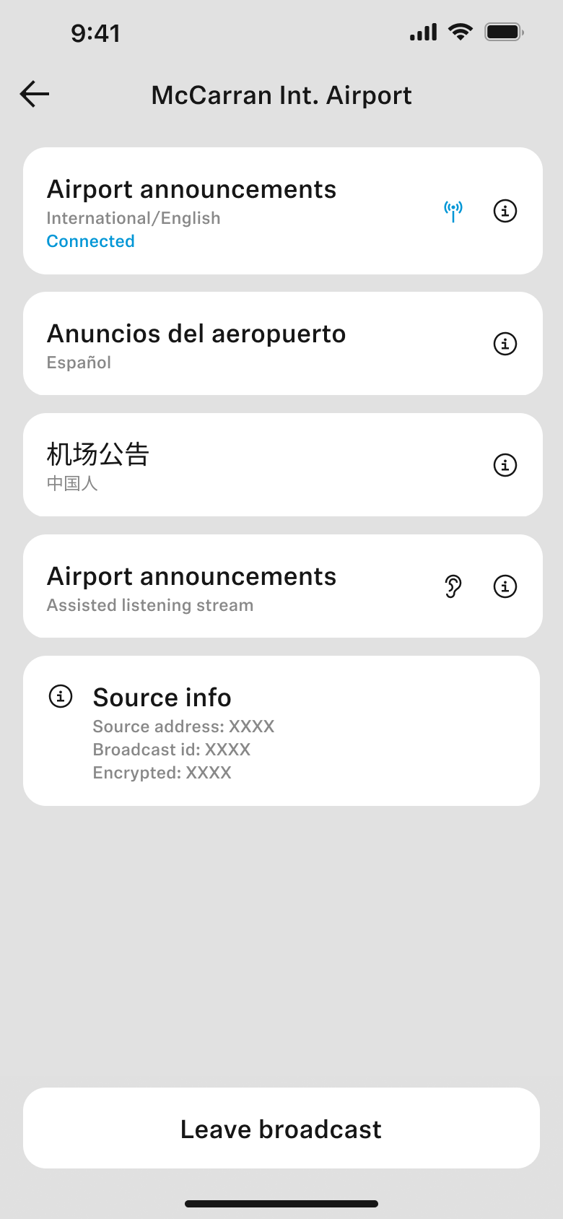

*“Smart Control continues to evolve with our customers’ needs while integrating features that are indispensable for power users,”* says Polina Gartenfluss, Sennheiser Senior Product Owner. *“Auracast assistant makes choosing an Auracast broadcast as easy as can be for MOMENTUM True Wireless 4 and ACCENTUM True Wireless wearers.”*

The Smart Control app can also *manage* Auracast connections from devices that do not natively support it, letting a MOMENTUM True Wireless 4 user with an iPhone connect to an Auracast stream from a television at an airport gate, for example.

**Find your buds**

The update also lets ACCENTUM True Wireless, MOMENTUM Sport and MOMENTUM True Wireless 4 owners keep track of where their earbuds were last located. Smart Control will give customers the option to use smartphone location services to display the earbuds’ last known whereabouts in the app, and even “ping” their nearby connected earbuds by activating an audible signal. The “Find headphones” feature is a boon for frequent flyers, dynamic remote workers, and athletes who find themselves frequently exploring new places.

*“Because our customers take their earbuds everywhere, it made perfect sense to give our newest true wireless releases find-my-device capabilities, too” Gartenfluss added.*

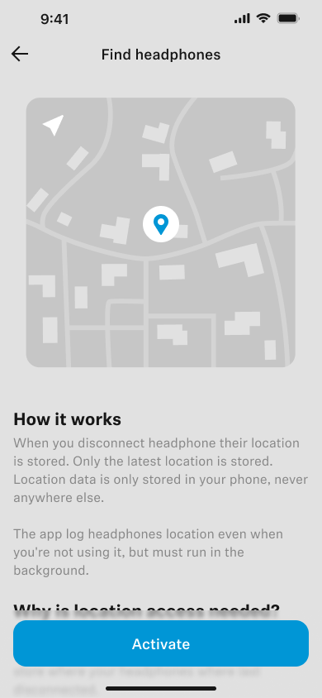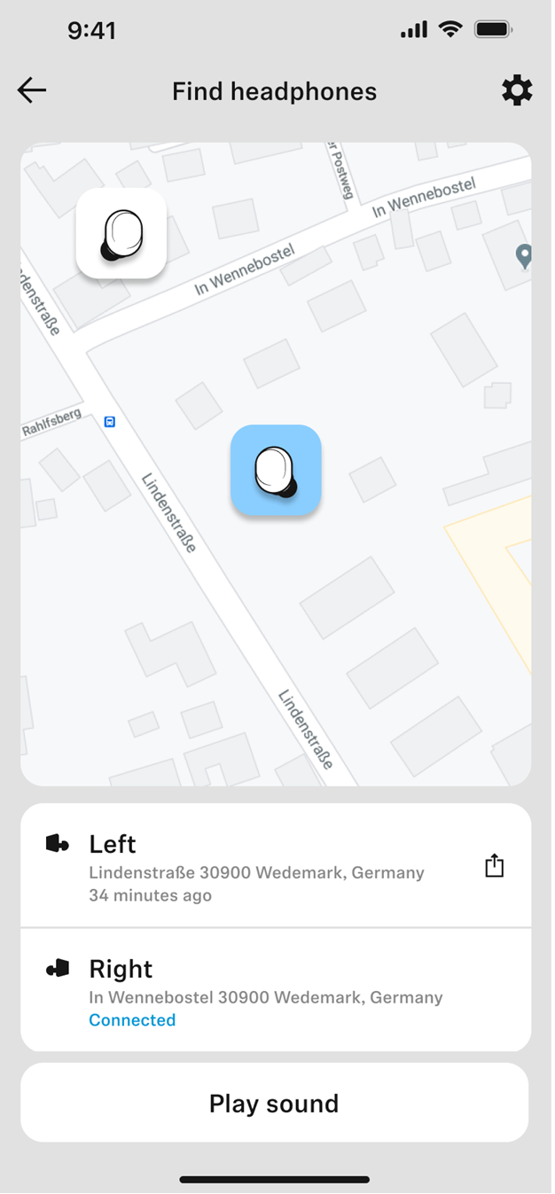

**Availability**

The Auracast assistant feature is available in the just-launched Smart Control App, version 4.9.0 and up, and can be installed from the App Store (iOS) or Google Play Store (Android). Auracast functionality is available on MOMENTUM True Wireless 4, and coming soon to ACCENTUM True Wireless, both via a firmware update. The “Find headphones” feature is available for MOMENTUM True Wireless 4, ACCENTUM True Wireless, and MOMENTUM Sport via a firmware update through Smart Control version 4.9.0 and up. The Sennheiser Smart Control App is free for all users.

**About the Sennheiser** **brand**

We live and breathe audio. We are driven by the passion to create audio solutions that make a difference. Building the future of audio and bringing remarkable sound experiences to our customers – this is what the Sennheiser brand has represented for more than 75 years. While professional audio solutions such as microphones, meeting solutions, streaming technologies and monitoring systems are part of the business of Sennheiser electronic GmbH & Co. KG, the business with consumer devices such as headphones, soundbars and speech-enhanced hearables is operated by Sonova Holding AG under the license of Sennheiser.

[https://www.sennheiser-hearing.com](https://www.sennheiser-hearing.com/en-UK/?srsltid=AfmBOorCQ8kIPoa_o8UK7es9OV2P6aZ-y-z7ADPdAageJ2beBxWeJD7f)

*Auracast™ is a registered trademark of the Bluetooth SIG, Inc.*

**Press contact**Kate SmartPR and Influencer Manager EMEASonova Consumer Hearing+44 7909 729925kate@sonova.com