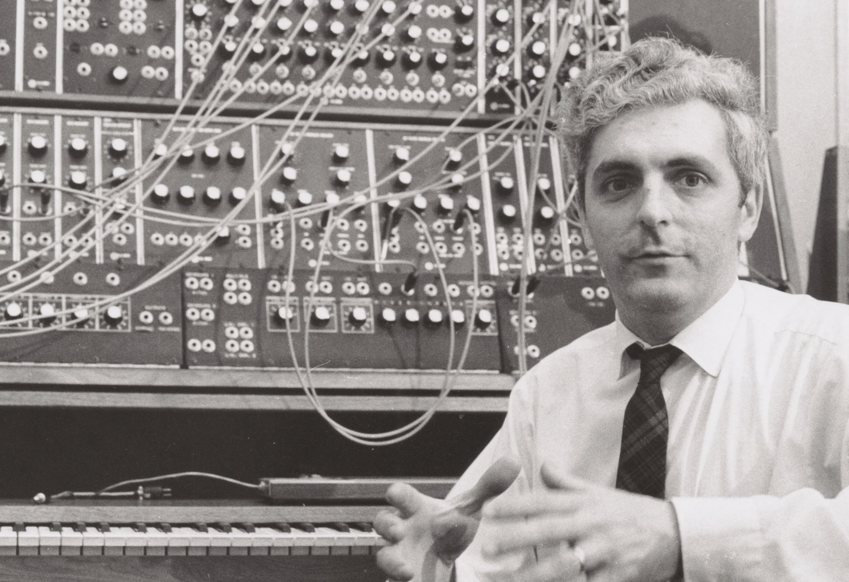

Electronic Music Enthusiasts Gather to Celebrate the Opening of Bob Moog’s Archives at Cornell University
Gary Numan and Suzanne Ciani Among Artists Attending the Opening This Weekend

Through his collaboration with musicians and deep connection to the field of electronics and engineering, Dr. Robert Moog developed an instrument that would forever change the face of modern music: the Moog synthesizer.

Later this week, synthesizer enthusiasts from around the world will travel to Ithaca, New York to take part in the unveiling of the inventor’s official archives.

Treasured relics from Moog’s early days of electronic music discovery have been kept safe at his alma mater, Cornell University, since 2013—and are now ready to be showcased after years of meticulous cataloging and curation. The collection generously donated by his wife, Dr. Ileana Grams-Moog, includes academic works, early circuit drawings and diagrams, Moog’s own soldering iron, and synthesizer module prototypes. Starting March 6th, all of this will be on display and open to the public at Cornell’s Carl A. Kroch Library.

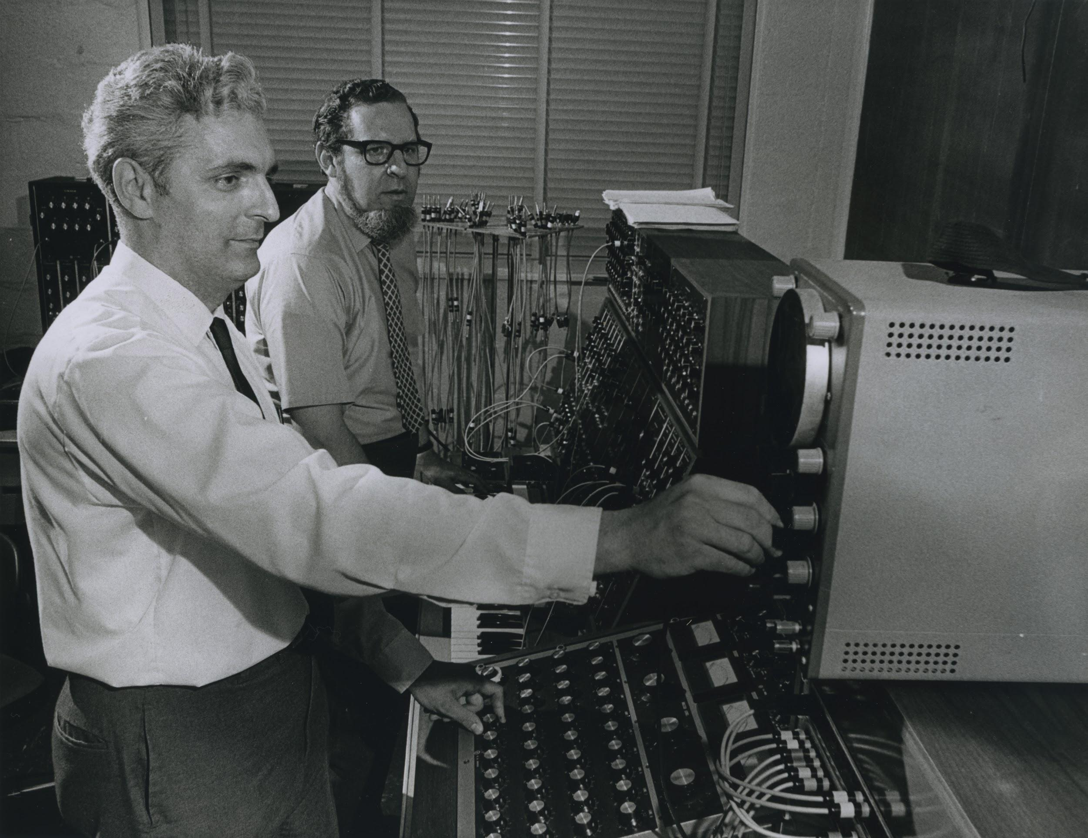

To kick off the exhibit honoring Bob Moog’s lifetime of achievements and contributions to science, music, and technology, the university is hosting “When Machines Rock: A Celebration of Robert Moog and Electronic Music” March 5th–7th, which will feature on- and off-campus panels, lectures, concerts, and workshops. Among the event’s distinguished guests are renowned synthpop and electro-industrial artist Gary Numan, five-time Grammy-nominated electronic music composer and synth pioneer Suzanne Ciani, and Moog synthesizer co-inventor Herb Deutsch. As part of Saturday’s programming, Deutsch will join Moog Music President Mike Adams and Senior Hardware Engineer (and student of Bob Moog) Steve Dunnington to discuss the evolution of analog sound in celebration of more than 60 years of Moog instruments and innovation. View the full list of events here.

The 1964 invention of the Moog synthesizer would forever shape the way we create and hear music. Bob Moog was not only an innovator of electronic music technology but also a collaborator and friend of artists spanning musical genres. Moog instruments have been used by the likes of The Beatles; Stevie Wonder; Emerson, Lake & Palmer; Nine Inch Nails; and Daft Punk.

Visit www.moogmusic.com to learn more about Bob Moog’s life and legacy.

