Koe äänen tulevaisuus: Sennheiser Group esittelee uusimmat innovaationsa NAB 2026 -tapahtumassa
Esittelyssä muun muassa Specteran uudet ominaisuudet, puheenvuoro 1,4 GHz:n taajuusalueen mahdollisuuksista sekä AMBEO Zone -ratkaisut yleisön sitouttamiseen

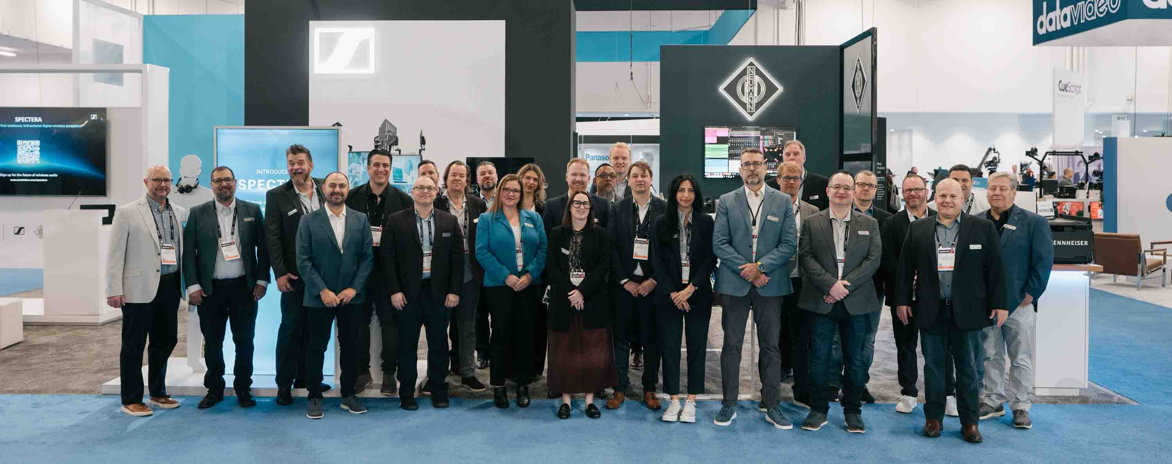

Sennheiser Group avaa ovet äänen tulevaisuuteen NAB 2026 -tapahtumassa ja kutsuu broadcast-alan ammattilaiset, studiot, striimauspalvelut ja sisällöntuottajat tutustumaan uusimpiin teknologioihinsa osastolle nro 4 931 (Central Hall).
Kävijät pääsevät tutustumaan ammattilaisen työnkulkuun kolmella teema-alueella: Reliable Integration, Connection ja Future & Innovation. Kokonaisvaltainen elämys kattaa kaiken sisällön taltioinnista ja monitoroinnista (Sennheiser, Neumann, Merging) aina saumattomaan integrointiin, jossa kumppanimme SoundBase esittelee RF-suunnittelu- ja -hallintasovelluksensa uudet ominaisuudet. Matka huipentuu Future & Innovation -alueeseen, jossa odottavat AMBEO Zone, Spectera-esittelypiste sekä Spectera Lab. Tervetuloa myös kuulemaan Sennheiser-asiantuntija Joe Ciaudellin puheenvuoroa langattomien mikrofonien käytöstä suurtapahtumissa (”Wireless Microphone Operation for Mega-Events in the 1435–1525 MHz Band”) lauantaina 18. huhtikuuta klo 14.10–14.30 huoneessa N25.
Lisää alla englanniksi.

Latest Spectera additions at NAB 2026
With the latest Spectera firmware update v 1.3.0, the OpenAPI specification 17.0 for the Spectera Base Station has been published. Spectera API enables deeper integration, new workflows and partner-driven innovation, with engineering teams, system integrators, automation specialists and enthusiasts now able to integrate Spectera into their own control systems, monitoring dashboards, and production workflows using the secure https-based SSCv2 interface for remote access.

“API access is not a nice-to-have, rather it’s essential for an ecosystem that is to thrive in user environments and workflows,” says Benedikt Euen, Senior Product Manager for Spectera. “It opens Spectera for all those ingenious operators and automation enthusiasts out there, who are eager to create customized workflows, for manufacturers seeking integration with their own devices, and for programmers creating audio plug-ins or other software.”

 | Spectera API enables deeper integration, new workflows and partner-driven innovation

At the booth, the customization possibilities offered by Spectera API are demoed with the Bitfocus Companion and Buttons app: In a typical live and touring setup, the app can be used in conjunction with DAW control and can achieve instrument switching and engineer mode through the active Spectera beltpack.

The possibilities are endless: Users can interact, control and monitor Spectera via devices like stream decks, touchscreens or DAW software, and trigger functionalities such as an Engineer Mode and instrument swapping, or create backups of mobile devices at the touch of a button.

Spectera Rental Finder
Whenever large broadcast productions require additional Spectera units, the Spectera Rental Finder helps locate Spectera systems worldwide via a scrollable world map. Available on the Sennheiser website, the tool connects customers with a network of professional rental partners, making it easy to find and source the equipment needed.

Spectera software landscape
Sennheiser has also announced a change in the software landscape for Spectera. “Ample feedback from our user community has shown a clear preference for Spectera WebUI over LinkDesk, and also a high interest in SoundBase for advanced multi-system, multi-vendor management,” says Euen. “We have therefore decided to not continue LinkDesk development beyond version 1.6.0, and have SoundBase put a focus on the integration of Spectera to cover all LinkDesk features in the future. This will make SoundBase the first brand-agnostic application that is able to coordinate both narrowband and wideband wireless, while Spectera WebUI remains the workhorse for individual Base Stations.”

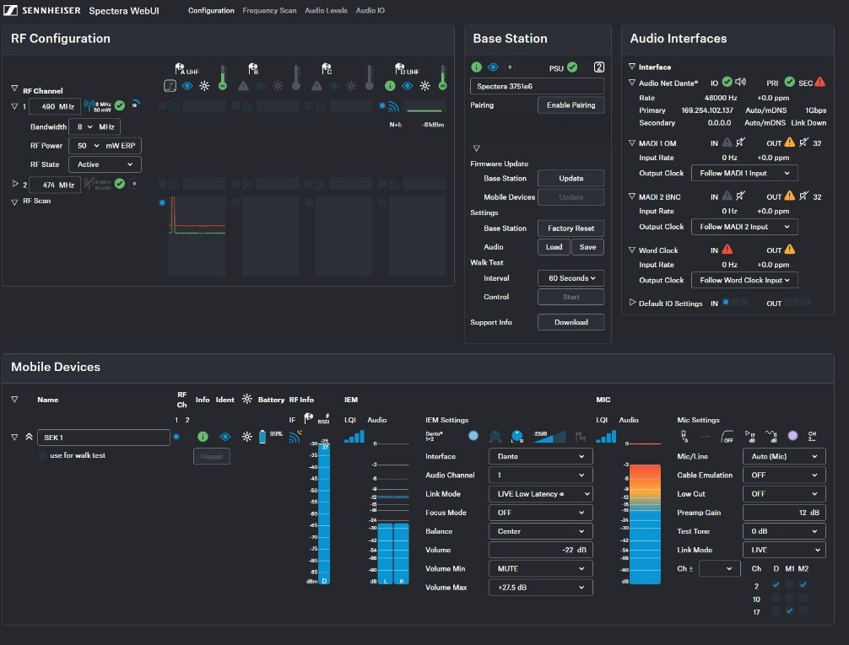 | Spectera WebUI (pictured) will be the on-device software for Spectera, while the brand-agnostic SoundBase application will become the recommended on-premise software going forward

Taiwan and Brazil now licensed for Spectera, trial license for Mainland China
Spectera now offers activation licenses for Taiwan (LIC ZONE 15), Mainland China (trial, LIC ZONE 17), and Brazil (LIC ZONE 16), where Anatel certification is now in place. Furthermore, the allowed frequencies in the 1.4 GHz band for LIC ZONE 1 (EU, EFTA, UK, Turkey) have been expanded, and now include 1492-1525 MHz in addition to 1350-1400 MHz. “This extension makes the Spectera 1.4 GHz even more attractive for users,” says Euen, “especially in view of crowded and shrinking UHF resources.”

Wireless microphone operation for mega-events in the 1435 – 1525 MHz band
Spectera firmware version v 1.3.0 also has the ecosystem prepared for AFTRCC e-key handling for 1.4 GHz systems in the USA. Professional wireless users who would like to know more about 1.4 GHz as a viable alternative to the congested UHF-TV band are invited to a talk by spectrum expert Joe Ciaudelli on Saturday, April 18, 2:10 – 2:30 p.m. in N256.

Ciaudelli will not only shed a light on broadcast use of the 1435 – 1525 MHz band for wireless microphones and in-ears at mega-events such as the Superbowl, World Series, Kentucky Derby, national elections, and the Academy Awards, but also detail the regulations, eligibility (applicants must hold an FCC Part 74 license), and procedure for operating wireless microphones in this frequency band.

 | On April 18, Joe Ciaudelli will speak about the 1.4 GHz band and how it can be used to support broadcast events in the USA (2:10 – 2:30 p.m., N256)

Immersive workflows for broadcasting and OTT in the AMBEO Zone
The AMBEO Zone has broadcasters, OTT platforms, and media creators discover how audience engagement can be deepened through advanced immersive audio technologies that elevate content played out on non‑immersive systems—both in real‑time broadcasting and for file‑based VOD productions.

“Content playback today more often than not happens on stereo devices, especially in mobile use cases,” explains Kai Detlefsen, Manager of AMBEO, the immersive audio initiative of the Sennheiser Group. “Our adaptable immersive workflows help professionals deliver consistent, reliable, and high‑quality audio experiences that strengthen the viewers’ emotional connection, all while preserving creative intent.”

On show is the file‑based AMBEO 2‑Channel Spatial Audio Renderer, a streamlined postproduction solution for VOD and catalog content, available both for on‑premise use and for cloud‑based processing. This workflow enables immersive mixes to be automatically rendered into a compelling AMBEO 2‑channel experience, while still giving engineers full access to parameters whenever creative adjustments are desired.

Inspired by the same principles, the real‑time AMBEO 2‑Channel Spatial Audio Broadcast Renderer encodes immersive and surround beds into a dynamic AMBEO 2.0 stream in real time. Thus, the renderer offers an immediate path to audience-ready immersion—without requiring any changes on the listeners’ side. At NAB, AMBEO showcases how the renderer can be deployed on compact professional devices such as the Neumann MT 48, enabling effortless integration into existing AES67, ST 2110, or Dante environments.

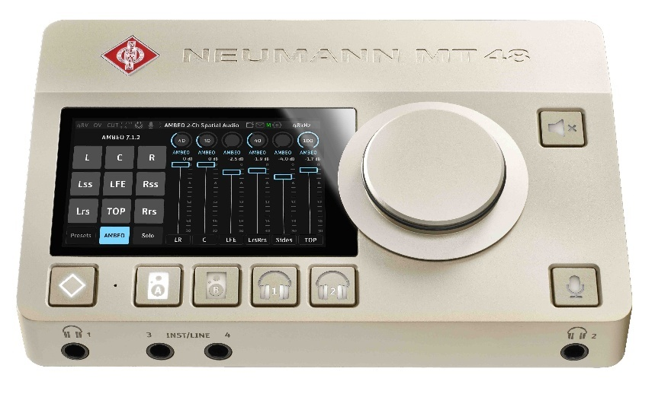 | The real‑time AMBEO 2‑Channel Spatial Audio Broadcast Renderer – deployed here on a Neumann MT 48 – creates a compelling AMBEO 2.0 live experience for listeners on standard stereo systems

Last but not least, the AMBEO Zone features the Neumann VIS visionOS application, showcasing how immersive productions can be created and refined in context using spatial computing devices like the Apple Vision Pro. By visualizing spatial mix elements within the actual playback environment, audio professionals gain an intuitive understanding of placement, depth, and movement—streamlining creative decisions and accelerating iteration cycles.

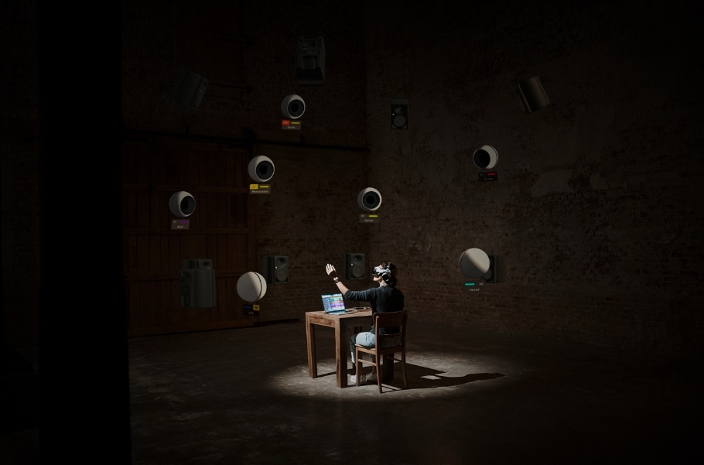 | Immersive audio mixing with Neumann’s VIS – Virtual Immersive Studio

Visit the Sennheiser Group at NAB, Central Hall, Booth No. 4931

(Ends)

The high-resolution images accompanying this media release can be downloaded here.

About the Sennheiser Group
Building the future of audio and creating unique sound experiences for our customers - this is the aspiration that unites the employees of the Sennheiser Group worldwide. The independent family-owned company Sennheiser was founded in 1945. Today, it is managed in the third generation by Dr Andreas Sennheiser, and is one of the leading manufacturers in the field of professional audio technology.

Press Contact:
Burson Finland Oy (previously Hill and Knowlton)
sennheiser.finland@hkstrategies.com

