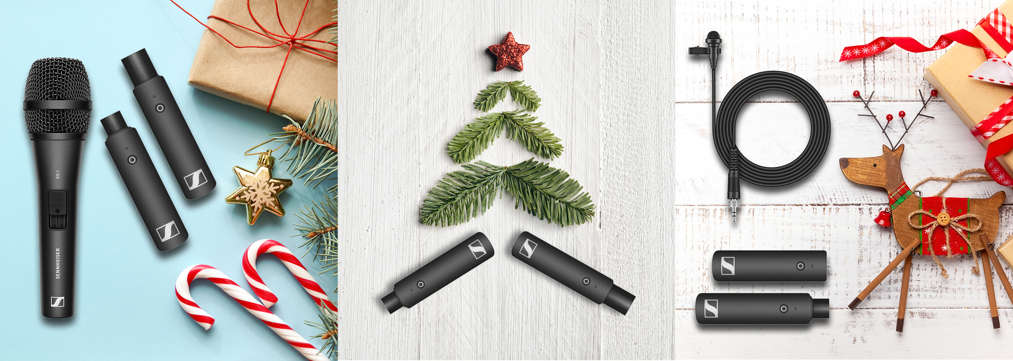

Musical Gifts from Sennheiser

Wedemark, November 2019 – There is no other time in the year that is so deeply linked with music than the holiday season – just think of carols and all the classic festive pop and rock songs. If your musical passion goes beyond just listening to Christmas classics and you also love to make music, you will want to check out the stage and recording gear from Sennheiser. The audio specialists’s headphones and microphones are the ideal gifts to make a musician’s heart beat faster this Christmas!

For first-time wireless users
XS Wireless Digital
+ Easy-to-use wireless system, immediately ready for use thanks to one-touch operation
+ Works on 2.4 GHz – can be used license-free worldwide
+ Vocal Set that’s ideal for carols and Instrument Base Set for the accompanying guitar
+ Choose the Pedalboard Set to integrate your wireless receiver into the pedalboard
MRSPs:
XSW-D Vocal Set: EUR 349
XSW-D Instrument Base Set: EUR 299
XSW-D Pedalboard Set: EUR 399

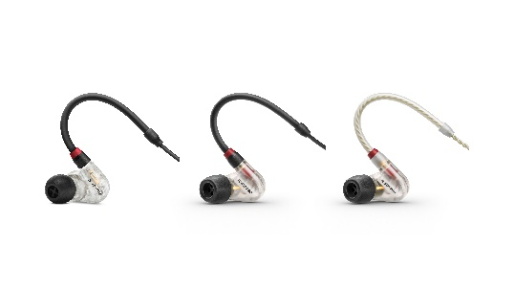 | In-ears for the best sounding Christmas ever  IE 40 PRO  + Powerful and accurate monitoring sound thanks to dynamic wideband transducers  + Homogeneous, low-distortion reproduction reduces acoustic stress  + Optimum fit and comfort  + Flat ear mould form  + Ear adapters made from silicone and memory foam to ensure good isolation on stage  + The IE 400 PRO and IE 500 PRO professional upgrades offer even more precise monitoring and a slim form factor  MRSPs: IE 40 PRO: EUR 99  IE 400 PRO: EUR 349  IE 500 PRO: EUR 599

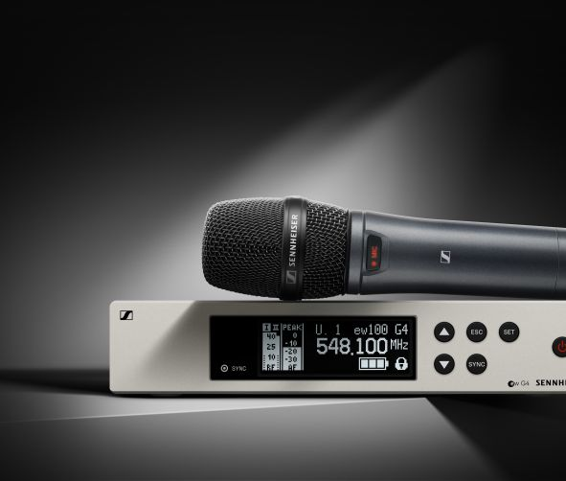 | Professional live audio  EW 100 G4 (935, 945, CI1)  + Rugged UHF wireless systems for singers (ew 100 G4-935-S, cardioid, and ew 100 G4-945-S, super-cardioid) as well as guitarists and bassists (ew 100 G4-Ci1)  + Reliable transmission in multi-channel set-ups  + Range of up to 100m  + Fast frequency allocation via new linking function  MRSPs:  EW 100 G4-935-S: EUR 649  EW 100 G4-945-S: EUR 699  EW 100 G4-Ci1: EUR 549

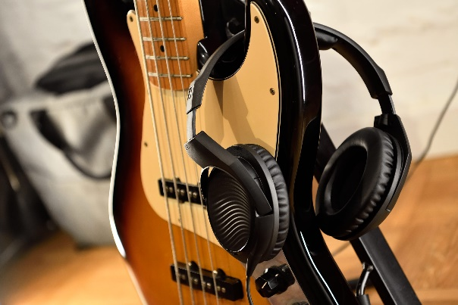 | Professional sound for the home (studio)  HD 200 PRO AND HD 300 PRO  + Closed, circumaural headphones provide good attenuation of ambient sound  + Soft ear pads ad headband padding ensures comfort even during long sessions  + HD 200 PRO with powerful bass  + HD 300 PRO with linear sound reproduction and great detail  MSRPs:  HD 200 PRO: EUR 75  HD 300 PRO: EUR 199

The high-resolution images accompanying this press release plus product images can be accessed here: https://sennheiser-brandzone.com/c/181/XWAThDBw.

About Sennheiser
Shaping the future of audio and creating unique sound experiences for customers – this aim unites Sennheiser employees and partners worldwide. Founded in 1945, Sennheiser is one of the world’s leading manufacturers of headphones, loudspeakers, microphones and wireless transmission systems. Since 2013, Sennheiser has been managed by Daniel Sennheiser and Dr. Andreas Sennheiser, the third generation of the family to run the company. In 2018, the Sennheiser Group generated turnover totaling €710.7 million. www.sennheiser.com

Global PR Contact

Stephanie Schmidt
stephanie.schmidt@sennheiser.com
+49 (5130) 600 – 1275

