DAVINIA CUÑAT
Beauty Salon Vanedis

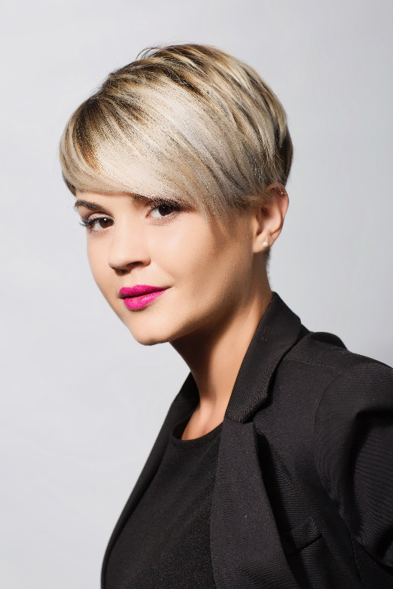
Davinia Cuñat started at the age of 16 in the profession out of a pure vocation. Hair and hairdressing had always attracted her, so she was very clear she wanted to be properly trained in order to make her passion her way of life, and this is something she continues to do to always offer the best of herself. She founded her own salon in 2016. It’s a space in which the customer is paramount, where personalized quality service is offered, with the best products. The treatment is always offered from closeness, honesty and cordiality. Besides, she is elegant and shows her interest and love for the profession in every detail. Her success is based on effort and the illusion of being able to overcome new professional challenges.

Her passion for hairdressing has led her to want to develop and grow in different fields. The result of this motivation is her collection, Henko, which was presented in the Revelation Hairdresser category at the Fígaro 2020 Awards, which has managed to be the cover of one of the most prestigious magazines in the hairdressing sector in Spain, another of her works, her Icon collection, has also been published in numerous media. During her career, she has collaborated in the fashion sector in different editions of the fashion shows of the firm El atelier de Loles.

