Sennheiser julkaisee DeviceHubin – turvallisen, pilvipohjaisen alustan älykkäämpään AV-hallintaan
DeviceHub keskittää Sennheiser-laitteet pilveen ja yhdistää etävalvonnan, intuitiivisen navigoinnin sekä sisäänrakennetun tietoturvan. Se tarjoaa tiimeille selkeämmän ja tehokkaamman tavan hallita AV-järjestelmiä laajassa mittakaavassa.
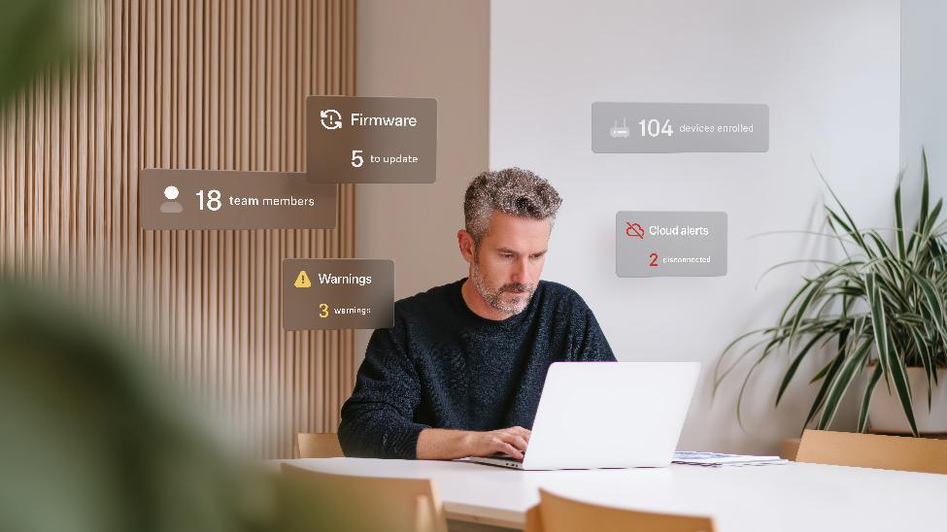
DeviceHub represents a major step forward in how customers manage their Sennheiser devices
Sennheiser on julkaissut DeviceHubin, turvallisen pilvipohjaisen alustan, joka antaa organisaatioille keskitetyn näkyvyyden ja hallinnan Sennheiser-laitteisiinsa kaikkialta maailmasta. Laajan sisäisen testauksen ja yksityisen beetavaiheen jälkeen DeviceHub on nyt julkisesti saatavilla beetaversiona, ja se tukee aluksi TeamConnect Bar -ratkaisuja.
Lisää alla englanniksi.

Aligned with Sennheiser’s mission to make collaboration and learning easier, DeviceHub combines remote monitoring, clear oversight, and secure role-based access into one browser-based environment. The launch follows the platform’s initial announcement at InfoComm US in June 2025, marking the next step in a broader DeviceHub roadmap, with additional Sennheiser devices gaining compatibility throughout 2026.
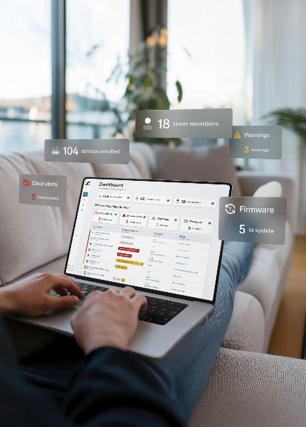
DeviceHub centralises Sennheiser devices in the cloud, combining remote monitoring, intuitive navigation, and built-in security to give teams a clearer, more efficient way to manage AV systems at scale
“DeviceHub represents a major step forward in how customers manage their Sennheiser devices,” said Iain Horrocks, Product Marketing Manager, Software & Security, Sennheiser. “By bringing secure, cloud-based control to the entire ecosystem, we’re giving IT and AV teams the tools they need to work more efficiently, collaborate more effectively, and support better learning and meeting experiences…and this is just the beginning.”

As a single cloud-based platform, DeviceHub makes management of networked Sennheiser devices accessible through any browser. Real-time monitoring, diagnostics, and alerts provide clear insight into device status and performance, helping teams act before issues disrupt meetings, classes, or collaboration spaces, whether on site or remotely.

For IT personnel, DeviceHub simplifies management at scale by organizing devices by room, building, campus, or region in a structure that mirrors real-world environments. This provides a clear view of every space from a single platform, allowing teams to navigate between locations easily, view devices in context, and understand system health at a glance, from a handful of rooms to global estates.
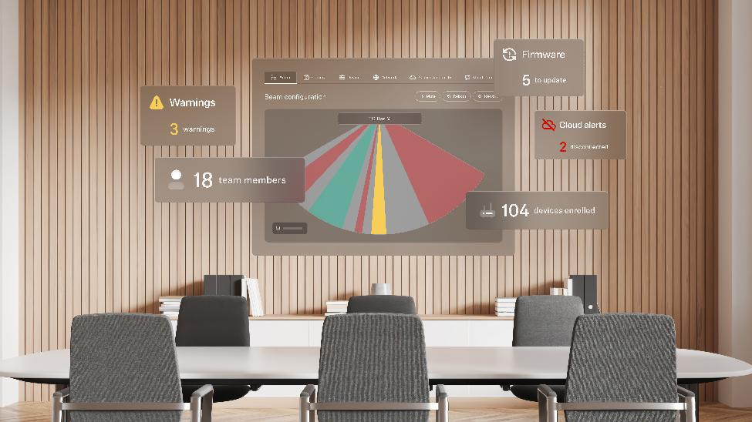
Built to grow with an organisation’s needs, DeviceHub will support TeamConnect Bar Solutions at launch, with compatibility expanding across additional Sennheiser devices throughout 2026
The platform enables teams to collaborate securely across an organization through role-based access, ensuring technicians, administrators, and integrators see and control only what they need, with access limited to the locations and systems relevant to their responsibilities. Support for modern authentication methods reinforces secure collaboration while keeping responsibilities clearly defined, workflows streamlined, and accountability transparent.

Built on Microsoft Azure, security and trust are built into DeviceHub from the start. The platform follows industry-recognised IT security standards across authentication, authorisation, encryption, and data handling. Ongoing evaluation and compliance oversight ensure DeviceHub meets the privacy and security expectations of enterprise and education environments.

Built to grow with an organisation’s needs, DeviceHub will support TeamConnect Bar Solutions at launch, with compatibility expanding across additional Sennheiser devices throughout 2026. A streamlined Local Web UI also supports efficient single-device setup through a browser, reducing software dependencies during installation. The platform will continue to evolve with new capabilities that strengthen monitoring, configuration, and collaboration across the ecosystem.

Early customers have already provided feedback regarding their experience with DeviceHub, with Guillaume Amaurin, AV Specialist, Sainte-Justine Hospital, Quebec, sharing, "DeviceHub has significantly simplified the management of our infrastructure. A single configuration is enough to onboard a new device, making the onboarding process fast and frictionless. The portal is easy to access and is used daily by the entire team to configure the bars and monitor their usage, wherever we are.”

Alain Lamontagne IT Specialist, Sainte-Justine Hospital, Quebec, added, “Compared to the previous method based on Cockpit, which was limited to a single computer and required the bars to be re-added whenever the machine changed, DeviceHub represents a major gain in both time and flexibility. We are looking forward to being able to add more devices synchronized with the portal."
Visit our DeviceHub product page to learn more.

About the Sennheiser Brand – 80 Years of Building the Future of Audio

We live and breathe audio. We are driven by the passion to create audio solutions that make a difference. This passion has taken us from the world’s greatest stages to the quietest listening rooms – and made Sennheiser the name behind audio that doesn’t just sound good: It feels true. In 2025, the Sennheiser brand celebrates its 80th anniversary. Since 1945, we stand for building the future of audio and bringing remarkable sound experiences to our customers.

While professional audio solutions such as microphones, meeting solutions, streaming technologies and monitoring systems are part of the business of Sennheiser electronic SE & Co. KG, the business with consumer devices such as headphones, soundbars and speech-enhanced hearables is operated by Sonova Holding AG under the license of Sennheiser.

www.sennheiser.com
www.sennheiser-hearing.com

Press contact
Burson Finland Oy (previously Hill and Knowlton)
sennheiser.finland@hkstrategies.com

