ABC survey reveals surge in podcast listening as women turn to true crime tales

The popularity of podcasts is on the rise with Australians listening to more podcasts more often, driven in part by the growing appetite among women for true crime tales.

The ABC’s third annual Podcast Survey reveals that almost half (44%) of podcast listeners listened to true crime in the past month, up from 30% in 2017. The surge in listening to true crime – including the ABC’s new series Unravel: Barrenjoey Road – was strongest with women, among whom listening increased by 15 percentage points.

Women also led an overall increase in podcast engagement, with almost two-thirds (65%) claiming to listen to more podcasts in 2018 than the previous year – versus 51% of men. While women turned to true crime, men were more likely to look for laughs – with the number of men listening to comedy podcasts up 10 percentage points.

ABC Director of Specialist content Judith Whelan said: “Our appetite for podcasts continues to grow across multiple genres, led by compelling true crime stories with real impacts on injustice in our society. At the heart of such podcasts are strong stories that engage listeners, no matter their gender. As Australia’s leading podcast producer, the ABC is proud to share such remarkable stories with listeners.”

Nine out of 10 Australian adults (91%) are now aware of podcasts, while one in three (33%) claimed to have listened to a podcast in the past month.

The results of the ABC’s survey of 2,583 podcast listeners, by ABC Audience Data & Insights, were revealed at today’s OzPod podcast industry conference in Melbourne. Other key findings of the 2018 survey of podcast listeners include:
- 65% listened to a podcast in the previous 24 hours, up from 57% from 2017.
- 59% listened to more podcasts in 2018 than in the previous year.
- The average listening time for those who listened to a podcast in the previous week is 6.1 hours, across an average of six podcast episodes and five series.

VIEW THE SURVEY RESULTS HERE

17 October 2018
___________________________________________________________
For further information contact:
Peter Munro, ABC Communications, Entertainment & Specialist
02 8333 3082 | munro.peter@abc.net.au
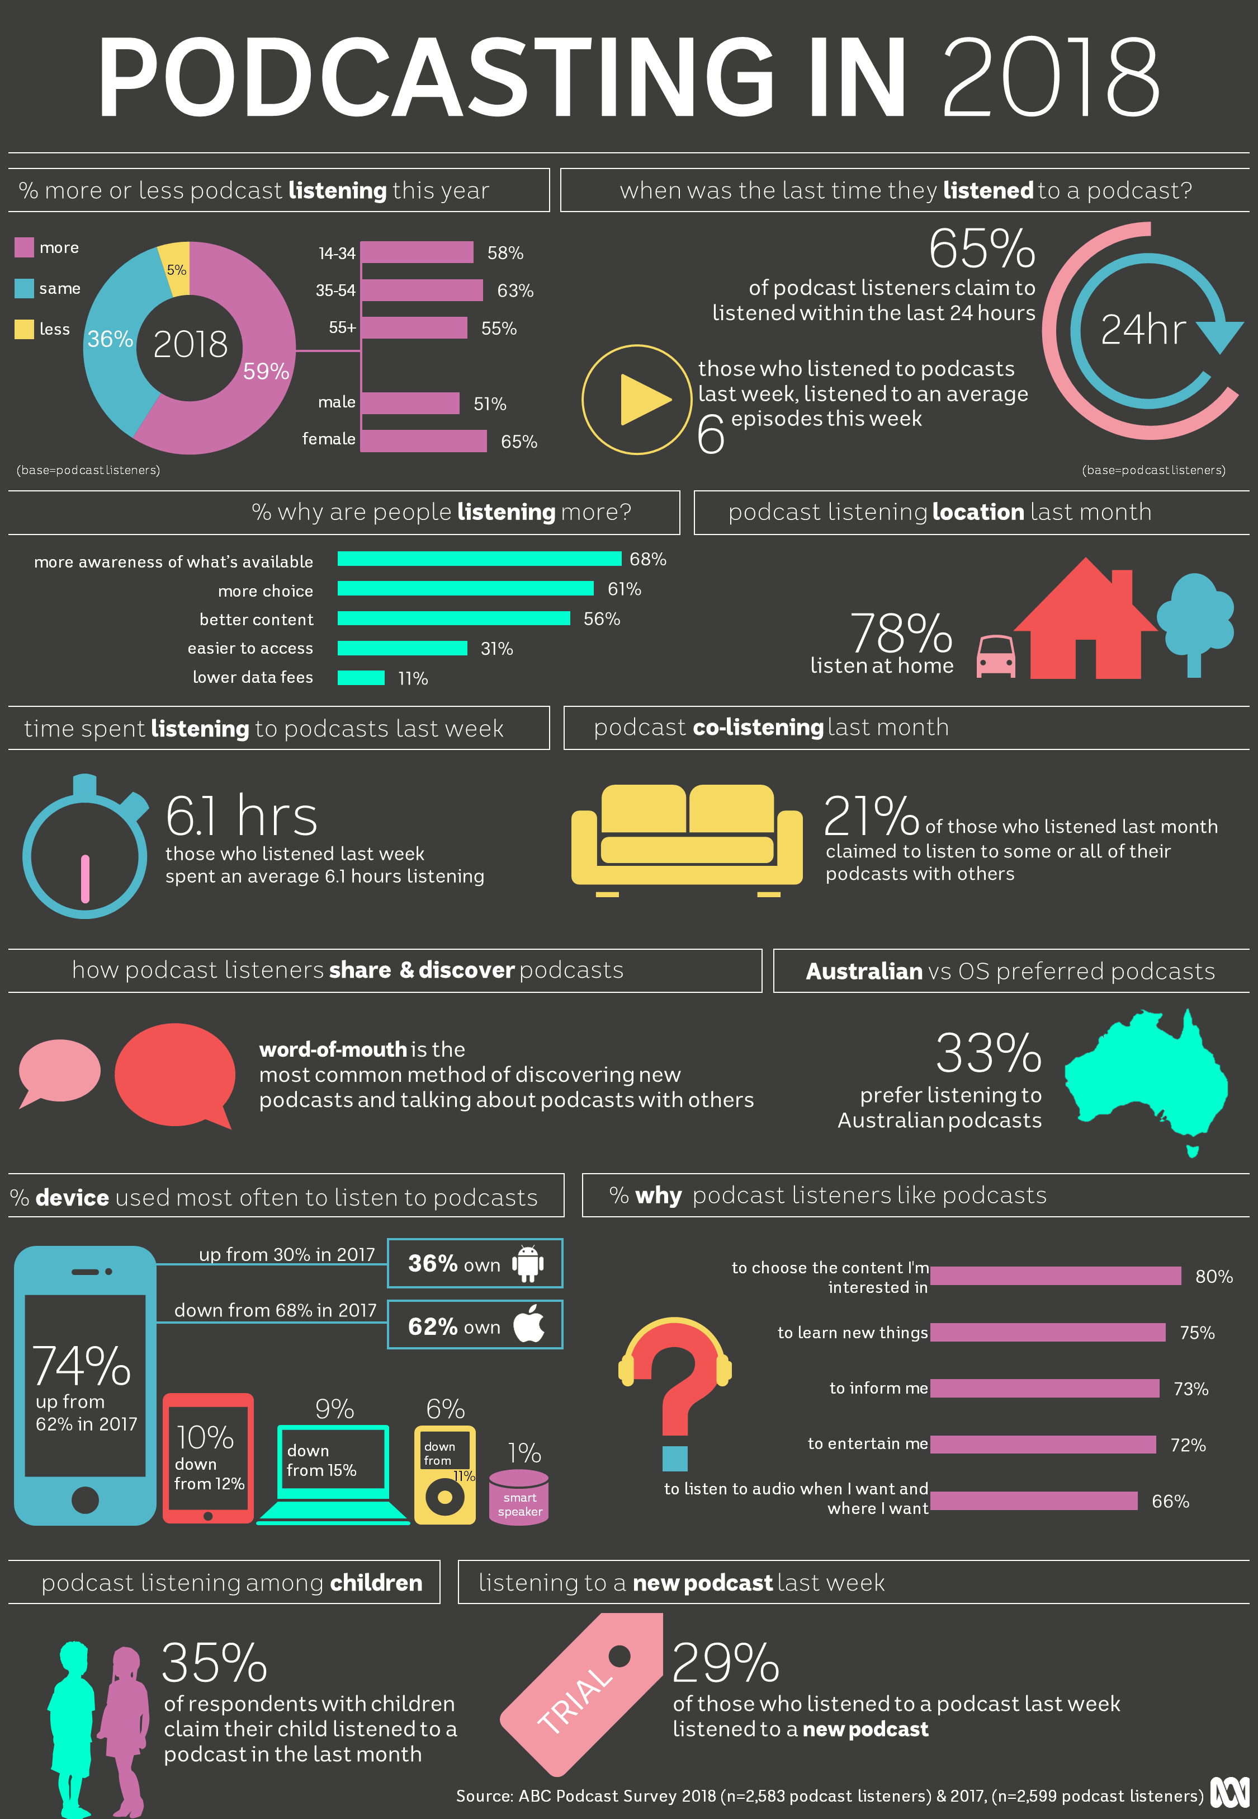

Podcasts listeners, who claimed to listen in the last month.
Source: ABC Corporate Tracking Study: August 2018, Australians aged 18-75, Nationally representative (n=1,505), online methodology.

