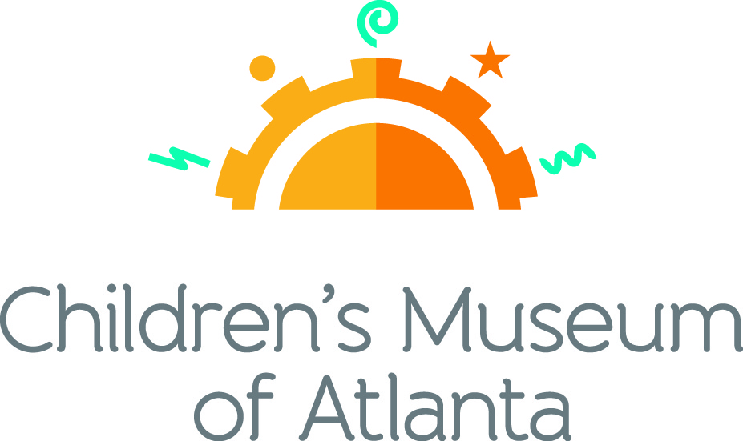

CONTACT
Becca Meyer/Jennifer Walker
BRAVE PR, 404.233.3993
bmeyer@emailbrave.com/
jwalker@emailbrave.com
FOR IMMEDIATE RELEASE

Children’s Museum of Atlanta Raises $180,000
with Sixth Annual ‘Tournament for PLAY’
Proceeds support Museum’s early childhood educational programming and community outreach

ATLANTA (September 4, 2018) – On Monday, August 27, 116 golfers participated in Children’s Museum of Atlanta’s sixth annual golf outing Tournament for PLAY at the prestigious Peachtree Golf Club. Presented by PNC, the event raised more than $180,000 through generous donations and golfer registration in support of the Museum’s early childhood educational programming and community outreach initiatives.

“Tournament for Play gives the Atlanta business community a great opportunity to connect with other local organizations that are committed to investing in quality early learning for Georgia’s preschoolers,” said Eddie Meyers, PNC regional president, Greater Georgia. “The funds raised each year through this event will help support Children’s Museum’s continued efforts to bring impactful early education experiences to underserved preschoolers, families and communities throughout metro Atlanta.”

Proceeds from the tournament directly impact more than 200,000 children and caregivers annually. Children’s Museum of Atlanta’s mission is to spark imagination and inspire discovery and learning for all children through the power of play.

Serving children, families and schools in Atlanta and throughout Georgia, the Museum has welcomed over 2.6 million visitors since opening in 2003. Since reopening in December 2015 following a massive renovation project, the Museum is further committed to serve the community as a world-class children’s museum and to continue to help ignite curiosity, imagination, problem-solving skills and a love of learning in the next generation of youth.

“It’s always such an honor to see local businesses and corporations participate in our annual Tournament for PLAY,” said Jane Turner, executive director of Children’s Museum of Atlanta. “The fan favorite event continues to sell out each year and in turn generates more funds for the Museum to provide the best opportunities for children within the Atlanta community.”

In addition to a charitable round of golf, players were treated to a special birdie breakfast presented by sponsor LexisNexis to kick off the morning. The event concluded with a cocktail reception and awards ceremony to honor top players. Other event sponsors included Mellow Mushroom, Georgia Power, Homrich Berg, Lazlo, Montag Wealth Management, Novare Group and Opsrey Corporation.

###

About PNC Bank:
PNC Bank, National Association, is a member of The PNC Financial Services Group, Inc. (NYSE: PNC). PNC is one of the largest diversified financial services institutions in the United States, organized around its customers and communities for strong relationships and local delivery of retail and business banking including a full range of lending products; specialized services for corporations and government entities, including corporate banking, real estate finance and asset-based lending; wealth management and asset management. For information about PNC, visit www.pnc.com.

About Children’s Museum of Atlanta:
Children’s Museum of Atlanta is the only educational venue of its kind in Atlanta, presenting educational programs and exhibits designed for young children ages 0-9. The Museum’s mission is to spark imagination and inspire discovery and learning for all children through the power of play. With six permanent learning zones consisting of bright, creative and hands-on exhibits, the Museum supports inventive play-based exploration and experiential learning focused on the whole child. Core competencies for literacy, math and science are promoted throughout all exhibits and programming in alignment with the state and national Core Performance Standards. Children’s Museum of Atlanta also offers parties, memberships, field trips, summer camp and private events. For more information or to support Children's Museum of Atlanta, visit childrensmuseumatlanta.org or call 404.659.KIDS [5437].
Museum Admission: Plan ahead and save! Families can purchase timed tickets online in advance to save money and guarantee entry to the Museum. Babies under 12 months and members are admitted for free. All daily programs are included in price of admission. Group rates and military discounts are available. For more information regarding ticket and membership options, visit childrensmuseumatlanta.org.
Museum Hours: Monday, Tuesday, Thursday and Friday 10:00 a.m. – 4:00 p.m.; Saturday and Sunday 10:00 a.m. – 5:00 p.m.; Closed on Wednesdays. Please check the Museum website to confirm hours of operation.

Facebook: https://www.facebook.com/childrensmuseumatlanta
Twitter: https://twitter.com/ChildMuseumATL
Instagram: https://www.instagram.com/childrensmuseumatlanta
Pinterest: http://pinterest.com/cmatlanta

