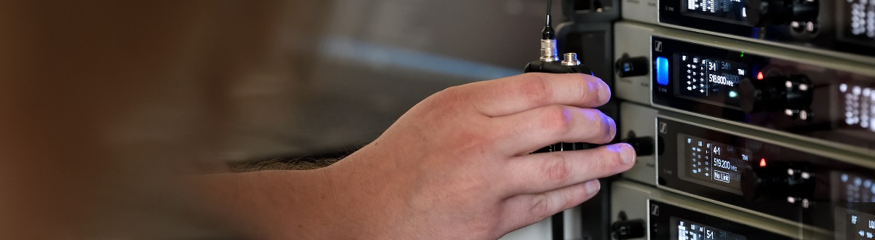#DontStopTheEducation

Mixing for monitors, calls with Tom Walker’s and Blake Shelton’s crews plus webinars on wireless microphone basics and touchless audio systems

Wedemark, June 5, 2020 – Three more exciting live round-table discussions are coming up in Sennheiser’s #DontStopTheEducation series: Meet members of the live touring crews of Tom Walker and Blake Shelton and join the Mixing Monitors Masterclass! Other live webinars in the series will look at Wireless Microphone Basics and new ways of voice pick-up and assistive listening in installed sound set-ups. As always, all panellists and hosts are very much looking forward to answering your questions.

Live Round-Table Discussion
Tuesday, June 9, 2020, at 17:00 Berlin time (16:00 London, 11:00 New York, 15:00 UTC)
Crew Call – Tom Walker
Sennheiser hosts Andy Egerton and Tim Moore welcome members from the live touring team of Tom Walker, the UK’s No.1 album selling artist and winner of the 2019 “Best Breakthrough Act” at the BRIT Awards. Guests include Ali Thynne (Drummer/MD and Playback tech), Dave Glover (Tour Manager), Mike Platt (Front-of-House Engineer), Liam Shannon (Monitor Engineer) and Ben Dawson (Backline Technician).

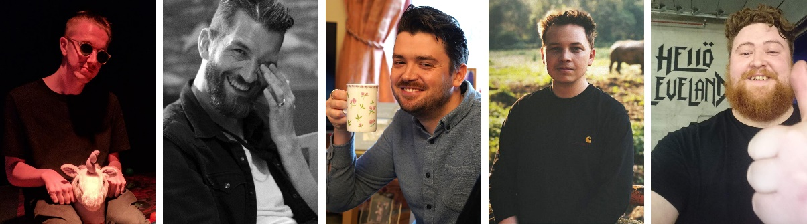
The Crew Call panellists: Ali Thynne, Dave Glover, Mike Platt, Liam Shannon and Ben Dawson (from left to right)

This webinar has something for everyone: If you are looking to get into the touring industry as a career, this webinar will highlight some key touring roles and requirements. If you’re already in the industry, this is a great way to gain insights into the life of another tour crew – and an opportunity to make up for some of the tour banter you might be missing during lockdown! Just sign up at https://zoom.us/webinar/register/WN_UhD-QdpyRuS9N4Urj0zcpA, tune in and remember to ask questions via the live Q&A section.

For your social media channels
Join members of Tom Walker’s team at Sennheiser’s live round-table discussion on June 9 at 17:00 CEST (11:00 EST). #Don’tStopTheEducation

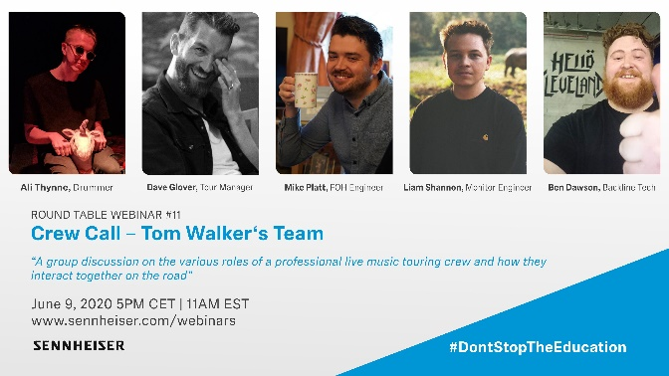 | Meet members of Tom Walker’s crew to gain insights into touring roles and requirements
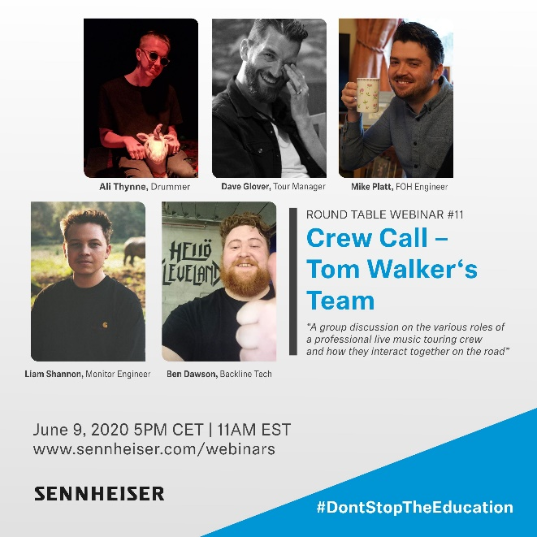 | 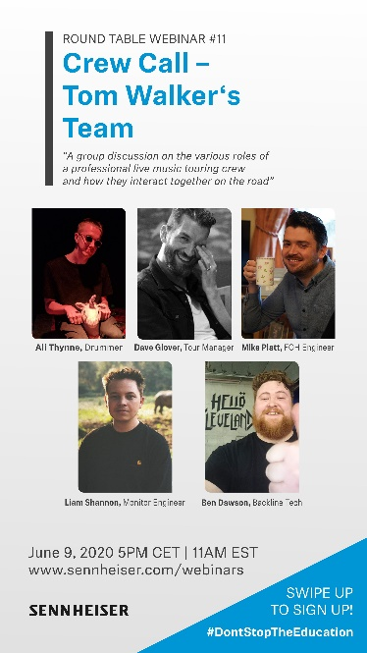

Live Round-Table Discussion
June 10, 2020 at 15:00 New York time (20:00 London, 21:00 Berlin, 19:00 UTC)

Mixing Monitors Masterclass
Sennheiser hosts David Missall and Tim Moore welcome five leading monitor engineers to discuss their approach to mixing monitors for touring artists. Matt Napier, Seamus Fenton, Karrie Keyes, Jon Lewis and Becky Pell will provide participants with a wealth of tips and tricks and are happy to answer any questions from the audience. Registration is now open at https://zoom.us/webinar/register/WN_0iQwo-yySlq7MpBIukbSmg.

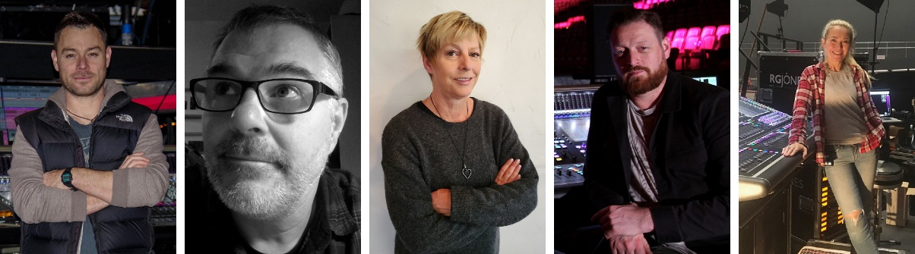
The panellists of the Mixing Monitors Masterclass: Matt Napier, Seamus Fenton, Karrie Keyes, Jon Lewis and Becky Pell (from left to right)

About the panellists
Matt Napier
25 years as a monitor engineer for the likes of Madonna, Roger Waters and Michael Bublé have given him a rather eclectic approach to mixing monitors. Matt has his own sound consultancy company Sonic Events Ltd and hopes one day to get off the road. Just not yet!

Seamus Fenton
A monitor engineer for over 25 years, Seamus’s roster includes Hugh Jackman’s recent world tour, a season with Strictly Come Dancing and, regularly, the Royal Variety Performance. He has also been the monitor engineer for the Pet Shop Boys for 12 years plus and many other artists and tours.

Karrie Keyes
Hailing from Los Angeles, Karrie has spent the last 29 plus years as the monitor engineer for Pearl Jam and Eddie Vedder. She first met and started working with Pearl Jam who opened for RHCP on their 1991-1992 Blood Sugar Sex Magic Tour. She has worked with Sonic Youth, Fugazi, and Neil Young.

Jon Lewis
Monitor engineer for P!NK, AC/DC, Cher. Over a 25-year career, Jon has mixed artists including Eric Clapton, Paul McCartney, Mark Knopfler, David Gilmore, Oasis, Gils Aloud, Jessie J, Paloma Faith, Will Young and Craig David. He has also designed and operated monitor systems for large-scale multi-band events including Live 8, MTV Awards, Brits Awards and Live Earth.

Becky Pell
Her mixing credits include Westlife, A-ha, Anastacia, The War of the Worlds, Muse, Take That, Il Divo, Kylie Minogue, Bill Wyman, James Brown, Jennifer Lopez, Sarah Brightman and Natalie Imbruglia.

For your social media channels
Join leading monitor engineers at Sennheiser’s live round-table discussion on June 10 at 15:00 EST (21:00 CEST). #Don’tStopTheEducation

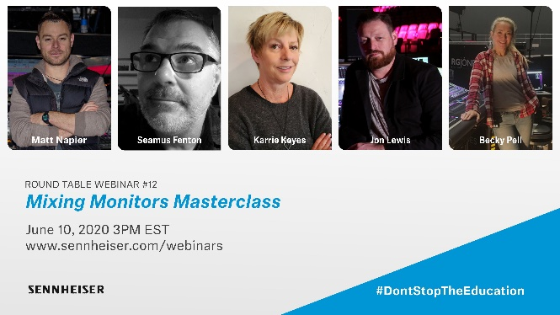 | Matt Napier, Seamus Fenton, Karrie Keyes, Jon Lewis and Becky Pell will discuss their approach to mixing monitors
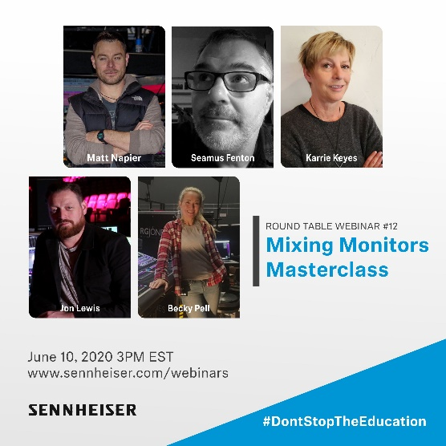 | 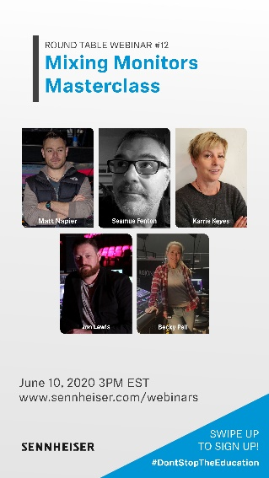

Live Round-Table Discussion
June 16, 2020 17:00 Berlin time (16:00 London, 11:00 New York, 15:00 UTC)

Crew Call – Blake Shelton
Sennheiser hosts Tim Moore and Andy Egerton welcome members of country artist Blake Shelton’s team. The guests will include members of the band, the audio team, and other production staff who will discuss how a crew works as a unit to approach audio, wireless, planning and the execution of a major tour. Brad Baisley (Monitor Engineer), Tracy Broussard (Drummer), Jeff Parsons (FoH), Ed Hardin (Drum Tech) and Jason Herndon (Guitar Tech) will share unique insights and are happy to answer questions from the audience. Please register at https://zoom.us/webinar/register/WN_WlQcOGGkTW2yClQKqbCtMw

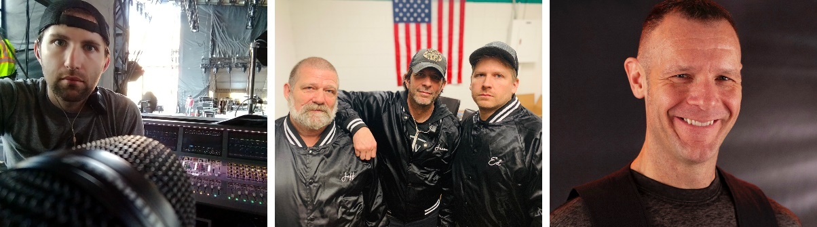
Panellists in the Crew Call: Brad Baisley, Jeff Parsons, Jason Herndon, Ed Hardin and Tracy Broussard (from left to right)

For your social media channels
Join members of Blake Shelton’s team at Sennheiser’s live round-table discussion on June 16 at 17:00 CEST (11:00 EST). #Don’tStopTheEducation

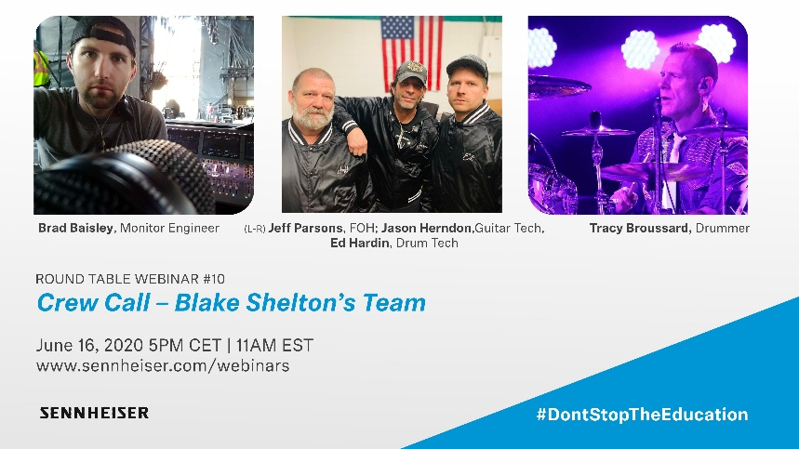 | Meet members of Blake Shelton’s crew who will discuss how a crew works as a unit to approach audio, wireless, planning and the execution of a major tour
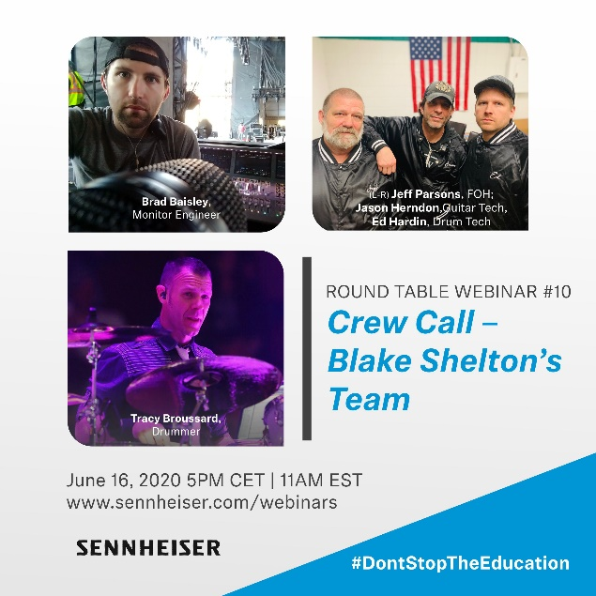 | 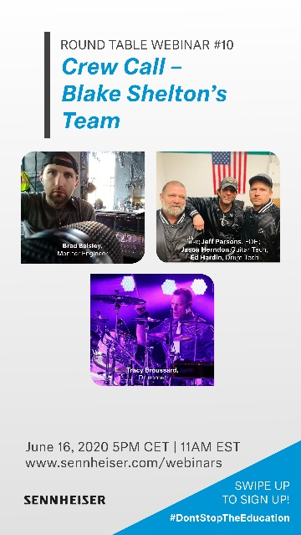

Live Webinar
June 15, 2020, with two time options: 8:30 to 10:00 or 18:00 to 19:30 (CEST, Berlin time)

Wireless Microphone Basics
Sennheiser RF expert Volker Schmitt kicks off a new live series on the trouble-free operation of wireless microphone systems. Consisting of three webinars (15, 22 and 29 June), this mini-series will deal with the topics carrier-to-noise ratio, RF gain structure, the importance of antennas and antenna placement as well as wireless monitoring systems, culminating in multi-channel systems in harsh RF environments in the last part of the series. Participants are welcome to ask questions which will be answered live. Please register at https://zoom.us/webinar/register/WN_vF9rmWnXQ9uKDMCyREYstg (8:30 slot) or https://zoom.us/webinar/register/WN_QpvDBOWpTOCLWPkcHPp6ng (18:00 slot)

RF wireless expert Volker Schmitt kicks off a series of three live webinars on Wireless Microphone Basics | 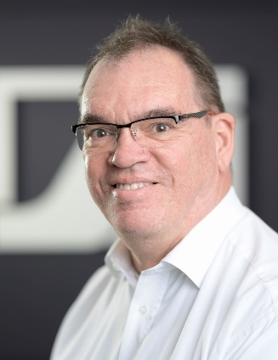

Live Webinar
June 17, 2020, with two time options: 16:00 to 17:00 or 20:00 to 21:00 (CEST, Berlin time)

Touchless Audio Systems: Voice Lift and Assistive Listening
Sennheiser’s Andrew Kornstein will take a look at the advances in microphone and assistive listening technology. To reliably pick up voices in an installed sound context, you will not always need multiple microphones, and pick-up can be done without having to touch a microphone or wear a microphone transmitter. The same is true for assistive listening, where new technologies allow personal mobile devices to be used, giving the user a more personal and sanitary experience. Andrew will discuss the TeamConnect Ceiling 2 microphone with patented beamforming technology, and the new MobileConnect assistive listening system which transmits over WiFi – two new technologies that change the way we work and listen.

Please register at https://zoom.us/webinar/register/WN_dj7NDfPGTXOan3vb7oJQJg for the 16:00 to 17:00 session and at https://zoom.us/webinar/register/WN_8U_KewAaTECpHnNdjrXwmA for the 20:00 to 21:00 session.

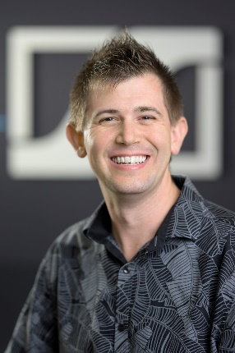 | Andrew Kornstein will talk about advances in microphone technology and assistive listening systems

Please visit https://www.sennheiser.com/webinars for a full, up-to-date list and to register free of charge for a SoundAcademy webinar of your choice. The free training sessions are offered at several different times to allow as many people from around the globe to tune in as possible.

The high-resolution images accompanying this press release can be downloaded at https://sennheiser-brandzone.com/c/181/L7fPaQzg.

About Sennheiser
Founded in 1945, Sennheiser is celebrating its 75th anniversary this year. Shaping the future of audio and creating unique sound experiences for customers – this aim unites Sennheiser employees and partners worldwide. The independent family company, which is managed in the third generation by Dr. Andreas Sennheiser and Daniel Sennheiser, is today one of the world’s leading manufacturers of headphones, loudspeakers, microphones and wireless transmission systems. In 2018, the Sennheiser Group generated turnover totalling €710.7 million. www.sennheiser.com

Global Press Contact

Stephanie Schmidt
Stephanie.schmidt@sennheiser.com
+49 (5130) 600 – 1275

