Classical guitarist Thibaut Garcia to release debut album *Leyendas*, on Erato September 2, including works by Albeniz,   
De Falla, Rodrigo, Piazzolla and more.

*The Frenchman with Spanish roots will launch the album with a six-month tour of the United States, including a performance at Carnegie Hall in New York on March 15, 2017*

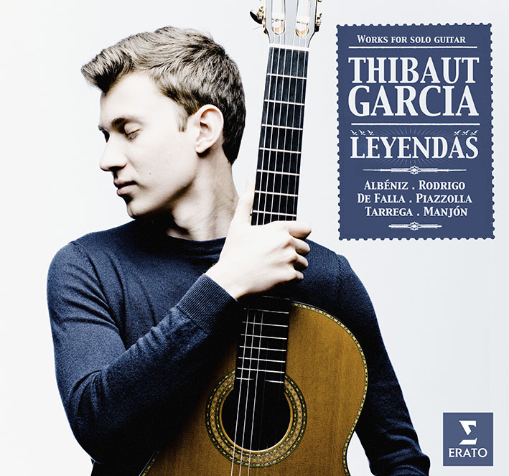

***“The new face of classical guitar”***

— Guitar Classique Magazine

22-year-old guitarist Thibaut Garcia makes his Erato debut with *Leyendas* (Legends), an atmospheric recital of music by Spanish and Argentinian composers: Albéniz, De Falla, Rodrigo, Tárrega (his famous, shimmering *Recuerdos de la Alhambra*), Manjón and Piazzolla. Thibaut will also tour the US this Fall/Winter with over 60 concerts, masterclasses, and outreach programs including stops at prominent venues like Carnegie Hall (March 15, 2017).

"For my first album with Erato, I wanted to show the guitar in its full glory. These legendary works are so close to my heart because they are part of my life and my travels. I wanted this first recording to be full of energy, sun, emotion, pain and tenderness – and to focus on repertoire that has been sustained me since my childhood.”

“Most of the works on *Leyendas* evoke Spanish or Argentinian cities where I have spent time: from Seville and Granada to Buenos Aires, passing through the Basque Country and Asturias. This meant I was able to give every piece a personal quality, as if each one featured in a travel diary.”

“This is music which made me love the guitar and which also reminds me of my Spanish roots. It shows various facets of the instrument, from the more popular style of Piazzola’s *Estaciones Porteñas* and **De** Falla’s *Siete canciones populares españolas* tothe more classical,intimate and elegant world of Albéniz. I am a great fan of music from the early 20th century – it displays the full palette of colors that the guitar can offer.”

Making a guest appearance on the album is Erato cellist Edgar Moreau, who plays in the group of pieces by De Falla. “This was the first time Edgar and I played together,” says Garcia. “It felt spontaneous, like two friends getting to know each other.”

While *Leyendas* focuses primarily on music from the last century, Garcia takes a panoramic view of his instrument, and Baroque and contemporary music – including new works – also feature strongly in his performing repertoire. He has many more stories to tell us …

**TRACKLIST**

**ISAAC ALBÉNIZ (1860–1909):** Extracts from ***Suite No.1*** Op. 47

[1]          Asturias */ Leyenda* - Arr. O. Chassain

[2]          Sevilla - Arr. F. Tarrega & M. Llobet

[3] **ANTONIO JIMÉNEZ MANJÓN (1866–1919): *Aire vasco*** Op. 19

**MANUEL DE FALLA (1876–1946): *Siete canciones populares españolas***   
Arr. M. Llobet, rev. E. Pujol

[4]          El paño moruno

[5]          Seguidilla murciana

[6]          Asturiana

[7]          Jota

*[8*]          Nana

[9]          Canción

[10]        Polo

[11]        **JOAQUIN RODRIGO (1901–1999): *Invocación y danza***Hommage à Manuel De Falla

**ASTOR PIAZZOLLA (1921–1992): *Estaciones Porteñas***

Arr. S. Assad

[12]        Primavera Porteña

[13]        Verano Porteño

[14]        Otoño Porteño

[15]        Invierno Porteño

[16]        **FRANCISCO TÁRREGA (1852–1909): *Recuerdos de la Alhambra***

**TOUR DATES**

***USA:*** *September 2016 – April 2017 :* ***60 concerts including Carnegie Hall***

*Date: City: State: Event:*

*9/10/16 Scranton PA Concert*

*9/13/16 Louisville KY Radio*

*9/14/16 Louisville KY Master Class/ Outreach*

*9/15/16 Louisville KY Concert*

*9/16/16 Louisville KY Master Class*

*9/18/16 Cincinnati OH Concert*

*9/19/16 Cincinnati OH Master Class*

*9/21/16 Oberlin OH Concert*

*9/22/16 Oberlin OH Master Class*

*9/24/16 Pensacola FL Concert & Master Class*

*10/1/16 St. Louis MO Concert*

*10/2/16 St. Louis MO Master Class*

*10/4/16 Buies Creek NC Concert*

*10/7/16 Portland OR Concert*

*10/13/16 Indianapolis IN Concert*

*10/14/16 Indianapolis IN Master Class*

*10/20/16 Flagstaff AZ Outreach*

*10/21/16 Flagstaff AZ Concert*

*10/22/16 Phoenix AZ Concert*

*10/27/16 Kalamazoo MI Concert*

*10/29/16 Detroit MI Master Class*

*10/30/16 Detroit MI Concert*

*11/3/16 Grand Rapids MI Concert*

*11/4/16 Youngstown OH Concert*

*11/5/16 Youngstown OH Master Class*

*11/6/16 Hartford CT Concert*

*11/9/16 Williamsburg VA Concert*

*11/10/16 Norfolk VA Master Class*

*11/11/16 Norfolk VA Concert*

*11/14/16 Charleston SC Concert*

*12/10/16 Minneapolis MN Concert*

*1/14/17 Austin TX Concert*

*1/21/17 Houston TX Concert*

*1/22/17 San Antonio TX Concert*

*1/23/17 San Antonio TX Master Class*

*1/25/17 Stuart FL Master Class*

*1/26/17 Stuart FL Concert*

*1/28/17 Miami FL Concert*

*1/31/17 Tallahassee FL Concert*

*2/1/17 Tallahassee FL Master Class*

*2/3/17 Tampa FL Concert*

*2/4/17 Sarasota FL Concert*

*2/11/17 Vancouver BC Concert*

*2/13/17 Cheyenne WY Master Class*

*2/14/17 Cheyenne WY Concert*

*2/17/17 San Jose CA Concert*

*2/18/17 Orange County CA Concert*

*3/3/17 Tucson AZ Concert*

*3/4/17 Tucson AZ Master Class*

*3/10/17 Columbus OH Concert*

*3/11/17 Evanston IL Concert*

*3/12/17 Evanston IL Master Class*

*3/15/17 New York City NY Concert*

*3/17/17 Sudbury ONT Master Class*

*3/18/17 Sudbury ONT Concert*

*3/24/17 Brownsville TX Master Class*

*3/24/17 Edinburg TX Concert*

*3/25/17 Brownsville TX Concert*

*3/28/17 Monterrey CA Concert*

*4/2/17 Albany NY Concert*

*4/6/17 Edmonton BC Concert*

*4/7/17 Edmonton BC Master Class*

*4/8/17 Calgary BC Concert*

*4/9/17 Calgary BC Master Class*

*4/14/17 Albuquerque NM Concert*

*4/20/17 Winnipeg MB Concert*

*4/21/17 Winnipeg MB Master Class*

*4/22/17 Wilmington DE Concert*

ABOUT THIBAUT GARCIA

Thibaut Garcia was born in Toulouse. His father played flamenco and classical guitar and Thibaut was given his first instrument when he was just seven years old. He went on to study in his home city and at the age of 16 entered the Conservatoire National Supérieur de Musique et de Danse de Paris, from which he graduated with special honours. Between 2008 and 2015 he won first prize in no fewer than six international competitions in Spain, Germany, Romania and the USA. Two important victories in Spain resulted in invitations to play around Europe, in Russia, China, the USA and Latin America, while his triumph at the Guitar Foundation of America’s competition in 2015 led to 50 dates in the USA, including a recital at Carnegie Hall.