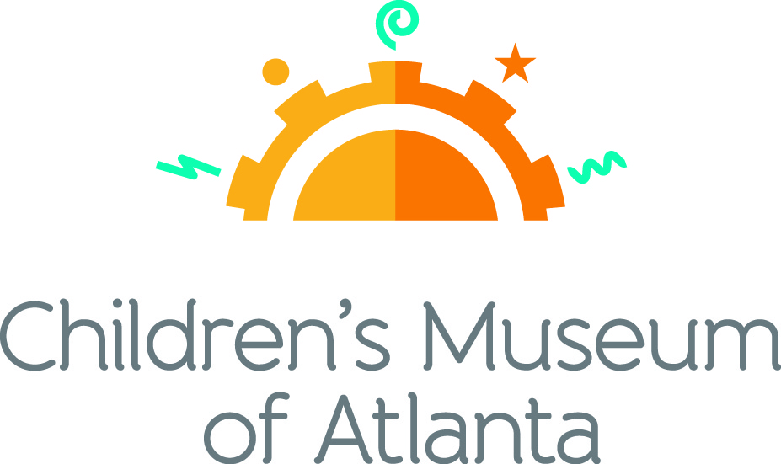

CONTACT
Alison Wentley
BRAVE Public Relations
404.233.3993
awentley@emailbrave.com

*MEDIA ADVISORY*

Superhero Science Night springs into action at Children’s Museum of Atlanta, March 14
Families are invited to explore the heroic powers of knowledge

ATLANTA (February 11, 2020) – Up, up and away! Little ones are welcome to soar to Children’s Museum of Atlanta and discover the magical powers behind learning at Superhero Science Night on Saturday, March 14 from 6:30 – 8:30 p.m. Kids and parents are encouraged to dress up as their favorite superhero as they save the world using the functions of science, technology, engineering and mathematics. The action-packed night will feature a number of hands-on activities, such as learning how The Human Torch produces combustion, testing Cat-Woman-like reflexes with a fulcrum, growing a Baby Groot and more! At the end of the night, Professor Labcoat will perform a special weather-themed Spectacular Science Show finale, which is sure to create a storm of fun!

Attendees can also look forward to a robotics demonstration from the gifted Oak Grove Elementary GroveBots. The Museum will also have volunteers from T.E.E.M.S. AmeriCorps members at Georgia State, Novelis and Children’s Healthcare of Atlanta.

WHAT: Superhero Science Night at Children’s Museum of Atlanta
Families are invited to blast off into the wonderful world of science

WHEN: Saturday, March 14
6:30 – 8:30 p.m.

WHERE: Children’s Museum of Atlanta
275 Centennial Olympic Park Drive, NW
Atlanta, GA 30313

HOW: Tickets are $10 for members / $20 for non-members and must be purchased in advance. Tickets will not be sold at the door. For tickets, visit tinyurl.com/SuperheroScienceNight20 or call 404-420-5910. *Prices increase March 9*

For more information or to support Children's Museum of Atlanta, visit childrensmuseumatlanta.org
###

