Wallace Detroit Guitars’ Reclaimed Guitar Bodies Now Available for
Individual Sale

The bodies constructed from the wood of former Detroit landmarks offer players the opportunity to create their own custom WDG instrument

Detroit, January 31, 2018 — Wallace Detroit Guitars, maker of guitars created from the wood of former Detroit landmarks, has announced that its guitar bodies are now available for individual sale — allowing players to create their own custom guitars that feature an authentic, hand-made touch of Detroit history. The guitar bodies are available for viewing and purchasing in the Wallace Detroit Guitars online shop.

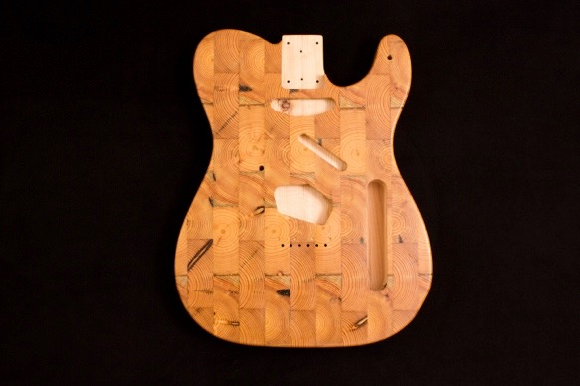
“We have been getting requests for our guitar bodies for quite a while, so we are excited that we can now offer these quality pieces to our customers,” said Mark Wallace, founder of Wallace Detroit Guitars. “Selling the bodies individually allows players to get creative and build their own musical work of art while also enjoying a little nostalgic piece of our city.”

Historical Bodies
WDG’s instruments are crafted of reclaimed wood from various Detroit historical landmarks, including former buildings that once lined Detroit’s storied Michigan Avenue — which has long been considered to be the state’s most important thoroughfare. Among this wood are the original floorboards of the former Detroit Fire Department Headquarters, Michigan's oldest fire department.

The bodies for sale are available in end grain or long grain pine from former Michigan Avenue buildings, as well as maple from the Fire Department Headquarters. In addition to offering individual bodies, Wallace Detroit Guitars will also be taking special wood and finish requests. To help customers with their purchases, WDG now offers 6-month layaway on all of its guitars and bodies.

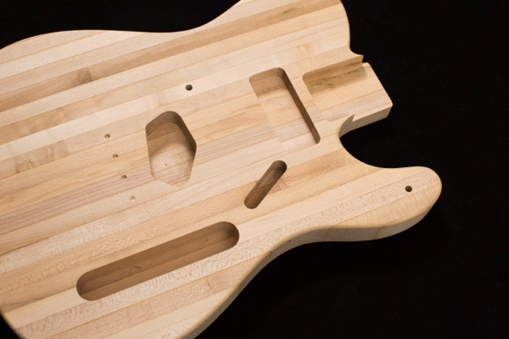
Pricing
Completely routed and oil-finished bodies will be available for $800. Routed unfinished bodies will be available for $675, while a completely unfinished body will be offered at $600.

“We are excited to see what our customers do with our guitar bodies,” Wallace said. “So, we are encouraging players to send us images of their finished guitars, and we will send them a WDG t-shirt as a ‘thanks’ and also share their photo on social media.”
For more information on the new guitar bodies, please visit wallacedetroitguitars.com.

About Wallace Detroit Guitars
Founded by Mark Wallace in 2014, Wallace Detroit Guitars breathes new life into reclaimed wood from Detroit buildings by shaping it into some of finest American guitars on the market. Their instruments acknowledge not only Detroit’s architectural history, but also its proud tradition of both great craftsmanship and great music. With superior construction, premium components, and a great story, each guitar delivers a truly timeless playing experience.

Contact Information:
Jeff Touzeau
Public Relations
Hummingbird Media, Inc.
(914) 602-2913
jeff@hummingbirdmedia.com

Katie Kailus
Public Relations
Hummingbird Media, Inc.
(630) 319-5226
katie@hummingbirdmedia.com

