September 7, 2018
Toyota Motor Corporation
GAZOO Racing Company

Rally Turkey: Preview
Toyota Yaris WRC to take on new ground in Turkey

The TOYOTA GAZOO Racing World Rally Team faces a brand new challenge on Rally Turkey (September 13-16): the 10th round of this year’s FIA World Rally Championship and a new addition to the calendar for this season. The Toyota Yaris WRC, driven by Jari-Matti Latvala, Ott Tänak and Esapekka Lappi, will take on the gravel event fresh from back-to-back victories in Finland and Germany.

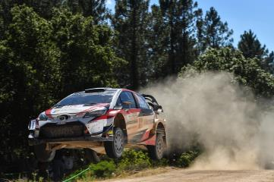

Yaris WRC Car 8

This will be the first WRC round in Turkey since 2010, and will be based in Marmaris on the Mediterranean coast. A mixture of smooth roads close to Marmaris and rockier mountain tracks to the north near Mugla are anticipated, but all of the stages will be brand new to the crews, who will use the pre-event recce to create their pace-notes from scratch. With testing in Turkey before the rally not permitted, the Yaris WRC was instead put through its paces on gravel in Portugal last week.

The rally will begin on Thursday evening with a street stage in Marmaris before two loops of three stages on Friday near Mugla. On Saturday the rally heads west for three stages all run twice, and the rally concludes on Sunday with four stages, including the Power Stage that will finish right by the service park.

Quotes:
Tommi Mäkinen (Team Principal)
“The last two rallies have been brilliant for us and our aim is of course to continue in that way, but there are many unknowns about Turkey for every team because it is a new rally. I did drive in Turkey when the WRC went for the first time in 2003: I remember that the conditions were very hard and the roads were pretty rough, but we are going to a different area this time and we don’t know exactly what the nature of the stages will be. We have been preparing as well as we possibly can and we had a good test last week in the south of Portugal, where hopefully we simulated the conditions that we will face very well, especially the high temperatures.”

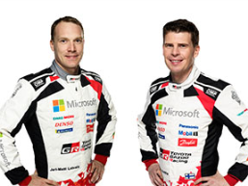
Jari-Matti Latvala (Driver car 7)
“This is the first time for many years that I am preparing for a completely new WRC event. There are many unknowns: you have to do new pace-notes, you don’t know the characteristics of the roads and you don’t know how they will change for the second pass. I remember from when we went to Turkey in 2008, near Antalya, that it was very hot. The long stages were very demanding and very hard on the tyres. From what I have seen so far, I think there will be some similarities to that rally and also to the Acropolis Rally. The pre-event test was really good for me. I was very happy with the car and we made some good steps with the suspension.”
Jari-Matti Latvala and Miikka Anttila

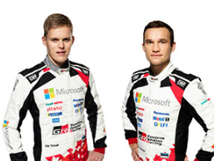
Ott Tänak (Driver car 8)
“Obviously we have had some very good results recently, but I am still taking it rally-by-rally. It is difficult to have any expectations for Turkey as we don’t have a lot of know-how about the rally. Everybody is talking about it being a rough event: we will have to wait and see how it is on the recce. We certainly know that it will be hot. I think that our pre-event test in the south of Portugal was good preparation for that and we are doing everything we can to be ready and be competitive. Now there is not too much more we can do until we get there and see the stages for ourselves.”
Ott Tänak and Martin Järveoja

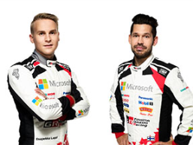
Esapekka Lappi (Driver car 9)
“We should expect the unexpected in Turkey. The information we have is that it will be rough with a lot of loose gravel, and that tyre management will be key. For that reason, the long afternoon loops will be crucial, I think. We saw on our test that the tyre wear is quite high when you have rough roads and it’s 35 degress outside. In general the test went very well and I think we managed to find some nice settings with the car. I am looking forward to the challenge: it’s a chance to learn something new. So far, being early on the road on loose gravel has not been a strong point for me, so I will try to improve that.”
Esapekka Lappi and Janne Ferm
Press release
URL: https://toyotagazooracing.com/release/2018/

Pictures will be uploaded here during the event
URL: https://www.tgr-dam.com

Follow us!
Follow TOYOTA GAZOO Racing WRT:
∇Facebook: https://www.facebook.com/TOYOTAGAZOORacingWRC
∇Twitter: https://www.twitter.com/TGR_WRC (@TGR_WRC)
∇Instagram: https://www.instagram.com/tgr_wrc/ (@TGR_WRC)
∇YouTube: https://www.youtube.com/channel/UCCtALHup92q5xIFb7n9UXVg

Contact

TOYOTA GAZOO Racing PR Office
Email: tgr_pr@tgr-dam.com

TOYOTA GAZOO Racing official website:
http://toyotagazooracing.com/

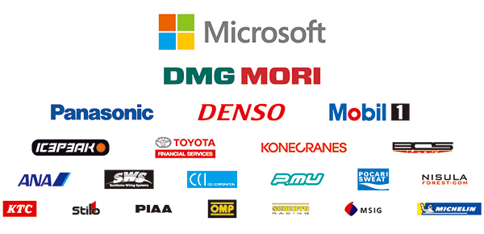
TOYOTA GAZOO Racing World Rally Team is supported by following partners:

