EMBARGOED UNTIL FRIDAY 15 SEPTEMBER 10:00 A.M. CET

Xytech Announces MediaPulse Transmission and Automation Releases for Broadcast Operations, New for IBC 2017

Best-in-class operational platform simplifies transmission and automation workflows, streamlining operations for facilities management

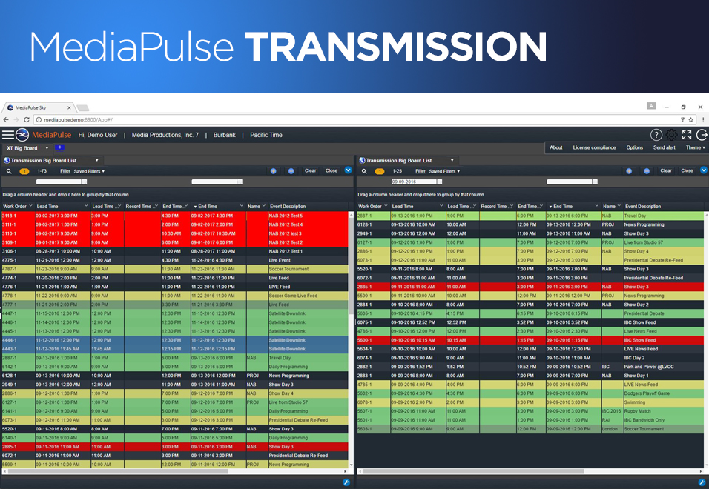
Amsterdam, 15 September 2017 — Xytech, the leader in facility management software for the broadcast, production, media services and video transmission industries, is exhibiting at IBC 2017 [stand #6.C22] between September 15 and 19 to demonstrate its new MediaPulse Transmission and Digital Order Automation features. Available now, the new transmission and automation releases are integral components of the company's best-in-class software platform MediaPulse.

MediaPulse Transmission's functional capabilities align with core key themes of IBC 2017, including mobility, transmission, cloud and internationalism. The new release offers enterprise-class operations and robust financial management tools designed specifically to streamline transmission and automation functionality across multiple broadcast platforms. This latest release of MediaPulse makes it easy for broadcast personnel to reserve, provision and monitor specific feeds, while simplifying the process of booking routes. Available as both on-premise and cloud installations, the new release also has a notification engine, personalized feed dashboards and a Big Board list of feeds appropriate for publication to the entire facility.

“After years of refining our transmission module, we have created a solution not only competitive in the marketplace, but completely superior," comments Greg Dolan, COO of Xytech. "There is a host of new functionality included: for instance, the system can become 'network aware' automatically; making a software defined network easily configured and it is completely localizable. If our customers need to transmit a broadcast signal between any two points, MediaPulse transmission makes the entire process more efficient while removing any uncertainty."

MediaPulse: Master of Workflows
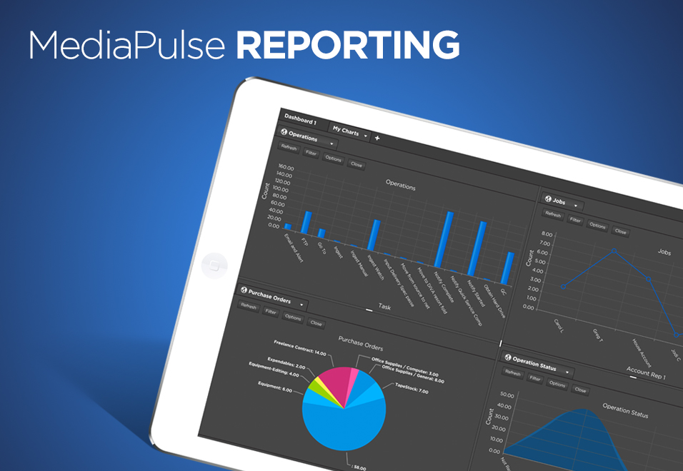
MediaPulse Reporting — the company's automation module — is able to capture an order and drive required tasks to ensure a seamless order process. The new Digital Order Automation module in MediaPulse streamlines the complex, expensive and time-consuming workflow processes all media servicing and broadcast facilities face. The software also integrates with third-party applications through an open adapter technology so order automation and multi system workflows are truly seamless. The result is a workflow elegantly navigating multiple dependencies across a range of possibilities.

“MediaPulse is the master of workflow management, making even the most complex path dependencies or multi-system automations look easy," Dolan said. "We are the 'workflow of workflows' for our customers so they can easily kick off a new sequence of required events and report on its progress or troubleshoot it as necessary. This can lead to vast operational savings, while reducing costly mistakes."

Xytech will be demoing the new MediaPulse modules at stand #6.C22 throughout IBC 2017. If you are interested in scheduling an appointment, please contact Alexandra Kuipers at akuipers@xytechsystems.com, + 1 (818) 698-4958 or Aurore Gilewicz at agilewicz@xytechsystems.com, +44 203 478 1462.

About Xytech Systems: For over 25 years, the world’s premiere media companies have depended on Xytech to run their businesses. MediaPulse is the only end-to-end solution for the complete content lifecycle. MediaPulse provides scheduling, automation, asset management, billing and cost recovery for broadcasters, media services companies and transmission facilities in a scalable platform-independent solution.

For more information, visit xytechsystems.com.

Media Contacts:

Media contact
Jeff Touzeau
Public Relations
Hummingbird Media
+1 (914) 602 2913
jeff@hummingbirdmedia.com

Katie Kailus
Public Relations
Hummingbird Media
+1 (630) 319-5226
katie@hummingbirdmedia.com

