MEDIA ALERT: Synthax Highlights Digigram’s Audio Over IP, Transmission Solutions for Broadcasters at 2019 Radio Show

The new IQOYA TALK, IQOYA X/LINK IP codecs simplify operations for broadcasters
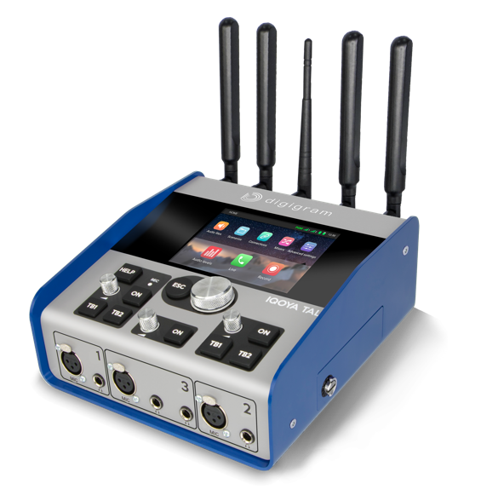
Dallas, Texas, September 23, 2019 – Synthax, distributor of Digigram broadcast audio systems, will showcase Digigram’s audio solutions designed to help streamline radio broadcasters’ setups at the 2019 Radio Show, booth 100 from September 24–26, 2019.
Radio Show attendees will get the chance to experience two of legacy-brand Digigram’s IP audio codecs — the new IQOYA TALK and the IQOYA X/LINK.
“With over 10,000 codecs currently in use, Digigram has been revolutionizing the way radio broadcasters record and transmit for years, and the company’s latest additions continue that mission,” said Derek Badala, Synthax’s Director of Sales, Americas. “One of the components that makes Digigram unique is its Fluid IP which means it offers air correction and dual streaming — so users always have a redundant stream. As a result, we are excited to show how Digigram’s offerings can continue to shape the industry’s landscape and streamline broadcasters’ processes.”
The Future of Transmission: Audio Over IP
With a user-interface designed for “non-technicals,” the IQOYA TALK IP portable codec allows remote reporters to perform key actions in just two simple clicks. Live reporting and commentary can be performed along with studio-quality interviews for up to four DJs and guests. Audio content is streamed through a large number of wired or wireless ‘last mile’ connections.

Boasting the most adaptable software on the market, IQOYA TALK features 11 inputs/10 outputs, dual Gigabit Ethernet ports, a dual built-in 4G/LTE module, an intuitive iPhone/Android hook up and 3 mic-line inputs and 4 headphone outputs, so users can not only feature a co-host and host, but also a guest and their guest — a big advantage for broadcasters.

IQOYA X/LINK is a 1U rack IP audio codec designed to deliver two stereo sources over IP networks ideal for web radio. As with all IQOYA products, its Fluid IP technology offer redundant dual streaming providing users with reliable connection over inexpensive IP links.

For more information on Synthax, visit: https://www.synthax.com/
For more information on Digigram, visit: http://www.digigram.com/
About Synthax, Incorporated
Synthax Inc. is the exclusive USA distributor for RME digital audio solutions, Digigram broadcast audio systems, Appsys digital audio tools, Ferrofish advanced audio applications, myMix personal monitoring systems and ALVA cableware. We supply a nationwide network of dealers with these products for professional audio, broadcast, music industry, commercial audio, theater, military and government applications. For additional information, visit the company online at http://www.synthax.com.

Media Contacts:
Katie Kailus
Public Relations
Hummingbird Media
+1 (630) 319-5226
katie@hummingbirdmedia.com

Jeff Touzeau
Public Relations
Hummingbird Media
+1 (914) 602 2913
jeff@hummingbirdmedia.com

