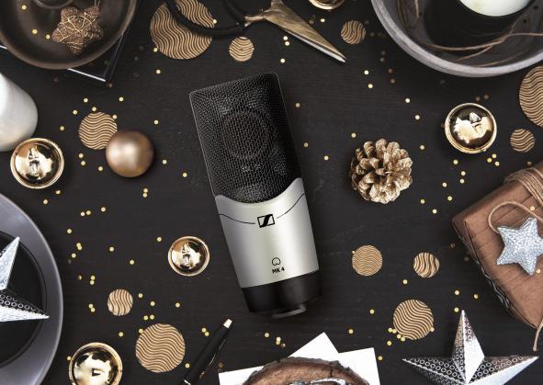 | 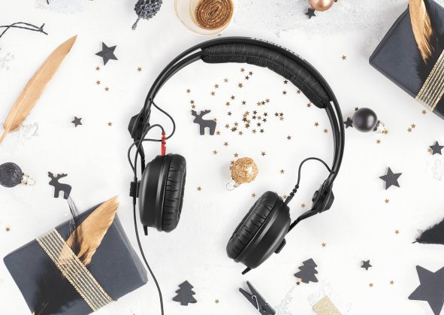

The perfect gift for the musician in your life: Make their creative dreams come true with Sennheiser

Wedemark, 16 October 2020 – There’s nothing quite like giving the perfect gift. That special item that becomes part of a loved one’s life. For creatives, it’s the tool that can take their art to new heights and make their vision a reality. And when you’re buying for a person with a passion for making music, Sennheiser is here to help with brilliant gift ideas that cater to a wide range of styles, recording and monitoring situations and budgets. The audio specialist has an exceptional range of microphones and professional headphones that make it a joy to capture and create pitch-perfect performances.

Bring a professional touch to every recording
MK 4
Ideal for home, project, and professional studios alike, Sennheiser’s MK 4 cardioid true condenser microphone brings professional quality to recordings – with outstanding value for money. Its large 1” diaphragm capsule uses high-end Sennheiser acoustics to deliver fine resolution, exceptional quality, and a powerful warm sound that’s great for vocals, acoustic instruments, guitar amps, voice-overs and much more.

Sennheiser’s MK 4 cardioid true condenser microphone brings professional quality to recordings

- True condenser, large-diaphragm microphone for vocals and instruments
- 24-carat gold-plated diaphragm and full metal housing
- Capsule shock-mounted internally to minimise structure-borne noise
- Designed for project studios and stage use
- Low inherent self-noise and high maximum SPL

A live vocal microphone that brings it all to life
e 835 / e 835 S
This is it. The vocal microphone that just delivers. Intended for home recording, semi-pro studios and live sound, the e 835 is a dynamic cardioid microphone that projects well and cuts through high volumes on stage. No muffled, mids-centric sound but tight low mids and present treble. No problem with feedback, spill or handling noise; instead, maximum flexibility for the voice: The e 835 is a solid choice for performers. Moderation and singing remain crystal-clear and natural, even at varying distances from the capsule. Its extremely rugged construction and uncomplicated handling make the e 835 the first choice for rehearsal rooms, home recording or the stage. It has also become a top seller in its class everywhere that speech intelligibility is critical such as in lectures and presentations in auditoriums large and small alike. Also available as e 835 S with noiseless on/off switch.

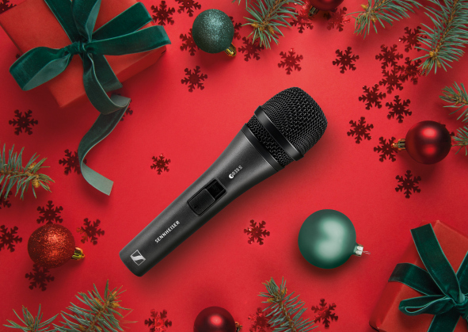 | The Sennheiser e 835 / e 835 S is a dynamic, cardioid microphone that’s ideal for vocals and capable of cutting through high on-stage levels

- Dynamic, cardioid microphone that cuts through high on-stage levels
- Clear reproduction with a high presence
- Handles high sound pressure levels
- Isolates handling noise, hum compensating coil
- Rugged metal housing

Extend Every Voice
e 935
Another exceptional vocal mic choice, Sennheiser’s e 935 steps up to provide even greater performance, durability and versatility, with a balanced frequency range that makes its suitable for songs of every genre. This dynamic cardioid vocal mic clearly gives the voice more space and positions it cleanly in front of loud instruments. With a transparent high-end and warm but well defined lower mids, it lends even gentle voices an impressive intensity and size and clearly increases the speech intelligibility. It remains extremely resistant to feedback as well as to the hard conditions of live gigs.

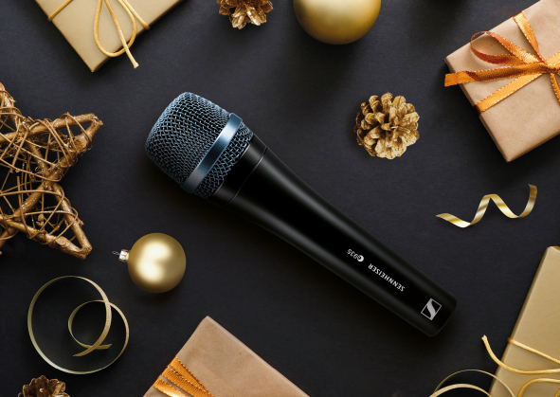 | With its famous sound, the Sennheiser e 935 gives the voice more space

- Dynamic cardioid microphone with a famous sound signature
- Highly consistent directivity
- High feedback rejection
- Shock-mounted capsule
- Hum compensating coil
- Extremely rugged metal housing

Play, record, and listen without distractions - all at an incredible special price
HD 200 PRO
There’s nothing like total focus on the sound to enhance the creative process. With the HD 200 PRO monitoring headphones, it’s possible to experience powerful studio sound anywhere. Whether recording one’s own compositions, practising silently, or just enjoying music at home – the closed-back HD 200 PRO is the perfect companion for monitoring tasks. The HD 200 PRO’s ambient noise attenuation makes it easy to fully concentrate – even at home over the holiday season – while the soft ear pads ensure outstanding comfort during long creative sessions. Even better, to celebrate its 75th anniversary, Sennheiser is offering the HD 200 PRO at just EUR 49 MSRP (USD 49.95 MAP) until the end of the year (www.sennheiser.com/special-deals).

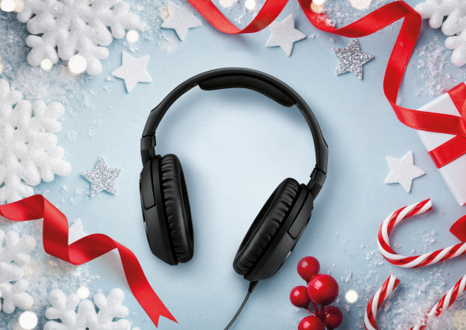 | Experience powerful studio sound anywhere with the HD 200 PRO monitoring headphones

- Closed, around-ear headphone design to reduce ambient noise
- Sennheiser’s proprietary transducers deliver an outstanding stereo sound reproduction with powerful bass
- The soft ear cushions and ergonomic design provide enhanced fit and comfort
- Robust 2.0 m singled-sided cable
- 6.3 mm (1/4”) stereo jack adaptor included

Give them an audio legend
HD 25
Considered to be the “Industry Standard” for DJs, Sennheiser’s HD 25 headphones have acquired a legendary status in the music world and can be found in DJ booths the world over. Capable of handling very high sound pressure levels, the HD 25’s cult status as DJ headphones is owed to their exceptional performance in loud environments, combination of robust construction and low weight, and the option of one-ear listening. These same qualities make them exceptionally versatile for a wide range of professional monitoring situations including for cameramen and for studio monitoring.

The HD 25 from Sennheiser has a legendary status among DJs, musicians and engineers

- Rugged and lightweight monitoring and DJ-ing headphones
- High sensitivity due to lightweight aluminium voice coils
- Capable of handling very high sound pressure levels
- Very lightweight and comfortable, even if used for long periods of time
- Tough, detachable, single-sided cable
- Rotatable capsule for single-ear listening

(Ends)

Price information:
MK 4: EUR 299 (MSRP) / USD 299.95 (MAP)
e 835/e 835 S: EUR 99 (MSRP) / USD 99.95 (MAP)
e 935: EUR 179 (MSRP) / USD 179.95 (MAP)
HD 200: on special offer until 31 December, EUR 49 (MSRP) / USD 49.95 (MAP)
HD 25: EUR 149 (MSRP) / USD 149.95 (MAP)

The images accompanying this press release plus additional photos can be downloaded at https://sennheiser-brandzone.com/c/181/ZS56WAXM.

About Sennheiser
Founded in 1945, Sennheiser is celebrating its 75th anniversary this year. Shaping the future of audio and creating unique sound experiences for customers – this aim unites Sennheiser employees and partners worldwide. The independent family company, which is managed in the third generation by Dr. Andreas Sennheiser and Daniel Sennheiser, is today one of the world’s leading manufacturers of headphones, loudspeakers, microphones and wireless transmission systems. In 2019, the Sennheiser Group generated turnover totaling €756.7 million. www.sennheiser.com

Global Press Contact

Stephanie Schmidt
Stephanie.schmidt@sennheiser.com
+49 (5130) 600 – 1275

