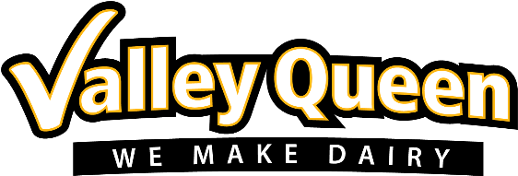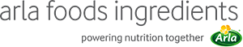

3rd March 2025

PRESS RELEASE

Arla Foods Ingredients strengthens US
foothold with Valley Queen agreement

Arla Foods Ingredients has signed a contract manufacturing agreement with Valley Queen, strengthening its ability to meet the growing demand for protein-enriched dairy in the US.

The South Dakota-based dairy processor will produce ingredients from the Nutrilac® ProteinBoost product range. The patented microparticulate whey protein concentrate is used to increase protein levels in food and beverage products while retaining texture and taste.

Privately owned and with a team of 440 employees, Valley Queen specializes in high-quality dairy products. It handles around three billion pounds (1.36bn kg) of milk annually and produces 330 million pounds (150M kg) of cheese. Production of Nutrilac® ProteinBoost is expected to begin at the company’s plant in Milbank, SD, in winter 2025/2026, after new specialty equipment has been installed.

Luis Cubel, Group Vice President and Managing Director of Arla Foods Ingredients, said: “Demand for protein-enriched dairy products continues to grow in the US. In order to meet it, and to fulfil our ambitious plans for growth in North America, it was essential for us to significantly increase our capacity for the production of Nutrilac® ProteinBoost. At the same time, it was important for us to choose a partner with the right values, history and expertise. We’re delighted to work with Valley Queen, a company with a long heritage which shares our commitment to producing dairy and whey products of the highest quality.”

Doug Wilke, CEO of Valley Queen, said: “Like us, Arla Foods Ingredients is dedicated to meeting the needs of American manufacturers and consumers. Nutrilac® ProteinBoost is a highly innovative ingredient, which offers the perfect way to create appealing dairy products enriched with high-quality protein. We’re excited to move ahead with its production, and we’re looking forward to a long and productive partnership with a global leader in the whey nutrition space.”

For more information contact:
Steve Harman, Ingredient Communications
Tel: +44 (0)7538 118079 | Email: steve@ingredientcommunications.com

About Arla Foods Ingredients
Arla Foods Ingredients is a global leader in improving premium nutrition. Together with our customers, research partners, suppliers, NGOs and others, we discover and deliver documented ingredients and products that can advance lifelong nutrition for the benefit of consumers around the world.

We serve leading global brands in early life nutrition, medical nutrition, sports nutrition, health foods, and other foods and beverages.

Five reasons to choose us:
- We're passionate about improving nutrition
- We innovate by connecting the best
- We master both discovery and delivery
- We build strong, long-lasting partnerships
- We are committed to sustainability

Headquartered in Denmark, Arla Foods Ingredients is a 100% owned subsidiary of Arla Foods.

https://www.arlafoodsingredients.com/

LinkedIn
http://www.linkedin.com/company/arla-foods-ingredients

LinkedIn (Latin America)
https://www.linkedin.com/showcase/arla-foods-ingredients-latin-america/

LinkedIn (China)
https://www.linkedin.com/showcase/arla-foods-ingredients-china/

About Valley Queen

Valley Queen Cheese was founded in 1929 by Alfred Nef and Alfred Gonzenbach. Valley Queen annually converts three billion pounds of milk into a variety of natural cheeses, dried lactose, WPC80 and anhydrous milk fat. These products are sold to some of the best-known food companies in the world.

https://www.valleyqueen.com/

https://www.linkedin.com/company/valley-queen-cheese-factory-inc-/

