Building a world of superior audio with BIMobject®
Sennheiser provides conferencing and professional audio products as BIM files for seamless architectural and building design

Wedemark, October 29, 2020 – Audio specialist Sennheiser has joined the BIMobject® content platform for architects and the building product manufacturing industry. Now, Sennheiser key products such as the innovative TeamConnect Ceiling 2 conferencing microphone are available as 2D and 3D objects for design and CAD solutions. Sennheiser’s BIM files also provide comprehensive product data, enabling architects, construction companies, and system integrators to better specify, plan, visualize and maintain Sennheiser products throughout the lifecycle of a building. Besides TeamConnect Ceiling 2, products from the SpeechLine DW and ew G4 microphone series as well as the pioneering MobileConnect assistive listening solution are available within the BIMobject catalog.

TeamConnect Ceiling 2, Mobile Connect and products from the SpeechLine Digital Wireless and evolution wireless G4 microphone series are available on the BIMobject platform

“Businesses are increasingly recognizing the competitive advantages offered by superior audio and demanding this capability from the modern workplace,” commented Kai Tossing, Head of Product Management, Business Communication at Sennheiser. “Whether it’s ensuring that people on site can easily communicate with remote customers or colleagues or that everyone in an auditorium can clearly hear the speaker, Sennheiser is committed to bringing an effortless experience of superior audio to everyone. The inclusion of our products in BIMobject will make it easier for architects, planners and integrators to create work and educational environments where outstanding Sennheiser audio comes built in.”

BIMobject is a global industry standard platform used by architects and the building product manufacturing industry that provides CAD and BIM (Building Information Modeling) data, including geometrically correct and true-to-life objects. In architectural and engineering applications, these standardized data files save time and enable more efficient planning, design, and creation of digital designs. Used in construction projects of every size from small to large construction projects, BIM files, which provide all relevant planning data and 2D as well as 3D files, are required for public projects in countries such as the US, UK and Germany.

With the creation of Sennheiser products as BIM objects, an architect or system integrator can now easily search for relevant audio solutions from the cloud-based BIMobject catalog. They can view detailed product information and place geometrically correct models of the product straight into their designs. For example, when designing a meeting room, Sennheiser’s TeamConnect Ceiling 2 can be placed into the CAD design, viewed on 2D plans or as a realistic 3D render, showing immediately how the innovative ceiling mounted beamforming microphone can help to free up space while offering minimal disruption to the aesthetics of the room.

https://www.sennheiser.com/bimobject

(Ends)

SENNHEISER Products on BIMobject

 | TeamConnect Ceiling 2 - This second generation of Sennheiser’s innovative ceiling microphone incorporates automatic adaptive beamforming technology to deliver superior audio quality for voice and video conferences in mid-sized to large meeting rooms. | On BIMobject:  - TeamConnect Ceiling 2
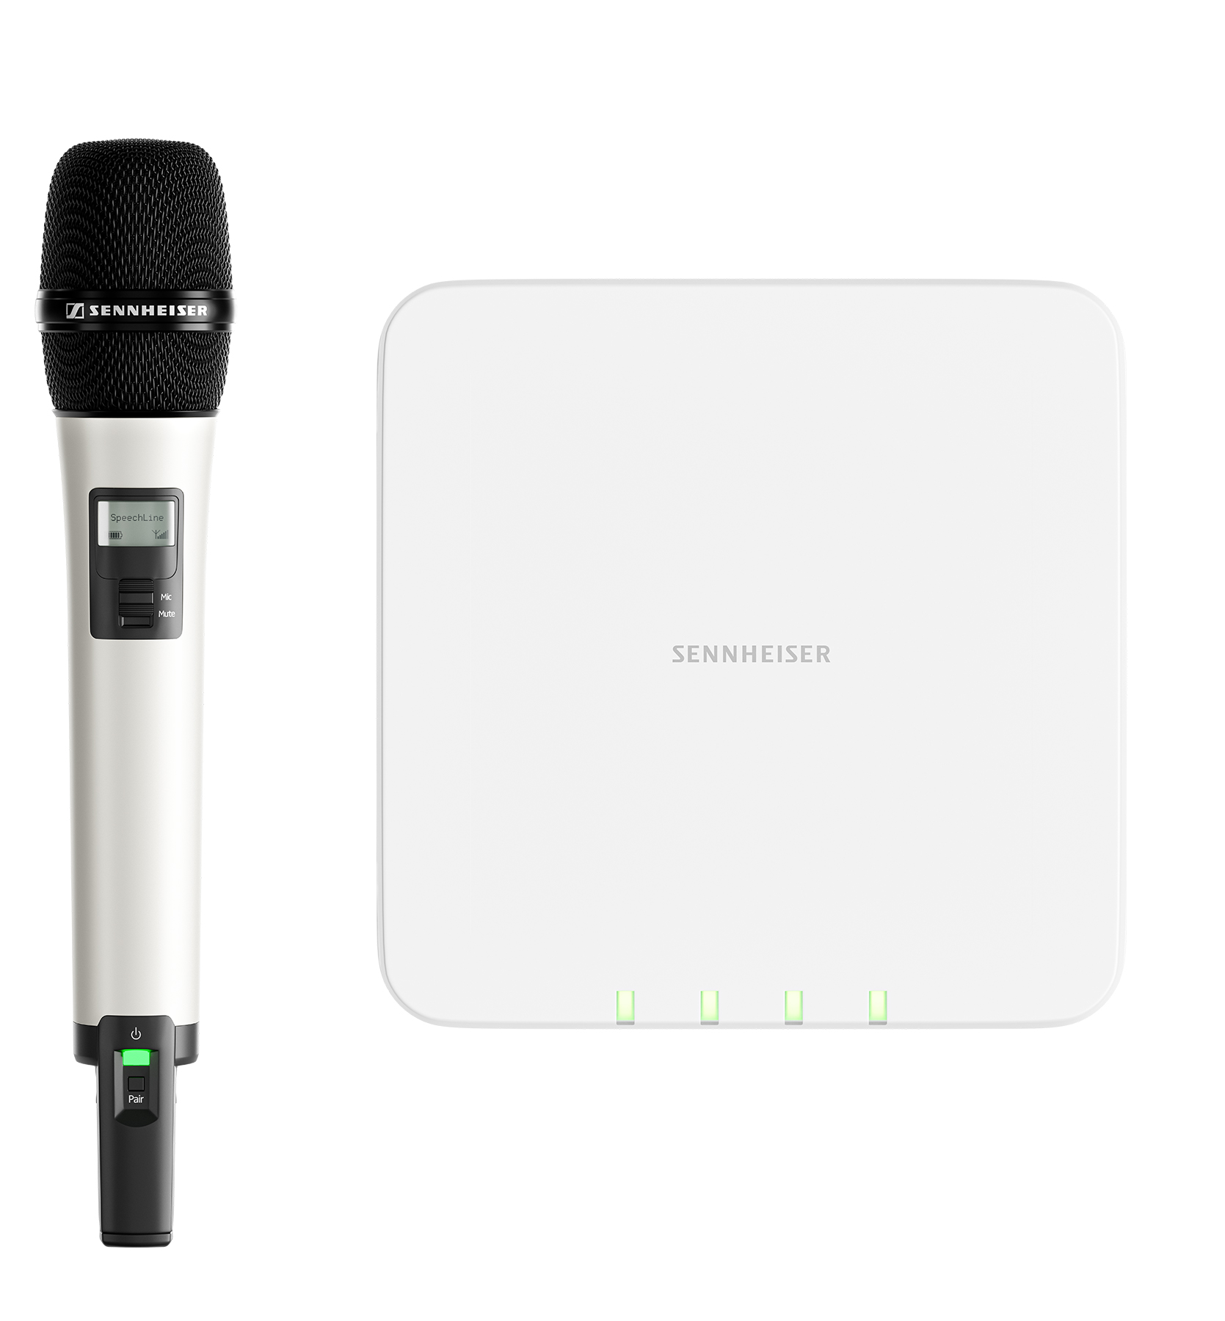 | SpeechLine Digital Wireless – This microphone system has been designed specifically for speech and lecture applications for higher education and corporate use | On BIMobject:  - SL Rack-Receiver DW  - SL Multi-Channel Receiver DW  - CHG 4N Charger  - CHG 2W Charger  - CHG 2 Charger  - AWM 2 Antenna  - AWM 4 Antenna
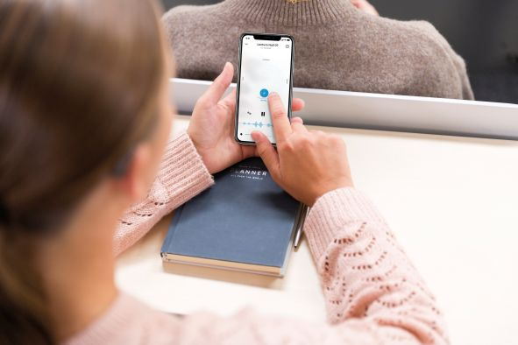 | MobileConnect – streaming solution for assistive listening over WiFi to mobile devices of students and audiences | On BIMobject  - MobileConnect Station
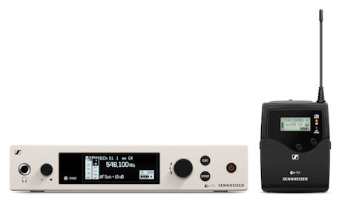 | evolution wireless G4 – the fourth generation makes professional wireless microphone technology even more simple, flexible and reliable. | On BIMobject  - EM 300-500 G4 rack-mount receiver  - EM 100 G4 rack-mount receiver

The image accompanying this press release can be downloaded at https://sennheiser-brandzone.com/c/181/XNRebyss.

About Sennheiser
Founded in 1945, Sennheiser is celebrating its 75th anniversary this year. Shaping the future of audio and creating unique sound experiences for customers – this aim unites Sennheiser employees and partners worldwide. The independent family company, which is managed in the third generation by Dr. Andreas Sennheiser and Daniel Sennheiser, is today one of the world’s leading manufacturers of headphones, loudspeakers, microphones and wireless transmission systems. In 2019, the Sennheiser Group generated turnover totaling €756.7 million. www.sennheiser.com

Global Press Contact

Stephanie Schmidt
Stephanie.schmidt@sennheiser.com
+49 (5130) 600 – 1275

